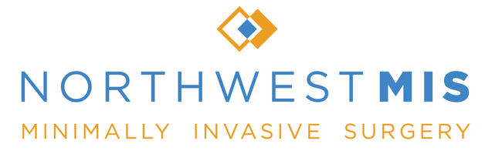

POST OPERATIVE INSTRUCTIONS: Laparoscopic Nissen fundoplication
Bloating: After laparoscopy it is very common to feel bloated from the gas used to inflate the abdomen. This should dissipate after 72 hours, but can last up to 1 week or more. The best treatment for this is to have daily bowel movements. Foods high in fiber such as prunes can help. Continuing with over the counter laxatives such as miralax, or senekot can help if constipation lasts for more than two days.
Pain Control: It is recommended that you begin taking anti-inflammatory medications after surgery. Typically it is recommended that you take scheduled LIQUID Ibuprofen and Tylenol afterwards. The medications should be alternated every 3 hours. In between the doses of Ibuprofen and Tylenol, if you have significant pain, feel free to take the liquid narcotic medications as needed. If you do not have significant pain, do NOT take the narcotics. If you do take the narcotic medications, please take a dose of milk of magnesia with the narcotics to prevent constipation.
Example:
Noon – Tylenol 650mg
(If still having significant pain, take narcotics 1 hour later with 15cc milk of magnesia )
3pm – Ibuprofen 600mg
(If still having significant pain, take narcotics 1 hour later with 15cc milk of magnesia)
6pm – Tylenol 650mg
(If still having significant pain, take narcotics 1 hour later with 15cc milk of magnesia)
9pm – Ibuprofen 600mg

Medications: Please stop taking all non-essential medications such as vitamins and minerals. Any essential medications such as blood pressure medications, heart medications, diabetes medications should be crushed if possible.

Post Nissen Diet (For first 2 weeks after surgery)
The post Nissen diet you will follow right after your surgery includes the following:
Apple juice
Cranberry juice
Grape juice
Chicken broth
Beef broth
Flavored gelatin (Jell-O)
Tea or coffee
Milk
Strained creamed soups (no tomato or broccoli)
Vanilla and strawberry ice cream (no whole strawberries)
Sherbet
Plain, blended or custard-style yogurt without pieces of fruit or seeds
Carnation Instant Breakfast (no chocolate-flavored)
Ensure or boost, protein shakes
Milkshakes
Yogurt - low fat
Carbonated drinks (sodas) are not allowed for the first six to eight weeks after surgery. After this time you can try them again in small amounts.
Please note: Dairy products, such as milk, cottage cheese, ice cream, and pudding, may cause diarrhea in some people just after surgery. You may need to avoid milk products at first and try them in small amounts as you advance your diet.

Lifting Restrictions: There are no specific lifting restrictions after this surgery other than pain. If you are still having pain from the surgery, do not engage in any heavy lifting or exercise until the pain is completely gone. Once the pain is completely gone, you may resume all normal activities.
Driving Restrictions: You may drive once off all narcotic pain medications.
Work Restrictions: You may not work for at least 1 week after surgery.

