



**APPRECIATION AND GRATITUDE**

We are all excited about the upcoming holiday season. It always brings a little extra joy, excitement and anticipation to us all and a chance to express our appreciation and gratitude.

Here are just some of the ways that Aly and I have shown our gratitude to others this past year. We donated to many organizations who are committed to helping people, animals and our environment. We have also donated food and funds to those in need due to our many natural disasters and more.

One special way we were able to show our gratitude to you, was to assist you and your tenants, in every possible way, during hurricane Dorian. We appreciate the many emails, phone calls and texts thanking us for supporting you. And, of course, if was our pleasure to do so.

*Again, we thank you and are grateful for your patronage, friendship and loyalty. And, we appreciate your confidence and trust in us and our company. Aly & I wish you and your families, an extraordinary Happy Holiday and a healthy, happy and prosperous New Year.*

**OUR NOTE TO YOU**

RENTAL MARKET STILL RISING

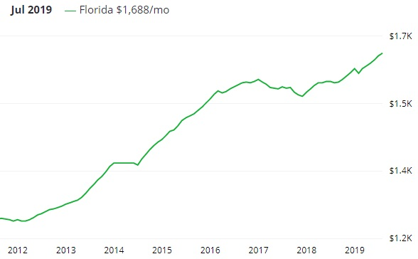

Florida rent prices 2012-2019

As you can clearly see, the rental market has continued to grow for 2019 and predictions show that the rental market will grow again for 2020, at the rate of about 2%-4%. Another year of great news for landlords.

**FALL HOME CLEANING**

As always, we will begin our gutter cleaning & power washing cleaning in November. Remember, leaves and debris can clog the gutters giving rise to a possibility of a leaky roof, or damage to the interior or exterior of your home. The cost is nominal and can ultimately save you expense money in the future. It includes all gutters cleaned, and the driveway, walkway, front porch and back patio power washed.

If you are interested in this service, please contact Aly at [myworkorder@comcast.net](mailto:myworkorder@comcast.net) to let her know. Thank you.

**PMTC NEWSLETTER**

**FALL/WINTER 2019 EDITION**