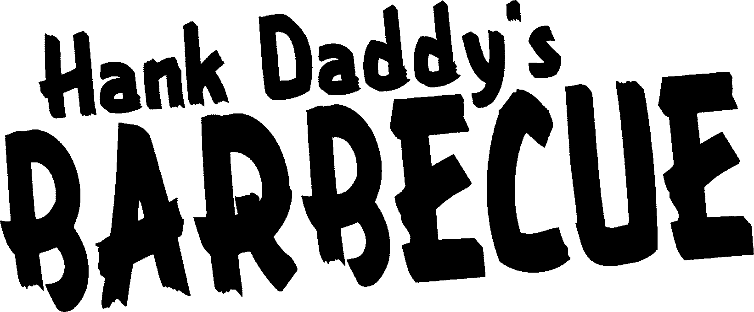

Bourbon Selection as of Sept 10 ‘21 Price indicated per 1 ounce.

*Denotes limited quantities.

|  |  |  |  |
| --- | --- | --- | --- |
| Angel’s Envy  1792 | Straight Kentucky Bourbon  Small Batch | $20  $12 |  |
|  | Single Barrel | $18 |  |
| Baker's | Straight Bourbon | $25 |  |
| Basil Hayden | Straight Bourbon | $11 |  |
| Blanton's | Original Bourbon | $18 |  |
|  | Special Reserve | $18 |  |
|  | Gold | $35 | **\*** |
| Breckenridge (Colorado)  Buffalo Trace | Straight Bourbon  Straight Bourbon | $18  $9 |  |
|  | Bourbon Cream | $7 |  |
| Bulleit | Bourbon Frontier | $ 9 |  |
|  | 10 Year Old | $11 |  |
| Burnside (Oregon) | Barrel Strength  Straight Bourbon | $18  $22 |  |
| Eagle Rare | 10 Year Old | $15 |  |
| E.H.Taylor | Small Batch | $20 | * |
|  | Single Barrel | $26 | * |
| Elijah Craig | Small Batch | $11 |  |
| Elmer T Lee | Single Barrel | $18 | * |
| Evan Williams | Straight Bourbon | $7 |  |
|  | Bottled - in - Bond | $12 | **\*** |
| Ezra Brooks | Straight Bourbon  7 Year Old Barrel Strength  Ezra Brooks 99 | $7  $15  $15 |  |
| Few | Small Batch | $18 |  |
| Four Roses | Straight Bourbon | $7 |  |
|  | Small Batch | $12 |  |
|  | Single Barrel | $14 |  |
| Jack Daniel's | Old Number 7 | $7 |  |
|  | Gentleman Jack | $10 |  |
|  | Single Barrel | $12 |  |
|  | Honey Whisky | $7 |  |
| Jefferson's Reserve | Very Small Batch | $27 | * |
|  |  |  |  |
|  |  |  |  |
|  |  |  |  |
|  |  |  |  |

|  |  |  |  |  |
| --- | --- | --- | --- | --- |
| Jim Beam | White Label | | $6 | |
|  | Devil's Cut | | $7 | |
|  | Black - Extra Aged | | $7 | |
|  | Blue - Double Oak | | $7 | |
|  | | Single Barrel | | $11 | |  |
|  | | Old Tub | | $10 | |  |
| Knob Creek | | Straight Bourbon | | $10 | |  |
|  | | 9 Year Old | | $11 | |  |
|  | | Single Barrel 120 Proof | | $15 | |  |
| Larceny | | Straight Bourbon | | $10 | |  |
| Legent | | Blended Bourbon | | $12 | |  |
| Maker's Mark | | Straight Bourbon | | $10 | |  |
|  | | 46 | | $15 | |  |
|  | | Private Select 2.0 | | $25 | | * |
| Michter's | | US-1 Small Batch  Single Barrel Sour Mash | | $25  $25 | | * |
| Old Forester | | US-1 Small Batch Unblended  Straight Bourbon | | $25  $7 | |  |
| Old Rip Van Winkle | | 10 Year Old | | $50 | | * |
| Rebel | | Straight Bourbon | | $7 | |  |
| Redemption | | Straight Bourbon | | $12 | |  |
| Rhetoric | | 24 Year Old | | $60 | | * |
| Weller | | Full Proof | | $18 | |  |
|  | | Antique 107 Wheated | | $15 | |  |
|  | | Special Reserve | | $11 | |  |
|  | | Single Barrel | | $15 | | * |
| Wild Turkey | | Straight Bourbon | | $7 | |  |
|  | | Rare Breed | | $12 | |  |
|  | | Longbranch | | $12 | |  |
| Woodford Reserve | | Straight Bourbon | | $11 | |  |
|  | | Double Oak | | $15 | |  |
| Yellowstone | | 96 Proof Staight | | $30 | | * |