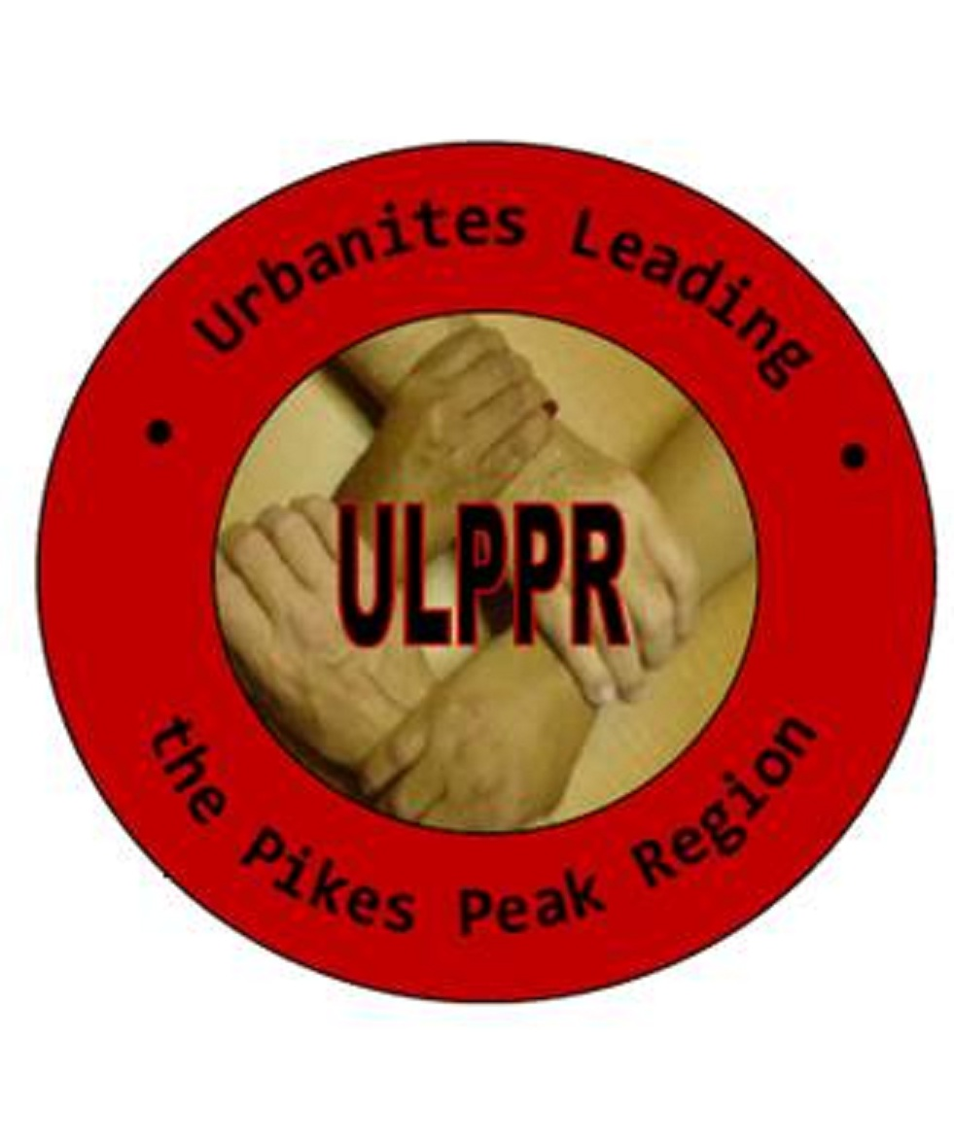
506 E. Moreno Ave
Colo Spgs, CO 80903

T (719) 634-1525
F (719) 634-3357

www.ulppr.org

URBANITES LEADING THE PIKES PEAK REGION

2019 Scholarship Applicant

Request for Letter of Recommendation

The student listed below is requesting that you submit a letter of recommendation to support their application to receive a scholarship from the Urbanites Leading the Pikes Peak Region (ULPPR). Scholarship applicants should obtain three letters of recommendation. The letters must be from adult non-relatives. The letters must be submitted with this questionnaire and emailed to jj.frazier@ulppr.org or mailed to: ULPPR Scholarship Review Committee, 506 E. Moreno Avenue, CSC 80903, by no later than Friday, February 22, 2019.

Recommendation Data Sheet
To the Student – Please write your name below and place a check mark in the appropriate box prior to giving this form to the individual you request to submit a letter of recommendation on your behalf.
STUDENT NAME:
LAST FIRST MIDDLE
The student named above is applying for consideration in the Urbanites Leading the Pikes Peak Region Scholarship Program. This scholarship program will award college scholarships in various amounts of $500-$1500 of undergraduate study starting with the 2019 academic year. Our goal is to recognize and reward academic excellence, community service, and academic promise among minority and underserved youth in the Pikes Peak Region.
Three letters of recommendation are requested. The ULPPR Scholarship Review Committee will review the letters and additional documents submitted by the student and his/her school. You are being asked to submit one recommendation as indicated below.
A teacher, counselor or other school official
An individual (non-relative) who can attest to the student’s character, community service and volunteer service
Please complete the following:
Name:
How long have you known the student?
In what capacity?

Signature: Date:

Please see guidelines for the written recommendation below.

To the school official – Please provide your assessment of the student’s academic performance, subject area, strengths, career goals, and potential for success. Comment about extracurricular activities, leadership skills, special talents and relationship with others at school.
To the community service commentator – Please cite specific organizations, activities and your impression of the student’s current and future potential.
Deadline: 5:00 p.m., Friday, February 22, 2019.

The mission of the Urbanites Leading the Pikes Peak Region is to provide equality and opportunities for the
socio-economically disadvantaged through education, empowerment and advocacy.

