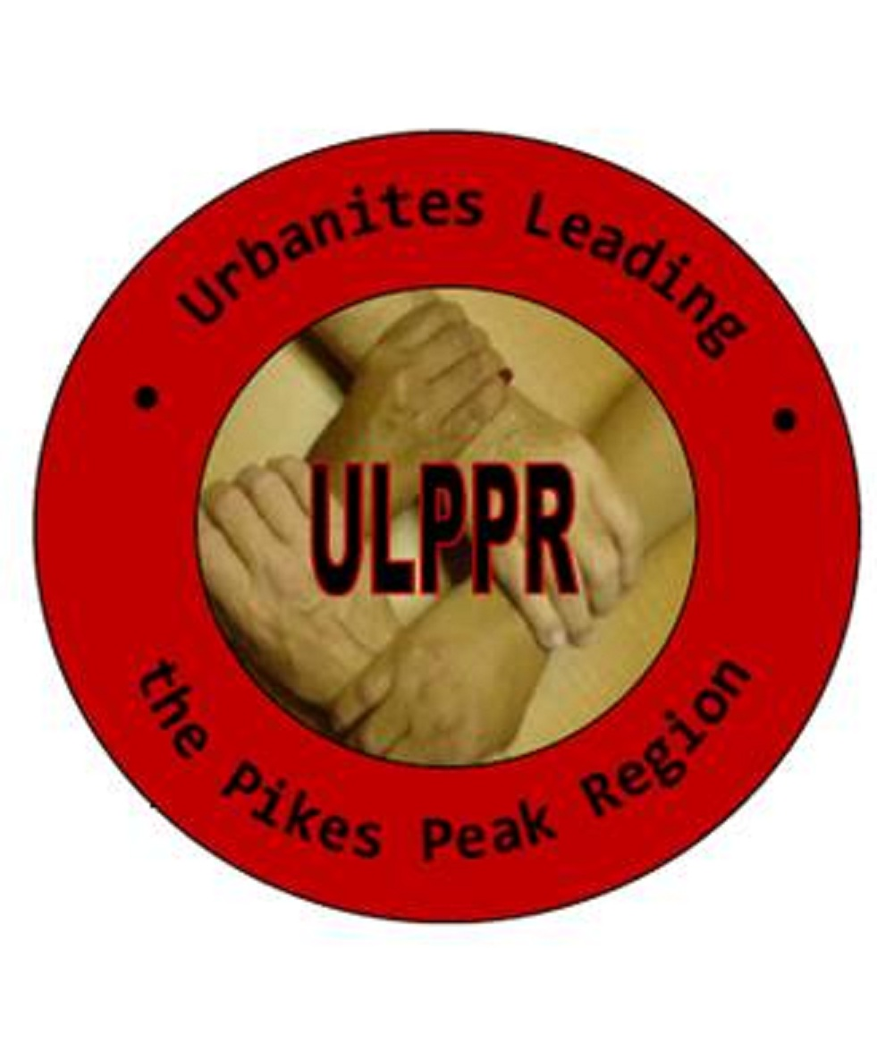

**The mission of the ULPPR is to promote equality and opportunities for the socio-economically disadvantaged by providing and supporting educational programs and fostering economic empowerment and public advocacy.**

January 2023

**TO: ULPPR Scholarship Applicant**

The Urbanites Leading the Pikes Peak Region (ULPPR) and its partnering organizations are pleased to invite you to participate in the ULPPR Scholarship Program.

In the past, the ULPPR has experienced great success with our Scholarship Awards Program, and we hope to build upon that success with deserving students who will commence their collegiate study in the fall of 2023.

The ULPPR is committed to identifying and awarding scholarships to outstanding students who have demonstrated an interest in attending college after high school. We urge you to review the enclosed materials very carefully and to apply to be considered to receive a scholarship in various amounts ranging from $500-$1500 of undergraduate study starting with the 2023 academic year.

Our goal is to recognize and reward academic excellence, community service, and academic promise among minorities and underserved youth in the Pikes Peak Region.

**Successful Applicants will:**

Be a 2023 graduating high school senior

Have a minimum 2.75 GPA on a 4.0 scale

Demonstrate leadership in school and community

Demonstrate a need for financial assistance to enter college

**Applicants must meet the following requirements:**

Submit a complete application signed by parents

Write an essay on *“***Why I think a non-profit organization such as the Urbanites Leading the Pikes Peak Region (ULPPR) is relevant today?”**(*Please include specific examples of how you have been affected on a local, statewide or national basis by such an organization.)*

Submit three Letters of Recommendation

Provide an official transcript that includes the first semester of the

2023 school year

All required documents must be returned to the ULPPR offices located at 506 E. Moreno Avenue, CSC 80903 or via email to: [jj.frazier@ulppr.org](mailto:jj.frazier@ulppr.org) by **5:00 p.m., Friday, February 24, 2023**. All scholarship award recipients are required to attend the **ULPPR Scholarship Awards Dinner in May 2023.**

Thank you for your interest in the ULPPR Scholarship Awards Program. If you have questions or require additional information, please feel free to call our office at **(719) 634-1525** or contact **JJ Frazier** at **(719) 244-2133**.

Sincerely,

Board of Directors

Urban League of the Pikes Peak Region

**Urbanites Leading**

**the Pikes Peak Region**

506 E. Moreno Avenue

Colorado Springs, CO 80903

T (719) 634-1525

F (719) 634-3357

[www.ulppr.org](http://www.ulppr.org)

Tax ID: 84-0537544