February 14, 2021 – 6th Sunday Ordinary Time

A leper came to Jesus and kneeling down begged him and said, “If you wish, you can make me clean.” Moved with pity, he stretched out his hand, touched him, and said to him, “I do will it.
Be made clean.” Mark 1: 40-45

A leper for the time being . . .

A painful moment recounted in The Christian Century [August 19, 2018]:
He had been a minister for 25 years. He was a generous colleague to other clergy in the area, serving on committees and attending ordinations and installations. He had friends in other churches — or so he thought.
Then a dispute erupted in his church resulting in public charges, counter charges, angry public meetings, and critical articles in the local newspaper. A long, ugly, drawn-out legal process tore the parish apart. Seeing him at meetings, his fellow clergy were friendly — but distant. After all, they had their own churches — and skins — to worry about.
In time, the issues were resolved and the parish was healing. At their next gathering, his fellow ministers greeted him warmly, clapping him on the back, shaking his hand. One minister offered a prayer of thanksgiving that all had ended well.
Later at the meeting, the minister stood and asked to speak. He didn’t talk about the issue his parish had faced or the long legal process. He told his brother and sister ministers “about the silence at the center of the noise” — about the phone that never rang in a gesture of friendship, his feeling of being deserted by friends and colleagues in ministry.”
“Where were you?” he asked. “I didn’t expect you to take a stand alongside me. It wasn’t your battle. I did expect your friendship, your offers of prayer, a shared cup of coffee. We could have talked about something else. Or we could just sit together for a bit, not saying anything. Where were you?”
A minister who was there remembers, “There was a silence and downcast faces. In our silence, we were ashamed. And, I hope, recalled our better selves, as ministers and as people.”

Our attitudes and perceptions can reduce others to “lepers”: those we avoid for fear of being caught up in their problems or crises, those who we don’t those who don’t “fit” our image of class and decorum, those whose politics or religion or race or gender seem to threaten our own. We exile these “lepers” to the margins of society outside our gates; we dismiss them with simplistic labels and unfair stereotypes; we reject them as too “unclean” to be part of our lives and our world. The Christ who heals lepers comes to heal us, as well, of our debilitating sense of self that blinds us to the sacredness and dignity of those we demean as “lepers,” to heal us of our own “leprosy” so that we are able to realize again that God extends his compassion and grace even to the likes of us. Before God, no one is a leper, no one is beyond the reach of God’s healing mercy and compassion; all of us are sons and daughters of God; all of us are made in the sacred image of the God of justice, peace and reconciliation.
www. ConnectionsMediaWorks.com

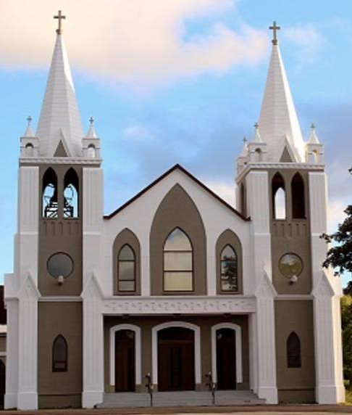
February 14th, 2021
6th Sunday of Ordinary Time
Sacred Heart Parish
A Stewardship Parish in Union with Christ
Parish Information
Pastor: Monsignor Jim Robertson
Office Administrator: Dianne Russell
Office Hours: Monday to Friday 9am - 1pm.
465 Curling Street  Corner Brook, NL, A2H 3K8  Tel: (709) 785-5025 | curlingparish@hotmail.com  e-transfers: sacredheartrcparish@gmail.com  Password "Church"  www.sacredheartrcparish.ca
Weekend Masses: Saturday 4:30 p.m., Sunday 11 a.m.
To Register, please call the office Monday to Friday
between 9 am and 1 pm.

Reconciliation: By request

Mass During the Week: Tuesday, Wednesday and Thursday at 7 pm
Friday at 10 am.

Holy Hour of Adoration: Discontinued until further notice.
Marriages: Six months’ notice required. A year's notice is recommended.
Baptisms: Please call the Parish Office to schedule preparation session.
St. Vincent de Paul: To assist those in need. Call 638-9010.
FACE MASKS: These masks should be worn at all times.
They may be removed if you are seated and able to maintain 2m distancing from others.

RECEIVED WITH THANKS
February 7, 2021
Regular Sunday | $1403.00
Building Fund | 180.00
Envelope Cost Contributions | 10.00
In Memorium  Late Imelda Staples | 10.00
Votive Candles | 5.00
Word Among Us | 10.00
St. Vincent de Paul | 35.00

MASS INTENTIONS
Tue. 7pm | Special Intention
Wed. 7pm | Late Rita Hall
Thu. 7pm | Late Edward Callahan
Fri. 10am | Late Francis Lewis
Sat. 4:30 | Late Wayne Callahan
Sun. 11am | Parish Community

Bible Study: Sunday at 7:00 pm in the parish meeting room. All are welcome.

RECEIPTS FOR 2020: Your 2020 receipts are available at the parish office.

FUNDRAISING DONATIONS: While we appreciate your generosity with our fundraising, no donations made to the fundraising efforts can be receipted for income tax purposes.

LENT-ADVANCE NOTICE: Please remember that Lent begins with the celebrations of Ash Wednesday. This year Ash Wednesday takes place on February 17th. Easter Sunday this year is April 4th.

ASH WEDNESDAY: Masses on Ash Wednesday will be as scheduled: 10:00 am at Sacred Heart Church, 5:30 pm at Our Lady Star of the Sea Church and 7 pm at Sacred Heart Church. Ashes will be distributed during each of these masses. Please make every effort to attend one of these masses.
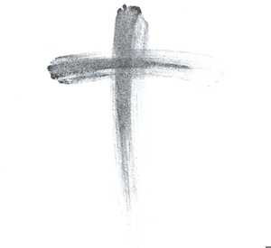
ASH WEDNESDAY - UPDATE: We are presuming that services will be going ahead on February 17th. You will have to pre-register for these masses. During the mass, those who wish to receive ashes will be asked to come forward and the priest will sprinkle ashes on your head. Due to Covid-19 regulations no personal contact is allowed.

CATHOLIC MISSIONS IN CANADA: Mission activity was the first action of the Apostles. When the Canadas began, French missionaries, accompanying explorers, continued that action in North America. Four hundred years later, some areas have yet to be fully established. Encouraged by Pope Francis, our home missions need our attention. The ‘Day of Prayer for Canadian Home Missions’ hopes to achieve this goal by asking God’s blessing on our mission areas. Our Canadian missionaries and the Catholics they serve need our prayers. Each Canadian Diocese is choosing its own time to celebrate our Canadian missions. Our Diocese has selected Ash Wednesday as a day of prayer for this worthy cause. In particular, we will be asked to make an offering on this day. Envelopes for this purpose are in our package. Extra envelopes will be available in our churches. Please join the initiative. Sponsored by Catholic Missions in Canada.

FOURTH DEGREE, KNIGHTS OF COLUMBUS, NEWFOUNDLAND AND LABRADOR: The NL District of the 4th Degree is planning a Virtual Fourth Degree Exemplification for Saturday, March 20, at 10:00 am using the application GoToMeeting. Contact your local Knights of Columbus Council, the Faithful Navigator or Faithful Comptroller of your local Fourth Degree Assembly for further information. Membership in the Fourth Degree allows a Knight to display pride in his country, while continuing to serve his community and Church. Please consider joining.

KNIGHTS OF COLUMBUS - Bishop O’Reilly Assembly 0624: Sir Knights will be meeting Tuesday, February 16th, at All Hallows’ Parish, upstairs at 7:45 P.M. Could Sir Knights please try to attend.

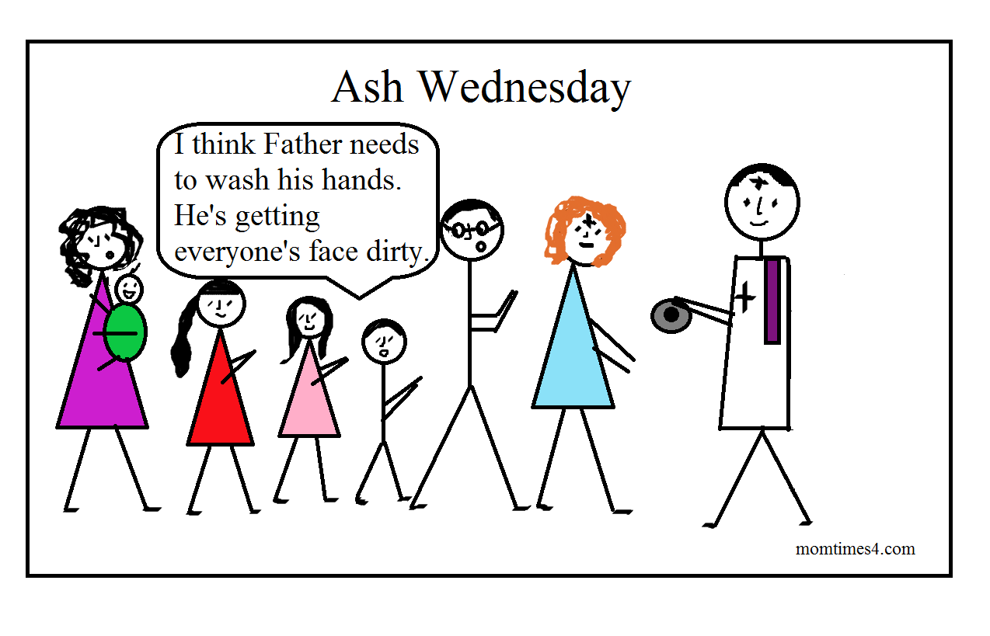
KNIGHTS OF COLUMBUS: The Knights of Columbus will be reciting the Holy Rosary on every Friday during lent on Bay of Island Radio 100.1 FM @ 7 PM. The knights would like to thank Fr. Terry Boland for his cooperation. Please join us and pray the rosary together.
CATHOLIC JOURNEY THROUGH LENT: At the beginning of each week, during Lent, a short 5-minute reflection will be available on the following week’s Gospel. Bishop Bergie from St. Catherine’s will be doing the reflections. These reflections can be viewed by going to the cccb.ca website.

PAPAL PRAYER INTENTION - February Violence Against Women: We pray for women who are victims of violence, that they may be protected by society and have their sufferings considered and heeded.

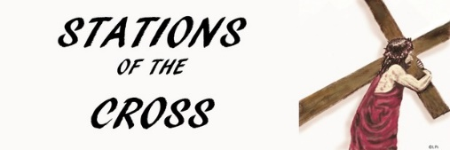
STATIONS OF CROSS: You are invited to join us at in celebrating the Stations of the Cross at 7 pm on the Fridays of Lent.
LADIES FUNDRAISER - BINGO:
Congratulations to Christine Chadderton on winning $68.00 in last month’s draw. Thank you to all who participated in our fund-raising efforts. Donors for this month include those whose last names begin with G to M. Donations must be in by Sunday, Feb 21. The draw will take place the following Sunday, February 28. I would like to remind you that anyone, whether from our parish or elsewhere, are welcome to take part in the draw. Your name will be entered once for each donation of $10.00. Good luck everyone!

IMMACULATE HEART OF MARY SCHOOL:
Immaculate Heart of Mary School collects Coleman’s Receipts as a fund-raiser. They can be dropped off at the main door of our church in the box labelled “Coleman’s Grocery Receipts”.

