SOCIETY OF SAINT VINCENT de PAUL - 2020 ANNUAL REPORT

2020 has been a year to remember for the wrong reasons. COVID-19 has taken its toll on people in various ways. It also has made it sometimes difficult for the S.S.V.P. members to do the excellent charity work that they do to help the less fortunate. This is a summary of the activities that the society has been involved in for the year 2020.

Receiving and delivering furniture to the needy is a big part of SSVP activities. There were 303 visits to residences in 2020 and the volunteer hours were 567. 460 Items including: Mattresses, Box Springs, Bed Frames and Rails, Dressers and Mirrors, Sofas, Chairs and Recliners, T.V. Sets and Stands, Major Appliances, Washers, Dryers, Stoves, etc., Kitchen Tables, Kitchen Chairs, Coffee Tables, End Tables, Nightstands, Lamps were delivered.

As well as furniture, Groceries and other items were also given out to needy persons who requested our service. There were 120 Christmas Hampers delivered at a cost of 14095.62.

Mary’s Kitchen was only available until the pandemic shutdown in March. It will resume operation when COVID is manageable. Here are the figures for Mary’s Kitchen for 2020. Adults served 396; Children served 6, Cost of food $4.865.40. The volunteer hours for Mary’s Kitchen were 436.

An integral part of our activities were the home visits. In 2020 there were 203 home visits with 144 adults and 55 children being cared for. The cost of this activity was $ 9791.87, and the volunteer hours were 281.

The S.S.V.P. van is used to pick up groceries for the food bank on Fridays and the total hours for this service was 90.5. Meetings, Training and Organizational activities accumulated a total of 562 hours.

We bought food for Mary’s Kitchen for a six-month period, but it was open for only three months. The remainder of the food was delivered to Mr. Wilsons store on Humber Road and he distributed the remainder of the food freely to those in need.

2020 has been a year of great disaster and great suffering to many people. It has been a pleasure for the members of the Society of St. Vincent de Paul to be a part of bringing some light to the dark world of the needy. It has been a pleasure to witness the delight that helping the needy brings to both the recipient and the messenger. We will continue to do our best to promote the ideals of the Society and to help all who ask. Thank you for all your support.

S.S.V.P. Members. Keep Safe

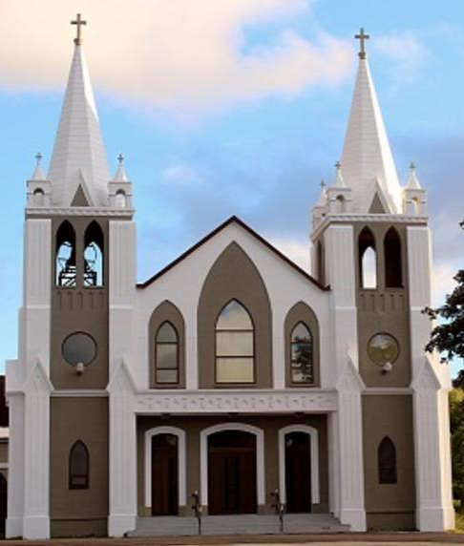
February 7th, 2021
5th Sunday of Ordinary Time
Sacred Heart Parish
A Stewardship Parish in Union with Christ
Parish Information
Pastor: Monsignor Jim Robertson
Office Administrator: Dianne Russell
Office Hours: Monday to Friday 9am - 1pm.
465 Curling Street  Corner Brook, NL, A2H 3K8  Tel: (709) 785-5025 | curlingparish@hotmail.com  e-transfers: sacredheartrcparish@gmail.com  Password "Church"  www.sacredheartrcparish.ca
Weekend Masses: Saturday 4:30 p.m., Sunday 11 a.m.
To Register, please call the office Monday to Friday
between 9 am and 1 pm.

Reconciliation: By request

Mass During the Week: Tuesday, Wednesday and Thursday at 7 pm
Friday at 10 am.

Holy Hour of Adoration: Discontinued until further notice.
Marriages: Six months’ notice required. A year's notice is recommended.
Baptisms: Please call the Parish Office to schedule preparation session.
St. Vincent de Paul: To assist those in need. Call 638-9010.
FACE MASKS: These masks should be worn at all times.
They may be removed if you are seated and able to maintain 2m distancing from others.

RECEIVED WITH THANKS
February 1, 2021
Regular Sunday | $1689.15
Building Fund | 55.00
Envelope Cost Contributions | 15.00
New Years Day | 10.00
Votive Candles | 25.00
Bingo Proceeds | 607.00
Sunday Missals | 5.00
St. Vincent de Paul | 110.00

MASS INTENTIONS
Tue. 7pm | Special Intention
Wed. 7pm | Late Bill & Betty McCarthy
Thu. 7pm | Late Ferd McCarthy
Fri. 10am | Special Intention
Sat. 4:30 | Late Bernard Brake
Sun. 11am | Parish Community

Parish Dues: Received with thanks from: Eugene & Evelyn Beales, Marie Pennell, Marina Cashin, and Joan Hutchings.
Bible Study: Sunday at 7:00 pm in the parish meeting room. All are welcome.

SUNDAY ENVELOPES FOR 2021: We thank you for your generosity in past years. The remaining envelopes for 2021 are at the Parish office. Please drop by the parish office to pick up your box of envelopes Mon-Fri, 9am-1pm.

RECEIPTS FOR 2020: Your 2020 receipts are available at the parish office.

LENT-ADVANCE NOTICE: Please remember that Lent begins with the celebrations of Ash Wednesday. This year Ash Wednesday takes place on February 17th. Easter Sunday this year is April 4th.

ASH WEDNESDAY: Masses on Ash wednesday will be as scheduled: 10:00 am at Sacred Heart Church, 5:30 pm at Our Lady Star of the Sea Church and 7 pm at Sacred Heart Church. Ashes will be distributed during each of these masses. Please make every effort to attend one of these masses.

CATHOLIC MISSIONS IN CANADA: Mission activity was the first action of the Apostles. When the Canadas began, French missionaries, accompanying explorers, continued that action in North America. Four hundred years later, some areas have yet to be fully established. Encouraged by Pope Francis, our home missions need our attention. The ‘Day of Prayer for Canadian Home Missions’ hopes to achieve this goal by asking God’s blessing on our mission areas. Our Canadian missionaries and the Catholics they serve need our prayers. Each Canadian Diocese is choosing its own time to celebrate our Canadian missions. Our Diocese has selected Ash Wednesday as a day of prayer for this worthy cause. In particular, we will be asked to make an offering on this day. Envelopes for this purpose are in our package. Extra envelopes will be available in our churches. Please join the initiative. Sponsored by Catholic Missions in Canada.

PAPAL PRAYER INTENTION - February Violence Against Women: We pray for women who are victims of violence, that they may be protected by society and have their sufferings considered and heeded.
DEVELOPMENT AND PEACE: Corner Brook and Labrador Diocesan Council, Share Lent Workshop: February 9th, at 1:00 pm, at All Hallows. Representatives from Parish Councils and those interested in the work of the Development and Peace are invited to take part in an afternoon of solidarity and learning about the upcoming Share Lent Campaign, Share Love, Share Lent, based upon Fratelli Tutti, Pope Francis Encyclical Letter on Fraternity and Social Friendship. Those interested, to assist with Covid-19 protocols, are asked to register in advance, please email pwalsh@devp.org

WORLD DAY OF THE SICK THURSDAY FEBRUARY 11th: The ministry of Jesus to the sick is central to the life of the Church. February 11th (Memorial of Our Lady of Lourdes) highlights the healing ministry of the Church. It reminds us that service to the sick and suffering cannot be neglected. It recognizes the great efforts of doctors, nurses, health care institutions and pastoral care givers to restore health to those afflicted with illness and diseases. Anointing of the sick will be offered during the 9:30 am Mass on this day at the Cathedral. All who are suffering from sickness of any kind are invited to participate. In order to commemorate February 11th, the Day of the Sick, the Diocese will dedicate its Thursday, February 11th weekday live-streamed Mass to all Medical Professionals in our Diocese. Though the live-feed will begin at 9am on our Facebook page, the celebration will be available on Facebook and You-Tube, later in the day. For those who would like to tune in later search under: “Diocese of Corner Brook and Labrador”, once you have entered one of the two platforms.

FOURTH DEGREE, KNIGHTS OF COLUMBUS, NEWFOUNDLAND AND LABRADOR: The NL District of the 4th Degree is planning a Virtual Fourth Degree Exemplification for Saturday, March 20, at 10:00 am using the application GoToMeeting. Contact your local Knights of Columbus Council, or the Faithful Navigator or Faithful Comptroller of your local Fourth Degree Assembly for further information. Membership in the Fourth Degree allows a Knight to display pride in his country, while continuing to serve his community and Church. Please consider joining.

FUNDRAISING DONATIONS: While we appreciate your generosity with our fundraising, no donations made to the fundraising efforts can be receipted for income tax purposes.

IMMACULATE HEART OF MARY SCHOOL:
Immaculate Heart of Mary School collects Coleman’s Receipts as a fund-raiser. They can be dropped off at the main door of our church in the box labelled “Coleman’s Grocery Receipts”.

Answer: Light switch

