January 1st - 2nd, 2022 – Mary, The Holy Mother of God & Epiphany of the Lord

[M]agi from the east arrive in Jerusalem, saying, “Where is the newborn king of the Jews?
We saw his star at its rising and have come to do him homage.” Matthew 2: 1-12

God of all colors

In a revealing but unsettling essay in The New York Times [November 14, 2021], Wajahat Ali tells of his five-year-old daughter, Nusayba, twirling around in her princess dress, fixing her silver tiara and checking out her newly applied eye shadow and red lipstick in the mirror. Then she examined her beautiful, brown skin.

“I don’t like my skin color,” she declared, ‘I wish my skin was lighter. It’s prettier.”

Nusayba’s comment, her dad writes, “was a gut punch. Up to that point, my wife and I were confident that we had protected our daughter from the curse of colorism, a toxic inheritance that still poisons our perception of self and beauty.”

Wajahat and his wife Sarah grew up in Pakistani immigrant families. Ali explains that discrimination based on the hue of one’s skin is a problem not only here in America but in Asian countries, as well. “Lighter” skin is preferable to “dark skin.” Even within families, Pakistanis will say about their daughters and nieces, “She’s so beautiful, but tragically, she is dark skinned” or “For a girl with dark skin, she’s actually pretty.” Little Nusayba is not alone in her negative image of her own skin.

Nusayba’s mom and dad are doing their best to protect their daughter, but “the fortress we built out of love and awareness was vulnerable to the insidious pull of whiteness,” Ali writes. Society, both here and around the world, “punishes darker-skinned people, who tend to make less money than those who are light-skinned and are more likely to be incarcerated and discriminated against in a variety of ways.

“Every day we stress to our children that the real beauty is not physical but instead shines from the inside, reflected by a loving generous heart [but] racism and colorism are daunting foes threatening our little girl.”

Undoubtedly, the company of the magi included travelers of every skin color. In their search for the Christ, God reveals his love for all peoples of every nation and culture. God sets his justice and peace as a brilliant “star” for all people of good will to follow — regardless of their language or culture or skin color. May the magi’s journey set us on a journey beyond our own biases and prejudices to realize Isaiah’s vision of a city of peace in our own time and place, a Jerusalem illuminated by the light of God’s complete and unconditional love of all peoples of every race and nation and language — and color. www. ConnectionsMediaWorks.com

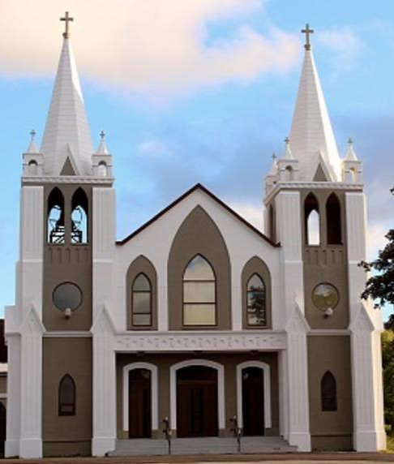
January 1st & 2nd, 2022
Solemnity of Mary the Mother of God
Epiphany of the Lord
Sacred Heart Parish
A Stewardship Parish in Union with Christ
Parish Information
Pastor: Monsignor Jim Robertson
Office Administrator: Dianne Russell
Office Hours: Office closed to the public until January 5th, 2022

465 Curling Street  Corner Brook, NL, A2H 3K8  Tel: (709) 785-5025 | curlingparish@hotmail.com  e-transfers: sacredheartrcparish@gmail.com  Password "Church"  www.sacredheartrcparish.ca
Weekend Masses: Saturday 4:30 pm, Sunday 11 am
To Register, please call the office Tuesday to Friday between 9 am and 2 pm.

Mass During Week: Tuesday, Wednesday, and Thursday at 7 pm.
Friday at 10 am.
Daily mass is cancelled any day schools are closed due to bad weather.

Lohnes Complex First Fridays - 2 pm at the Lohnes Complex, closed to public.

Bible Study: Sunday at 7pm in parish meeting room.
Holy Hour of Adoration: Discontinued until further notice.
Reconciliation: By request.
Marriages: Six months’ notice required. A year’s notice is recommended.
Baptisms: Please call the Parish Office to schedule preparation session.
Family Connections: At www.rcchurch.com you will find a link to family connections.
St. Vincent de Paul: To assist those in need. Call 638-9010.
Masks are again mandatory at all indoor public gatherings
As well please maintain physical distancing at all times.

MASKS THAT COVER BOTH THE NOSE AND THE MOUTH MUST BE WORN AT ALL TIMES WHEN ATTENDING SERVICES OR FUNCTIONS IN THIS CHURCH.

RECEIVED WITH THANKS
December 26, 2021
Regular Sunday | $2665.00
Building fund | 85.00
Envelope Contributions | 35.00
Advent | 300.00
Sunday Missals | 10.00
Shepherds Fund | 45.00
Christmas | 2600.00
Flowers | 330.00
St. Vincent de Paul | 95.00
MASS INTENTIONS
Tue. 7pm | Late Gerald Rowsell
Wed. 7pm | Deceased Members of the MacDonnell Family
Thu. 7 pm | Late Joe & Sylvia Hickey
Fri. 2pm | Late Michael Basha  Lohnes
Sat. 11am | Late Michael & Ada George
Sun. 11am | Parish Community

PARISH DUES: Received with thanks: Mike & Alvina George, John Hayes, Jack & Clara Joyce, Denise Bruce, and Tom & Eileen Moore.

HOLIDAY OFFICE HOURS: The office will be closed Tuesday, January 4th reopening Wednesday, January 5th, 2022.

Sunday missals: The new missals are available at the back of the Church. $5 each.

PARISH COUNCIL: Next meeting will be January 10th at 6 pm.

BIBLE STUDY: Bible Study January 2nd at 7pm.
THANK YOU: I want to thank you for your generosity to me at Christmas and throughout the year. Your gifts have been appreciated by me and my family. Your generosity allows me to be generous to other needy organizations. Again, thank you very much Happy New Year. Fr. Jim.

CHRISTMAS FLOWER DONATIONS: Donations were made for Christmas flowers by the following: Valerie O’Conner, Jocelyn Kennedy & Serenna Callahan, Veronica Hickey, Joe & John Hayes, Jim & Brenda Griffin and Barbara Neville. Donations made in memory by the following: Catherine Musseau in memory of George, Gary and Greg Musseau; Joan Hutchings in memory of deceased members of the Hutchings family; Tom and Eileen Moore in memory of Jack & Joan Hearn and the deceased members of the Tracey Family; Gerry & Sandy Buckle in memory of Thomas Griffin Sr. Brian Griffin and Edward Buckle; Annie Griffin in memory of Thomas Griffin Sr. Brian Griffin; Doug and Donna Beales in memory of their daughter Dana Beales and brother Fred Beales; Don & Theresa George in memory of Michael, Ada, Reanie and Lawrence; Margaret McCarthy in memory of Bill & Betty McCarthy and deceased members of the McCarthy Family; The George Family in memory of Michael, Ada, Reanie and Lawrence.

THANK YOU: A very big thank you to everyone who helped prepare Christmas Liturgies. This was very difficult in light of changing regulations dealing with Covid 19. Thank you to musicians, cantors, choirs, sacristans, servers, ushers, readers, communion minsters, and all persons who helped in anyway. Their work has made for beautiful celebrations here at Scared Heart Parish, Thank you.
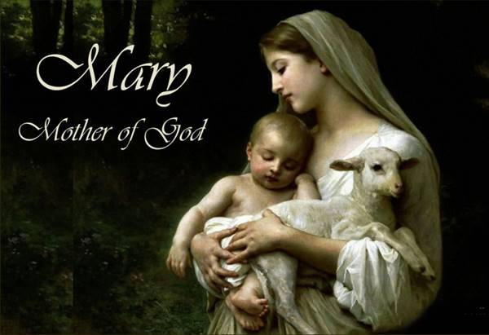

THE SOLEMNITY OF MARY: On January 1, the Church celebrates the Solemnity of Mary, the Holy Mother of God. This, the highest title of the Blessed Virgin Mary, was given to her at the Council of Ephesus in 431 A.D. and is the oldest feast of Mary celebrated by the Catholic Church. It is a Holy Day of Obligation in the Canadian Church.

A NEW YEAR’S PRAYER:
Lord, you make all things new,
You bring hope alive in our hearts
and cause our Spirits to be born again.
Thank you for this new year
for all the potential it holds.
Come and kindle in us a mighty flame
so that in our time,
many will see the wonders of God
and live forever to praise Your glorious name. Amen.

PRAYER FOR HEALING: Lord our God we trust in your care for us. We pray you give us strength to combat covid-19. We ask your help in freeing us of fear and in helping us follow the guidelines that will help us contain this virus. Be with our health care professionals in combating this illness. Keep us safe. In Jesus’ name we pray. Amen
THE MAGI OR WISEMEN: in ancient Iran - also known as Persia - a priest was called a “magus”. The plural is “magi”. The word “magic” comes from the same root. Magi were experts in astronomy. This was useful in determining the calendar and the end of winter and the spring planting season. They believed that stars and other celestial objects actually influenced, rather than merely coincided with, earthly events. One, or possibly a series of omens, led them to believe that a royal prince had been born in Israel. They were sent as ambassadors to provide tribute to the newborn. They bible does not say how many Magi visited. It is assumed that there were three because of the number of gifts. The Holy Family welcomed the Magi on Epiphany. There is a beautiful tradition that has been inspired by this event. Take some chalk and either have it blessed by your pastor or say your own blessing over it with your family. Ask God to welcome strangers to your home during the coming year. Finally write these numbers and letters over the front door of your home: 20 + C + M + B + the last digits of the current year. The letters represent the traditional names of the Wise Men - Casper, Melchior and Balthasar.

