January 9th, 2022 – Baptism of the Lord

“I am baptizing you with water, but one mightier than I is coming . . . He will baptize you with the Holy Spirit and fire.” Luke 3: 15-16, 21-22

Baptismal moments

It’s her first job after college. She had majored in communications, with a specialization in news writing. She landed a job at a small television station, the kind of operation where everyone did everything. For the first couple of weeks, she shadowed one of the veteran reporters. Then the news director sent her to cover a city council hearing on a new bond issue — her first solo assignment. She met the crew and headed downtown. Now came her baptism in professional journalism.

His first year of teaching math and science to fourth and fifth graders was going well. He loved the kids and they loved him. Then one day a student had a meltdown — the poor kid was just not getting it and his frustration came out. So the new teacher calmed him down and said to meet him after school. For more than an hour he went over the math problems, explaining and re-explaining, using example after example. Finally, the student’s face lit up. “I think I get it now,” he said. The teacher ran him through the math one more time to make sure. Yeah, he had it. Teacher and student high-fived each other in victory at this baptismal moment in each other’s education.

They sat together, her hand squeezing his for dear life. They listened as the doctor explained the test results and the next steps. Every so often, they would look at each other, knowing that their forty-year marriage was about to enter a new baptism.

Our lives are filled with “baptismal” moments when we are “submerged” in the waters of change, of discovery, of decision, of illness, of death. Baptism is not just a one-time ritual or milestone but a continuing experience of transformation in the spirit of Christ, the suffering servant of God, in the many “baptisms” we experience. Baptism is to take on a faith that becomes part of the very fabric of our lives, to embrace an identity in which God and the things of God become both our life’s journey and destination.
www. ConnectionsMediaWorks.com

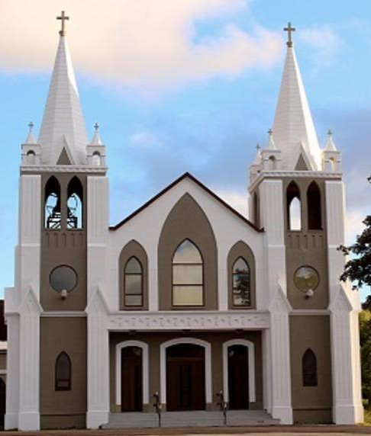
January 9th, 2022
Baptism of the Lord
Sacred Heart Parish
A Stewardship Parish in Union with Christ
Parish Information
Pastor: Monsignor Jim Robertson
Office Administrator: Dianne Russell
Office Hours: Tuesday to Friday 9am - 2pm.

465 Curling Street  Corner Brook, NL, A2H 3K8  Tel: (709) 785-5025 | curlingparish@hotmail.com  e-transfers: sacredheartrcparish@gmail.com  Password "Church"  www.sacredheartrcparish.ca
Weekend Masses: Saturday 4:30 pm, Sunday 11 am
To Register, please call the office Tuesday to Friday between 9 am and 2 pm.

Mass During Week: Tuesday, Wednesday, and Thursday at 7 pm.
Friday at 10 am.
Daily mass is cancelled any day schools are closed due to bad weather.

Lohnes Complex First Fridays - 2 pm at the Lohnes Complex, closed to public.

Bible Study: Sunday at 7pm in parish meeting room.
Holy Hour of Adoration: Discontinued until further notice.
Reconciliation: By request.
Marriages: Six months’ notice required. A year’s notice is recommended.
Baptisms: Please call the Parish Office to schedule preparation session.
Family Connections: At www.rcchurch.com you will find a link to family connections.
St. Vincent de Paul: To assist those in need. Call 638-9010.
Masks are again mandatory at all indoor public gatherings
As well please maintain physical distancing at all times.

MASKS THAT COVER BOTH THE NOSE AND THE MOUTH MUST BE WORN AT ALL TIMES WHEN ATTENDING SERVICES OR FUNCTIONS IN THIS CHURCH.

RECEIVED WITH THANKS
January 2nd, 2021
Regular Sunday | $1424.25
Building fund | 110.00
Envelope Contributions | 125.00
Advent | 40.00
Votive Candles | 77.00
Christmas | 125.00
New Years | 695.00
In Memorium (Gerry Rowsell) | 25.00
St. Vincent de Paul | 7.00
MASS INTENTIONS
Tue. 7pm | Late Patricia Gregory
Wed. 7pm | Late Agnes Walsh
Thu. 7pm | Late Michael Blackmore
Fri. 10 am | Thomas & Edith  James Hackett
Sat. 4:30 pm | Late Bridget & Jordan Blackwood
Sun. 11am | Parish Community

PARISH DUES: Received with thanks: Peggy Young, Marina Cashin, Linda Cashin, Eileen Buckle, Ken Bennett, David and Dorothy Brake.

Sunday missals: The new missals are available at the back of the Church. $5 each.

PARISH COUNCIL: Next meeting will be January 10th at 6 pm.

BIBLE STUDY: Cancelled until further notice.

LOHNES COMPLEX MASS: Cancelled until further notice.

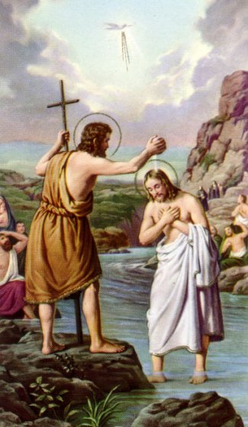
BAPTISM OF THE LORD: Today the Church marks the end of the Christmas season. During the season of Christmas, the Church celebrates three feasts which mark the revelation of God to humanity: Christmas as the Incarnation of God, Epiphany as the revelation of God to the Gentiles through the visitation of the Magi and the Baptism of Jesus as the revelation of the Trinity (Jesus Son of God present at the baptism, the descent of the Holy Spirit in the form of a dove and the voice of God the Father announcing that this was His Son in whom He was well pleased). For more about the Feast of the Baptism of Jesus, visit www.rcchurch.com.

COVID RESTRICTIONS UPDATE: Due to the rising positive cases of Covid-19 numbers are limited to a total of 50 people for any gatherings in the church. This includes people who are active with the church services, Priest, readers, musicians etc. Anyone attending a mass or service for any reason must be pre-registered to enter the church. Please call the office (785-5025) during office hours or email curlingparish@hotmail.com to add your name to the upcoming weekend registration list. Remember masks must cover both the nose and the mouth and be worn at all times when attending services or functions in this church.

PAPAL PRAYER INTENTION: We pray for all those suffering from religious discrimination and persecution; may their own rights and dignity be recognized, which originate from being brothers and sisters in the human family.
SYNOD ON COMMUNION, PARTICIPATION AND MISSION ALL ABOUT: WHAT IS THIS ALL ABOUT? A Synod is a formal process, used by the Church, in which a large number of people are consulted on a specific topic for discussion. Though it usually leads to a formal gathering from which a formal document is produced, Synods can involve countless discussion groups that precede the formal gathering, assuring the greatest amount of participation possible. Two of the most recent Church Synods include the Synod on the Family and the Synod on Youth.
In the latest Synod, opened by Pope Francis on October 10th, 2021, the Pope has asked the Church to reflect on how we journey together as Church, listen and respond to the working of the Holy Spirit in the Church and in the world, and how decisions are reached at all levels: who is involved, who is excluded and how can our processes be improved. In order to be a Church that walks, works and worships together, it is important that we work together for the greatest amount of participation and respect.

LADIES GROUP FUNDRAISING: Happy New Year everyone! Thank you for your past support. Our monthly draw this month.
will be held on Sunday, January 30. Parishioners with last names beginning with F through N will be asked for a donation this month. The deadline for entries will be Sunday, January 23rd. As always, anyone is welcome to enter the draw. Good luck everyone.

RECEIPTS FOR 2020: The receipts for 2021 contributions are currently being worked on and will be available very shortly.

PRAYER FOR HEALING: Lord our God we trust in your care for us. We pray you give us strength to combat covid-19. We ask your help in freeing us of fear and in helping us follow the guidelines that will help us contain this virus. Be with our health care professionals in combating this illness. Keep us safe. In Jesus’ name we pray. Amen

CHRISTIAN UNITY WEEK: During the Week of Prayer for Christian Unity, taking place from January 18th – 25th, Christians from many different traditions and confessions around the world gather to pray for the unity of the Church. Due to Covid-19 restrictions, the Ecumenical Service, scheduled for Tuesday, January 18th at 7:00pm at the Cathedral, is currently under review at this time. Should the service go ahead, all efforts will be made to inform parishioners of the event as much as possible.
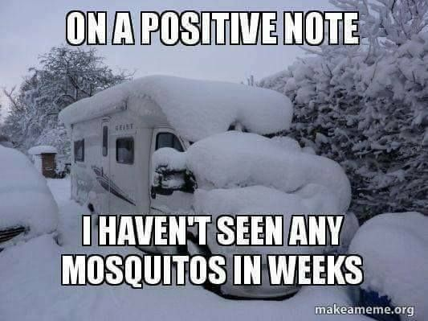
WEATHER FORCAST: Tomorrow, it may be warm and sunny...or cold and snowy...or rainy...or Hey, it depends on the weather!

