July 18, 2021 - 16th Day of Ordinary Time

“Come away by yourselves to a deserted place and rest a while . . . ”
Jesus was moved with pity for the vast crowd, for they were like sheep without a shepherd.
Mark 6: 30-34 (53-56)
Keeping a piece of “lockdown”

Dare we believe that COVID-19 is behind us?
The vaccines seem to be doing their job. Infections, hospitalizations and (most blessedly) deaths are down. Our world and lives are re-opening.
We’re starting to feel “normal” again.
But for some of us, that’s not an entirely happy prospect.
Make no mistake: No one wants to go back to being shuttered in our homes, to be terrified of physical contact with loved ones, to spending our days in front of computers and Zoom cameras, to juggling face masks and hand sanitizer.
But . . .
Stephanie Paul sell of the Harvard Divinity School writes in an essay in The Christian Century [May 19, 2021] that while her university looks forward to fully opening up next month, “I’ve heard from a few students that they’re dreading a little the return to the intensity of busyness, the social pressures, the competing events. They . . . have found things to like in their online classes.
They’ve had more face time (Zoom is nothing if not face time) with their professors, more control over their own participation. They’re nervous about what a return to ‘normal’ will mean . . .
“There’s so much to look forward to in a post-pandemic world: hugs, unmasked faces, gathering in churches and classrooms again. But our worries about how to renter the world of classrooms and offices are reminders that the post-pandemic world also looms up as a challenge. As the world reopens, how will we find our way in it? We have an opportunity to do more than go back to the way things were — a chance, even a responsibility, to do better. How can we rise to it . . . ?
“The pandemic has made it impossible not to know what needs to be done; the injustices fracturing our world have been laid bare for all to see. As I heard a student ask in a presentation on the structural inequalities revealed by COVID: Will we still care when the pandemic is over? Will we stay dissatisfied enough to keep looking for new ways of living that cherish every life?”

The challenge of the past year and a half required us to live our lives in new ways: a new emphasis on family, less obsessiveness about our jobs and careers, rediscovered gratitude for the simple, ordinary things of life that we had taken for granted. In some ways, this time has been a “deserted place” to recalibrate our lives; it’s been a time to rediscover love and friendship, empathy and joy in the things of God. So, while we’re happy to move beyond this horrible pandemic, may we continue to preserve the “deserted” places and times it afforded us to escape the demands of our calendars and things-to-do lists in order to re-center our lives in the compassion and grace of God, to hear again the voice of Christ the Shepherd calling us to lives of joyful gratitude and fulfilling service.

ConnectionsMediaWorks.com

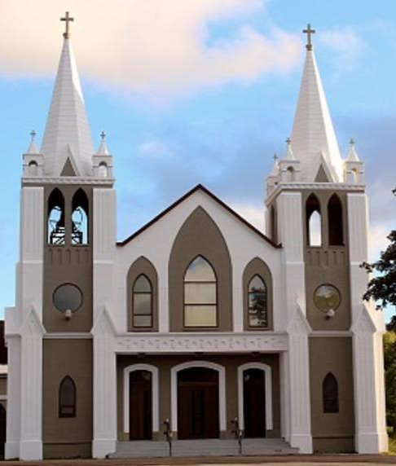
July 18th, 2021
16th Sunday in Ordinary Time
Sacred Heart Parish
A Stewardship Parish in Union with Christ
Parish Information
Pastor: Monsignor Jim Robertson
Office Administrator: Dianne Russell
NEW (Summer) Office Hours: Tuesday to Friday 9am - 2pm.

465 Curling Street  Corner Brook, NL, A2H 3K8  Tel: (709) 785-5025 | curlingparish@hotmail.com  e-transfers: sacredheartrcparish@gmail.com  Password "Church"  www.sacredheartrcparish.ca
Weekend Masses: Saturday 4:30 p.m., Sunday 11 a.m.
To Register, please call the office Tuesday to Friday between 9 am and 2 pm.

Mass During Week: Tuesday, Wednesday, and Thursday at 7 pm
Friday at 10 am.
Lohnes Complex First Fridays - 2 p.m. at the Lohnes Complex, closed to public.

Bible Study: Discontinued for the summer.
Holy Hour of Adoration: Discontinued until further notice.
Reconciliation: By request
Marriages: Six months’ notice required. A year's notice is recommended.
Baptisms: Please call the Parish Office to schedule preparation session.
Family Connections: At www.rcchurch.com you will find a link to family connections.
St. Vincent de Paul: To assist those in need. Call 638-9010.
Masks must be worn at all times. (As per newest Government Regulations).
Always remain 2 meters distant from others.

RECEIVED WITH THANKS
July 11th, 2021
Regular Sunday | $1301.65
E transfers June | 425.00
Building Fund | 60.00
Cemetery Fund | 50.00
Votive Candles | 15.00
In Memorium | 50.00
Mass Stipends | 10.00
Development & Peace | 5.00
St. Anne’s Oil | 17.00

MASS INTENTIONS
Tue. 7pm | Cemetery Mass - Curling
Wed. 7pm | Late John King
Thu. 7pm | Cemetery Mass – Benoits Cove
Fri. 10am | Late Edward & Geraldine Bennett
Sat. 4:30pm | Late William & Elizabeth and Deceased Members of the Dobbin Family
Sun. 11am | Parish Community

CONDOLENCES: We offer our prayerful condolences to the families of the late
Chris Marks, the late Mary Jane Basha and the late Richard Pieklo. May they rest in peace.

THANK YOU: Thank you to everyone who helped with the cleanup and mowing of Mount Cecilia Cemetery. It is certainly now a beautiful place to have our cemetery mass.

CEMETERY MASSES – Sacred Heart: Mass will be at Mount Cecilia Cemetery in Curling on Tuesday, July 20th at 7pm. In the event of bad weather, mass will take place Wednesday, July 21 in the cemetery if possible. If the weather is still inclement then mass will take place in the church on that Wednesday.

CEMETERY MASS COLLECTION: A free will offering will be accepted as you leave the cemetery mass this year. All monies collected will help defray the cost of our new fence.

CEMETERY MASSES - Cathedral: Please take note that these masses will be celebrated in the Cathedral. Mass for Mt. Patricia cemetery will take place on Tuesday, July 27th at 7pm. Mass for Townsite Cemetery will be July 28th
at 7pm.

CHURCH – MAJOR PROJECTS: The finance committee has met and discussed major upcoming possible projects for our church properties. Next weekend Father Jim will speak about those projects and the expenses. Currently we have completed a new cemetery fence and are completing concrete and stucco repairs to the church as well as the repainting of the exterior of the church. We are looking at the possibility of paving the parking lot and the necessity of replacing the church roof. With the church roof we are looking at the possible cost of shingles and the possible cost of a steal roof. It is our hope that while we have the funds, we can do these projects which will provide for our physical church properties for a number of years into the future. We will however need to look at fundraising to provide for these projects and still have a bank balance for day-to-day operations.

PARISH COUNCIL: Thank you to those who serve on our parish Council. Every year three council members finish their terms in September. We will need new members to have a full slate. If you know someone who would be a good member, please speak with them and put their name forward for election.

WORLD DAY FOR GRANDPARENTS AND ELDERLY: July 25 of this year will mark the first World Day for Grandparents and the Elderly. The theme of this first World Day is “I am with you always” (cf. Mt 28:20). The theme’s purpose is to convey the closeness of God and the Church to the elderly and to also emphasize the intergenerational closeness between the young and the elderly.

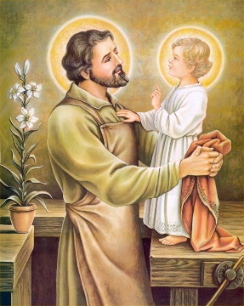
THE YEAR OF ST. JOSEPH - DIOCESAN PILGRIMAGE OPENING MASS: To celebrate the Year of St. Joseph, the Diocese of Corner Brook and Labrador has made St. Joseph’s Parish Church in St. George’s a pilgrimage site for the said Holy Year. In line with this, a special opening Mass in honour of St. Joseph will be held on Monday July 19, 2021, at 5:00pm in St. Joseph’s Parish Church. It will be presided by Bishop van Roijen, with priests of the Diocese concelebrating. Only 100 people will be able to attend, so please contact the parish secretary, Phyllis Long, to make reservations. She can be contacted in the mornings at 709-646-2232 and in the afternoons at 709-647-3255.

ST. MICHAEL PRAYER: St. Michael the Archangel, defend us in battle. Be our protection against the wickedness and snares of the devil. May God rebuke him, we humbly pray; and do Thou, O Prince of the Heavenly Host - by the Power of God - cast into hell, Satan and all the evil spirits, who prowl throughout the world seeking the ruin of souls. Amen. (this prayer can be said after Mass, after praying the Rosary, or whenever one is in need of protection)
PAPAL PRAYER INTENTION: We pray that, in social, economic, and political situations of conflict, we may be courageous and passionate architects of dialogue and friendship.

CLEANING SERVICES: The Diocesan Office is in need of cleaning services to help clean the building on a weekly basis. Cleaning of the building typically takes place once per week, taking approximately 5 hours per session. Interested parties can call Brian Buckle at the Diocesan Office at 639-7073 ext. 224

SAINT ANNE’S OIL: The parish has a supply of Saint Anne’s Oil. These are available at the parish office. We ask a $7 offering for each.

VOTIVE CANDLES: Please speak to servers about having candles lit. The cost is $5.

MARY’S KITCHEN: Brown Bag it – Friday’s 5:30pm to 6:30pm at Immaculate Heart of Mary School, the side entrance.

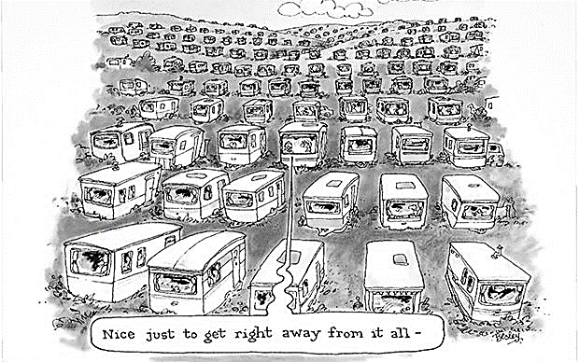
Nice to get away from it all!

