July 4, 2021 - 14th Day of Ordinary Time

“A prophet is not without honor except in his native place and among his own kin and in his own house.” Mark 6: 1-6

Maya Lin’s “Ghost Forest”

In New York City’s Madison Square Park there stands a “ghost forest.”
A “ghost forest” is a dead woodland that once was vibrant with living trees and plant life — but this “ghost forest” is the work of Maya Lin, the architect and artist who designed the Vietnam Veterans Memorial in Washington, D.C., and the Civil Rights Memorial in Montgomery, Alabama.
Lin and her team erected 49 dead Atlantic white cedar trees to create the forest on the lush green lawn of the park. Each cedar, gray from saltwater inundation, stands over 40 feet tall. Every tree in the exhibit was handpicked by Lin from the Pine Barrens of New Jersey. The architect was looking for “trees in trouble” — trees that had been broken and bashed by rising temperatures, extreme weather events, saltwater intrusion and fires.
The Atlantic cedar once grew in massive forests in the northeast and were first cut down to build cities, but the species is now endangered by clear cutting and the effects of climate change, including severe weather and fire.
A soundscape of woodland scenes and animals — bears, wolves, cougars, harsh wind and rain — adds a gently eerie dimension to The Ghost Forest.
The Ghost Forest will remain in place through the fall.
The Madison Square Conversancy commissioned Lin to create a work that would highlight the loss of forests around the world to climate change. Lin was inspired by the once flourishing forests near her family’s summer home in Colorado that are slowly becoming “ghosts forests.”
Walking in Maya Lin’s “dead forest” is both a haunting and beautiful experience. There is a still a majesty to these trees, even in death; visitors can’t help but understand what is being lost.
Maya Lin explains that the goal of the “ghost forest” is to make us “aware of things that are disappearing right before our eyes.”
“We really want to focus on nature-based solutions to climate change. I didn’t want to just wake you up to climate change . . . nature is resilient. If we give it a chance, it will come back.”

Maya Lin’s “ghost forest” is a work of prophetic witness. Her work “proclaims” what God has entrusted to us in love and what we’re losing through avarice and ignorance. No matter what our background or education or skill set, God instills in us an “authority” that is centered in seeing God’s hand in every moment of time and molecule of creation — and from such authority we find the courage to “prophesy”: to point to God’s love in our midst, to re-create our “ghost forests” into living, healing, giving places of the life of God.
ConnectionsMediaWorks.com

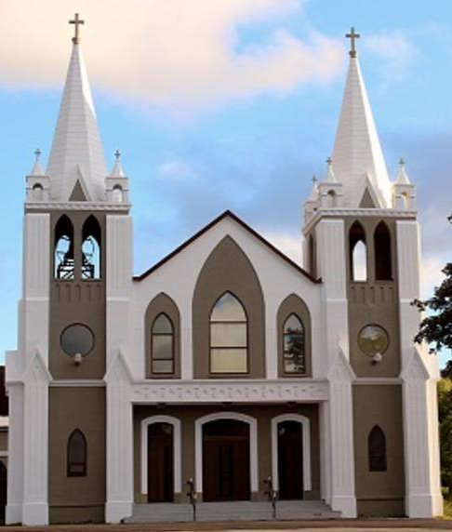
July 4th, 2021
14th Sunday in Ordinary Time
Sacred Heart Parish
A Stewardship Parish in Union with Christ
Parish Information
Pastor: Monsignor Jim Robertson
Office Administrator: Dianne Russell
NEW (Summer) Office Hours: Tuesday to Friday 9am - 2pm.

465 Curling Street  Corner Brook, NL, A2H 3K8  Tel: (709) 785-5025 | curlingparish@hotmail.com  e-transfers: sacredheartrcparish@gmail.com  Password "Church"  www.sacredheartrcparish.ca
Weekend Masses: Saturday 4:30 p.m., Sunday 11 a.m.
To Register, please call the office Tuesday to Friday between 9 am and 2 pm.

Mass During Week: Tuesday, Wednesday, and Thursday at 7 pm
Friday at 10 am.
Lohnes Complex First Fridays - 2 p.m. at the Lohnes Complex, closed to public.

Bible Study: Discontinued for the summer.
Holy Hour of Adoration: Discontinued until further notice.
Reconciliation: By request
Marriages: Six months’ notice required. A year's notice is recommended.
Baptisms: Please call the Parish Office to schedule preparation session.
Family Connections: At www.rcchurch.com you will find a link to family connections.
St. Vincent de Paul: To assist those in need. Call 638-9010.
Masks must be worn at all times. (As per newest Government Regulations).
Always remain 2 meters distant from others.

RECEIVED WITH THANKS
June 27th, 2021
Regular Sunday | $1497.65
Building Fund | 70.00
Votive Candles | 53.00
Bingo Proceeds | 530.00
Pope’s Pastoral Works | 10.00
St. Anne’s Oil | 35.00
St. Vincent de Paul | 170.00

MASS INTENTIONS
Tue. 7pm | Late Margaret Jacobs
Wed. 7pm | Late Mary Russell
Thu. 7pm | Late Dr. Kevin & Dr. Marjorie Smith
Fri. 10am | Late Greg Joyce
Sat. 4:30pm | Late Gus & Irene Rumboldt
Sun. 11am | Parish Community

VOTIVE CANDLES: Please speak to servers about having candles lit. The cost is $5.

SAINT ANNE’S OIL: The parish has a supply of Saint Anne’s Oil. These are available at the parish office. We ask a $7 offering for each.

PAPAL PRAYER INTENTION: We pray that, in social, economic, and political situations of conflict, we may be courageous and passionate architects of dialogue and friendship.

PARISH COUNCIL: Thank you to those who serve on our parish Council. Every year three council members finish their terms in September. We will need new members to have a full slate. If you know someone who would be a good member, please speak with them and put their name forward for election.

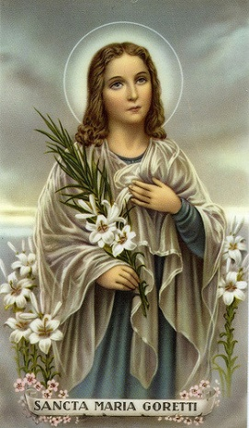
SAINT MARIA GORETTI: July 6th is the feast day of Saint Maria Goretti. Maria Goretti died at the age of 12 of multiple stab wounds inflicted by her attempted rapist because she refused to submit to him. Before she died, however, she forgave her attacker. He was sentenced to 30 years in prison and remained unrepentant for his crime until, one night, he dreamt of Maria giving him flowers. He repented his life of crime, asked Maria’s mother to forgive him after his release from prison and lived out the end of his life working as a lay brother in a monastery. Saint Maria Goretti is one of the Church’s youngest canonized saints. She is the patron saint of youth, young women, purity and victims of rape.

4YOUTH: As you settle into the easy rhythm of summer vacation, be sure to keep your eyes open for the presence of God in your life. If you look carefully, you can recognize Him in the beautiful nature around you, in the family members with whom you spend time, in the friends who share in your activities, in the new people that you meet and in the special pleasures of summer. And don’t forget to thank God every day for all of the blessings in your life. Take care and stay safe.

CEMETERY MASSES - Cathedral: Please take note that these masses will be celebrated in the Cathedral. Mass for Mt. Patricia cemetery will take place on Tuesday, July 27th at 7pm. Mass for Townsite Cemetery will be July 28th
at 7pm.
CEMETERY MASSES – Sacred Heart: Mass will be at Mount Cecilia Cemetery in Curling on Tuesday, July 20th at 7pm. In the event of bad weather, mass will take place Wednesday, July 21 in the cemetery if possible. If the weather is still inclement then mass will take place in the church on that Wednesday.
Plans are being made for cemetery mass in Benoits Cove on Thursday, July 22nd at 7pm.

CEMETERY MASS COLLECTION: A free will offering will be accepted as you leave the cemetery mass this year. All monies collected will help defray the cost of our new fence.

CREMATION: When a loved one dies; cremation is a very popular option which many are requesting. However, studies show that viewing the body is helpful to family and friends in the grieving process. It also provides comfort and closure for all relatives and friends. The fact is clear - we need to be with the body in our story telling and tributes. With this thought in mind, we would appeal to everyone to consider this. It facilitates healing and enables the grieving process to unfold. Cremation would be best considered later - especially in view of the fact that many families postpone the inurnment until a suitable time. For more information, please read the pamphlet “Catholics and Cremation” available at the back of the church.

CLEANING SERVICES: The Diocesan office is in need of a person to provide cleaning services for the Diocesan Center once a week, approx. 5 hours. Interested parties can call Brian at 709-639-7073 Ext 224

HUMOUR: Knock, Knock. Who’s there? Chicken. Chicken who? Chicken in your pockets, I think your keys are there.
LADIES GROUP FUNDRAISING: Thank you to all who took part in the Bingo draw over the past year. Together we raised approximately $4,400.00 for our parish. We wish everyone a safe & happy summer break. Thanks to the following people for your donation for the June Bingo Draw; Fr. Jim, Veronica Stone, Victoria Murphy, Carol Reid, Annette Rowsell, Bernice Rowsell, Derm Travers, Peggy Young, Joan Penney, Veronica Hickey, Joseph Hayes, Valerie O’Connor, Patricia Payne, Glenda Neilson, Linda Tarbett, Agatha Poole, Eileen Moore, Diane Bennett, Gen Quigley, Maxine Staples, Rita Woodman, Linda Cashin, Margie Pennell, Maureen George, Karen Roche, Assumpta Roche, Jim Park, Brian Park, Maryann Park, Christine Jewer, Barbara Neville, Alvina George, Mary Gallant, Brian Sparkes, and Linda Corbett.
Congratulations to Victoria Murphy on winning $55.00 in the final draw.

MARY’S KITCHEN: Brown Bag it – Friday’s 5:30pm to 6:30pm at Immaculate Heart of Mary School, the side entrance.
