March 7th 2021 – 3rd Sunday of Lent

[Jesus] found in the temple area those who sold oxen, sheep, and doves, as well as the money changers seated there. He made a whip out of cords and drove them all out of the temple area . . .
“Take these out of here, and stop making my Father’s house a marketplace.”
John 2: 13-25

“Heaven in Stone and Glass”

In Heaven in Stone and Glass, Bishop Robert Barron takes readers on a spiritual pilgrimage through the world’s great Gothic cathedrals. He tells the stories of these beautiful buildings constructed not just of stone but of spirit. These centuries-old structures are celebrations of faith and hope in color and light.

Bishop Barron includes this:

“There is a wonderful description of the construction of Chartres Cathedral that has come down to us from the twelfth century. It says that people from all walks of life and social strata — lords, ladies, soldiers, and common workers — came together in the grueling task of transporting stones, wine, grain, and oil to the work site. They labored side by side and in reverential silence — and all forgave their enemies. What we see here is a hint of the new city made possible by the authority of the Risen Christ at work in his Church. When we visit a Gothic cathedral and move into the magnificent light of the place, it is the true God that we are meant to praise and this new world that we are compelled to imagine.”

Today’s Gospel challenges us to consider the purpose of the church we (and those who came before us) have created here: Is our church truly “the Father’s house” where the poor find compassion, the broken find healing, the grieving find support — or are we too concerned about worshiping our own safe, undemanding image of God, about maintaining our privileged social and economic status, about keeping a comfortable distance from those we don’t want anything to do with? Every church community, if it is to be faithful to the vision of Christ, is constantly being built and rebuilt on a foundation of forgiveness and reconciliation. Jesus’ cleansing of the temple challenges us to take a look at our own parish with Lenten eyes: to realize that Christ has called this church, our church, to be a place where his compassion, healing, justice and peace are revealed to all who come through these doors.
www. ConnectionsMediaWorks.com

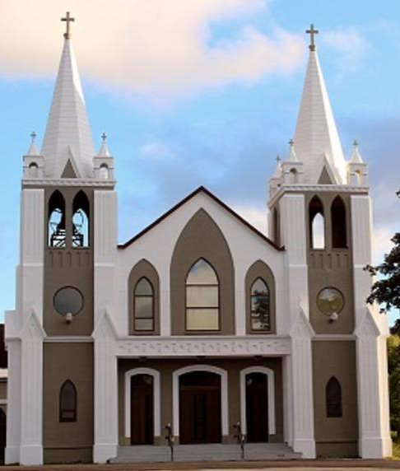
March 7th, 2021
3rd Sunday of Lent
Sacred Heart Parish
A Stewardship Parish in Union with Chris
Parish Information
Pastor: Monsignor Jim Robertson
Office Administrator: Dianne Russell
Office Hours: Monday to Friday 9am - 1pm.
465 Curling Street  Corner Brook, NL, A2H 3K8  Tel: (709) 785-5025 | curlingparish@hotmail.com  e-transfers: sacredheartrcparish@gmail.com  Password "Church"  www.sacredheartrcparish.ca
Weekend Masses: Due to COVID-19 regulations,
Mass is cancelled until further notice.

Reconciliation: By request

Mass During the Week: Tuesday, Wednesday and Thursday at 7 pm
Friday at 10 am.

Holy Hour of Adoration: Discontinued until further notice.
Marriages: Six months’ notice required. A year's notice is recommended.
Baptisms: Please call the Parish Office to schedule preparation session.
St. Vincent de Paul: To assist those in need. Call 638-9010.
FACE MASKS: These masks should be worn at all times.
They may be removed if you are seated and able to maintain 2m distancing from others.

PAPAL PRAYER INTENTION – March Sacrament of reconciliation: Let is pray that we may experience the sacrament of reconciliation with renewed depth, to taste the infinite mercy of God.

YEAR OF THE FAMILY: Beginning on the Feast of St. Joseph on March 19th, 2021 and culminating on June 26th, 2022, with the 10th World Meeting of Families (in Rome). Pope Francis has declared a special Year of the Family. To begin this special year, we invite our diocesan family to join us in praying a Novena to St. Joseph, which will be live streamed on the Diocesan Facebook page each evening at 7:00 pm beginning Thursday, March 11th culminating on March 19th. May we find, in St. Joseph, the support and protection that our families need.
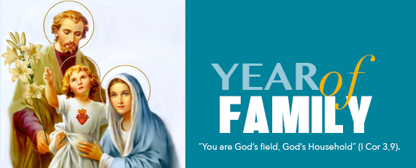

D&P - NATIONAL ONLINE THINKfast, March 11 and 12th - If you’re looking for a fun way to put your faith into action during Lent this year, THINKfast is for you! Young people can do it on their own, or with all their family and friends - it’s open to all ages. During the fast, we will gather online for prayer, discussions, activities, films, and entertainment. In addition to the spiritual aspect, we will organize a space to discuss how we can take care of ourselves and the most vulnerable in the South. Register at http://bit.ly/3slhrXt.

KNIGHTS OF COLUMBUS - DURING LENT: will be reciting the Rosary Fridays at 7:00 pm on Bay of Islands Radio (BOIR) 100.1 FM and also on the website boir.ca. Please join us in praying the Rosary together. The Knights of Columbus would like to thank Father Terry Boland for his cooperation.

LADIES GROUP FUNDRAISING: Even though we are unable to attend Mass in church at this time, we are continuing with our Bingo Draw to help keep funds flowing into our parish. All donations received for Feb have been put aside and the draw will be made as soon as Mass resumes. Donations for March draw are now being accepted. Each $10 donation gives you one chance in the draw. Donors for this month are those with last names starting with N through Y and anyone else who would like to enter. For your convenience, you may drop off your donation in my mailbox at 86 Allen’s Rd or to Pat Jones at 11 Noseworthy’s Ln., or to the parish house. Please stay safe, follow the medical guidelines, and hopefully we will be able to return to church in the near future.

FOURTH DEGREE, KNIGHTS OF COLUMBUS, NEWFOUNDLAND AND LABRADOR: The NL District of the 4th Degree is planning a Virtual Fourth Degree Exemplification for Saturday, March 20, at 10:00 am using the application GoToMeeting. Contact your local Knights of Columbus Council, the Faithful Navigator or Faithful Comptroller of your local Fourth Degree Assembly for further information. Membership in the Fourth Degree allows a Knight to display pride in his country, while continuing to serve his community and Church. Please consider joining.

CATHOLIC JOURNEY THROUGH LENT: At the beginning of each week, during Lent, a short 5-minute reflection will be available on the following week’s Gospel. Bishop Bergie from St. Catherine’s will be doing the reflections. These reflections can be viewed by going to the cccb.ca website.

THE GOD SQUAD - a Catholic Outreach Ministry to Men: Originating out of Calgary, the God Squad are offering their 24th Annual Men’s Conference on-line on March 20 from 10 a.m. CST to 1 p.m. CST (12:30 p.m. to 3:30 p.m. in NL). Registration is free of charge. Speakers include: Bishop Scott MCCaig, Military Ordinariate, Andre Regnier, Co-founder of C.C.O. (Campus Ministry) and Jake Khym. The Focus: St. Joseph.

E-TRANSFER: You may use this option through your online banking to support Sacred Heart Parish at this time for convenience, but also at any time.
Email your E-Transfer to sacredheartrcparish@gmail.com
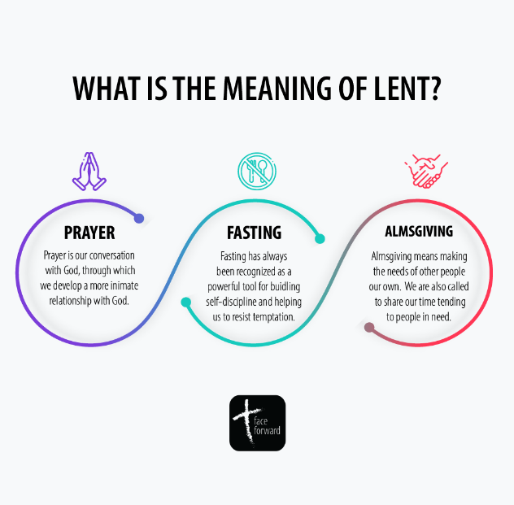
password “Church”.
MARCH 14, 2021-
Daylight Savings Time Starts
2 am Sunday Morning

