**October 3rd, 2021 – 27th Sunday of Ordinary Time**

***At the request of Bishop Bart***, all parishes are asked to distribute information on the truth and reconciliation commission. This information will help us understand the relationship of the Federal Government, the Catholic Church and the First Nations of Canada. Hopefully this information will also generate discussion that allows us to deal with our failures and build for better results.

**We are sorry… and we apologize… (Part 4)**

While the federal residential school system began around 1883, the origins of the residential school system can be traced to as early as the 1830s, when the Anglican Church established a residential school in Brantford, ON. The Catholic Church also ran a few residential schools out West prior to 1883. Attendance at these schools was voluntary.

It is estimated that 150,000 children between the ages of 3 and 16 were forced to attend federal residential schools, operated in Canada between 1883 and the early 1970s (The last residential school closed in 1996).

Of the 139 residential schools identified in the Indian Residential School Settlement Agreement, 46% (64 schools) were operated by Catholic entities; approximately 16 out of the 70 Catholic dioceses in Canada were associated with these schools, in addition to about three dozen Catholic religious communities. At its height there was a maximum of 89 schools operating at the same time.

No residential schools were operated in the Province of Newfoundland. The closest residential school was run by the Catholic Church in Shubenacadie, Nova Scotia from 1930 to 1967. The Moravian Christian Church ran 5 boarding schools in Labrador during this same time period. Day Schools were operated by the Catholic Church among the Innu of Labrador.

Almost all residential schools closed in the 1960s and early ‘70s as provincial governments began to provide schooling in each community.

(For a more detailed understanding of what happened, please read the Truth and Reconciliation Report: nctr.ca/records/reports, and scroll down to “Honouring the Truth, Reconciling for the Future”.)

**Prayer of Healing and Reconciliation**

O God, Creator and Father of us all,

Healer of all our sorrows and afflictions,

we come to you today to express our sorrow

at the wrongs that have been afflicted

on the First Peoples of this land.

Send us your spirit of truth and love,

so that we may grow in wisdom and knowledge of the past

and understand the wrongs that were done.

Grant us the courage and strength to work together, as your children, in faith, hope and love,

towards reconciliation and healing in our Church and in our Land.

We ask this through Christ our Lord. Amen.

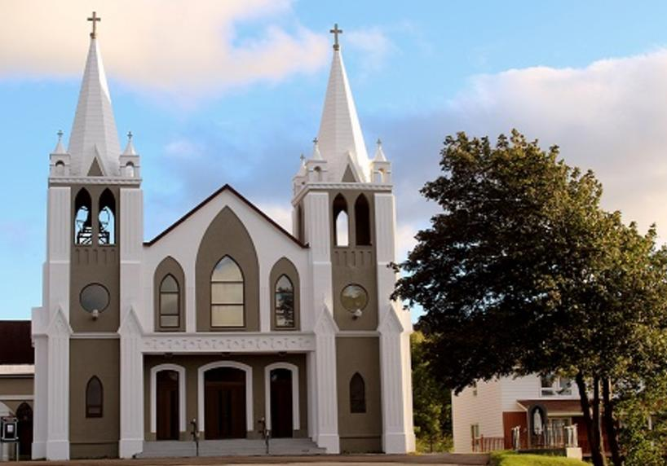**October 3rd, 2021**

**27th Sunday of Ordinary Time**

Sacred Heart Parish

A Stewardship Parish in Union with Christ

Parish Information

Pastor: Monsignor Jim Robertson  
Office Administrator: Dianne Russell  
**Office Hours: Tuesday to Friday 9am - 2pm.**

|  |  |
| --- | --- |
| 465 Curling Street Corner Brook, NL, A2H 3K8 Tel: (709) 785-5025 | [curlingparish@hotmail.com](mailto:curlingparish@hotmail.com) **e-transfers: sacredheartrcparish@gmail.com**  **Password "Church"**  www.sacredheartrcparish.ca |

**Weekend Masses**: Saturday 4:30 pm, Sunday 11 am

***To Register, please call the office Tuesday to Friday* between *9 am and 2 pm.***

**Mass During Week**: Tuesday, Wednesday, and Thursday at 7 pm.

Friday at 10 am.

**Lohnes Complex** First Fridays - 2 pm at the Lohnes Complex, ***closed to public.***

**Bible Study:** Sunday at 7pm in parish meeting room.

**Holy Hour of Adoration**: Discontinued until further notice.   
**Reconciliation:** By request.

**Marriages:** Six months’ notice required. A year’s notice is recommended.

**Baptisms:** Please call the Parish Office to schedule preparation session.

**Family Connections**: At www.rcchurch.com you will find a link to family connections.

**St. Vincent de Paul:** To assist those in need. Call 638-9010.

**Masks are again mandatory at all indoor public gatherings**

**As well please maintain physical distancing at all times.**

**RECEIVED WITH THANKS**

**September 26, 2021**

|  |  |
| --- | --- |
| Regular Sunday | $1641.20 |
| Building Fund | 15.00 |
| Need of the Canadian Church | 130.00 |
| Mass Stipends | 50.00 |
| St. Vincent de Paul | 85.00 |
| In Memoriam ***Gerald Rowsell*** | 20.00 |
| Votive Candles | 24.00 |

**MASS INTENTIONS**

|  |  |
| --- | --- |
| Tue. 7pm | No Mass-Priest on Retreat |
| Wed. 7pm | No Mass-Priest on Retreat |
| Thu. 7pm | No Mass-Priest on Retreat |
| Fri. 7pm | No Mass-Priest on Retreat |
| Sat. 4:30pm | Late Edward Buckle |
| Sun. 11am | Parish Community |

**PRIEST RETREAT**: The annual Priest retreat will take place October 4th - 8th. A Priest will remain at the Cathedral Parish to provide pastoral service in our area. Please pray for the Priests during this time of retreat.

**CONDOLENCES:** We offer our prayerful condolences to the family of the late Gerald Rowsell. May he rest in peace.

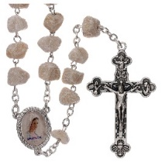

**LEADING THE ROSARY**:

**The Ladies Group of Sacred Heart Parish** will be leading the Rosary at 4 pm Saturdays during the month of October.

**Knights of Columbus** will be leading the Rosary at 10:30 am Sundays, before the mass at Sacred Heart during the month of October.

**BIBLE STUDY:** Will be Sunday at 7 pm in the parish meeting room. All are welcome.

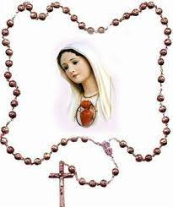**THE ROSARY:** October is the month of the Holy Rosery. During this month we are encouraged to make the Rosary a part of our daily prayer routine. If you pray the Rosary, you should consider all four versions of the Rosary (Joyful, Sorrowful, Glorious, and Luminous).

**LADIES GROUP MEETING**: The ladies’ group will be having a meeting Wednesday at 7pm in the church meeting room.

**LADIES GROUP BINGO DRAW**: Thank you to everyone who supported September’s bingo draw. The draw will take place Saturday October the 2nd. The winner’s name and the list of donors will be published next week.

**PARISH COUNCIL**: Thank you to Carl Bennett who completes two terms on the Parish Council and is not eligible re-election until he sits out one full term, according to parish council constitution. Joe Byne and Jack Pennell have both completed one term and are eligible and have been nominated for re-election. This year we have a number of persons nominated and so there will an election on the weekend of October 2-3. Nominated are Joe Byrne, Jack Pennell, John Carroll, Marie Pennell, Pat Moore, and Gerard Deveaux. Ballets and a Ballet box will be available in church this weekend.

**CHILDRENS LITURGY:** The Children Liturgy room has been sanitized and the Covid-19 protocols will be in place for this years Children’s Liturgy Program. You are invited to bring your children to take part in children liturgy if you feel comfortable.

**SACRAMENTAL PREPARATION 2021:**

Forms for registration for Sacramental Preparation are now available at the back of the church.

**Mass of Remembrance:** Our Annual Mass of Remembrance will take place in early November. Family members of persons whose funerals we have celebrated since November last year will be contacted and offered special roles in the mass of that day. If you have had family members / friends who have died within this last year, and whose funeral/burial has taken place outside this parish, please contact the parish office if you want their names included at that mass.

**PAPAL PRAYER INTENTION**: We pray that every baptised person may be engaged in evangelization, available to the mission, by being witnesses of a life that has the flavour of the gospel.

**FOOD BANK/Thanksgiving Day Food Drive:** Please donate non-perishable food items to your child’s upcoming school food drive, at your church, at any local community fundraiser, or in the food collection bin located in the major grocery stores. Thank you for your continued support.

**SOCIETY OF ST VINCENT DE PAUL**: Because of the pandemic, you haven’t heard a lot about what SSVP has been doing. Major furniture items were distributed April 1st to September 30th. This period included us making 91 delivering as well as accepting 118 furniture donations. Next week we will relay the food distribution. Presently, we need mattresses of all sizes except king size, and we could use tables and chairs, sofas, and the like. Thank you for your continued support.

**BELBEDERE ORPHANAGE FUND:** If you are a male or female orphan or half orphan who is in need, please contact the Parish Office to see if you are eligible for assistance. Applications must be submitted, verified by the Parish Priest and forwarded to Secretary to Board of Directors, Belvedere Orphanage Fund, Sisters of Mercy by **October 18, 2021.**

**KNIGHTS OF COLUMBUS SCHOLARSHIPS**:

Available to all students who graduated Grade XII with Honours in June 2021 and are attending a post-secondary institution in September. Application deadline: October 31, 2021. Information and applications under scholarships on the State Council website at www.kofcnl.org.

**OCTOBER IS BREAST CANCER AWARENESS MONTH**: The two major risk factors for breast cancer are being a woman and getting older. At least 80% of women with breast cancer have no family history of this disease. The Breast Screening Program for NL offers screening mammograms for women aged 50 – 74. Women under 50 and over the age of 74 are advised to check with their health-care provider. A mammogram can detect changes years before they can be felt. It’s the best tool we have for early detection. Women can self – refer by calling toll free 1-800-414-3443 or locally at 634-8558. For more information please visit: call: 709-632-3008 (toll free 866-643-8719) / email: loriwellman@

westernhealth.nl.ca SCREENING SAVES!

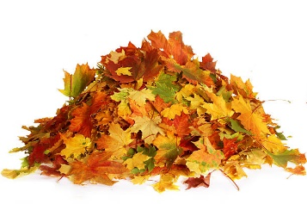**HUMOUR:**

Hey Google....,

Rake the Leaves!