September 19th, 2021 – 25th Sunday of Ordinary Time

At the request of Bishop Bart, all parishes are asked to distribute information on the truth and reconciliation commission. This information will help us understand the relationship of the Federal Government, the Catholic Church and the First Nations of Canada. Hopefully this information will also generate discussion that allows us to deal with our failures and build for better results.

We are sorry… and we apologize…
In this series of bulletin announcements, the Diocese of Corner Brook and Labrador not only wants to apologize for the Catholic Church’s involvement in Indian Residential Schools, we want to provide the necessary education that the Truth and Reconciliation Report asks us to provide to our people. It is hoped that greater knowledge and sensitivity to what happened will help in the ongoing work towards reconciliation.
To begin, I, the Bishop, and we, the Church in Western Newfoundland and Labrador, echo the words of one of the original apologies made by the Missionary Oblates of Mary Immaculate in 1991:
“We apologize for the existence of the schools themselves, recognizing that the biggest abuse was not what happened in the schools, but that the schools themselves happened… We wish to apologize in a very particular way for the instances of physical and sexual abuse that occurred in those schools… Far from attempting to defend or rationalize these cases of abuse in any way, we wish to state publicly that we acknowledge they were inexcusable, intolerable and a betrayal of trust in one of its most serious forms. We deeply and very specifically apologize to every victim of such abuse, and we seek help in searching for means to bring about healing.” Bishop Bart

(For a more detailed understanding of what happened, please read the Truth and Reconciliation Report: nctr.ca/records/reports, and scroll down to “Honouring the Truth, Reconciling for the Future”.)

Prayer of Healing and Reconciliation
O God, Creator and Father of us all,
Healer of all our sorrows and afflictions,
we come to you today to express our sorrow
at the wrongs that have been afflicted
on the First Peoples of this land.
Send us your spirit of truth and love,
so that we may grow in wisdom and knowledge of the past
and understand the wrongs that were done.
Grant us the courage and strength
to work together, as your children, in faith, hope and love,
towards reconciliation and healing
in our Church and in our Land.
We ask this through Christ our Lord. Amen.

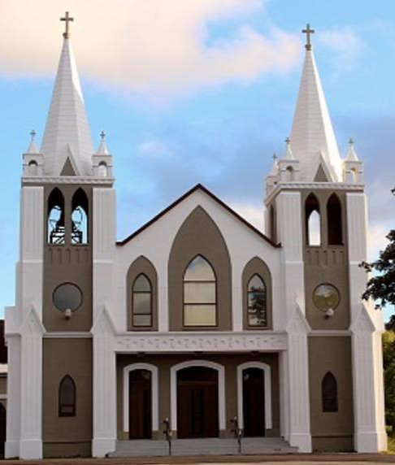
September 19th, 2021
25th Sunday of Ordinary Time
Sacred Heart Parish
A Stewardship Parish in Union with Christ
Parish Information
Pastor: Monsignor Jim Robertson
Office Administrator: Dianne Russell
Office Hours: Tuesday to Friday 9am - 2pm.

465 Curling Street  Corner Brook, NL, A2H 3K8  Tel: (709) 785-5025 | curlingparish@hotmail.com  e-transfers: sacredheartrcparish@gmail.com  Password "Church"  www.sacredheartrcparish.ca
Weekend Masses: Saturday 4:30 pm, Sunday 11 am
To Register, please call the office Tuesday to Friday between 9 am and 2 pm.

Mass During Week: Tuesday, Wednesday, and Thursday at 7 pm.
Friday at 10 am.
Lohnes Complex First Fridays - 2 pm at the Lohnes Complex, closed to public.

Bible Study: Sunday at 7pm in parish meeting room.
Holy Hour of Adoration: Discontinued until further notice.
Reconciliation: By request.
Marriages: Six months’ notice required. A year’s notice is recommended.
Baptisms: Please call the Parish Office to schedule preparation session.
Family Connections: At www.rcchurch.com you will find a link to family connections.
St. Vincent de Paul: To assist those in need. Call 638-9010.

Masks are no longer mandatory but are still encouraged.
As well please maintain physical distancing at all times.

RECEIVED WITH THANKS
September 12, 2021
Regular Sunday
Building Fund
Baptism Fee
St. Vincent de Paul
Saint Anne’s Oil

MASS INTENTIONS
Tue. 7pm
Wed. 7pm
Thu. 10pm
Fri. 10am
Sat. 4:30pm
Sun. 11am | Parish Community
**please note change in time of mass on Thursday. I want to encourage as many as people as possible to take part in the Family Matters presentation in All Hallows.

MASS INTENTIONS: Our current list is exhausted. This is a good time to request Masses and have them said in a timely manner.

BIBLE STUDY: Beginning again this Sunday, September 12 at 7pm in the parish meeting room. All are welcome to attend.

THANK YOU- Holy Lands support:
Dear Friends in Christ, this year, in the midst of the Covid pandemic, many of you contributed generously in your parish collections or by direct donations to the Custody of the Holy Land. On Behalf of the Custos, Fr. Francesco Patton, ofm, I sincerely thank you for your solidarity and support of the pastoral works that benefit our Christian brothers and sisters and for maintaining the Holy Sites of our Church.
PARISH COUNCIL: Thank you to those who serve on our parish Council. We need 3 new members to have a full slate. If you know someone who would be a good member, please speak with them and put their name forward for election.

LAY VISITORS TO HOSPITAL: We have been advised that lay visitation may resume in September of this year. This is wonderful news! But because we have been out of service for almost two years, we are inviting anyone who would like to participate to give this serious consideration. If you haven’t taken part in visitation before, you will need your security check done with the R.N.C. and come to a gathering for further briefing. Fr. Ed Terry, hospital chaplain, is most willing to meet with you for the purpose. A date will be announced. In the meantime, if you are interested or have done this before, kindly call the Cathedral at 634-5161 and leave your name and phone number with our secretary. Remember, “I was sick, and you visited me.” (Matt. 25:36)
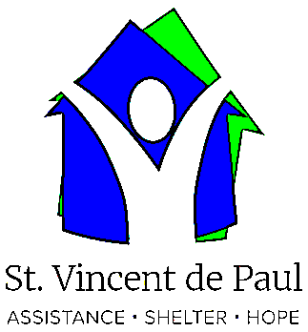
SOCIETY OF ST. VINCENT DE PAUL:
The Society will be having a meeting on Wednesday, Sept. 15th, in the basement of the Cathedral.
New members are more than welcome.
FAMILY MATTERS: On September 16 at 7pm at All Hallows Church, Corner Brook there will be a 1-hour session on Family Matters. The presenter will be Dr. Anne Jamieson, she is a wife, mother, author, teacher, and life-long learner. She loves to share stories and practical tips for joyful sharing of the faith.
Not all lessons come from books. How we live, play, eat, talk to one another, celebrate, and forgive are all ways we teach our children about our deepest beliefs - who and whose we are. Join us as we consider how the 'stuff' of our lives matters. It's not about one more job for already busy parents, grandparents,
catechists. It's about being more intentional in all we do. If people can attend in person, it would be great, if not they can join us on FB with the link below or they can just search Diocese of Corner Brook and Labrador to find us. I have heard Anne several times. She is very practical and down-to-earth.
https://www.facebook.com/dioceseofcornerbrookandlabrador

The Exaltation of the Holy Cross:
The Feast of the Exaltation of the Holy Cross, celebrated annually on September 14, recalls three historical events: 1. the finding of the True Cross by Saint Helena, the mother of the emperor Constantine; 2. the dedication of the churches built by Constantine on the site of the Holy Sepulchre and Mount Calvary; and 3. the restoration of the True Cross to Jerusalem by the emperor Heraclitus II. But, most importantly, this feast celebrates the cross as the instrument of our salvation, as expressed in the words of the entrance antiphon for Mass on this day: We should glory in the Cross of our Lord Jesus Christ, in whom is our salvation, life and resurrection, through whom we are saved and delivered.

KNIGHTS OF COLUMBUS SCHOLARSHIPS:
Available to all students who graduated Grade XII with Honours in June 2021 and are attending a Post-Secondary institution in September. Application deadline: October 31, 2021. Information and applications under scholarships on the State Council website at www.kofcnl.org.

FOOD BANK-Meeting: The Network of the Bay of Islands Ministerial Association, inc. will hold the annual general meeting on Wednesday, 15 September, at 2:00 p.m. at St. Michael & All Angels Church on Park Drive. All are welcome to attend.

MOUNT PATRICIA CEMETERY FALL CLEANUP: The clean up will take place the last 2 weeks of September 2021. Mount Patricia Policy - Flowers and other personal items must be removed from graves by October 1. Any items remaining after this date that cause obstruction to the operations of the cemetery will be removed by the cemetery staff. Thank you to all who assist in the clean up and keeping Mount Patricia grounds clean and tidy. Any questions, contact Denna Newman at 634-4774.

HUMOUR:

