**September 19th, 2021 – 25th Sunday of Ordinary Time**

***At the request of Bishop Bart***, all parishes are asked to distribute information on the truth and reconciliation commission. This information will help us understand the relationship of the Federal Government, the Catholic Church and the First Nations of Canada. Hopefully this information will also generate discussion that allows us to deal with our failures and build for better results.

**We are sorry… and we apologize… part 2**

The Catholic Church’s relations with the indigenous people of this land pre-dates the Indian Residential School System. Though fraught with its own difficulties, this relationship was seen as mutually beneficial and engendered a sense of respect and understanding. Missionaries took the time to learn the various spoken languages and helped in developing a series of Indigenous Alphabets to facilitate translation. Missionaries also served as mediators and/or translators in a number of treaties and agreements.

Considering the fair amount of trust between the Early Missionaries and the Indigenous Peoples of this land, the Catholic Church’s involvement in the Government of Canada’s Residential School Program was a betrayal of that trust. Far from the original treaties that the Church helped to broker between the Indigenous Peoples and the Crown, the Catholic Church were made complicit in what the Truth and reconciliation Commission’s Final Report describes as “the central goals of Canada’s Aboriginal Policy”:

“To eliminate Aboriginal governments, ignore Aboriginal rights; terminate the Treaties; and through a process of assimilation, cause Aboriginal peoples to cease to exist as distinct legal, social, cultural, religious, and racial entities in Canada. The establishment and operation of residential schools were a central element of this policy. The federal government’s residential schools were part of a horrendous assumption that it was in an Indigenous child’s interest to be taken from his or her parents and to be culturally and linguistically reconstructed.”

(For a more detailed understanding of what happened, please read the Truth and Reconciliation Report: nctr.ca/records/reports, and scroll down to “Honouring the Truth, Reconciling for the Future”.)

**Prayer of Healing and Reconciliation**

O God, Creator and Father of us all,

Healer of all our sorrows and afflictions,

we come to you today to express our sorrow

at the wrongs that have been afflicted

on the First Peoples of this land.

Send us your spirit of truth and love,

so that we may grow in wisdom and knowledge of the past

and understand the wrongs that were done.

Grant us the courage and strength to work together, as your children, in faith, hope and love,

towards reconciliation and healing in our Church and in our Land.

We ask this through Christ our Lord. Amen.

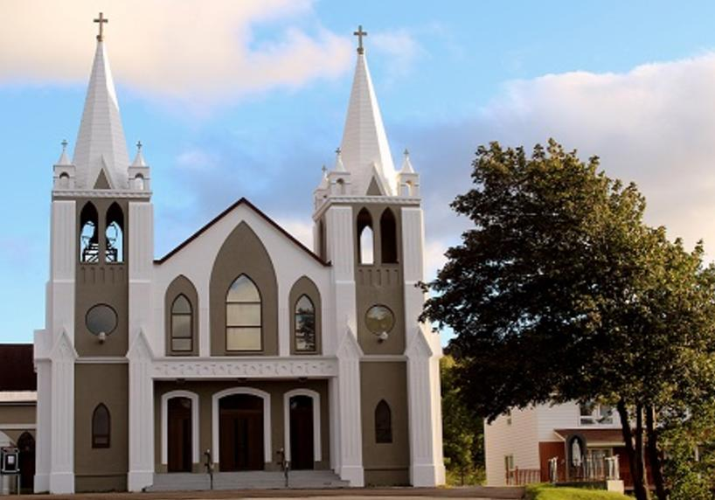**September 19th, 2021**

**25th Sunday of Ordinary Time**

Sacred Heart Parish

A Stewardship Parish in Union with Christ

Parish Information

Pastor: Monsignor Jim Robertson  
Office Administrator: Dianne Russell  
**Office Hours: Tuesday to Friday 9am - 2pm.**

|  |  |
| --- | --- |
| 465 Curling Street Corner Brook, NL, A2H 3K8 Tel: (709) 785-5025 | [curlingparish@hotmail.com](mailto:curlingparish@hotmail.com) **e-transfers: sacredheartrcparish@gmail.com**  **Password "Church"**  www.sacredheartrcparish.ca |

**Weekend Masses**: Saturday 4:30 pm, Sunday 11 am

***To Register, please call the office Tuesday to Friday* between *9 am and 2 pm.***

**Mass During Week**: Tuesday, Wednesday, and Thursday at 7 pm.

Friday at 10 am.

**Lohnes Complex** First Fridays - 2 pm at the Lohnes Complex, ***closed to public.***

**Bible Study:** Sunday at 7pm in parish meeting room.

**Holy Hour of Adoration**: Discontinued until further notice.   
**Reconciliation:** By request.

**Marriages:** Six months’ notice required. A year’s notice is recommended.

**Baptisms:** Please call the Parish Office to schedule preparation session.

**Family Connections**: At www.rcchurch.com you will find a link to family connections.

**St. Vincent de Paul:** To assist those in need. Call 638-9010.

**Masks are no longer mandatory but are still encouraged.**

**As well please maintain physical distancing at all times.**

**RECEIVED WITH THANKS**

**September 12, 2021**

|  |  |
| --- | --- |
| Regular Sunday | $1958.75 |
| Building Fund | 45.00 |
| Votive Candles | 25.00 |
| Word Among us | 5.00 |
| Mass Stipends | 30.00 |
| St. Vincent de Paul | 60.00 |

**MASS INTENTIONS**

|  |  |
| --- | --- |
| Tue. 7pm | Funeral |
| Wed. 7pm | Late David & Violet Dicks |
| Thu. 7pm | Late Jack Hearn |
| Fri. 10am | Late Joe Gallant |
| Sat. 4:30pm | Late Gus & Irene Rumboltd |
| Sun. 11am | Parish Community |

**LEADING THE ROSARY**: **The Ladies Group of Sacred Heart Parish** will be leading the Rosary at 4 pm Saturday during the month of October.

**Knights of Columbus** will be leading the Rosary at 10:30 am Sunday, before the mass at Sacred Heart during the month of October.

**BIBLE STUDY:** Will be Sunday at 7 pm in the parish meeting room. All are welcome.

**SACRAMENTAL PREPARATION 2021:**

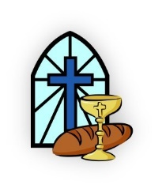Forms for registration for Sacramental Preparation are now available at the back of the church.

**PARISH COUNCIL****:** Thank you to those who serve on our parish Council. We need 3 new members to have a full slate. If you know someone who would be a good member, please speak with them and put their name forward for election.

**CHILDRENS LITURGY:** The Children Liturgy room has been sanitized and the Covid-19 protocols will be in place for this years Children’s Liturgy Program. You are invited to bring your children to take part in children liturgy if you feel comfortable.

**NEEDS OF THE CANADIAN CHURCH:** A special collection for the Needs of the Church in Canada is being taken up in all parishes on the weekend of September 25-26. The annual Collection for the Needs of the Church in Canada invites all the faithful to participate in this financing by helping their diocese meet its financial obligations to the regional assemblies and to the national Conference. Any additional revenues raised help the diocese support its own diocesan pastoral programs and other activities.

**LAY VISITORS TO HOSPITAL**:(UPDATE) We have been advised that lay visitation may resume in September of this year.  This is wonderful news! But because we have been out of service for almost two years, we are inviting anyone who would like to participate to give this serious consideration. If you haven’t taken part in visitation before, you will need your security check done with the R.N.C.*,* if you are interested or have done this before, kindly call the Cathedral at 634-5161 and leave your name and phone number with our secretary. ***A gathering will take place on Wednesday, September 22nd., 10am., at Holy Redeemer Cathedral for anyone interested in lay visitation at Western Regional Health facilities. Father Ed Terry will facilitate this information session so if you would like to participate, kindly come to this gathering*.** Remember, “I was sick, and you visited me.” (Matt. 25:36)

**BISHOP O’REILLY ASSEMBLY 0624**: There will be meeting at All Hallows’ Parish Humber Road Corner Brook upstairs at 7:45 P.M. on Tuesday September 21st could Sir Knights please try to attend. Also, we will be having our Installation of Officers and our Master will be at the meeting to do the Installation.

**Mass of Remembrance:** Our Annual Mass of Remembrance will take place in early November. Family members of persons whose funerals we have celebrated since November last year will be contacted and offered special roles in the mass of that day. If you have had family members / friends who have died within this last year, and whose funeral / burial has taken place outside this parish, please contact the parish office if you want their names included at that mass.



**ALL SOULS DAY:** All Souls Day, November 2, is a day to pray for the souls of our faithful departed. Envelopes are available in our church for parishioners to list the names of their family members and friends who they would like remembered. Throughout the month of November there will be masses in commemoration of All Souls and the persons you have named will be prayed for in our petitions.

**MOUNT PATRICIA CEMETERY FALL CLEANUP**: The clean up will take place the last 2 weeks of September 2021. Any items remaining after October 1 that cause obstruction to the operations of the cemetery will be removed by the cemetery staff. Thank you. Any questions, contact Denna Newman at 634-4774.

**KNIGHTS OF COLUMBUS SCHOLARSHIPS**:

Available to all students who graduated Grade XII with Honours in June 2021 and are attending a Post-Secondary institution in September. Application deadline: October 31, 2021. Information and applications under scholarships on the State Council website at www.kofcnl.org.

**BINGO**: The Ladies’ Group will be having their bingo draw for September on the first Sunday of October. Entries must be received no later than Sunday, September 26. Parishioners will be entitled to one entry per each $10 donation. People whose last names begin with A through E are being asked to donate, but anyone can participate. Thank you for your continued support of our parish.

**SAINTS FOR THIS WEEK:**

Saint Matthew

Saint Andrew Kim Tae-Gon and companions

Saint Pius Pietrelcina (Padre-Pio)

**HUMOUR**: