September 26th, 2021 – 26th Sunday of Ordinary Time

At the request of Bishop Bart, all parishes are asked to distribute information on the truth and reconciliation commission. This information will help us understand the relationship of the Federal Government, the Catholic Church and the First Nations of Canada. Hopefully this information will also generate discussion that allows us to deal with our failures and build for better results.

We are sorry… and we apologize… (Part 3)
Considering the generally cordial relationships the early missionaries enjoyed, one might ask the reasons for the Catholic Church’s involvement in residential schools. In a day and age when missionary work was hard, and involved great effort to reach a small number of people, the unfettered access to the minds and lives of children was a tempting proposition. Involvement by “Rival Christian Providers” also served as a strong motivator. Though more and more resources shifted to the schools, missionary outreach to the people “on the land” continued to receive strong support.
As for the government, the various churches that were contracted provided the cheapest labour. The churches had already built a certain amount of trust and respect, each with a particular People. Their involvement made the whole idea more sellable (both to the indigenous and non-indigenous peoples).
We are sorry for the misuse of power that was exercised while the Catholic Church gained unfettered access to the minds and lives of Indigenous Children over successive generations. We apologize for ridiculing indigenous cultural and religious practices, discouraging indigenous languages and belittling indigenous identity, each act an assault on the human person.

(For a more detailed understanding of what happened, please read the Truth and Reconciliation Report: nctr.ca/records/reports, and scroll down to “Honouring the Truth, Reconciling for the Future”.)

Prayer of Healing and Reconciliation
O God, Creator and Father of us all,
Healer of all our sorrows and afflictions,
we come to you today to express our sorrow
at the wrongs that have been afflicted
on the First Peoples of this land.
Send us your spirit of truth and love,
so that we may grow in wisdom and knowledge of the past
and understand the wrongs that were done.
Grant us the courage and strength to work together, as your children, in faith, hope and love,
towards reconciliation and healing in our Church and in our Land.
We ask this through Christ our Lord. Amen.

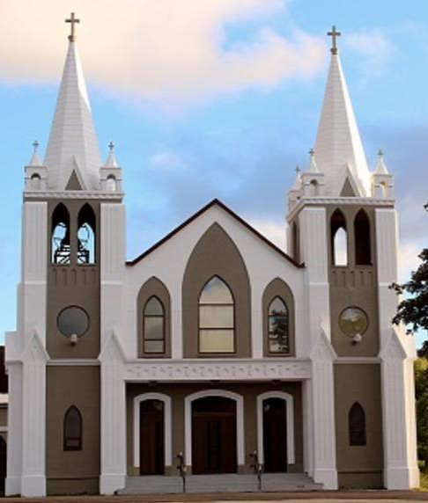
September 26th, 2021
26th Sunday of Ordinary Time
Sacred Heart Parish
A Stewardship Parish in Union with Christ
Parish Information
Pastor: Monsignor Jim Robertson
Office Administrator: Dianne Russell
Office Hours: Tuesday to Friday 9am - 2pm.
Office closed September 30th for National Truth and Reconciliation Day.

465 Curling Street  Corner Brook, NL, A2H 3K8  Tel: (709) 785-5025 | curlingparish@hotmail.com  e-transfers: sacredheartrcparish@gmail.com  Password "Church"  www.sacredheartrcparish.ca
Weekend Masses: Saturday 4:30 pm, Sunday 11 am
To Register, please call the office Tuesday to Friday between 9 am and 2 pm.

Mass During Week: Tuesday, Wednesday, and Thursday at 7 pm.
Friday at 10 am.
Lohnes Complex First Fridays - 2 pm at the Lohnes Complex, closed to public.

Bible Study: Sunday at 7pm in parish meeting room.
Holy Hour of Adoration: Discontinued until further notice.
Reconciliation: By request.
Marriages: Six months’ notice required. A year’s notice is recommended.
Baptisms: Please call the Parish Office to schedule preparation session.
Family Connections: At www.rcchurch.com you will find a link to family connections.
St. Vincent de Paul: To assist those in need. Call 638-9010.

Masks are again mandatory at all indoor public gatherings
As well please maintain physical distancing at all times.

RECEIVED WITH THANKS
September 19, 2021
Regular Sunday | $1145.25
Building Fund | 75.00
Need of the Canadian Church | 10.00
Mass Stipends | 190.00

MASS INTENTIONS
Tue. 7pm | Late Madonna Dalton
Wed. 7pm | Late Cameron Carew
Thu. 7pm | Late Jackie Griffin
Fri. 2pm | Late Joyce Brothers  (Lohnes Complex)
Sat. 4:30pm | Late Edward Callahan
Sun. 11am | Parish Community

LEADING THE ROSARY: The Ladies Group of Sacred Heart Parish will be leading the Rosary at 4 pm Saturday during the month of October.
Knights of Columbus will be leading the Rosary at 10:30 am Sunday, before the mass at Sacred Heart during the month of October.

STATUTORY HOLIDAY: The office will be closed on Thursday September 30th for the
National Truth and Reconciliation Day.

BIBLE STUDY: Will be Sunday at 7 pm in the parish meeting room. All are welcome.

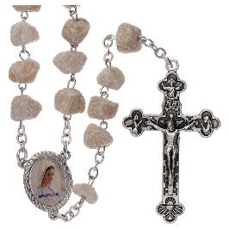
THE ROSARY: October is the month of the Holy Rosery. During this month we are encouraged to make the Rosary a part of our daily prayer routine. If you pray the Rosary, you should consider all four versions of the Rosary (Joyful, Sorrowful, Glorious, and Luminous).
PARISH COUNCIL: Thank you to those who serve on our parish Council. We need 3 new members to have a full slate. If you know someone who would be a good member, please speak with them and put their name forward for election.

SACRAMENTAL PREPARATION 2021:
Forms for registration for Sacramental Preparation are now available at the back of the church.

CHILDRENS LITURGY: The Children Liturgy room has been sanitized and the Covid-19 protocols will be in place for this years Children’s Liturgy Program. You are invited to bring your children to take part in children liturgy if you feel comfortable.

NEEDS OF THE CANADIAN CHURCH: A special collection for the Needs of the Church in Canada is being taken up in all parishes on the weekend of September 25-26. The annual Collection for the Needs of the Church in Canada invites all the faithful to participate in this financing by helping their diocese meet its financial obligations to the regional assemblies and to the national Conference. Any additional revenues raised help the diocese support its own diocesan pastoral programs and other activities.

BINGO: The Ladies’ Group plans to have their bingo draw for September on the first Sunday of October. Entries must be received no later than Sunday, September 26. Parishioners will be entitled to one entry per each $10 donation. People whose last names begin with A through E are being asked to donate, but anyone can participate. Thank you for your continued support of our parish.
Mass of Remembrance: Our Annual Mass of Remembrance will take place in early November. Family members of persons whose funerals we have celebrated since November last year will be contacted and offered special roles in the mass of that day. If you have had family members / friends who have died within this last year, and whose funeral / burial has taken place outside this parish, please contact the parish office if you want their names included at that mass.
ALL SOULS DAY: All Souls Day, November 2, is a day to pray for the souls of our faithful departed. Envelopes are available in our church for parishioners to list the names of their family members and friends who they would like remembered. Throughout the month of November there will be masses in commemoration of All Souls and the persons you have named will be prayed for

SAINT VINCENT DE PAUL FEAST DAY: Monday, September 27 is Saint Vincent de Paul Feast Day. This year, the Holy Redeemer Conference in Ottawa is hosting the national broadcast of the Feast Day Mass. It will be recorded on Saturday, September 25, in conjunction with the Holy Redeemer Parish’s 40th anniversary and the SSVP conference 35th anniversary. For this celebration, the celebrant will be Msgr Peter Schonenbach. Msgr Schonenbach has had a great impact on the Society of Saint Vincent de Paul in Ottawa, including as well being a Spiritual Advisor for the National Council of Canada for many years. Livestream on Saturday, Sept. 25th, 2021 at 12:30 pm. Watch on Facebook: www.facebook.com/
holyredeemerkanata
FOOD BANK THANKSGIVING DAY FOOD DRIVE: We are able to hold our annual Thanksgiving Day Food Drive this year. Please donate non-perishable food items to your child’s upcoming school food drive, at your church, at any local community fundraiser, or in the food collection bin located in the major grocery stores. Thank you for your continued support.

KNIGHTS OF COLUMBUS SCHOLARSHIPS:
Available to all students who graduated Grade XII with Honours in June 2021 and are attending a post-secondary institution in September. Application deadline: October 31, 2021. Information and applications under scholarships on the State Council website at www.kofcnl.org.

THINGS TO PONDER:
Why is it that when you transport something by car, it's called a shipment, but when you transport something by ship, it's called cargo?

Isn't it a bit unnerving that doctors call what they do "practice"?

Why are there flotation devices under plane seats instead of parachutes?

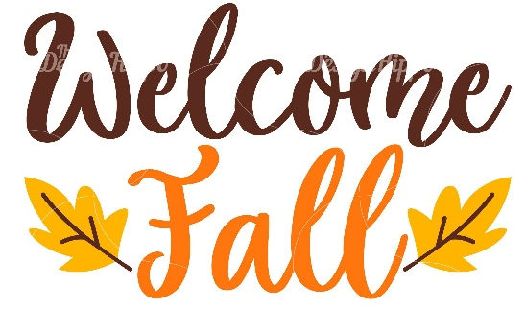
Why is it, whether you sit up or sit down, the result is the same?

