**September 5th, 2021 – 23rd Sunday of Ordinary Time**

**[Jesus] put his finger in the man’s ears, and, spitting, touched his tongue; then he looked up to heaven and groaned, and said to him, “Ephphatha!” — that is, “Be opened!”**

**Mark 7: 31-37**

**“**The stonecutter

Once there was a stonecutter who was very unhappy with his work and life.

  One day he passed by a wealthy merchant’s house. Through the open gateway, he could see the rich man’s many beautiful possessions and important guests. “How powerful that merchant must be!” thought the stonecutter. “How I wish I could live such a life.” Suddenly, the stonecutter became the merchant, enjoying the luxuries and more power than he had ever dreamed of possessing. But he soon found himself detested and envied by his poor friends.

  Soon a high official of the king passed by, carried in a sedan chair, with a retinue of soldiers and attendants. Even the very wealthy had to bow before the official. “How powerful that official is! I wish I could be such a high official,” he thought.

  And suddenly, the erstwhile stonecutter became the high official, carried everywhere in a beautifully embroidered sedan chair, with all the people bowing before him. But it was a hot summer day, and he soon became very uncomfortable in the sticky sedan chair. He looked up at the sun, shining brilliantly in the sky, illuminating the entire earth. “How powerful the sun is!” he thought. “I wish I could be the sun.”

  And immediately, he became the sun, scorching the fields and cursed by farmers and laborers. But a huge black cloud soon moved between him and the earth so that his light could no longer shine. “How powerful that storm cloud is! I wish I could be a cloud.”

  And suddenly, he became the cloud, flooding fields and villages, despised by everyone. But soon he found himself pushed away by a strong wind. “How powerful a force is the wind! I wish I could be the wind.”

  And so he became the wind, uprooting trees, plants and homes; as the wind, he was hated and feared. But soon he came up against something he could not move no matter how forcefully he blew against it: a huge, towering stone wall. “How powerful that stone is! I wish I could be a stone.”

  And then he became the stone, more powerful and stronger than anything on earth. But as he stood there, he heard the sound of hammer and chisel pounding against him and he felt himself being changed. “What could be more powerful than I, the stone?”

  He looked down and saw far below him the figure of a stonecutter.

***“Ephphatha” — “openness” of heart and mind and spirit — is the mark of the discipleship. “Ephphatha” is to understand who we are and to realize the good we can do, no matter the degree of “power” we possess. “Ephphatha” is to hear the voice of God in the midst of the noise and distractions that surround us, to sense God’s presence when we are overwhelmed by anger, jealousy and disappointment, to see the possibilities we have for bringing God’s peace and forgiveness into our lives and the lives of those we love.***

***ConnectionsMediaWorks.com***

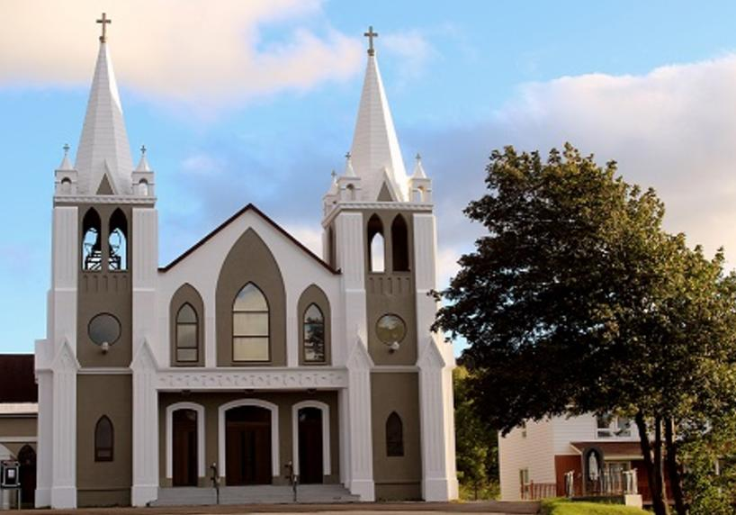**September 5th, 2021**

**23rd Sunday of Ordinary Time**

Sacred Heart Parish

A Stewardship Parish in Union with Christ

Parish Information

Pastor: Monsignor Jim Robertson  
Office Administrator: Dianne Russell  
**Office Hours: Tuesday to Friday 9am - 2pm.**

***Please note:*** ***Parish office will be closed Tuesday September 7th***

|  |  |
| --- | --- |
| 465 Curling Street Corner Brook, NL, A2H 3K8 Tel: (709) 785-5025 | [curlingparish@hotmail.com](mailto:curlingparish@hotmail.com) **e-transfers: sacredheartrcparish@gmail.com**  **Password "Church"**  www.sacredheartrcparish.ca |

**Weekend Masses**: Saturday 4:30 pm, Sunday 11 am

***To Register, please call the office Tuesday to Friday* between *9 am and 2 pm.***

**Mass During Week**: Tuesday, Wednesday, and Thursday at 7 pm.

Friday at 10 am.

**Lohnes Complex** First Fridays - 2 pm at the Lohnes Complex, ***closed to public.***

**Bible Study:** Discontinued for the summer.

**Holy Hour of Adoration**: Discontinued until further notice.   
**Reconciliation:** By request.

**Marriages:** Six months’ notice required. A year’s notice is recommended.

**Baptisms:** Please call the Parish Office to schedule preparation session.

**Family Connections**: At www.rcchurch.com you will find a link to family connections.

**St. Vincent de Paul:** To assist those in need. Call 638-9010.

**Masks are no longer mandatory but are still encouraged.**

**As well please maintain physical distancing at all times.**

**RECEIVED WITH THANKS**

**August 29, 2021**

|  |  |
| --- | --- |
| Regular Sunday | $1810.20 |
| Building Fund | 125.00 |
| Parish Insurance | 50.00 |
| Needs of the Canadian Church | 20.00 |
| St. Vincent de Paul | 100.00 |
| Government Wage Subsidy | 6695.23 |

**MASS INTENTIONS**

|  |  |
| --- | --- |
| Tue. 7pm | Deceased members of Gallant & Quigley Families |
| Wed. 7pm | Late James Brake |
| Thu. 7pm | Late Fletcher & Sarah Joyce |
| Fri. 10am | Late Cameron Carew |
| Sat. 4:30pm | Late Roderick Blanchard |
| Sun. 11am | Parish Community |

**LABOUR DAY:** Labour Day weekend marks the end of the summer vacation period and the resumption of activities in home, parish and school. Our Parishes take this weekend as an opportunity to encourage active and renewed participation in our parish community**. Parish office will be closed on Tuesday for the Labour Day holiday.**

**CONDOLENCES:** We offer our prayerful condolences to the families of the late Imelda Staples and the late Frank Lewis. May they rest in peace.

**PARISH COUNCIL:** Thank you to those who serve on our parish Council. Every year three council members finish their terms in September. We will need new members to have a full slate. If you know someone who would be a good member, please speak with them and put their name forward for election.

**LADIES GOUP:** There will be a ladies group meeting on Tuesday, September 7th at

7pm in the Church meeting room.

**FAMILY MATTERS**: On September 16 at 7pm at All Hallows Church, Corner Brook there will be a 1-hour session on Family Matters. The presenter will be Dr. Anne Jamieson, she is a wife, mother, author, teacher, and life-long learner. She loves to share stories and practical tips for joyful sharing of the faith.

Not all lessons come from books. How we live, play, eat, talk to one another, celebrate, and forgive are all ways we teach our children about our deepest beliefs - who and whose we are. Join us as we consider how the 'stuff' of our lives matters. It's not about one more job for already busy parents, grandparents,

catechists. It's about being more intentional in all we do. If people can attend in person, it would be great, if not they can join us on FB with the link below or they can just search Diocese of Corner Brook and Labrador to find us.  I have heard Anne several times.  She is very practical and down-to-earth.

https://www.facebook.com/dioceseofcornerbrookandlabrador

**HOLY LANDS COLLECTIONS**: At Mass, on Sunday, September 12th, you will hear proclaimed that “The Lord God has opened my ear, “to hear God’s graciousness. May your faith in our gracious God be expressed by your solidarity with and your care for the needs of the people and the Church in the Holy Lands.

Despite the Covid pandemic’s upsetting the usual Good Friday collection, many of you have already used your parish envelopes or donated in other ways. On behalf of the Custos of the Holy Land, Fr. Francesco Patton, o.f.m., I sincerely thank you for your generous support.

**LAY VISITORS TO HOSPITAL**: We have been advised that lay visitation may resume in September of this year.  This is wonderful news! But because we have been out of service for almost two years, we are inviting anyone who would like to participate to give this serious consideration. If you haven’t taken part in visitation before, you will need your security check done with the R.N.C. and come to a gathering for further briefing. Fr. Ed Terry, hospital chaplain, is most willing to meet with you for the purpose. A date will be announced. In the meantime, if you are interested or have done this before, kindly call the Cathedral at 634-5161 and leave your name and phone number with our secretary. Remember, “I was sick, and you visited me.” (Matt. 25:36)



**ST. VINCENT DE PAUL:** The Society announces that it will be re-starting Mary’s Kitchen effective Friday, September 10th at 4:30 PM. If weather permits the first supper will be a BBQ on the Cathedral parking lot. We will ask people who attend to keep in mind the restrictions in place because of Covid-19. People in a bubble may sit together. Others are asked to keep social distancing as they enjoy their meal. Each week thereafter the Kitchen will be held in the Church basement.

**VOTIVE CANDLES/VIGIL LIGHTS:** With the change in covid-19 regulations the regulations on touching common surfaces are lifted. You are invited to light votive candles in the votive candle stand as you offer prayers for your needs or the needs of others. We ask a donation of $4 per candle.

**WELCOME BACK TO SCHOOL:** We pray for the students and teachers as they begin this year of study with the contining global pandemic. We pray that the advice and work of our health and education departments will continue help keep all persons safe and help them to grow in education.

**PAPAL PRAYER INTENTION**: We pray that we will make courageous choices for a simple and environmentally sustainable lifestyle, rejoicing in our young people who are resolutely committed to this.

**HUMOUR:**

"Why do fathers take an extra pair of socks when they go golfing?" "In case they get a hole in one!"

"I thought the dryer was shrinking my clothes. Turns out it was the refrigerator all along."

"What do a tick and the Eiffel Tower have in common?" "They're both Paris-sites."

"Why couldn't the bicycle stand up by itself? It was two tired."

"Where do you learn to make a banana split?" "Sundae school."

"That car looks nice, but the muffler seems exhausted."

"Shout out to my fingers. I can count on all of them."