September 20th – 25th Sunday of Ordinary Time

The parable of the generous vineyard owner: “‘Are you envious because I am generous?’ Thus, the last will be first, and the first will be last.”
Matthew 20: 1-16a

A perspective of gratitude

Life is not easy right now — for some of us, things could not get any worse. Our frustrations and impatience get the better of us. We avoid confrontation for the most part, but we quietly seethe at being disrespected or dismissed or overlooked.

Gratitude is a much more difficult attitude to embrace — it demands a total recalibration of how we look at our life and world.

In his book The Lord Is My Shepherd: Healing Wisdom of the Twenty-Third Psalm, Harold S. Kushner reflects on the importance — and blessings — of gratitude:
“I read of a person who had formed the habit of writing Thank you on the lower left corner of every check he wrote. When he paid his electric bill or his phone bill, he would write Thank you to express his gratitude to the companies that made those services available to him at the press of a button. Even when he paid his taxes, he would write Thank you on the check as a way of reminding himself (he didn’t think the Internal Revenue Service would notice it) that his taxes were the price he willingly paid for living in the United States with all of its benefits. . . .

“Each night as I prepare for bed, I put drops in my eyes to fend off the threat of glaucoma that would rob me of my sight and take from me the pleasure of reading. Each morning at breakfast, I take a pill to control my blood pressure, and each evening at dinner I take another to lower my cholesterol level. But instead of lamenting the ailments that come with growing older, instead of wishing I were as young and fit as I once was, I take my medicine with a prayer of thanks that modern science has found ways to help me cope with these ailments. I think of all my ancestors who didn’t live long enough to develop the complications of old age and did not have pills to take when they did.”

The kingdom of God that Jesus proclaims is centered in a spirit of gratitude for what we have received and the humility to seek to share those blessings with others — and in that spirit of gratitude, we discover the happiness that is centered in the Spirit of God. The workers in today’s Gospel feel cheated by the vineyard owner’s generosity — their resentment at their coworkers’ good fortune diminishes them and clouds any satisfaction in being able to provide for their families. Jesus calls us to a change in perspective: to look beyond what we do not have and realize and rejoice in all that we have been given, including the love of family and friends, good health, opportunities to learn and grow, the freedom and resources to live lives of fulfillment and meaning.
connectionsmediaworks.com

September 20th, 2020
25th Sunday of Ordinary Time
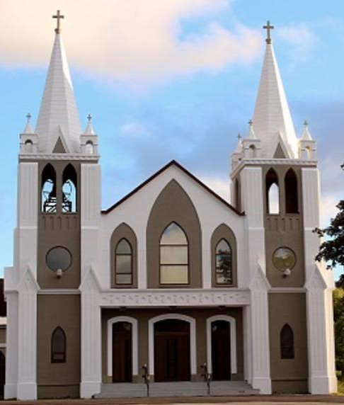
Sacred Heart Parish
A Stewardship Parish in Union with Christ
Parish Information
Pastor: Monsignor Jim Robertson
Office Administrator: Dianne Russell
Office Hours: Monday to Friday 9 a.m. - 1 p.m.
465 Curling Street  Corner Brook, NL, A2H 3K8  Tel: (709) 785-5025 | curlingparish@hotmail.com  e-transfers: sacredheartrcparish@gmail.com  Password "Church"  www.sacredheartrcparish.ca
Weekend Masses: Saturday 4:30 p.m., Sunday 11 a.m.
To Register, please call the office Monday to Friday
between 9 am and 1 pm.

Reconciliation: By request

Mass During the Week: Tues & Thurs at 7 p.m. and Wed 7 pm this week
& Fri at 10 a.m.
Holy Hour of Adoration: Discontinued until further notice.
Marriages: Six months’ notice required. A year's notice is recommended.
Baptisms: Please call the Parish Office to schedule preparation session.
St. Vincent de Paul: To assist those in need. Call 638-9010.
Note a change in time for Wednesday’s mass.
RECEIVED WITH THANKS
September 13th, 2020
Regular Sunday | $1830.20
Building Fund | 50.00
St. Vincent de Paul | 5.00
Good Friday | 20.00
In Memorium | 125.00
Mass Stipends | 10.00

MASS INTENTIONS
Tues, 7 pm | Late Bern Joyce
Wed, 7 pm | Late Patrick Joyce
Thur, 7 pm | Special Intention
Fri, 10 am | Late Jack Hearn
Sat, 4:30 pm | Late Thomas Griffin SR.
Sun, 11 am | Parish Community
Note time change for Wednesday’s mass.
PARISH DUES: Received with thanks from Linda Randell.

LADIES GROUP: There will be a meeting on Tuesday, September 22nd following evening Mass (7:30). All members are asked to attend. Face masks must be worn at all times.

HOME RELIGION PROGRAM – Sacred Heart Parish: Our home religon program will begin sometime in the month of October. As with so many other things because of the presents of Covid-19 it is difficult to finalize plans and develop progams. Please be patient with us and you will be contacted as soon as the diocesan and parish plan is in place. By bringing your children and grandchildren, you will help form your children and grandchildgren in the formation of faith.

SOCIETY OF ST VINCENT DE PAUL: Sunday, September 27th is the Feast of St Vincent de Paul. We ask God’s blessings and thank all those who serve and for the countless contributions and all your missionary zeal to assist the poor and all who are in need. The New Horizons for Seniors Program funded by the Government of Canada and delivered by the Society of St Vincent de Paul, Holy Redeemer Conference, Corner Brook, effective September 18th, 2020. This program is aimed at house-bound, low income seniors who find themselves in financial difficulty during the Covid-19 pandemic. Seniors, ages 60 and over, may call our volunteer dispatcher who will take the senior’s personal information (name, address, MCP number, and food requirements) and forward the information to volunteer homevisiting teams who will pick up food at local grocery stores and deliver to the senior’s home. It is not intended to be a home delivery service to any senior who calls, just those who truly need the service, and not more often than on a monthly basis. Those wishing to avail of the program should call 709-638-9010.

NEEDS OF THE CANADIAN CHURCH: A special collection for the Needs of the Church in Canada is being taken up in all parishes on the weekend of September 26-27. The annual Collection for the Needs of the Church in Canada invites all the faithful to participate in this financing by helping their diocese meet its financial obligations to the regional assemblies and to the national Conference. Any additional revenues raised help the diocese support its own diocesan pastoral programs and other activities.

Parish council: Current members of our parish council are: Mike Leonard, Brian Sparkes, Victoria Murphy, Carl Bennett, Joe Byrne, Jack Pennell, Bill Brake, and Art Hall. There is also one representative of each of the following: Finance Committee, the Ladies Group and the Men’s Group. Also, there is one vacancy. Three of these members will be completing their term this year. Some will be eligible to run for another term. We are now looking for nominations of four persons for our parish council. Nomination forms are available at the back of the church. You must have the consent of the person you are nominating. Nominations should be completed by September 27th, 2020.

HUMOR:
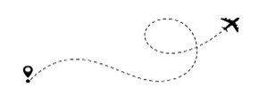
Larry was a photographer for the N.Y. Times and was scheduled to meet a plane on the runway to take him on a job. “Hit it,” said Larry climbing into the first plane he saw on the runway. The pilot took off, and was soon in the air. “OK,” said Larry, “fly low over the trees over there, I want to take a few pictures.” “What do you mean?” asked the pilot. Larry looked at the pilot and answered a little annoyed, “I need to take some pictures for the N.Y. Times, so please…..” There was a long pause, before the pilot asked in a shaky voice, “you mean you’re not my pilot instructor?”

PAPAL PRAYER INTENTION : We pray that the planet’s resources will not be plundered but shared in a just and respectful manner.
Welcome to Fall
INTERNATIONAL DAY OF PEACE – Sept. 21st: Each year the International Day of Peace is observed around the world on 21 September. The UN General Assembly has declared this as a day devoted to strengthening the ideals of peace, through observing 24 hours of non-violence and cease-fire.
This year, it has been clearer than ever that we are not each other’s enemies. Rather, our common enemy is a tireless virus that threatens our health, security and very way of life. COVID-19 has thrown our world into turmoil and forcibly reminded us that what happens in one part of the planet can impact people everywhere.
To mark its 75th anniversary, the UN has invited millions of people worldwide to join UN75, the largest and furthest-reaching global conversation on building the peaceful and prosperous future that we want.
The 2020 theme for the International Day of Peace is “Shaping Peace Together.” Celebrate the day by spreading compassion, kindness and hope in the face of the pandemic. Stand together with the UN against attempts to use the virus to promote discrimination or hatred. Join us so that we can shape peace together.

COVID-19: MASK WEARING: You must wear a mask over your “mouth and nose” while entering and moving around the church; you can remove your mask when seated as long as the 2m physical distancing rule is practiced. You must wear a mask going up for communion but remove it at the time of communion.

