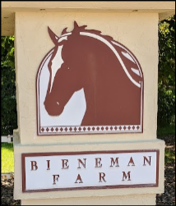

**TOWNHOMES OF BIENEMAN FARM HOA**

**PARKING VIOLATION NOTICE**

**Date Issued:**

**VEHICLE DESCRIPTION**

|  |  |
| --- | --- |
| **MAKE/MODEL/COLOR:** |  |
| **PLATE STATE/NUMBER:** |  |

**NOTICE**

|  |  |
| --- | --- |
| Pursuant to the *Rules and Regulations* for the above Property and/or posted signage,  **YOU ARE ILLEGALLY PARKED**  **AND ARE SUBJECT TO BEING TOWED AT YOUR EXPENSE**  for one or more of the following reasons: | |
| **Vehicle parked overnight in an area reserved for GUESTS ONLY** | **Vehicle parked overnight on a private street** |
| **Vehicle blocks or prevents access to premises** | **Vehicle is parked in a snow removal zone or was not moved for snow removal** |
| **Vehicle is parked in an area not intended for motor vehicles (e.g., sidewalks, lawns, landscaping, etc.)** | **Vehicle blocks or prevents emergency vehicle access to property or is parked too close to a fire hydrant** |
| **Recreational or oversized / modified commercial vehicle parked in a driveway or on a private street** | **Vehicle is inoperative, in disrepair, or has been abandoned** |
| **Vehicle is parked facing oncoming traffic** | **Other:** |

***It has been noted that this vehicle has not moved in*** ***days. If the vehicle remains parked here after*** ***AM / PM on*** ***the vehicle will be towed to Jerry’s Towing in Roberts, WI at the owner’s expense.***

**Thank you for your cooperation.**

**MJF & Associates (612) 819-0133**