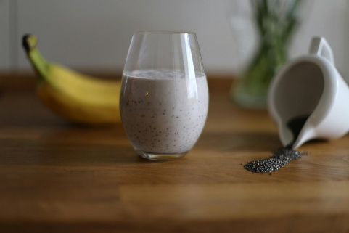

**Overnight Chia Pots**

* 3.5 tablespoons chia seeds
* 1 cup plant milk i.e. almond, oat, soy
* 1 small ripe banana
* ½ tsp cinnamon to dress

Optional:

* Berries
* Tbsp whey powder
* Tablespoon of nuts
* ½ tsp cinnamon to dress

Whilst mason jars are great and commonly used, any type of jar will do that has a lid and can hold the ingredients – I have a cupboard full of recycled jars for all types of uses.

1. Mix the chia seeds and milk, put in the fridge for 15 mins then mix again to avoid lumps
2. Mash the banana and add, mix well.
3. Leave overnight
4. Take out fridge, mix well and add whey powder if using.
5. Add cinnamon and drizzle with honey, or add any other toppings you like.

**Tips:**

This is the ratio of seeds / milk, if you want more just double etc... but stick to the ratio.

If you don’t like the tapioca texture, or struggle eating seeds for digestion or dental reasons, you can grind these up at the start.

You can also blend fruit and add to the overnight pot – but use 4 tbsp seeds per cup milk here.