A MULTI AWARD TEAM THAT YOU CAN TRUST FOR YOUR SUPPORT CARE NEEDS
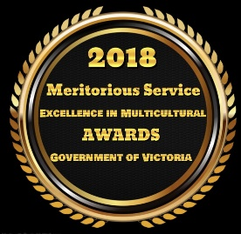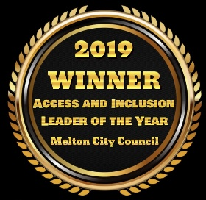
GETTING TO KNOW YOU
AICSs appreciates that everyone is unique, please help us to get to know you by answering the following:
General Info
Today’s Date:
Participant Name: |  |  |  |  | Participant DOB:
Address:
Contact Number: |  |  |  |  | Name of Enquirer:
My preferred emails: |  |  |  |  | Enquirers Contact #:
How is Enquirer related:
ATSI Information | Aboriginal but not Torres Strait Islander origin |  | Torres Strait Islander but not Aboriginal origin | Both Aboriginal and Torres Strait Islander origin |  | Neither Aboriginal or Torres Strait Islander origin | Prefer not to answer
Which services are you interested in?

NDIA Funding Info
How is Funding Managed: | Self-Managed / Fin Plan Man / NDIA Agency - (Please highlight)

Personal Care and Mobility Support Requirements
Assistance with toileting | Assistance with feeding (PEG feed)
Assistance with mobility | Support with managing feminine hygiene
Wheelchair or mobility aid | Bowel or bladder incontinence
Assistance with transfers | Other requirements of care
Further information:

No dietary requirements
Vegetarian
Vegan
I am allergic to (please list foods)
I am unable to eat (sensory/intolerances)
My favourite food is
AICSs can assist me during meal times by……

I can identify what foods are safe for me to eat (if required due to allergy or dietary requirements).
If I have a food allergy, I have provided AICSs with a management plan.
If required I will bring any medications to assist me with my allergy and have completed the relevant medication forms.
I prefer to provide my own food and will do so.

Depression | Anxiety
Psychosis | Schizophrenia
Bipolar | Other
I would like AICS to help me manage this by …

My triggers may include …
I am supported/linked with the following organisations who assist me…
Please supply relevant management plans.

I receive medical support to assist me and AICS has a copy of any relevant management plans to help me manage

Diabetes | Sleep Apnoea
Epilepsy | Allergies to ………………………
Asthma | Dietary Needs
Visual Impairment | Blood Disorders
Cognitive Impairment | Hearing Impairment
Heart Conditions | Other

A BIT ABOUT YOU AND YOUR GOALS
To help our us understand you better, please fill the below:
My strengths are (what I am really good at) …..

I like ……

I don’t like…….
(Please include any sensory considerations)

You will know when I am happy by ……

You will know when I am unhappy by …….

I prefer to communitcate by……..

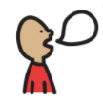
Anything else should we know about you?

Behaviour | I Can Do Independently | I Need a Little  Help | I Cannot Do Independently
Traffic awareness
Staying with the group
Communicating appropriately
Looking after property
Being aware of personal space
Keeping my hands to myself
Travelling safely in a car
Following instructions
Swimming and safety around water
I can handle my own spending money
I am comfortable in my sleeping routine
AICSs can assist me by ……

Once completed please email this to enquiries@aics.org.au
We will organise a free meet and greet prior to the service if required.

