Bar Services

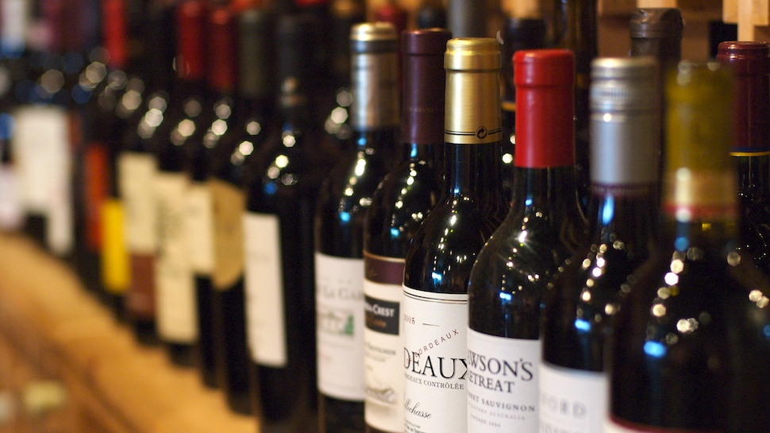

Bartenders

$100 each per event

Soft Bar

$1.50 per guest

Soft Bar includes: Coke, Diet Coke, Sprite, Gingerale, Tonic Water, Orange Juice, Cranberry Juice, Grapefruit Juice, Pineapple Juice, Cups, Napkins, Stirrers, and Fruit for garnishing.

The Customer will provide the liquor, beer, and wine.