

Duckbunker.com

**Instructions**

Parts list

1 End piece 2

2 Arms 5

3 Front cover 1

4 Rear cover 1

5 Legs (optional) 4

6 Mounting clamps (optional) 4

7 Self-tapping screws 20

Tools required:

Phillips head screwdriver

Mallet/hammer

Adjustable wrench

Measuring tape

Power drill w/1/4” metal bit and ½” bit (12mm)

Zip ties/twine

*Two man lift recommended

*Always wear eye protection

*Gloves recommended

Assembly

Before starting, if you are putting this blind on a boat, configure how you want to mount it. The blind has five foot squared ends; this allows you to rotate the blind to place the short side - the front - to either side of the boat as you prefer according to your shooting style. Keep in mind the position of the blind needs to account for motors, controls and general boat layout.

1. Lay out end pieces

1. Connect arms. These should be 5 equal lengths, either 9’ or 12’ in length. We recommend sliding the arms through the cover and attaching to one end at a time.
2. Slide one arm in the top of the front cover and attach to the top arm on one end piece on the short side.

1. Slide the second arm in the front cover and attach it to the same end piece on the frame base.

1. Slide one arm in the top of the rear cover, then attach to the movable arm on the end piece.

1. Slide one arm in the bottom of the rear cover, then attach to the bottom of the end piece.
2. Attach the other end piece to the 4 arms.

1. Slide the middle arm in the loops of the rear cover and attach to the rear side of the end piece. If necessary, use a mallet or a hammer to seat the arms firmly. If necessary, use self-tapping screws to fasten the arms in their seated positions.
2. On the adjustable models, should you wish to configure to your boat, undo the connecting bolts and position at your desired width.
3. A black object on a stone surface

   AI-generated content may be incorrect.

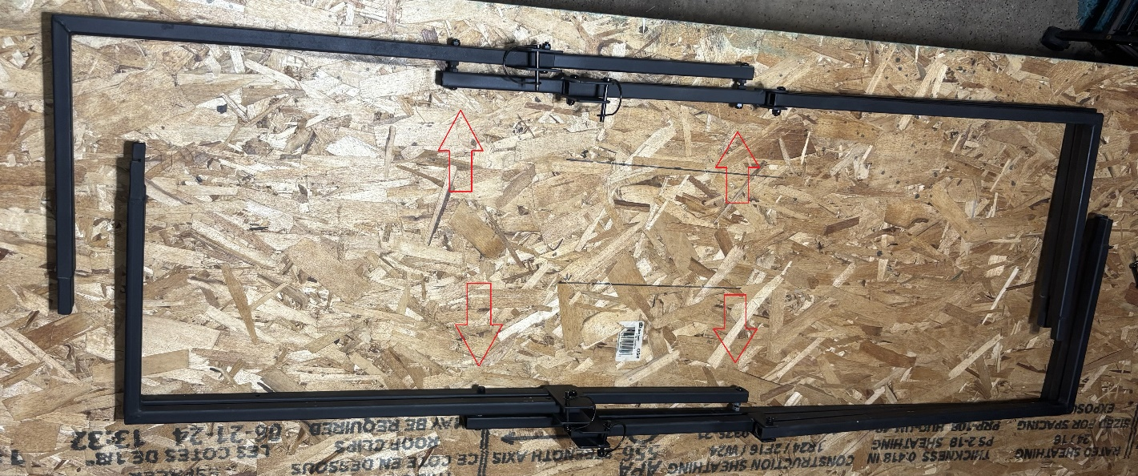

Note: The end pieces are staggered so that the arms are all the same length. It is recommended that you keep the same configuration.

1. When matching up the end pieces, drill a 1/4” hole to rebolt the two pieces back together at the desired width.

The blind is now ready for mounting. Lower the arms and place the blind. After assembling the frame and slipping the cover on, you have a few options to mount to the boat. You can insert the legs into to end frames and stand it up in the boat, we recommend tieing down the base of the frame leaving the arms free to be raised.

Another option is to use clamps to attach to the gunnel of the boat directly. When attaching, figure your clamp placement for the gunnels, then drill a ½” or 12mm hole in the arm, then using the accompanying m10 bolt through the arm and screw into the clamp.

When mounting make sure that you can access and employ the motor and any other essential equipment necessary such as anchors. Every boat setup is different and subject to individual preferences, please don’t hesitate to drill, clamp or otherwise attach the blind in a manner that works for you.

1. Add camo material. Netting, fast grass, etc., use zip ties, or twine to attach to the provided loops on the outside of the cover.

Notes

Never store the blind wet, allow the blind to dry before storage, this keeps mold and mildew down and cuts down on rust.

When storing, wrap in the storage flaps, particularly when storing in sunlight to prevent fading of colors.

Touch up the frame with paint when needed to match the environment and to keep the metal from rusting.

Traveling with the blind up is not recommended.

Always maintain a firm grip when raising or lowering the blind arms.

Never lean firearms against the blind (ALWAYS keep positive control of firearms).

Always follow the instructions and obey all cautions of your equipment’s manufacturers. This includes boats, motor, etc.

Nearly all physical aspects of duck hunting have risk, mitigate that risk by following all applicable instructions and common sense.