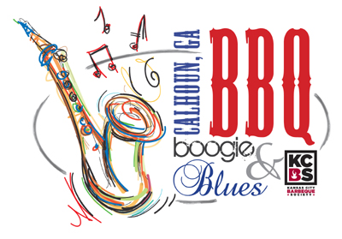
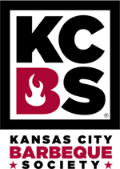
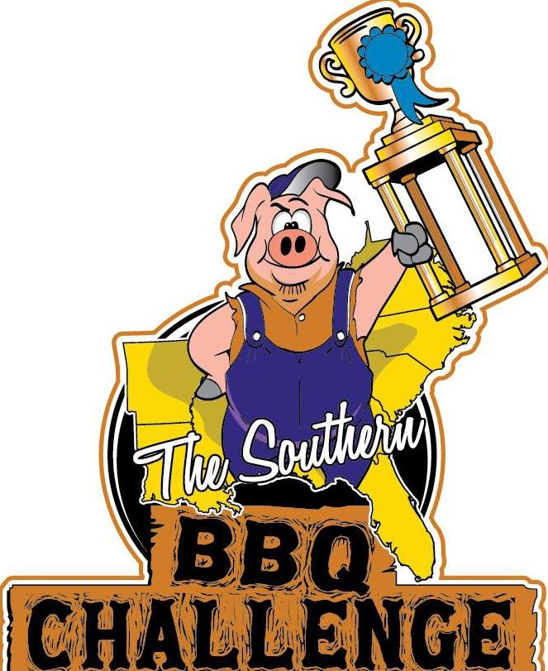
BBQ BOOGIE & BLUES
April 24 & 25, 2020 · Downtown Calhoun, GA
KCBS PROFESSIONAL CONTESTANT APPLICATION
(please print clearly)

Team Name ________________________________________ Date ______________
Contact Name ______________________________________
Address ___________________________ City _____________ State ___ Zip ______ Phone ____________________________ Cell _______________________________ Email _______________________________________ KCBS # _________________

Team Entry Fee: $275 $ ________________
Food Vendor? Yes ____ No ____ $125 $ ________________
Booth Description: ___________________________________________
Electricity Required? Yes _20AMP?__ 30AMP? __ 50AMP? ($30 charge for 50AMP) No __ $ ________________
T-Shirt Size ________ (One Complimentary T-Shirt Per Entry)
Additional T-Shirts? $10 each (pre-ordered with application)
Number of T-Shirts ____ x $10 (List Sizes ______________) $ ________________
Total Fee Due $ ________________
*Refunds will not be available after April 3, 2020. Registration fees can only be transferred to the 2021 event after that date.

Size of Space Needed: (Please check all that apply)
RV ____ (Type __________________________ Length _________________)
TENT ____ Length of Smoker or pull behind trailer ________________________

Team to compete in: Ribs ____ Chicken ____ Pork ____ Brisket ____
Competitors must enter all categories in order to be eligible for Grand Champion and Reserve Champion.

People’s Choice Participant? Yes ____ No ____
A complimentary Boston Butt will be provided for each team entry. Winners will be chosen by people’s votes. Samples will be distributed at Organizer’s Tent (not at contestant’s location). Anonymous voting. Winner will receive $100 and trophy.

Mail completed application with fees to: Sarah Ostuw, Gordon County CVB, Calhoun, GA 30701. Please make checks payable to Gordon County CVB.

For Credit Card Payments, Call 706.625.3200.

Card Type: Visa ____ MasterCard ____ Discover ____

Card # ___________________________________ Expiration ____________ CCID# ___________
Name as it appears on Card: ________________________________________________________
Billing Address for Card: ____________________________________________________________

For questions or additional information, contact Aaron Walkover at 706-307-9129, Suzanne Roberts at 706-602-5570 or Sarah Ostuw at 706-625-3200.

General Release: Contestant does hereby and forever discharge the Gordon County Chamber of Commerce/Convention & Visitors Bureau, City of Calhoun Government, all sponsoring organizations and their directors, officers, employees, agents and volunteers from all manner of the actions, suits, damages, claims, and demands whatsoever in law or equity from any loss or damage arising out of or in conjunction with application to or participation in the BBQ Boogie & Blues, which is not responsible for any injury sustained by contestants or guests. The undersigned has read and shall comply with all rules of this application and further agrees to notify all members of his/her team about these important rules and assumes full responsibility for team conduct and compliance. Further, I hereby grant full permission to the BBQ Boogie & Blues and/or its agents authorized by them, to use any photographs, video tapes, motion pictures recordings or any other record of the event for any legitimate purpose.

SIGNATURE ____________________________________________

BBQ Boogie & Blues – Calhoun, Georgia
April 24 & 25, 2020

PRIZES

Grand Champion: $1,800.00
Reserve Champion: $1,200.00

KCBS Categories: Chicken, Ribs, Pork, Brisket as follows:
1st Place $300.00 6th Place $ 75.00
2nd Place $ 250.00 7th Place $ 55.00
3rd Place $ 200.00 8th Place $ 45.00
4th Place $ 125.00 9th Place $ 40.00
5th Place $ 100.00 10th Place $ 35.00

People’s Choice: $100

Total Cash Winnings $ 8,000.00

