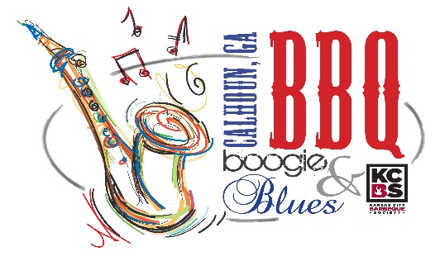

Sponsor the 9th Annual BBQ Boogie & Blues

Join Downtown Calhoun for the 9th Annual BBQ Boogie & Blues on April 24 & 25, 2020. This is your opportunity to be a part of an event the Kansas City BBQ Society (KCBS) have declared a nationally sanctioned barbecue competition! In addition to BBQ, festivities include live entertainment, food and arts & crafts vendors, kids zone, Amazing Race contest and much more. The event draws a great local crowd and attracts new faces to the area! Sponsorship of BBQ Boogie & Blues provides an excellent advertising opportunity for your business.

Hogzilla $2,500
- Prominent advertising in brochures, banners, publications, and local media, including company logo and name on all printed materials (including Chamber newsletter & weekly What’s Going On emails)
- Logo included in blast email campaigns, Chamber & CVB Facebook promotions, and on Chamber, CVB & BBQ Boogie & Blues websites
- Logo on front side of t-shirts
- 5 complimentary t-shirts
- Listing on the Chamber’s digital sign
- Complimentary preferred vendor booth space at event
- Emcee coverage at the event
- 4 tickets to participate in the “People’s Choice” competition ($40 value)

Whole Hog $1,500
- Listed in event advertising including brochures, banners, publications, and local media (including Chamber newsletter & weekly What’s Going On emails)
- Included in blast email campaigns, Chamber & CVB Facebook promotions, and on Chamber, CVB & BBQ Boogie & Blues websites
- Listing on Chamber’s digital sign
- Logo on backside of t-shirt
- 4 complimentary t-shirts
- Complimentary vendor booth space at event
- Emcee coverage at the event
- 2 tickets to participate in the “People’s Choice” competition ($20 value)

Half Rack $1,000
- Advertising at event (included on sponsor banner and emcee coverage)
- Included in blast email campaigns, Chamber & Facebook promotions, and on Chamber, CVB & BBQ Boogie & Blues websites
- Included in event article(s) in the Chamber newsletter
- Logo on backside of t-shirt
- 3 complimentary t-shirts
- Complimentary booth space at event

Pitmaster $500
- Advertising at event (included on sponsor banner and emcee coverage)
- Included in event article(s) in the Chamber newsletter
- Name listed on backside of t-shirt
- 2 free t-shirts
- Complimentary booth space at event

Griller $250
- Advertising at event (included on sponsor banner and emcee coverage)
- Name listed on backside of t-shirt
- 1 free t-shirt

- - - - - - - - - - - - -

We’re in! Sign us up for the $________ level.

Company Name _________________________________________________________________

Billing Address __________________________________________________________________

Contact Name __________________________________________________________________

Email _________________________________________________________________________

Phone Number _________________________________________________________________

T-Shirt Size(s) _________________________________________________________________

If sponsorship is $500 level or more, do you wish to set-up a booth at the event? _____________

Authorized Signature ______________________________________ Date__________________

For additional information:
Downtown Development Authority
P.O. Box 248 Calhoun, GA 30703
(706) 602-5570
Suzanne Roberts- sroberts@calnet-ga.net

