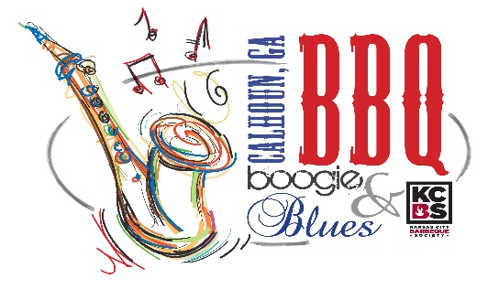

Sponsor the 12th Annual BBQ Boogie & Blues

Join Downtown Calhoun for the 12th Annual BBQ Boogie & Blues on April 26th & 27th, 2024

This is your opportunity to be a part of an event the Kansas City BBQ Society (KCBS) have declared a nationally sanctioned barbecue competition! In addition to BBQ, festivities include live entertainment, food and arts & crafts vendors, kids zone, contest and much more. The event draws a great local crowd and attracts new faces to the area! Sponsorship of BBQ Boogie & Blues provides an excellent advertising opportunity for your business.

Premier Sponsor – S5,000
- Recognition as the “Presenting Sponsor” of the event
- Prominent advertising in social media, posters, brochures, banners, printed and digital media, including company logo and name on all printed materials and mentioned in announcements at Chamber events, Downtown Calhoun events, civic clubs etc.
- Logo included in blast email campaigns, Chamber & CVB social media outlets, Downtown Calhoun Social Media Outlets and BBQ, Boogie & Blues website.
- Logo on front side or sleeve of t-shirts
- Logo on event Billboards
- 10 Complimentary Shirts
- Listing on Chamber digital sign
- Complimentary booth space
- Emcee coverage at the event

Hogzilla $2,500
- Prominent advertising in brochures, banners, publications, and local media, including company logo and name on all printed materials (including Chamber newsletter & weekly What’s Going On emails)
- Logo included in blast email campaigns, Chamber, Downtown & CVB Facebook promotions, and on Chamber, CVB & BBQ Boogie & Blues websites
- Logo on front side of t-shirts
- 5 complimentary t-shirts
- Listing on the Chamber’s digital sign
- Complimentary preferred vendor booth space at event
- Emcee coverage at the event
- 4 tickets to participate in the “People’s Choice” competition ($40 value)

Whole Hog $1,500
- Listed in event advertising including brochures, banners, publications, and local media (including Chamber newsletter & weekly What’s Going On emails)
- Included in blast email campaigns, Chamber, Downtown Calhoun & CVB Facebook promotions, and on Chamber, CVB & BBQ Boogie & Blues websites
- Listing on Chamber’s digital sign
- Logo on backside of t-shirt
- 4 complimentary t-shirts
- Complimentary vendor booth space at event
- Emcee coverage at the event
- 2 tickets to participate in the “People’s Choice” competition ($20 value)

Half Rack $1,000
- Advertising at event (included on sponsor banner and emcee coverage)
- Included in blast email campaigns, Chamber & Downtown Calhoun Facebook promotions, and on Chamber, CVB & BBQ Boogie & Blues websites
- Included in event article(s) in the Chamber newsletter
- Logo on backside of t-shirt
- 3 complimentary t-shirts
- Complimentary booth space at event

Pitmaster $500
- Advertising at event (included on sponsor banner and emcee coverage)
- Included in event article(s) in the Chamber newsletter
- Name listed on backside of t-shirt
- 2 free t-shirts
- Complimentary booth space at event

Griller $250
- Advertising at event (included on sponsor banner and emcee coverage)
- Name listed on backside of t-shirt
- 1 free t-shirt

- - - - - - - - - - - - -

We’re in! Sign us up for the $________ level.

Company Name _________________________________________________________________

Billing Address __________________________________________________________________

Contact Name __________________________________________________________________

Email _________________________________________________________________________

Phone Number _________________________________________________________________

T-Shirt Size(s) _________________________________________________________________

If sponsorship is $500 level or more, do you wish to set-up a booth at the event? _____________

Authorized Signature ______________________________________ Date__________________

For additional information:
Downtown Development Authority
P.O. Box 248 Calhoun, GA 30703
(706) 602-5570
Misty Caudle- mcaudle@calnet-ga.net

