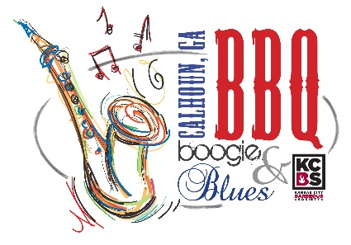
Backyard Grilling Competition Application

April 24 & 25, 2020

(Note: If you have competed in a KCBS Pro Tournament, you are NOT eligible to compete in the Backyard Competition)

Team Name __________________________________________________ Date __________________
Contact Name ____________________________________________________________________________
Address _____________________________________ City _______________ State _____ Zip _________
Cell Phone ____________________________ Email ____________________________________________

Team Entry Fee $125 $ ________________
Brisket Competition? $25 Yes____ No____ $ ________________
Food Vendor? $150 Yes ____ No ____ $ ________________
Booth Description: ____________________________________________________________________
Electricity Required? Yes _ (20AMP only in Backyard Grilling area) No __
T-Shirt Size ________ (One Complimentary T-Shirt Per Entry)
Additional T-Shirts? $10 each (pre-ordered with application)
Number of T-Shirts ____ x $10 (List Sizes ______________) $ ________________
Total Fee Due $ ________________
*Refunds will not be available after April 3, 2020. Registration fees can only be transferred to the 2021 event after that date.

Backyard Entrants will be judged on one or three categories: Chicken, Pork and/or Ribs, Brisket*

*Brisket is optional and costs an additional $25 fee if competing in that category.

People’s Choice Participant? Yes ____ No ____ ($25 Entry Fee)
A Boston Butt will be provided for each team entry. Winners will be chosen by people’s votes. Samples will be distributed at Organizer’s Tent (not at contestant’s location). Anonymous voting. Winner will receive $100 and trophy.

Mail completed application with fees to: Sarah Ostuw, Gordon County CVB, 300 South Wall Street, Calhoun, GA 30701 or submit by email to sostuw@gordoncountychamber.com Please make checks payable to Gordon County CVB.

For Credit Card Payments, Call 706.625.3200.

Card Type: Visa ____ MasterCard ____ Discover ____

Card # ____________________________________________ Expiration ____________ CCID# ___________
Name as it appears on Card: __________________________________________________________________
Billing Address for Card: ____________________________________________________________________

For questions or additional information, contact Aaron Walkover at 706-307-9129, Suzanne Roberts at 706-602-5570 or Sarah Ostuw at 706-625-3200.

General Release: Contestant does hereby and forever discharge the Gordon County Chamber of Commerce/Convention & Visitors Bureau, City of Calhoun Government, all sponsoring organizations and their directors, officers, employees, agents and volunteers from all manner of the actions, suits, damages, claims, and demands whatsoever in law or equity from any loss or damage arising out of or in conjunction with application to or participation in the BBQ Boogie & Blues, which is not responsible for any injury sustained by contestants or guests. The undersigned has read and shall comply with all rules of this application and further agrees to notify all members of his/her team about these important rules and assumes full responsibility for team conduct and compliance. Further, I hereby grant full permission to the BBQ Boogie & Blues and/or its agents authorized by them, to use any photographs, video tapes, motion pictures recordings or any other record of the event for any legitimate purpose.

SIGNATURE __________________________________________________________________

*Backyard prizes will be based on the number of entries. Turn-in times and additional details will be emailed to all participants at least one week prior to the event.

