**Dessert Que Competition Application**

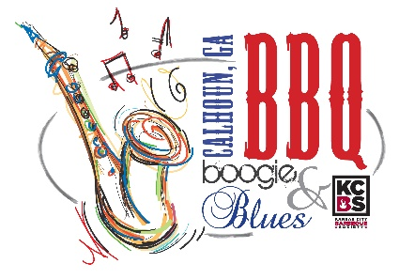**Friday, September 24th, 2021**

**Turn-In Time – 7:30 p.m.**

**For people of all ages that love a sweet treat!**

**Theme: Anything Apple!**

**Contestants must provide at least six portions.**

**The cook should do the preparation, cooking and presentation. Entries will be submitted in the numbered containers provided by organizers. Judging will be on appearance, texture and taste. Awards will be presented Friday night.**

Name _____________________________________________________ Date __________________

Address _____________________________________ City _______________ State _____ Zip _________

Phone ____________________________ Email ________________________________________________

Entry Fee $25  $ ________________

T- Shirt Size (specify youth or adult size) ________________

**Mail completed application with fees to: Suzanne Roberts, City of Calhoun DDA, Calhoun, Georgia 30703.** Please make checks payable to the DDA.

**For questions or additional information, contact Aaron Walkover at 706-307-9129.**

**General Release**: Contestant does hereby and forever discharge the Gordon County Chamber of Commerce/Convention & Visitors Bureau, City of Calhoun Government, all sponsoring organizations and their directors, officers, employees, agents and volunteers from all manner of the actions, suits, damages, claims, and demands whatsoever in law or equity from any loss or damage arising out of or in conjunction with application to or participation in the BBQ Boogie & Blues, which is not responsible for any injury sustained by contestants or guests. The undersigned has read and shall comply with all rules of this application and further agrees to notify all members of his/her team about these important rules and assumes full responsibility for team conduct and compliance. Further, I hereby grant full permission to the BBQ Boogie & Blues and/or its agents authorized by them, to use any photographs, video tapes, motion pictures recordings or any other record of the event for any legitimate purpose.

SIGNATURE: ___________________________________________________

**\*Prizes will be based on the number of entries.**