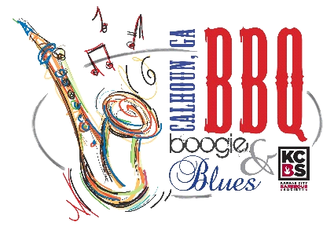

**Kids Que**

**Grilling Competition Application**

**Friday,**

**April 28th**

**202**

**3**

**Turn**

**-**

**In Time**

**–**

**7**

**p.m.**

**Kids Cook Meeting**

**–**

**5:30 p.m. at the Calhoun Depot**

**For all the future grill**

**-**

**masters in training, this contest is for the little ones ages 15 & under!**

**Hamburger will be the meat entry and provided to each contestant.**

**Contestants must provide their own grill.**

**The child cook should do the preparation, cook**

**ing and presentation. One adult will be allowed**

**to assist, but children are encouraged to do as much as possible on their own. Entries will be**

**submitted in the numbered containers provided by organizers. Judging will be on appearance,**

**tenderness/texture**

**and taste. Awards will be presented Friday night.**

Child’s

Name ______________________________________

__________

_

___

_

Date ___________

____

___

Adult’s

Name

_____________________________

______________________________________

_________

Address _______________________

__________

____

City ____

__

_________

State __

__

_

Zip __

___

____

Phone ____________________________ Email _______________________

____

________________

_____

Entry Fee

$

25

$ ________________

T

-

Shirt Size (specify youth or adult size)

________________

**Mail completed**

**application with fees to: Suzanne Roberts, P.O. Box 248, Calhoun, GA 30703.**

Please

make checks payable to

the DDA

.

**General Release**

: Contestant does hereby and forever discharge the Gordon County Chamber of Commerce/Convention & Visitors

Bureau, City of Calhoun Government, all sponsoring orga

nizations and their directors, officers, employees, agents and volunteers

from all manner of the actions, suits, damages, claims, and demands whatsoever in law or equity from any loss or damage arisi

ng out

of or in conjunction with application to or partic

ipation in the BBQ Boogie & Blues, which is not responsible for any injury sustained

by contestants or guests. The undersigned has read and shall comply with all rules of this application and further agrees to

notify all

members of his/her team about thes

e important rules and assumes full responsibility for team conduct and compliance. Further, I

hereby grant full permission to the BBQ Boogie & Blues and/or its agents authorized by them, to use any photographs, video ta

pes,

motion pictures recordings or a

ny other record of the event for any legitimate purpose.

SIGNATURE

OF PARENT/GUARDIAN _______

____________________________________________

**\*Prizes will be based on the number of entries.**