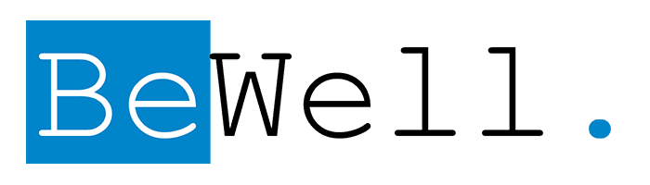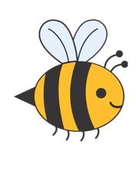
Cynosure Icon Laser
Candidates
Candidates for the Cynosure Icon Laser have a wide range of skin concerns, from fine lines and wrinkles to stretch marks or scars. Patients looking to enhance their existing beauty and improve the overall health of their skin to reduce and slow down the signs of aging are great candidates for skin renewal and revitalization treatments. Candidates should be in good general health, use sunscreen and proper skincare, and have realistic expectations about their results.

ThreeForMe
ThreeForMe is a comprehensive option that targets unwanted wrinkles, sun damage, and facial veins all in one laser treatment. This 45-mintue, non-invasive procedure gives you glowing skin with minimal downtime. This treatment is performed in two stages known as “passes”. The first pass treats discoloration, such as brown spots, age spots, and freckles. It also targets blood vessels and facial veins and can treat rosacea through the use of intense pulsed light (IPL). The second pass renews the skin by stimulating the production of collagen and elastin, resulting in the improvement of fine lines, wrinkles, and scars. It is suggested that you undergo three treatments spaced 4 weeks apart to achieve the best results. Dr. Bowers will discuss your treatment options during your consultation. With this treatment, you will begin to notice results right away and these improvements will increase over the course of six months.

Photorejuvenation (IPL)
Freckles, age spots, moles and vascular lesions on the face, chest, arms and hands are all signs of aging and years of exposure to the sun. When these signs are premature, they can feel prominent, unsightly, and bothersome. This is where photorejuventation comes in. Photorejuvenation uses intense pulsed light (IPL) to refresh the skin. IPL delivers light energy to the skin, treating age spots and sun damage. This energy is selectively absorbed into the skin by unwanted pigment and then cleared away by the body. This procedure is the gold standard in non-surgical treatments that get rid of unwanted pigment without harming the surrounding areas.

Within a few sessions, you can expect more even skin tone and a decrease in the appearance of unwanted skin pigment. Depending on the size of the treatment area, IPL can be performed in just minutes. Following the treatment, patients may experience minimal discomfort, but they can resume normal activities immediately. Temporary darkening of the treated pigment should be expected, but soon it sloughs away, revealing a clearer, more uniform look.

Skin Resurfacing
Treating texture irregularities such as fine lines and wrinkles and improving the overall health of the skin is now easier than ever with Icon 1540 laser. This laser uses a technology known as fractional resurfacing to deeply penetrate the top layer of skin without damaging it. With this treatment, an array of high-precision microbeams are delivered to the skin, creating deep, narrow columns of skin coagulation surrounded by healthy, untreated skin. As time passes, the skin will actually begin to repair itself, and younger, healthier skin will replace the damaged skin.
In addition to treating fine lines and wrinkles, the Icon 1540 Laser can also treat the following conditions
- Stretch Marks
- Scars
- Uneven skin tone and texture

Depending on the condition treated, you may experience swelling and redness for a few days following the treatment, but treatments are gentle and don’t require a lot of downtime. It may take several sessions to achieve ideal results.

Laser Hair Removal
Make shaving and waxing a thing of the past. The Icon Laser offers long-lasting hair removal for the face, underarms, legs, back bikini area, and chest in as little as 5-7 sessions. This treatment targets and destroys hair cells without damaging the surrounding skin. Any additional growth will come in finer, lighter, and far less noticeable. It is available for a variety of skin types and can be tailored to fit your needs.

Recovery
All treatments with Cynosure Icon Laser are outpatient procedures performed in one hour or less. Depending on the skin condition treated, there is minimal to no downtime and only minimal to moderate discomfort. Following treatment, you may experience minor swelling and redness similar to a mild sunburn for up to 5 days. It may take several sessions to achieve ideal results.

