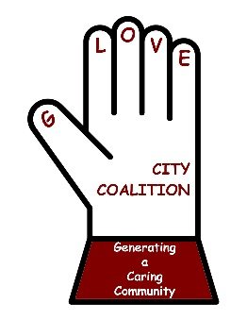
Glove City Coalition Agenda
Date: Thursday, January 19, 2023
10:00 am, via Zoom
Promoting healthy futures through collaboration and education. GCC strives to reduce youth substance use by engaging and supporting the community through education and collaboration to promote and sustain healthy lifestyles.

TOPIC | DISCUSSION
Welcome/ Introductions  Note Taker: | Bonnie Peck  Sally Baker
Spotlight Speaker  Melissa Geier, Human Trafficking of Youth | Please note that this was a brief overview-1 and 2 hr trainings are available at flexible times. Geoff will give Melissa a POC to coordinate a training for providers at NL Hospital.  Highlights of Melissa’s presentation: NY has the worst rate of trafficking in the country. There IS trafficking in Fulton and Montgomery counties. 45% of youth victims are male. There are 3 elements to be aware of: force, fraud, Scoercion. People with SUD are especially vulnerable. Red flags are bruising, showing fear, anxiety, running away, disconnecting, tattoos that may show ‘ownership’, gaps in stories, youth with older friends, friends with no names, STIs, youth homelessness, couch surfing, using unfamiliar words, phrases. Use “Urbandictionary.com” to learn what these words mean. The more drugs there are, the more trafficking there will be. There are many under-utilized services and supports. Contact Melissa to discuss further training.
Old Business  Approval of Nov 2022 minutes:  Action Team Reports:  Youth Coalition:  Media/Publicity:  Parent Engagement:  Capacity Building:  GPD  GHS  OD Mapping Update | Sara Butler motioned to approve; Gwen seconded.  Five students did a radio ad on BUG Radio and KISS FM playing thru late March. Sticker Shock campaign will be done Feb-Mar. Students are learning how to present the Vape Escape and will participate at the Winter NEU event, the teens are designing their shirts, two students will be attending the CADCA conference.  There are new billboards, I Heart radio will be doing a social media campaign in Apr-June, Bonnie and Sally visited the retailers who passed the Alcohol Compliance Check last fall and presented them with a window cling giving pro-social public appreciation for not selling to minors. Looking for members to write letters to the editor-contact Bonnie for a template or specific points to cover.  A parent from the local area Facebook group “Recovering Our City” joined. Events in the works: A town hall meeting with a short video, guest speakers, Q&A, possibly combine with an awareness walk through the heart of the city, where many parents have stopped walking their children due to the drug paraphernalia, garbage, prolific advertising for tobacco, alcohol and THC, in Apr-May, talking with Michael from the Glove Theater to use that venue for the meeting and the end location of the walk.  Select tabling for agencies and groups aimed towards recovery, family case management, and prevention only. Details after Feb meeting, will advertise at the NEU event, hoping for a great turn out with this group of recovering parents I believe easily we would have close to 100 if not more attending.  Tabling at the girls’ basketball game, Bonnie, Jessica and Carolyn  will be tabling the game on the 27 th to recruit for parent engagement committee and youth coalition. Next meeting will be 3pm February 6 th . If you are interested in attending please email Sara or Bonnie.  Fundraising: Scentsy profit $100. Next time will be done differently so people don’t have to pay for shipping. Chicken BBQ through Sturgess will be held Thur, May 11, 2023 2-6pm in the Runnings parking lot, 8 volunteers needed from 1-6pm, must sell 300 dinners at $15pp, $5 profit for GCC. Tickets will be available to sell at the Winter NEU event. Plan to table at FMCC and sell tickets.  NTR (nothing to report)  NTR  Included below
Coalition updates  - Notetaker  - Spotlight speaker  - Vice Chair | Sign-ups will be sent out  Feb-Sara Butler, Mar-Christine Stegel, Apr-Brenda  Bonnie will speak about the Youth Development Survey  Still need a Vice Chair (after the meeting Ginger Champain agreed to this position. Thank you, Ginger!)
New Business  Pride Picnic  Naloxone boxes  Winter NEU event | There is interest in having the Pride Picnic/Celebration again this year. With Ralph not in our community anymore, Valerie Acklen from the Library has offered to take leadership. If you are interested in helping plan for this summer’s event, reach out to her (or Bonnie and she will forward to Valerie)  There are about 5 boxes left. A map, report will be sent out showing where the boxes are. Contact Brenda bhansson@hmahec.org, for more info on Narcan Boxes  Thurs Feb 23, 2023 at Gloversville Library, 3-6pm, Alternate Weather Date: Mar 17, 2-5pm Email Brenda at bhansson@hmahec.org, if you would like a tabling registration form.
Next Meeting/WHEN:  Note Taker:  Spotlight Speaker: | Feb 16 ZOOM? In-person? TBD  Sara Butler  Bonnie Peck –Feb; Carlie Krzys MHA -May

In Attendance: Bonnie Peck, Glove City Coalition; Cassandra VanNostrand, PPGNY; Nicole Walrath, Fulton Montgomery Regional Chamber of Commerce; Lydia Gonzalez, MVP Health Care; Sally Baker, CDTF at HFM; Brenda Hansson, Hudson Mohawk Area Health Education Center; Shannon Endsley-Berowski, Fulton County Public Health; Ginger Cato, Jolene King Rob Constantine Recovery Center; Lashawn Hawkins, I Can Breathe and I Will Speak; Jenise Tirado, Fidelis Care Community Relations Specialist of Montgomery, Fulton, Schenectady, and Schoharie Counties; Joyce Royal, Sara Butler No Main UMC; Nicole Walrath, Fulton Montgomery Chamber; Francesca Padilla, Community Empowerment Specialist, Healthy Alliance; Ginger Champain, Cancer Prevention in Action; DiAnne Mott, The Loft; Michelle Chavarria, Albany Stratton VA Medical Center; Gwen Ossenkop Montgomery County Cares Coalition; Geoff Peck Vice President, Business Development & Executive Director of the Nathan Littauer Foundation; Sy Do, Public Health Specialist II, Fulton County Public Health; Christina Lais;, GHS Christine Stegel; Congregational Church!!! Carlie Krzys MHA

Member Reports: Joyce Royal - People Can drop off donated food that is non perishable and not out of date at our office at the corner of 7th Ave and No Main St. Mon- Thurs from 9-12.
Jenise- “ According to the state, the first group of families or individuals enrolled through the New York State of Health (Medicaid, Child Health Plus or Essential Plan) with a renewal end date of 6/30/2023 will receive notice that they must complete their redeterminations. Please reach out to Community Relations Specialist Jenise Tirado (518-275-8307) or the New York State of Health to help answer any questions” Also, Veggie-To-Go is a Fidelis initiative that focuses on distributing vegetables to communities within our counties. Fidelis will be hosting a few this year and I would like to hopefully have one in Montgomery County. If anyone is interested in discussing this further please have them reach out to me via jtirado1@fideliscare.org

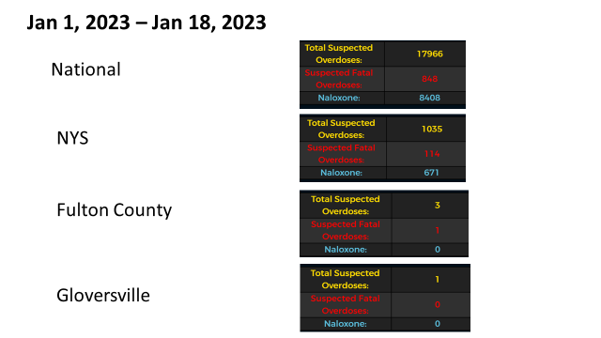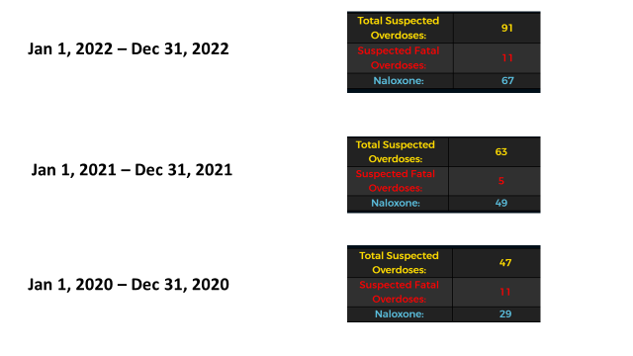 Picnic

