Ageless Grace
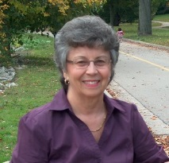
Cindy Knight, RHN,RNCP, ROHP
Registered Nutrition Consulting Practitioner & Ageless Grace Educator.
Ageless Grace Body/Mind Fitness Exercises consists of movement to 1960’s music and are done while sitting comfortably and safely on a chair. The exercises consist of 21 different exercises. Each week we start with Juicy Joints and add another 7 exercises. By week 3 we have done all 21 exercises. This will help you choose those exercises you want to do in your own home for 10 minutes each day.
Our ½ hour work-out emphasizes joint mobility, spinal flexibility, right-left brain co-ordination, bone density, cognitive function, balance, self-esteem, confidence and most of all some fun. They are designed for all ages and abilities and are based on everyday movements that are natural.
Almost anyone can do these exercises regardless of most physical conditions but if you have concerns about whether or not you should do these exercises you should inform your medical practitioner of the sessions. Otherwise you are doing these sessions at your own risk.
Classes will be each week on Wednesday for ½ hour starting at 1:30 Ontario time.

