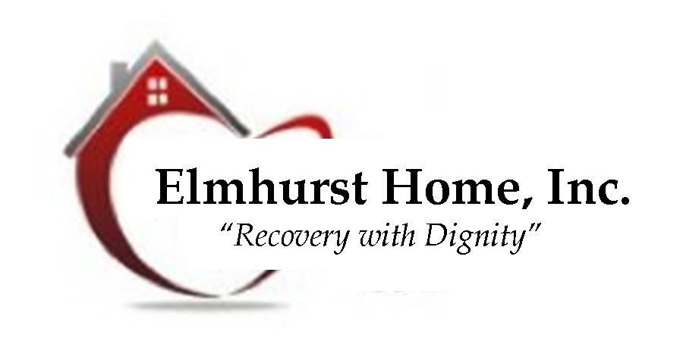

Naomi’s Nest

**(EFFECTIVE AS OF October 7th 2024)**

**Clothing Drop off after initial intake**

**THE MONTH DROP-OFFS WILL BE AS FOLLOWS:**

**(Must Have House Manager’s Approval)**

**What Items:** Hygiene items and clothing

**When:** 1st Wednesday of each Month

**Time: 8:00 am to 4:00 pm**

**Where:** 245 Pitkin, Highland Park, MI 48203

**Telephone:** (313) 865-1500 Ext. 307 (Central Office/House Manager)

**MONDAY – WEDNESDAY DROP-OFFS WILL BE AS FOLLOWS:**

**What Item:** Money, Cigarettes, and Hard Candy Only

**(No Other Drop Offs Will Be Accepted Unless Approved)**

**When:** Monday --- Wednesday

**Time**: **8:00 am to 4:30 pm**

**Where:** 245 Pitkin, Highland Park, MI 48203

**Telephone:** (313) 865-1500 Ext. 301 (Front Desk)