CBT CYCLEBREAKING

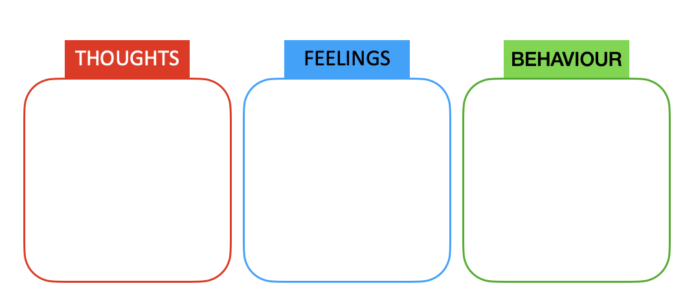

create behaviour

create feelings

THOUGHTS

FEELINGS

reinforces thoughts

BEHAVIOUR

When I feel ……..