**No. 16 Fatima House**

Corner Margaret Spyker Street

9750, Aliwal North

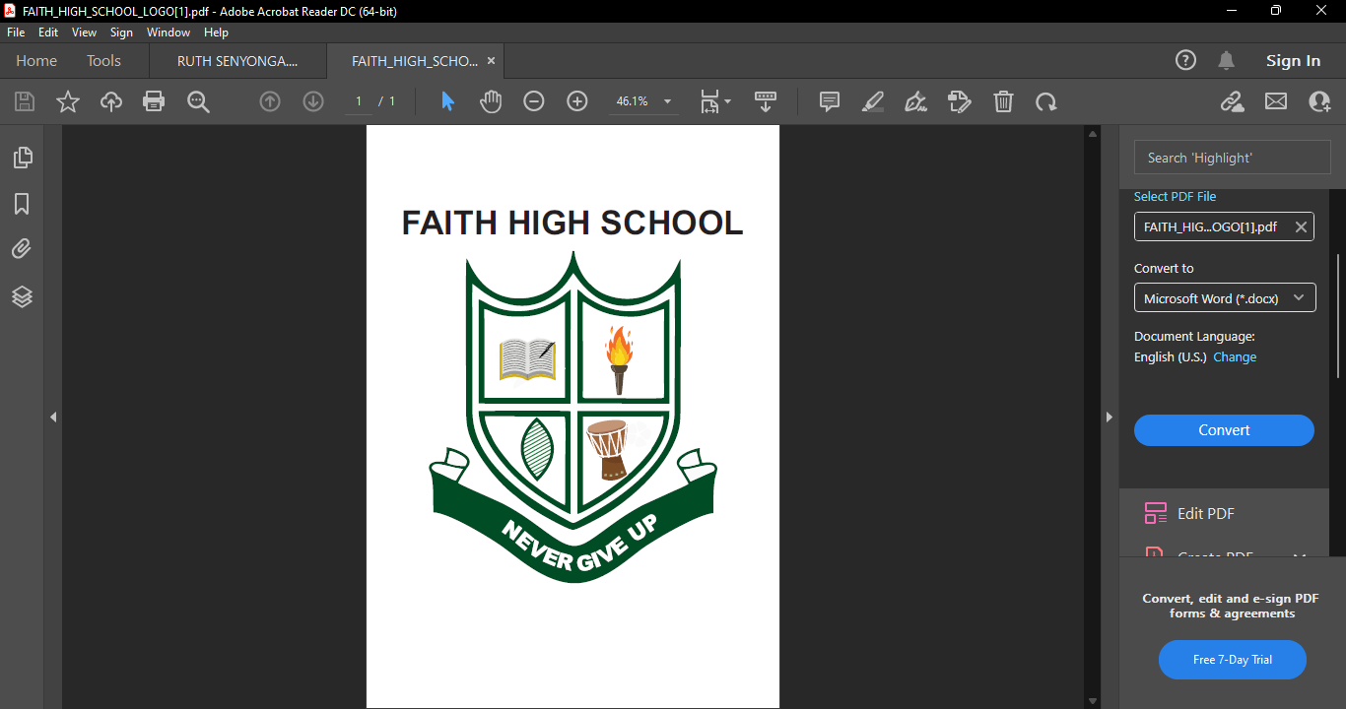

**Contacts**

TEL. 051 633 2733

CELL.0827028974/0634684401

Email: faith4highschool@gmail.com

**FOR OFFICIAL USE ONLY**

**LEARNERS NO: .**.…………………………………….

**DATE OF RECEIPT:** ………………..…………….

**APPLICATION FOR ADMISSION 2026**

**NOTE:** This form must be completed in full. All documents are to be initiated or signed by a parent/guardian.

Filling the form does not necessarily mean that the learner has been accepted.

|  |  |  |  |  |  |  |
| --- | --- | --- | --- | --- | --- | --- |
| **Grade applied for** | **Highest Grade Passed** | | | | **Year when Grade was Passed** | |
| **If SA, indicate Province of Residence**  **Country of Residence:**  **Race:**  **Date of Birth: YYY MM DD**  **First Name:**  **Surname:** | | | **Initials:**  **Nick Name:**  **Other Names:**  **Gender: Male: Female**  **Identification/Passport No.**  **Citizenship:** | | | |
| **Learner Email Address:**  **Code:**  **Learner Telephone:**  **City/Suburb:**  **Physical Address:**  **Emergency Telephone:**  **Home Telephone:** | | | | | | |
| **Home Language: Preferred Language of Communication:** | | | | | | |
| **Boader:** | | **Yes** | | | | **No** |
| **Deceased Parent: Mother Father Both** | | | | | | |
| **Religion:** | | | | **Mode of Transport:** | | |
| **Previously School Information:**  **Name of Previous School:**  **Code:**  **School Address:**  **Country:**  **Province:** | | | | | | |
| **Learners Medical Information:** | | | | | | |
| **Reg. Social Grant: Yes No**  **Rec. Social Grant: Yes No**  **Dexterity of a Learner: Righthanded Lefthanded Ambidextrous**  **Medical Condition**  **Special Problems Requiring Counselling**  **Doctor’s Address:**  **Doctor’s Telephone No.**  **Medical Aid Main Member:**  **Doctor’s Name.**  **Medica Aid No.**  **Medica Aid Name:** | | | | | | |
| **Parents/Guardian Information:** | | | | | | |
| **Title: Mr./Mrs./Ms./Miss/Dr./Prof.**  **Surname:**  **Initials:**  **Other Name(s):**  **Country of Origin**  **First Name:**  **Date of Birth: YYY MM DD**  **Home Tel:**  **Identification/Passport No.**  **Suburb: Town: Code:**  **Physical Address:**  **Email:**  **Parent’s Cell No.** | | | | | | |

**CERTIFICATE OF CONDUCT**

**[This section should be completed by the Principal of the School where the learner is currently enrolled]**

**Name of Learner: ………………………………………………………………………………………………………………**

**Current Grade: ……………………………………………………………………………………………………………..**

**Name of School: ………………………………………………………………………………………………………………**

**School Address: ………………………………………………………………………………………………………………**

**This is to certify that the Learner named above is/was enrolled at this school from**

**…………………………………………………………….. to ………………………………………………………….**

**Briefly Comment about the Learner’s Conduct:**

**………………………………………………………………………………………………………………………………………………………….…………………………………………………………………………………………………………………………………………………………….………………………………………………………………………**

**Fees Payment Record:**

**………………………………………………………………………………………………………………………………………………………………………………………………………………………………………………………………………………………………………………………………………………………………………………………………**

**Principal’s full Name: ………………………………………………………………………………………………………………**

**Signature: …………………………………………………………………. School Stamp**

**Date: …………………………………………………………………..**

**Note:** The deadline for admissions for 2026 is **30th September 2025**

**REQUIREMENTS:**

1. Transfer letter from the previous school
2. Certified copy of Learner’s Birth Certificate
3. Students recent ID Photo should be attached on Application form.
4. Certified copy of Parent/Guardian’s ID
5. Certificate of Conduct filled from the previous school.
6. Current Learner’s Report for the year 2024 and Term 4 report 2023
7. Please make sure you sign all the relevant pages.

**Declaration by Parent/Guardian**

I hereby declare that to the best of my knowledge, the above information as supplied is accurate and correct.

Name of Parent/Guardian (Please Print): ……………………………………………………………………………………..

Signature of Parent/Guardian: ………………………………………….. Date: …………………................................