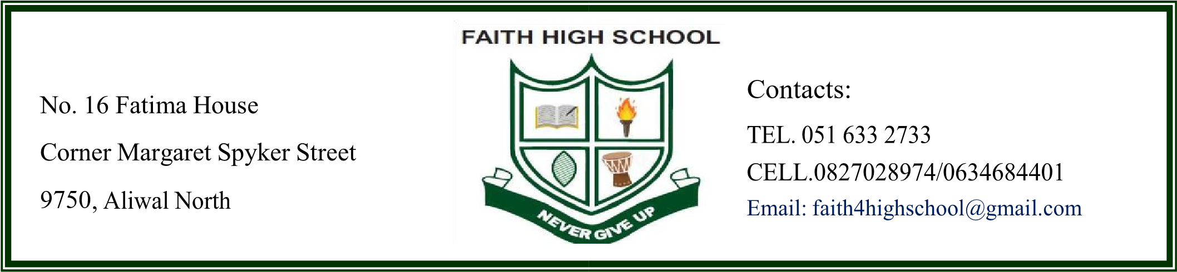
SCHOOL FEES STRUCTURE
ITEM | TERMLY | ANNUALLY
Admission & Registration Fees |  | R850 (Once off)
Maintenance Fee |  | R200 (Once Off)
Grade 8 textbook fee  - Second hand  - New textbooks (Afrikaans FAL)  - New textbooks (Isixhosa FAL) |  | R1648.20  R2664.55  R2564.25
Tuition Fees GR 8 | R4,500 (PER TERM) | R18,000
Hostel Fees Only GR 8 | R5,500 (PER TERM) | R22,000

Note: A 10% discount will be applied if the school fees for the entire year are paid in full at once before the end of term 1.

PAYMENT METHOD:
OPTION 1; Each term’s fees are paid in advance on or before the first day of each term.
OPTION 2; The entire year’s fees are paid in advance on or before the first day of the first term.
BANK DETAILS
BANK: FNB
TYPE: BUSINESS ACCOUNT
ACCOUNT NAME: FAITH HIGH SCHOOL
ACCOUNT NUMBER: 63030452667
CODE: 250655

Note: Kindly make payment using the above account number and send/bring your proof of payment to get the Acceptance Letter.
THANK YOU FOR PARTNERING WITH FAITH HIGH SCHOOL
NEVER GIVE UP

