Administrative Disqualifying Hearings
Introduction:
Kandi Griffith – Welfare Fraud Specialist, San Joaquin County
I have been with San Joaquin County since January 1989. My first position was as a receptionist in the intake applications lobby for Human Services. I then went on to work as a dispatcher for the San Joaquin County Sheriffs, followed by a three year position for the San Joaquin County Treasurer/Tax Collector. In November 1998, I was hired as an Eligibility Worker where I worked in the intake division for 13 years. In 2011, I was hired as a Welfare Fraud Investigator in a non-sworn position, now classified as Welfare Fraud Specialist. In 2016, while attending a CWFIA Roundtable meeting in Monterey County, I gained information on the processing of Administrative Disqualification Hearings. Upon return from that Roundtable, I presented a solution to the Deputy Director for processing the backlog of ADH cases and was given the greenlight to try a pilot program for one year. That first year, I obtained 98 signed ADH waivers and collected over $250,000.00 in over-issuances and over-payments. After that, I was given the green light to continue the program. San Joaquin County currently processes more Administrative Disqualification Hearings than any other county in California. We currently hold 20 - 30 Administrative Disqualification Hearings per month with an excellent success rate. In addition to processing and presenting Administrative Disqualification Hearings, My division, currently 3 of us, investigate all of the early fraud complaints and in person employer verifications. In my spare time, I compete in the sport of Combined Driving with my horses Kara and Jackson. I am usually cheered on by her husband Jim and remotely by her son Wyatt, who is stationed in Hawaii with the US Navy.
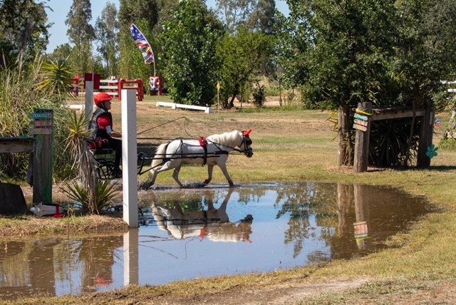
Administrative Disqualification Hearing Process
- Prior to cases being referred to either Prosecution or ADH.

- Benefit Recovery Unit (BRU) gathers the supporting documentation of the OP/OI. Checks for all signed forms, SAWS 2 PLUS, SAR7, SAWS 2A SAR, Case Journal.
- Threshold Determination for ADH or Prosecution (Determined by your County)
Our county, Over $5,000.00 to DA for Prosecution or over $1,000.00 with prior IPV
Is it SB360 compliant? Yes – to DA. No - ADH
- Sufficient evidence to determine intent
More than one failure to report.
Over IRT, then not reported at recertification or on SAR7.

- Prior to Writing the Position Statement

- Review case for ADH requirements.
- Review all documents in OP/OI period. (I check 1-2 years prior as well)
- Respondent must have signed all necessary documents.
- IEVS and New Hire reports must now have been ignored by EW.
- Case record must show clear intent.
- County did not possess information that could have avoided OP/OI
- No report by respondent to WTW etc.
- Review case journals. Was it reported by phone?
- NOA’s informing of the OP/OI must have actually been sent.
- Respondent must have demonstrated knowledge of reporting.
- Forms and NOA’s must be in the respondents reported primary language.
- Verify the known address/telephone # on file for the Respondent (since 2020, all ADH have been heard by telephone)
- Currently on aid, or case closed within last 6 months.
- Address verified by USPS.
- Phone number verified.
- Call number on file to verify
- Journal in collection notes of recent phone contact.
- Attempt to contact the Respondent to review the collector file and cause of the OP/OI.
- 1st letter, 2nd letter.

- Writing the Position Statement

- After 90 days from mailing of RA NOA’s, write the Statement of Position (SOP - DPA 435).
- Prepare a separate allegation packet for each person.
- Husband/Wife. Both must have signed all forms.
- Unmarried couple (More on losses here later!)
- Unreported Income Cases – Required Verifications.
- Copy of ID and SS Card provided to county at application.
- Employment verification from employer, WorkNumber, VerifyFast etc. Must have at least last 4 of SS# and name.
- IEVS report or New Hire report. How did county become aware of the income not reported.
- SAWS 2A SAR – Rights and Responsibilities signature page signed by the respondent prior to OP/OI timeframe.
- SAR7 failing to report income.
- SOF – SAWS 2 PLUS, CF 37, CF 285 failing to report income.
- Any prior SAR7’s or SOF showing client reported income in the past.
- EW journal narratives.
- Mail DPA435, DPA 479 (waiver) and DPA436b (county information letter) to respondent.
- Wait 20 days, if no waiver received, upload SOP to CDSS.
- Upload DPA 436b, DPA 479, DPA 435 and numbered evidence.
- Case scheduled and hearing number assigned.
- CDSS mails packet of hearing to address at least 30 days prior to the hearing date.
- Respondent signs the ADH Waiver, DPA 479
- CalWORKs - The respondent has 7 days to withdraw the Waiver and request a Hearing.
- The Notice of Administrative Disqualification should be issued within 45 days of the 7th day following the date the Waiver was signed. (based on DCA per MPP 20-354.3)
- References: MPP 22-320.321
- When the individual waives his or her right to appear at a disqualification hearing, the period of disqualification shall begin no later than the first day of the second month which follows the date of notice. (If on aid)
- References: 45 CFR 235.113(c)(3) & MPP 22-320.41
- CalFresh - The respondent has 7 days to withdraw the Waiver and request a Hearing.
- The Notice of Administrative Disqualification should be issued within 45 days of the 7th day following the date the Waiver was signed. (based on DCA per MPP 20-300.43)
- References: MPP 22-202.4
- The period of disqualification shall begin with the first month which follows the date the household member receives written notification of the disqualification.
- References: 7 CFR 273.16 (f)(2)(i) & MPP 20-300.41, and .411
- The Hearing

- Beginning 2020, due to COVID pandemic, all ADH’s have been scheduled and heard telephonically.
- No later than the day before the hearing, re-verify there has not been a reported change of address or telephone number which would result in a postponement of the hearing.
- Check ACMS (Appeals Case Management System) that the Affidavit of mailing has been signed by the State representative.
- ALJ opens the record.
- Jurisdiction established
- SOP presented with or without respondent present.
- Possible issues at the hearing.
- Identity or mistaken identity.
- Someone used the respondents SS# without permission.
- Respondent did not sign SOF or SAR7.
- Insufficient knowledge of reporting requirements.
- Language Barrier.
- New recipient didn’t understand.
- Education or learning disability.

- The Decision
- Dismissed without prejudice.
- No proof of mailing.
- No proof of phone # or address.
- Claim granted.
- The Penalty. CalFresh - Disqualification penalties vary from 12 months to permanent depending on the type of violation. CalWORKs - Disqualification penalties vary from 6 months to permanent depending on the type of violation.
- Denied.
- See possible issues.

