Fraud 102:

Understanding IEVS Matches
& Overpayments

Introduction

This workshop provides an overview of the Income Eligibility Verification System (IEVS). It will cover the required processing timeframes and will also examine the Overpayment and Over Issuance processes and computation methodology.

Investigators will learn the history, origin, frequency, and data that is received on each of the IEVS Matches. They will learn the processing requirements of the IEVS matches, and how the information impacts eligibility.

Lastly, Investigators will have an understanding of how overpayments are computed in accordance with the program rules.

Income and Eligibility Verification Systems (IEVS)

In July 1987, the California Department of Health Services, which is now the Department of Health Care Services (DHCS), and the California Department of Social Services (CDSS) implemented the Income and Eligibility Verification System (IEVS).

The Income and Eligibility Verification System (IEVS) is system mandated by federal and state law that is utilized for the purposes of verifying eligibility and benefit amounts for CalWORKs, Refugee/Entrant Cash Assistance, CalFresh (including California Food Assistance Program), and Medi-Cal programs.

IEVS matches applicant name, date of birth, and Social Security Number (SSN) with state welfare files, wage and unemployment/disability benefit files, interest and dividend information from State Franchise Tax Board (FTB) files and Social Security Administration (SSA).

There are two components to IEVS.
- Applicant
- Recipient

Applicant IEVS

When an applicant applies for CalWORKS, CalFresh, or Medical, the county submits identifying information (name, SSN, etc..) to DHS via the MEDS system. The applicant information is cross matched with the MEDS file and IEVS Applicant file and with the various income and benefit sources. When all the information is received, the abstract data is sent through the consortia to the county within 3 to 4 working days. This information is used during the eligibility determination process to verify the accuracy of income, assets, and eligibility information provided by the client.

Processing Time Frame

Applicant IEVS abstracts must be processed no later than 30 days for CalWORKs applications and 45 days for the CalFresh and Medi-Cal programs from the date the IEVS abstract is generated, which is identified as the “report date”, or prior to allowance of assistance if abstracts are received prior to issuance of benefits, whichever is earlier.

Recipient IEVS

Recipient IEVS provides income and eligibility information at various times of the year, depending on the match. An abstract is generated on an individual when there is information in excess of the tolerance level for that individual. The tolerance level and/or thresholds for some matches are used to ensure that only information is sent to counties which, if unreported, could be expected to impact eligibility or benefit amount.

This is a list of the matches with a description and frequency of the runs.

Processing Time Frame
Recipient IEVS matches are required to be processed within 45 days of receipt, an OP/OI must be established by the end of the quarter after the match was received.

Integrated Fraud Detection (IFD 440) | Quarterly

Wage Match
The wage match contains earnings that were reported to the EDD from employers and this information is 9-12 months old. A request for verification must be sent to the client to determine if the earnings continue, the amount paid, and the frequency of payments.

Duplicate Aid
This match finds two or more records containing the same identifiers. This information is 7-9 months old.

SSI/SSP Match
This match compares information with the Social Security Administration and will identify individuals receiving CalWORKs/CalFresh benefits and SSI/SSP benefits.

Internal Revenue Service (IRS) Asset Match | Annually
Provides information on unearned income (e.g. interest or dividends) reported to the Internal Revenue Service and other income information not on the Franchise Tax Board’s file. This report will provide information on Pensions, Lottery winnings, interest on bank accounts, and retirement accounts (401k). Pensions and Lottery winnings are acted on to determine if current eligibility will be affected and if there are Over payments and Overissuances to be calculated. Interest on bank accounts, stocks, bonds, retirement accounts are generally exempt.

Beneficiary Earning Exchange Record (BEER) | Monthly
Provides wage information that includes out-of-state wages, self-employment, and wages not previously reported to EDD. Wages that do not appear on the IFD440 will appear on the BEER Report, such as Self-Employed Earnings, and Federal and out of state earnings.

Fleeing Felon Match (FFM | Monthly
The Department of Justice provides CDSS with a computer file of all felony warrants from the Wanted Person’s System.
For the CalFresh Program (ACL 15-82) the warrant must have one of the 3 NCIC codes:
- Escape (4901
- Flight to Avoid (prosecution, confinement, ect) (4902)
- Flight-Escape (4999)
The individual are not eligible for CalWORKs.

California Youth Authority (CYA) Match | Monthly
The CYA provides CDSS with a file of minors incarcerated in a juvenile hall or other county juvenile facility.

Nationwide Prisoner Match (NPM) | Monthly
The CDSS matches records against the Social Security Administration’s Prisoner Update Program System(PUPS), which contains data from other states’ jails and prisons when an individual is incarcerated in federal, state and local correctional, penal, or other detention facilities.

Deceased Persons Match (DPM) | Semi-Annually
The DPM obtains information from SSA on deceased individuals and uses the information to verify and otherwise ensure that food stamps and CalWORKs benefits are not issued to individuals who are using the SSNs of a deceased person.

Payment Verification System (PVS) | Monthly
SSA provides information on Retirement, Survivors and Disability Insurance. EDD provides information on State Unemployment Insurance, and State Disability Insurance benefits. This match also provides information from the SSA BENDEX file of recipients reported as being on aid in two or more states at the same time.

New Hire Registry Match (NHR) | Monthly
Provides counties with information on welfare recipients who were recently hired, rehired, or returned to work.

IEVS Processing Timeframes
ACL 17-41

Initial 45-Day Processing of IEVS Match
Potential discrepancies are considered “Discovered” or “Identified” on the run date, or date of receipt. The IEVS Match follow-up must be completed within 45 calendar days of receipt. Further rules state that the match is considered “Initiated or Pursued” when the county has reviewed the match and determined whether it may affect eligibility or benefit level. If there is no discrepancy, or a discrepancy has been identified and at a minimum, the client has been mailed a client verification letter. The 45-day processing does not apply to the Criminal Matches.

Completion of IEVS Match Processing
For open cases, the IEVS match is considered “Complete” when the county has either established the OP/OI by the quarter after the quarter in which the discrepancy was “Discovered/Identified” or determined there was no discrepancy.

Criminal Prosecution of Intentional Program Violation Time Frames
ACL 18-22 (SB 360)

This ACL affects IEVS matches received on or after January 1,2018. It excludes from criminal prosecution the portion of the OP/OI that includes the period of time when the CWD did not process the IEVS information timely.

It specifically stipulates that a person shall not be subject to criminal prosecution for an OP/OI for any month in which the CWD was in receipt of any IEVS data match information indicating any potential for an OP/OI when:

- The CWD has not processed the IEVS data match timely: and/or
- Has not provided a timely and adequate notice of action for the collection of the OP/OI.

SB 360 prohibits criminal prosecution for the portion of the OP/OI which accrued due to untimely processing of IEVS and/or inadequate notice. This includes subsequent IEVS data matches showing the same unreported income. The criminal prosecution timeframes will apply to the first IEVS data match received in the CWD.

See Examples:

Overpayments and Overissuances

The computation of an OP/OI is based on that individuals reporting requirements. This impacts when the OP/OI will start. The computation is based on the Mandatory Reporting requirements the client falls under. There are 3 different reporting requirements within the CW/CF programs:

Semi Annual Reporting (SAR)
Clients are assigned to a SAR cycle are based on the beginning date of aid.
- Cases will be assigned to one of the six SAR cycles.
- Each cycle consists of two Payment Periods.
- In each SAR period, there is
  - Data/Report Month
  - Submit Month
  - Payment Period

Mandatory Mid Period Report Requirements

CalWORKs
Clients are mandated to report certain changes within 10 days of the date the change becomes known to them. These changes are:
- Income exceeds their IRT
- Drug Felony Convictions
- Fleeing Felon Status
- Parole/Probation Violations
- Address Changes

CalFresh
- Income exceeds their IRT

Annual Reporting for a Child Only (AR/CO)
An ARCO case is a case that has no eligible adult. These are child only cases that are only required to complete their annual renewal. Since there is no periodic report requirement, the Mid period reporting requirements have 1 additional requirement:

Mandatory Mid Period Report Requirements
AR/CO
Clients are mandated to report certain changes within 10 days of the date the change becomes known to them. These changes are:
- Income exceeds their IRT
- Drug Felony Convictions
- Fleeing Felon Status
- Parole/Probation Violations
- Changes in Household Composition
- Address Changes

*The IRT levels differ between the CalWORKs and CalFresh Programs.

CalWORKs
The CalWORKs IRT amount for each Assistance Unit (AU) is the lesser of A or B below.

- Tier 1: $953 (55% of the Federal Poverty Level (FPL) for a family of three, plus the amount of income last used to calculate the recipient’s monthly benefits or;
- Tier 2: The amount of income likely to render the AU of that size ineligible, as shown in the charts below.
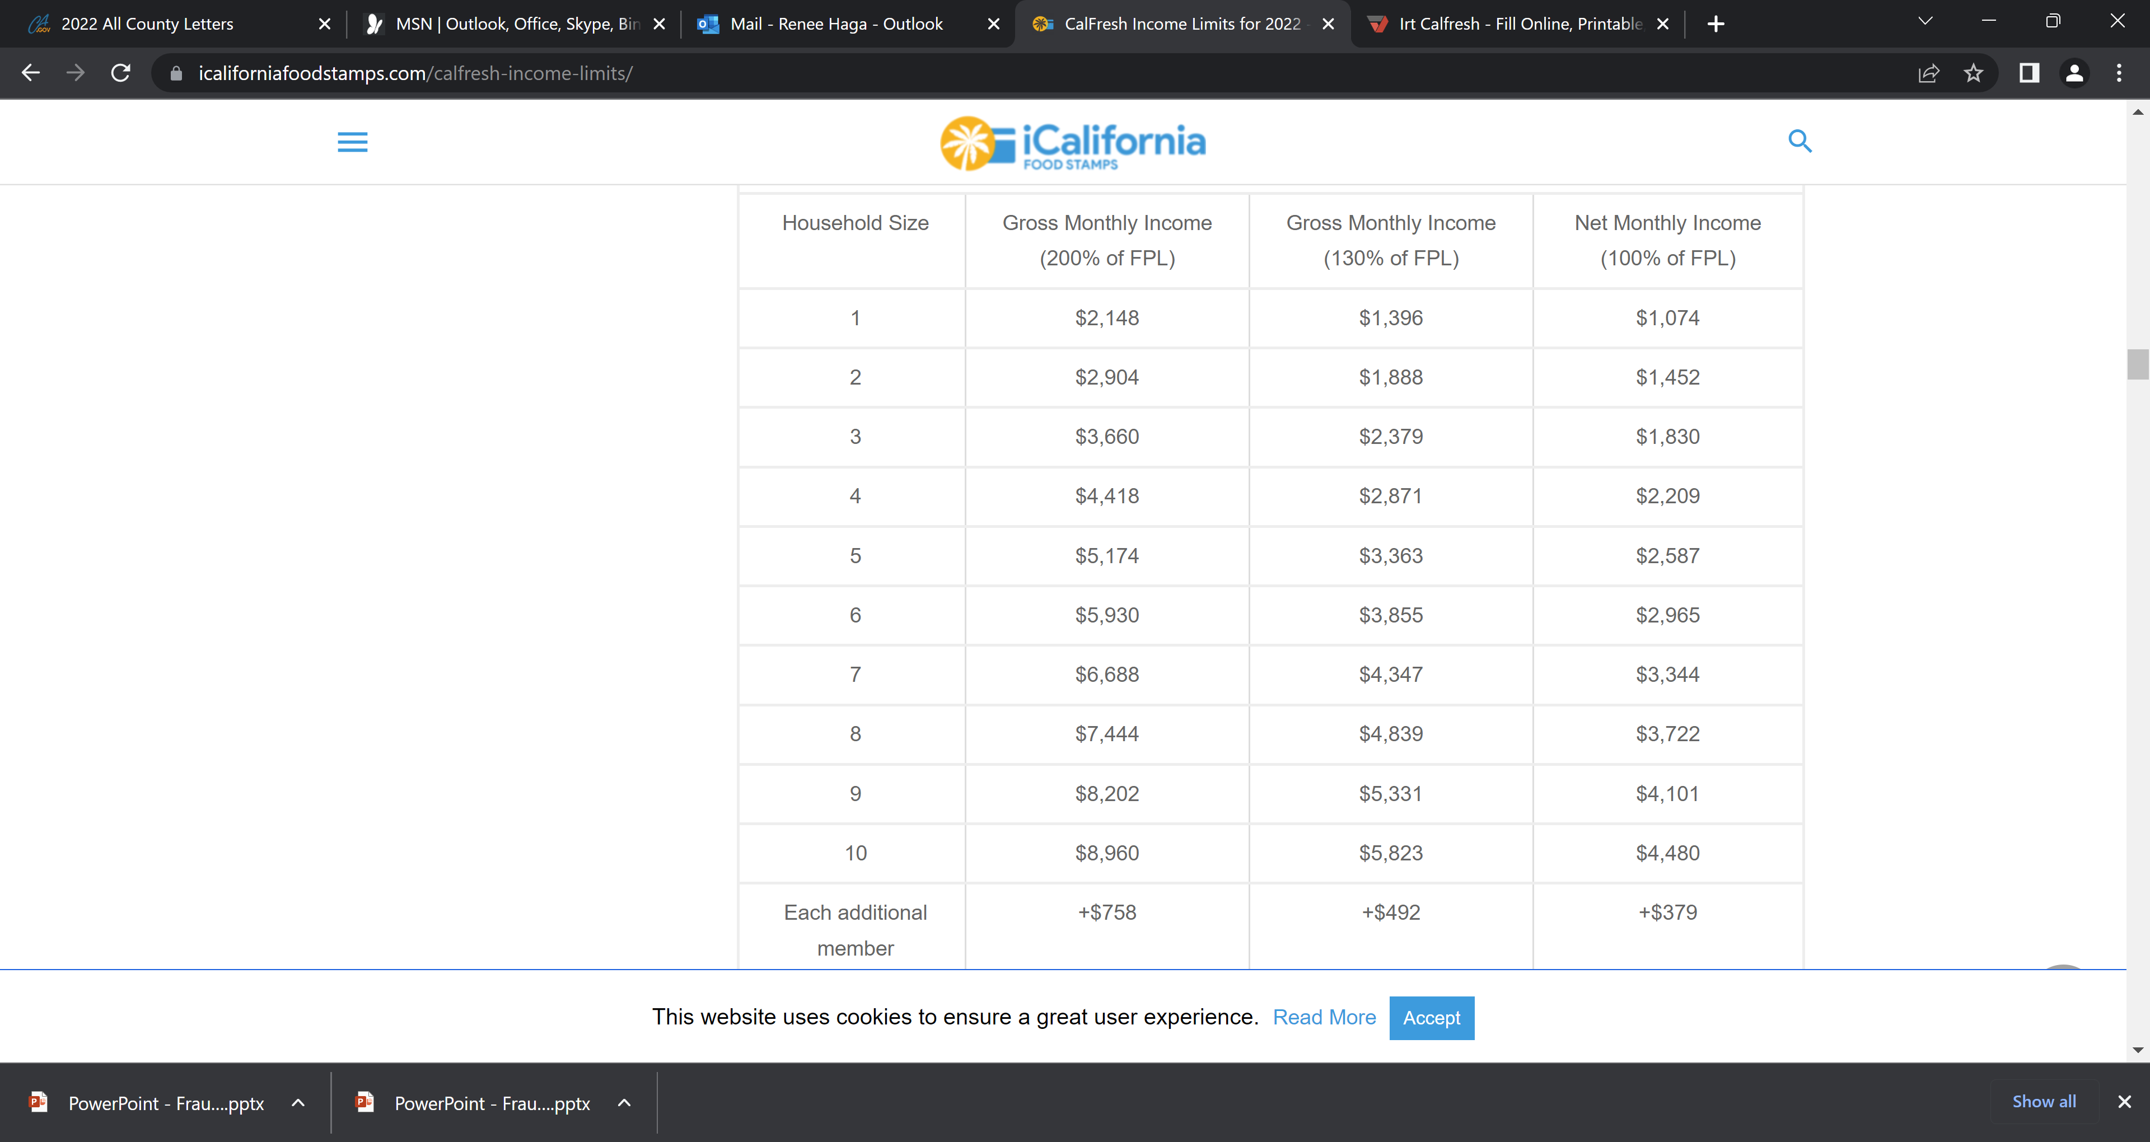

CalFresh
The CF IRT amount is based off the number of people in the House Hold.

In a CalWORKS/PA CalFresh Household, the OP/OI will start when the household exceeds the CalWORKs IRT.

Start dates
The CalWORKs program does not require 10-day notice when a client fails to report exceeding the IRT to establish an OP, whereas the CalFresh Program does when establishing an OI. Therefore, you will see the different OP/OI start dates.

Self Employed Earnings

Budgeting Methodology
ACL 15-95

ACL 15-95 was issued to implement a policy change in the way that OP’s and OI’s were calculated under the SAR and AR/CO reporting systems in CalWORKs and CalFresh. Previously, the computation was based on what income the client was required to report, not taking into consideration any decrease in income. With the longer reporting periods, this caused higher amounts of OP/OI’s. The change required the CWD to take the changes in income into account to more accurately recreate case circumstances.

Need budget examples to show consistent/inconsistent OP/OI
Self Employed income
Examples:

Computing & Establishing Claims & Notification

CalFresh
ACL 18-99
The CWD will only collect in an Over Issuance up to three years prior to the date of discovery, the same timeframe that determines when an OI claim can be established.

CalWORKs
There are no time limits on computing Over Payments for the CalWORKs program

Liable Individuals
The Liable Individual, or, the person or persons that are responsible for the debt differ by program. EAS 44-352.2
CalWORKs:
A member of the AU as an adult or emancipated minor at the time an OP occurred. In a two parent AU, both parents are responsible parties
CalFresh:
All adults over the age of 18, and Sponsors at the time of the OI are responsible parties.

