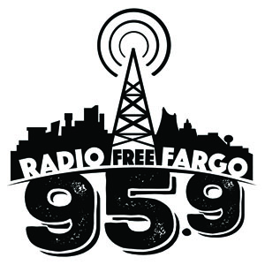

Radio Free Fargo, LLC
Your Community Alternative Radio Station
KRFF-LP 95.9 FM

P.O. Box 1899
Fargo, ND
58107
Underwriting Order Form124 N 8th St

Business/Entity/Event Name: _______________________________________________________________

Contact: ________________________

Address: _______________________________________________________________

City, State and Zip: _________________________________________________

Phone: (______) ___________________ E-Mail: ___________________________________

Website: _______________________________________________________________

Slogan: _______________________________________________________________

Yes / No - please indicate your permission to use your business/entity/event name to be posted on our website as an
Underwriting supporter of KRFF/Community Radio.

Please provide any additional information client wants included in this Underwriting announcement:

Choose ONE underwriting package below. Each package runs for 30 days or until completed

[___] $100 package consisting of 60 LIVE mentions for 1 month $1.66 per spot/underwriting message

[___] $250 package consisting of 60 LIVE mentions + :15 recorded message for $1.42 per underwriting message

[___] $500 package consisting of 120 LIVE mentions + :30 recorded message in automation $1.19 per underwriting message

Billing Info: (Choose ONE billing option and remit payment)

[___] Check Enclosed [___] Bill via Net 30

[___] Monthly [__] Quarterly [__] Annually

[___] Credit Card #_______________________________

Name on CC_______________________________________ Exp. Date ____/____ CCV:________

Please sign & date below

Signature: _______________________________ Date: ________________

Radio Free Fargo is IRS approved 501(c)(3) – EID number available upon request. Version: 08 Nov 2018

