***Thank you for choosing the Balliol Hall***

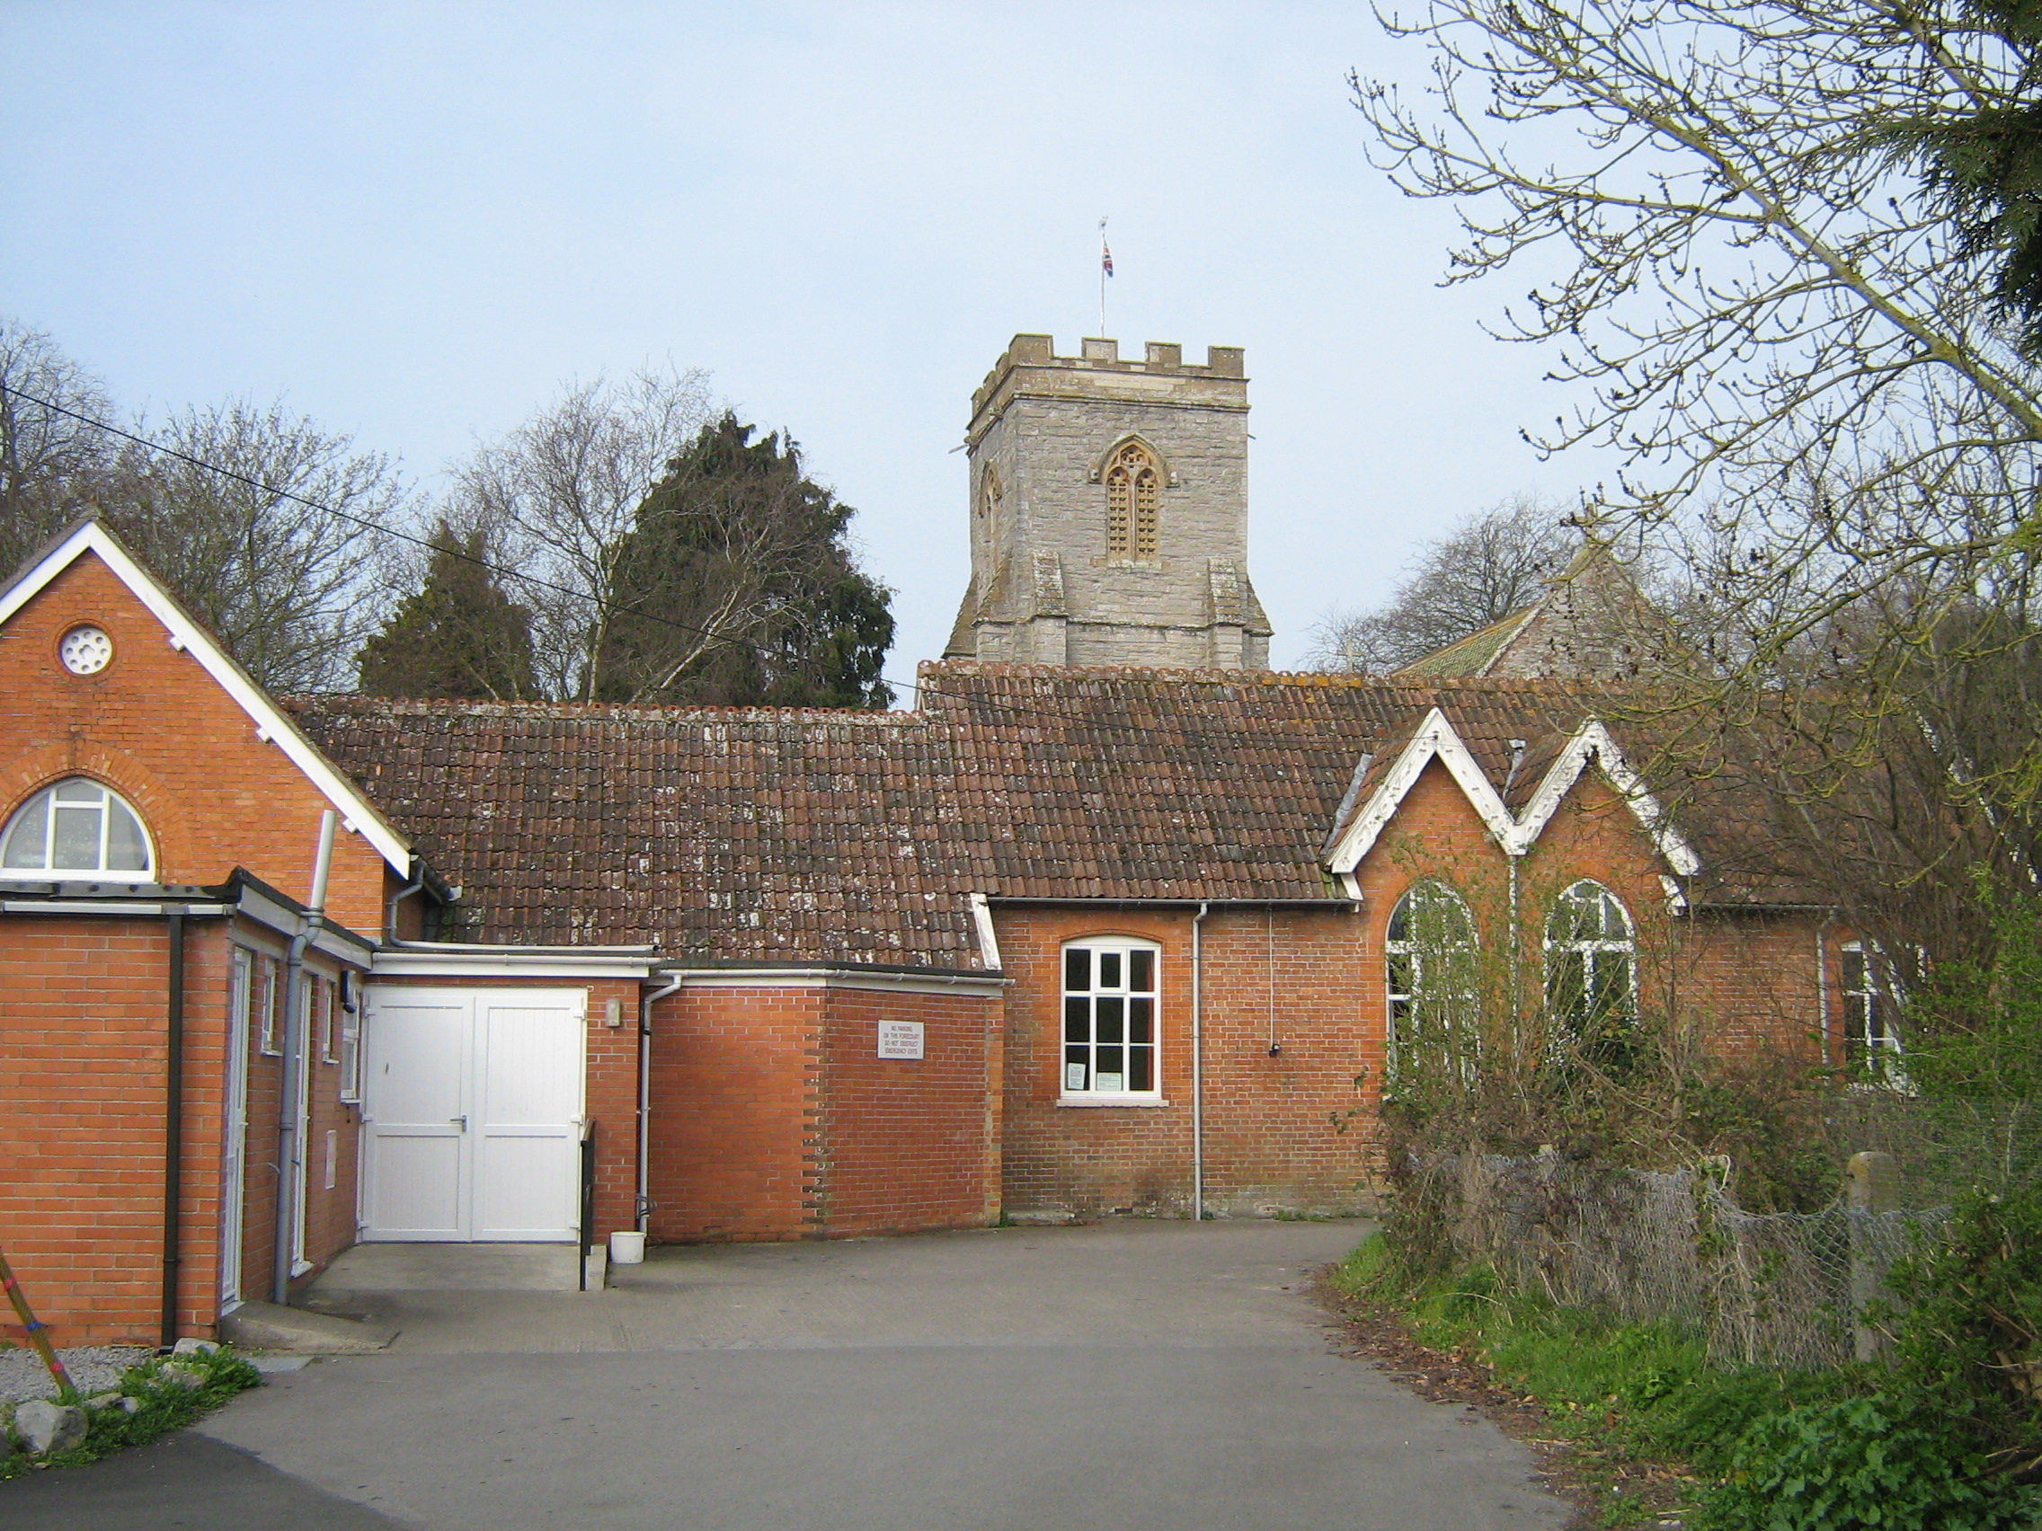

**Here is some information you may find helpful when using the hall.**

**Full address: The Balliol Hall, Church Road, West Huntspill, TA9 3RN**

**MAP REFERENCE ST305455**

**WEBSITE:** [**www.theballiolhall.moonfruit.com**](http://www.theballiolhall.moonfruit.com/)

**Booking Secretary – Phill Perryman (Tel: 07518 192580)**

**e-mail: theballiolhall@gmx.co.uk**

**Key arrangements.**

Unless otherwise arranged, please collect and return the Hall key to the Booking Secretary. The key must be returned **immediately** at the end of your session, together with any unused electricity tokens.

**Session Hours**

The session times are:

**Morning: – 09:15 - 13:30**

**Afternoon****: – 13:30 – 18:30**

**Evening: – 18:30 – 23:45 (Sundays 22:30)**

All functions must cease by the end of the session time booked, having allowed time to clear away.

Please remember that there may be another booking immediately after yours.

**Equipment and Furniture**

Extra tables and chairs may be found in the store room accessible from the Main Hall. School Room hirers please consult the Booking Secretary to ensure that you have all your requirements prior to the start of your booking.

At the end of the hire period please return all items to the usual place of store in a clean and tidy manner.

School Room chairs remain in the School Room.

Main Hall Chairs – please ensure that chairs without arms are stacked in the store room and chairs with arms are left around the edge of Hall.

**Electricity Tokens**

Electricity tokens are required for **heating** in both Halls and for use of the **kitchen appliances**. These are available from the Booking Secretary and can be obtained when collecting the key.

The tokens cost £2.50 each and power the heating for one hour and the kitchen appliances for up to 5 hours, depending on usage.

The meter boxes are situated as follows:

**Main Hall:** near the main hall thermostat.

**School Room:** near the thermostat and fire exit.

**Kitchen:** in the kitchen wall cupboard above the counter / dishwasher and next to the enclosed water tank.

**In an emergency you may need to know the following:-**

**Water:** The stop cock is located in the floor cupboard between the sink & cooker.

**Electricity:**  **Main Switches**

**Main Hall.** In the wall cupboard in the stage area near the exit door.

**School Room & Kitchen.** In the wall cupboard near the School Room entrance door.

**The First Aid Box** is located in the kitchen near the main hatch

**Fire Precautions**

Please familiarise yourself with the location of fire extinguishers and fire escape routes. At no time must doors or escape routes be blocked by furniture or equipment.

You are advised at the start of your hire session to inform your guests of the action to take in the case of fire.

**In case of fire...**

Everyone must leave the building by either the main doors or the emergency exits and assemble on the Church lawns, near the War Memorial well away from the Hall. Do not stop to collect belongings.

**Call the fire service 999.**

For fire & safety reasons please note that neither fireworks nor candles are permitted in the Hall, except for birthday cake candles and candles for religious occasions.

**Kitchen**

The Kitchen is a shared facility between the two rooms. Should there be a function in both rooms, please show consideration for the other users.

The kitchen is well equipped with crockery with place settings for over 100 persons, including tumblers and water jugs, and 6 dozen sets of cutlery. Kitchen utensils include oven proof dishes, baking trays, bowls, china and polythene jugs and of course teapots!

Tea Towels are not supplied.

The following appliances are available for use:

Refrigerator, dishwasher, microwave oven, catering boiler giving a constant supply of boiling water for hot drinks and a rangemaster cooker with main oven, side oven and 5 rings.

Tokens, available from the Booking Secretary, will be needed for the kitchen appliances.

Please remember to switch off all the appliances in the kitchen after use.

**Under 18s**

Parties or groups with predominately under 18s present must be supervised.

**Animals & Birds**

With the exception of guide dogs, no animals or birds are permitted within the premises without prior consent of the Hall Committee.

**Licences for the sale of alcohol**

If you wish to sell or supply alcohol, please ask the Booking Secretary about the necessary licence arrangements.

**Decorations**

These may be displayed but must be secured on the PVC strip around the Hall, not on the walls. Please only use ‘Blu-tack‘ as **‘Sellotape‘ must not** be used either inside or outside the building.

**Seating capacity**

In the interest of fire regulations and health and safety, please do not exceed the recommended numbers for seating; dancing; or dancing with seating at tables.

Full details may be obtained from the Booking Secretary.

**Car Parking**

Please park tidily to maximise the capacity of the car park. There is security lighting around the car park.

**At the end of your use of the hall, please:**

1. Return all furniture or equipment to the place of store in a tidy and safe manner.
2. Leave the premises clean and tidy for the next user. Brooms and a mop can be found near the entrance.
3. Close all windows and doors on leaving.
4. Switch off lights and kitchen appliances.
5. **Take all rubbish away.**
6. Lock all outside doors and return key as arranged.

**Damage / Breakages**

It would be helpful if you could report any damage / breakages to the Booking Secretary as soon as possible.

**When leaving the premises at night please consider the nearby homes and leave quietly.**