

WINTERVIEW FARM
2026
HORSE SHOW
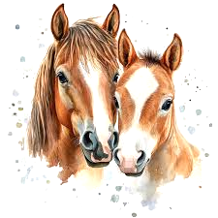
Mothers Day Classic Show
May 9th, 2026

RECOGNIZED BY:
MISSISSIPPI HUNTER JUMPER ASSOCIATION

JUDGE
Jay Moore
USEF “R” H/HE/J
Madison, AL

SHOW MANAGER
Brittany Jones-Short
636-399-3874

COURSE DESIGNER
Meghan Roider-Humphreys
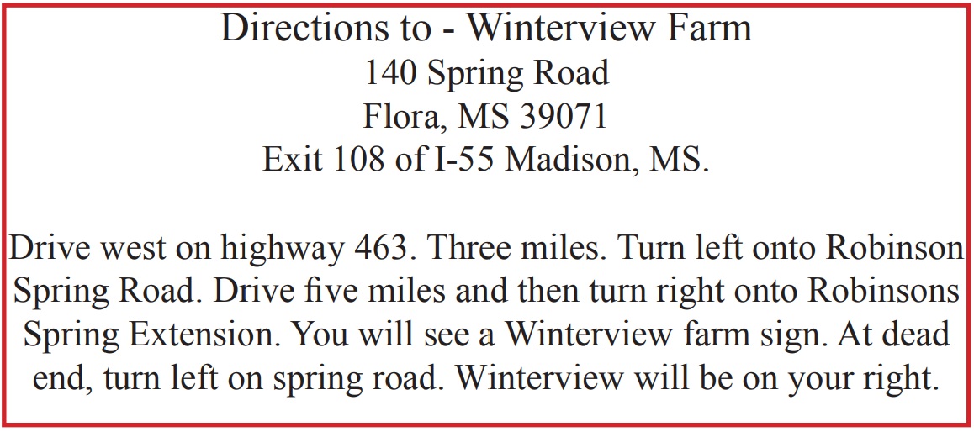
ANNOUNCER
TBA

EMT
April Little

CONCESSIONS
There will be concessions on site! DoorDash also delivers a lot of options to the barn now!

VETERINARIAN
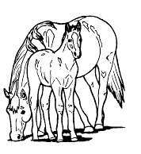
Dixie Equine Medicine and Surgery 601-853-1717

FARRIER
ON CALL

SECRETARY
Jordan Skinner
THANK YOU TO OUR SPONSORS
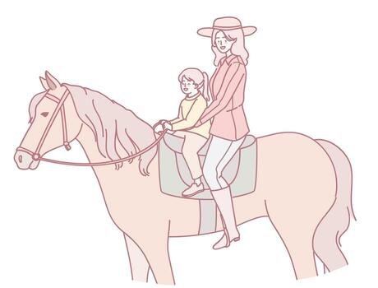
Class Number 53 -$500 I ♥️ Mom Hunter Classic

Description:The first round of the classic will be scored during the second round of over fences. The classic round will be ridden and scored immediately following the qualifying round.

Entry fee- $50

Prize
1st- $150
2nd -$110
3rd - $75
4th-$50
5th -$35
6th -$30
7th -$25
8th -$25
RULES AND REGULATIONS

All MHJA rules will be in effect at this show. A copy of the MHJA rule book will be available at the Show Secretary’s table.

When mounted all riders must wear protective headgear in accordance with current USEF rules- includes show rings and schooling areas.

All dogs must be on a leash.

A valid Negative Coggins must be presented before numbers will be issued.

First through sixth place ribbons will be awarded in each class.

Champion and Reserve Champion will be awarded in each Hunter Division.

PROPER ATTIRE
Boots, Breeches, Polo Shirts, and Helmets

SCHOOLING
No more than 8 horses in the ring at one time. FRIDAY 1:00- 6:00PM
SATURDAY 6:00-7:30AM in small ring
7:00-Noon in big ring
SCHEDULE

SATURDAY
Little Ring 8:00AM Start Time
1,2,3 WALK/TROT
4,5 TROT X
6 TROT X FLAT
7,8,9 WALK/TROT/CANTER
10,11 X TO VERTICAL
12 X TO VERTICAL FLAT
13, 14 RUSTY STIRRUP
15 RUSTY STIRRUP FLAT
16, 17 MINI STIRRUP
18 MINI STIRRUP FLAT
19,20 PRE-SHORT/LONG
21 PRE-SHORT/LONG FLAT
Big Ring to start at the conclusion of Little Ring Showing
67 HUNTER WARM UP (Open All Day)
22,23 SHORT STIRRUP HUNTER
24 SHORT STIRRUP HUNTER U/S
25, 26 LONG STIRRUP HUNTER
27 LONG STIRRUP HUNTER U/S
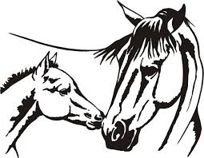
28 SHORT/LONG STIRRUP EQ
29 SHORT/LONG STIRRUP EQ FLAT
30 11 & UNDER EQ
31 11 & UNDER EQ FLAT
32 PONY MEDAL

33,34 PONY HUNTER
35 PONY HUNTERS U/S
36,37 BABY GREEN HUNTER
38 BABY GREEN HUNTERS U/S
39,40 PRE CHILD/ADULT HUNTER
41 PRE CHILD/ADULT HUNTER U/S
42 12-14 EQ
43 12-14 EQ FLAT
44,45 MODIFIED CHILD/ADULT HUNTER
46 MODIFIED CHILD/ADULT HUNTER U/S
47,48 GREEN HUNTER
49 GREEN HUNTER U/S
50,51 CHILD/ADULT HUNTER
52 CHILD/ADULT HUNTER U/S
53 MHJA MEDAL
54 15-17 EQ
55 15-17 EQ FLAT
56,57 JUNIOR/AO HUNTER
58 JUNIOR/AO HUNTER U/S
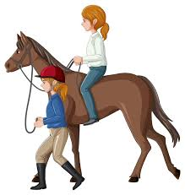
59 $500 I ❤️Mom HUNTER CLASSIC
66 MOTHERS DAY LEADLINE
🌸FREE TO ENTER
🌸Open to Kids leading Moms
and Moms leading Kids!
🌸No experience needed!
60,61,62 PUDDLE JUMPERS .65M
63,64,65 HOPEFUL JUMPERS .75M

MHJA DIVISION SPECIFICATIONS
Fence heights listed below apply to MHJA sponsored horse shows. At a USEF rated show, fences will be set to meet USEF Division specifications

HUNTER DIVISIONS Points towards annual awards will be given in the following sections:

SHORT STIRRUP HUNTER: Open to horses and ponies ridden by riders twelve (12) years and under. A rider may not compete at the same show in any class where fences exceed 2’3”. Fences 18”-2’
LONG STIRRUP HUNTER: Open to horses and ponies ridden by riders over twelve (12) years of age. A rider may not compete at the same show in any class where fences exceed 2’3”. Fences 18”- 2’
MHJA PONY HUNTER: Open to ponies ridden by junior riders. USEF age rules apply. MHJA Pony Hunter will be held in three sections according to pony size. Sections with less than three ponies will be combined. Pony riders who compete in Children’s Hunter Pony, Green Pony Hunter or Regular Pony Hunter classes at affiliated shows will receive points in the appropriate MHJA Pony Hunter height section. Fences 2’ for small/medium ponies and 2’6” for large ponies
PRE-CHILDREN’S HUNTER: Open to any junior rider on a horse or pony. A rider may not compete at the same show in any class where fences exceed 2’9”. Fences 2’6”
PRE-ADULT HUNTER: Open to any adult amateur rider on a horse or pony. A rider may not compete at the same show in any class where fences exceed 2’9”.
Fences 2’6”
MODIFIED CHILDRENS HUNTERS: Open to any junior on a horse or pony. A rider may not compete at the same show in any class where fences exceed 3’.
Fences 2’9”
MODIFIED ADULT HUNTER: Open to any adult amateur on a horse or a pony. A rider may not compete at the same show in any class where fences exceed 3’. Fences 2’9”
BABY GREEN HUNTER: Open to horses and ponies in their FIRST or SECOND year of showing. Open to horses which have not shown 3’ or higher. Fences 2’6”
2’6” OPEN HUNTER: Open to all horses and riders. Specs for USHJA 2’3” and 2’6” divisions apply. Fences 2’6”.
3’ & 3’3” GREEN HUNTER: A Green hunter has two competition years of eligibility once it competes at 3’. Fences 3’ and 3’3 as entered
3’6” GREEN HUNTER: Horses are eligible in their FIRST or SECOND year of jumping 3’6” or higher. Fences 3’6”
PERFORMANCE HUNTER: 3’ & 3’6” Open to all horses and riders. Fences 3’ and 3’6” as entered. CHILDREN’S HUNTER: Open to horses and ponies ridden by a junior rider. Horse/Rider may not cross enter in classes exceeding 3’3”. Fences 3’.
ADULT AMATEUR HUNTER: Open to horses and ponies ridden by an amateur rider. Horse/Rider may not cross enter in classes exceeding 3’3”. Fences 3’.
JUNIOR HUNTER: Open to horses ridden by a junior. Junior Hunter 3’ and 3’6” will be combined for year-end awards. Fences 3’3” or 3’6”.
AMATEUR OWNER HUNTER: Open to horses ridden by an amateur rider. The horse must be owned by the rider or a member of the rider’s family. AO Hunter 3’3” and 3’6” will be combined for year end awards.
Fences 3’3” or 3’6”

EQUITATION DIVISIONS Points toward annual awards will be given in the following sections, separately on the flat and over fences.

SHORT STIRRUP EQUITATION: Flat and over Fences-open to riders twelve(12) years of age and under. The rider is not eligible for any other classes at the same show where fences exceed 2’3”. No testing. Fences 18”-2’.
LONG STIRRUP EQUITATION: Flat and Over Fences-open to riders over twelve(12) years of age. The rider is not eligible for any other classes at the same show where the fences exceed 2’3”. No testing. Fences 18”-2’.
PRE-CHILDREN'S EQUITATION: Open to junior riders. A rider may not compete at the same show in any class where the fences exceed 2’9”.
PRE-ADULT EQUITATION: Open to junior amateur riders. A rider may not compete at the same show in any class where fences exceed 2’9”. Fences 2’6”.

AGE GROUP EQUITATION Age groups may be combined if there are fewer than 3 entries in any section. Fences and tests at the level indicated for each age group; points to be awarded in the appropriate age group for annual awards.

11 AND UNDER EQUITATION: Flat and over Fences. Tests 1-8. Fences 2’3”
12-14 EQUITATION: Flat and over Fences. Tests 1-13. Fences 2’6”-2’9”
15-17 EQUITATION: Flat and over Fences. Tests 1-16. Fences 3’
ADULT AMATEUR EQUITATION: Flat and over Fences. Open to Amateur riders. Tests 1-16. Fences 3’
MHJA HORSE MEDAL: Open to junior and amateur members of the MHJA. Fences 3’
MHJA 2’6” MEDAL: Open to junior and amateur members of the MHJA. Fences 2’6”.
MHJA PONY MEDAL: Open to junior riders on ponies who are members of the MHJA. Fences 2’ for small/medium and 2’6” for large ponies.
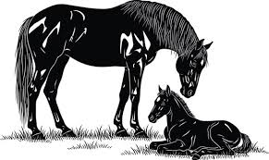
COMPLETE RULE BOOKS ARE AVAILABLE AT THE SECRETARY DESK

MHJA ACADEMY: MHJA Academy classes are open to beginner riders who have not jumped higher than 2’ at any horse show. Riders may not cross enter into any other classes at a horse show where they compete in the MHJA Academy classes. To be judged on Equitation with an emphasis on safety and control.
WALK-TROT: riding on the flat at the walk and the trot
WALK-TROT-CANTER: riding on the flat at the walk, trot, and canter
TROT X RESTRICTED: Trot a course of cross rails. Only riders who have never cantered a course in competition are eligible for restricted Trot X.
TROT X: Trot a course of cross rails
X TO VERTICAL: Trot X and canter out over vertical. MHJA MINI STIRRUP: Riders on horses or ponies canter a course of six to eight jumps not to Exceed 12”.
PRE-SHORT/LONG STIRRUP: Canter a course. 18”.
RUSTY STIRRUP: Riders ages 16 and older canter a course set to their choice of 18” Crossrails or Verticals

JUMPER DIVISIONS: Points toward annual awards will be given in the following sections.

PUDDLE JUMPER: Open to any horse or pony/rider combination that does not jump higher than 0.90 meter at the same show. Fences .65
HOPEFUL JUMPER: Open to any horse or pony/rider combination who does not jump higher than 1m at the same show. Fences .75m
Winterview Farm Horse Show Entry Form

WARNING: UNDER MISSISSIPPI LAW, AN EQUINE SPONSOR IS NOT LIABLE FOR ANY INJURY TO, OR THE DEATH OF A PARTICIPANT IN EQUINE ACTIVITIES RESULTING FROM THE INHERENT RISK OF EQUINE ACTIVITIES (HOUSE BILL NO. 96, FEDERAL LAWS OF MISSISSIPPI 1194)

WINTERVIEW FARM AND THE MANAGEMENT OF THIS HORSE SHOW WILL NOT BE RESPONSIBLE FOR ARTICLES LOST, STOLEN, OR DESTROYED NOR LIABLE FOR ANY INJURY TO ANY HORSES, EXHIBITORS, VEHICLES, SPECTATORS, OR EMPLOYEES.

ENTREES CANNOT GO “NOT TO BE JUDGED” ” IN ANY CLASS.

THE UNDERSIGNED HAS READ, VOLUNTARILY SIGNED, AND UNDERSTANDS THAT THIS RELEASE AND WAIVER FOR ALL LIABILITY AND INDEMNITY AGREEMENT FULLY RELEASES PATRICA WRIGHT-SHOEMAKER AND/OR WINTERVIEW FARM FOR ANY LIABILITY TO THE UNDERSIGNED.
PARENTS OF MINOR CHILD:
________________________________
TRAINER OF COMPETITOR:
________________________________
OWNER/ COMPETITOR:
________________________________
WINTERVIEW FARM HORSE SHOW ENTRY FORM
ONE HORSE/RIDER COMBINATION PER ENTRY FORM
HORSE | RIDER | OWNER
DIVISIONS (Circle all class numbers you will participate in)
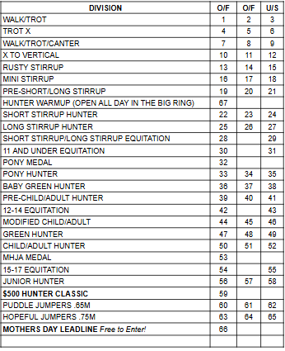
NOTICE!! ENTRIES CLOSE Friday May 8th
Late fee of $25 if received after closing date.
Please enter classes in the Horse Show Office by 5:00 PM the
day before you show.
Entry forms will not be processed without all signatures. Show age as of Dec. 1, 2025
