
Dorchester Garden Club
Founded in February 1930
Federated 1966

P.O. Box 1005
Cambridge, MD 21613-1005
www.dorchestergardenclub.com
dorchestergardenclub@gmail.com

Table of Contents
DGC—What We Do and Why We Do It! 3
Club Policies and Procedures 4
Club Officers and Executive Board 4-5
Standing Committees 5-16
Membership and Member Responsibilities 17-19
Dues and Fees 20
Fiscal Requirements and Financial Procedures 21-22
Club Support and Donations 23-24
How do I know what is going on with the garden club— 24-32
when and where to show up?
Club Yearbook 24-25
Meeting Information 25-27
Club Projects 27-28
Club Communications 28-30
Awards (Club, District, State and National) 30-32
Flower Show “How-To”--Competitive Exhibition of Horticulture & Design 33-40
Why Do We Belong to National Garden Clubs & Federated Garden Clubs of Maryland? 41-47
Background 41
How NGC Honors Members 43
Access to Unique Grant Programs 44
Involvement in National Programs for the Public Good 46-48

Additional Educational Resources from NGC and FGCMD Affiliation 48
NGC Councils and Schools
Some additional things you may need/want to know 49-50
Non-Discrimination Policy 49
Conflict of Interest Policy 49
Liability Insurance Coverage 49
Raffles of Personal Property/Gambling 50
Calendar Posting Procedure 50
Media Release 50
Appendices 51-63
A. Structure of FGCMD, Inc. 51
B. Maps: Five Districts in Maryland, District I 52
C. Summary of Parliamentary Procedure 53-54
D. Application Form 55
E. Evaluation Form 56
F. Sample Dues Analysis 57
G. Financial Forms 58-60
H. Media Release Form 61
DGC 101: What we do and why we do it!

Welcome to the Dorchester Garden Club!
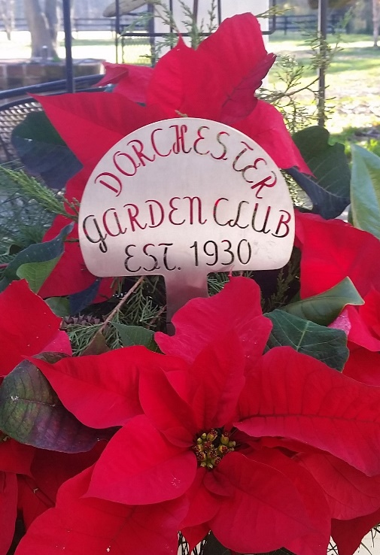
We are a non-profit, 501(c)(3) organization founded in 1930 and federated as part of the National Garden Clubs, Inc. in 1966. Currently comprised of approximately ninety members who reside in and around Dorchester County, we are a very active, dynamic group engaged in numerous civic and community service projects. Our engaging programs are both educational and entertaining and span a broad range of horticulture, conservation, floral and landscape design topics with appeal to novice and experienced gardeners alike.
It is our vision that, “inspired by the natural beauty of Maryland’s Eastern Shore, the Dorchester Garden Club sets an example for the greater community through commitment to conservation, education and celebration of the joys of gardening, landscape and floral design.”
Our mission is that the club shall:
- promote the knowledge of gardening;
- protect and restore the quality of the environment;
- advance the conservation of America’s natural resources;
- enhance civic beautification;
- extend the knowledge and appreciation of arranging plant material; and
- foster social interaction and community building.

This vision and mission are fulfilled by committed members engaged in a wide variety of projects and committee work. We believe in collaboration and partner with other garden clubs and with public, private and non-profit entities to enhance our community and quality of life.

Our club meets a minimum of ten times a year and features stimulating programs on a broad range of topics such as—
Caring for houseplants
Bay-wise conservation practices
Integrated pest management
Bird-friendly gardens
Forcing bulbs and ‘layered’ bulb gardening
Growing and using herbs
Vegetable gardening
Terrariums and fairy gardens
Traditional and creative floral design
Attracting pollinators
Hypertufas and leaf casting
Succulent Gardening and so much more!

Whether you are an experienced or novice gardener or designer, whether you garden on the shore, in an urban setting, on a deck or in your living room, we aim to cover topics that address everyone’s needs and interests.
About this Handbook

DGC is considered a large club (60-99 members) based on the standards set by the Federated Garden Clubs of Maryland, Inc. (FGCMD). As such we comply with requirements set forth for clubs of like size. The policies and procedures that follow are effective as of Spring 2021 and detail our club’s organizational structure, membership guidelines, financial responsibilities, club projects and the activities & organizations we support, awards, flower show procedures, affiliations and additional resources, educational opportunities and incentives for members. Some of the information presented in this handbook may be much more than you care to know about the operations of our club, but we hope it will demonstrate the complexity and vitality of our organization. Who knows? At some point this might be information you need to know!

Club Officers and Executive Board

The officers of the Dorchester Garden Club include President, Vice President, Recording Secretary, Corresponding Secretary and Treasurer. These officers make up the Executive Committee (‘a board within a board’) and are empowered to act in the Executive Board’s place between board meetings. Officers serve for two years (one term) or until a successor is elected. They may serve a maximum of two consecutive terms, with the exception of the Treasurer who may serve for three terms. After a hiatus of one term, any officer may serve in the same capacity again. Elections are held every two years (in the even year) and officers are installed at the following Annual Meeting (March of the odd-numbered year). The details of resignation, vacancy and removal of officers are addressed in the club’s by-laws which can be found in Appendix A and in the annual yearbook.

President
The President provides leadership and inspiration for club members and guides the club in fulfilling its vision and mission. The President presides over all meetings of the club and of the Executive Board. This officer, an ex-officio member of all committees except the Nominating Committee, appoints the chairs of standing committees and the chairs of any additional or ad-hoc committees convened. The President performs such other duties within the realm of the office as may arise during the term. The President or his/her designee represents the club at community events and at State and District garden club or board meetings, reporting on club activities as requested.

Vice President
The Vice President performs all duties as directed by the President, supporting the President in the fulfillment of the club’s vision and mission and conformance with the rules set forth in the club’s by-laws. In the President’s absence, the Vice President assumes all duties of the President.

Recording Secretary
The Recording Secretary keeps the minutes of all regular and special meetings of the club and the Executive Board, documenting a summary of action items discussed, motions made and votes taken. The Recording Secretary distributes minutes to the President, Board and club members for review and filing. After presenting the minutes, if there are no additions, changes or corrections, the Secretary states “the minutes are approved as read (or corrected).”

Corresponding Secretary
The Corresponding Secretary conducts the correspondence of the club and currently maintains the club’s social media presence on Facebook.

Treasurer
The Treasurer collects, deposits and pays out the funds of the club as directed by the Executive Board, keeping accurate books of accounts which, at all times, may be open to inspection. The Treasurer, collaborating with the Finance Committee, oversees the preparation of a proposed annual budget and monitors expenditures by members and committees throughout the year to keep accounts financially healthy.

A summary Treasurer’s report is presented at all business meetings of the club, while a full Treasurer’s report is to be available for review upon request. Following a discussion of the monthly Treasurer’s report and assuming no objections are raised, the Treasurer states “the Treasurer’s report will be filed.” The annual report of the Treasurer for the completed fiscal year is presented to the membership at the April meeting. The Treasurer maintains records of all banking transactions, grants and donations and files tax forms as required.

Executive Board
The Executive Board is comprised of the elected officers of the club, the immediate Past President, an advisor, the Parliamentarian and the chairs of the following committees: Civic Improvement, Conservation & Environmental Awareness, Design, Fundraising, Horticulture, Membership & Recruitment and Publicity.

This Board meets a minimum of four times per year, virtually or in-person, and, at the discretion of the President or presiding officer, the meeting is open to other committee chairs and members interested or invited to attend. The Board may devise and amend these policies and procedures at any meeting provided there is a quorum. The Board sets the dues for each membership category, advises the President in the appointment of committees and in administering the affairs of the club.

Standing Committees
All committees have a chair appointed by the President or his/her designee. The chair may identify a co-chair to share the leadership responsibilities, to facilitate transition between administrations and to appoint members to serve on their committee. Committee chairs may verbally report at regular business meetings if there is information relevant to the membership to be shared. Oral reports are limited to two minutes. A written report should be provided to the President and Recording Secretary in advance of the meeting and will be made available to members when meeting minutes are distributed.
All club members are encouraged to volunteer for at least one committee to the extent they are able and serve as ‘worker bees’ to complete the tasks of each committee. Our hard-working and dedicated committees do the work of our club, helping us to accomplish a tremendous amount throughout the year, from planning to community outreach to fundraising.
Awards and Recognition Committee
This committee’s responsibility is to promote recognition of outstanding achievement of the club or individual members through a program of club, district, state, regional and national awards, the details of which can be found herein or on the respective websites. The Awards Chair/Committee for our club becomes familiar with the availability of awards and the process and requirements for submission of applications. The chair advises other club committees about the eligibility of their projects for awards and recommends how they should document progress and accomplishments, such as by photographing ‘before, during and after’ images of their projects as well as how best to satisfy award requirements. Awards are given based on the ‘story’ told in the application—why was the project important, what was its impact, how many people were involved, etc. Carefully following the application criteria enhances the possibility of success. More details about awards can be found on pages 30-32.

By-Laws Committee
This committee advises club officers and the Executive Board on the terms and interpretation of the club’s by-laws, policies & procedures. The chair of the By-Laws Committee is the Parliamentarian, who is appointed by the President and serves on the Executive Board. The Parliamentarian should be familiar with the club’s rules and procedures, having a copy of Robert’s Rules of Orders, revised 1990 edition for reference as this is the club’s parliamentary authority, governing all club proceedings.

The committee is tasked with reviewing the By-Laws periodically, but especially during the first year of a term to ascertain relevance of the document to current practice and to recommend changes, if any, to the Executive Board for further action. Items codified in the By-laws may only be changed by a vote of the membership, whereas the Board may vote to make changes to policies and procedures at any time.

Civic Improvement Committee
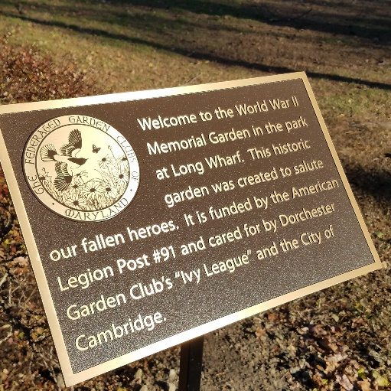
Garden clubs all over the country are engaged in beautifying and greening their communities. Beautification of public spaces is explicitly stated in our mission and is consistently a priority of our membership. This committee recommends and executes beautification and civic improvement projects as authorized by the Executive Board and, when appropriate, as requested by local governing bodies. The committee chair(s) recruits and coordinates volunteer work teams, as needed, for all projects. Our civic improvement volunteers are affectionately called “Ivy-Leaguers.”

DGC designs, funds, currently maintains and enhances the following community garden spaces:
- A four-square cottage garden (formerly the Colonial-style Herb Garden) at the Heritage Museums & Gardens of Dorchester (in partnership with the Dorchester County Historical Society and the UME Master Gardeners). The garden features Native and African American quarters, native plantings and an herb garden;
- Heron Garden at Long Wharf featuring the ‘Patient Fisher’ sculpture;
- World War II Memorial Garden;
- Dorchester County Courthouse—Club members seasonally maintain and provide new garden plants, potted containers and holiday greenery to enhance the landscape and appearance of this very visible public building.

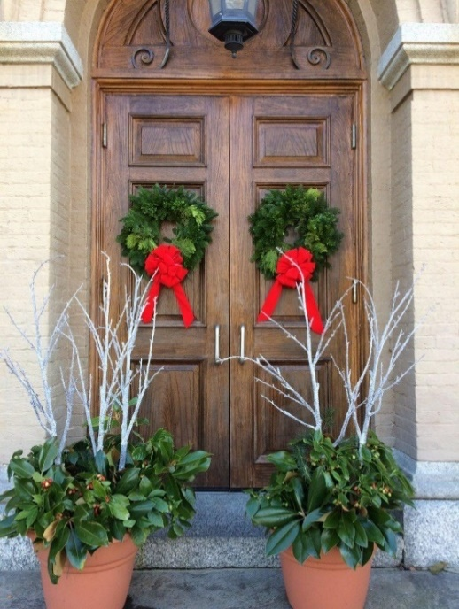
Each site is identified by a permanent metal sign which offers a brief description of the garden and recognizes DGC’s contribution. Our garden signs were funded, in part, by a Plant America Community Project grant from NGC.
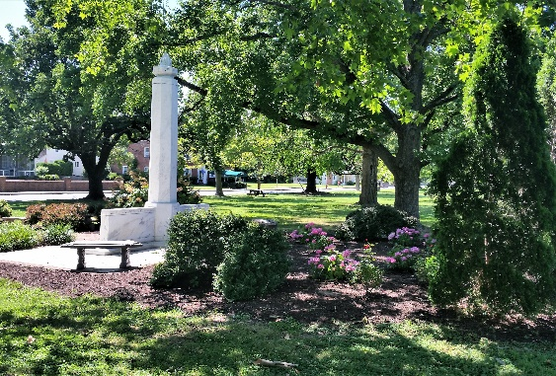

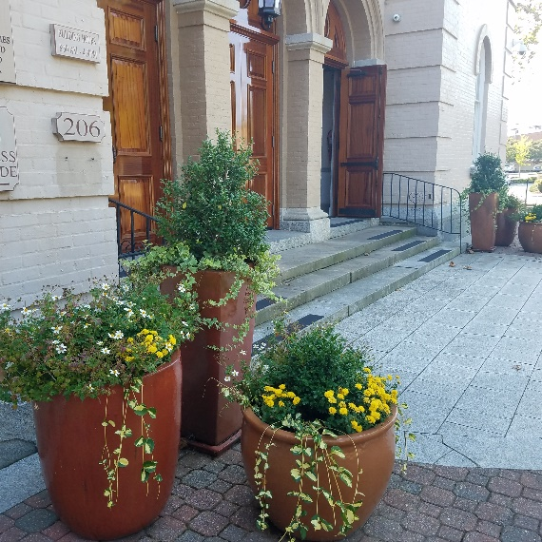

Conservation & Environmental Awareness Committee
This committee is one of two required by NGC (the other is Horticulture). The work of this committee derives inspiration from DGC’s vision and mission statements as well as the NGC Conservation Pledge:

"I pledge to protect and conserve the natural resources of the planet Earth
and promise to promote education so we may become caretakers of our
air, water, forest, land, and wildlife."

By educating and raising awareness of club members and the public-at-large about pressing environmental concerns (e.g., climate change, sea level rise, endangered species, pollution, etc.), this committee encourages members to aid in the protection of natural resources, recommends planting of regional native species and discourages invasive species.

The committee chair(s) reports monthly to the club on relevant environmental issues concerning such topics as birds and butterflies, predators and pests, pollinators, beneficial insects, landscape issues related to the Chesapeake watershed, integrated pest management, the hazards of pesticide and lawn fertilizer usage and any other pressing issues of conservation concern. Recommendations for environmentally-friendly gardening and landscape practices are made based on scientific information reported in the literature or recommended in State and Federal legislation. The committee also provides leadership in support of important conservation and environmental programs such as the Penny Pines reforestation project, Baywise certification, Bird-Friendly and Wildlife Gardens, the Million Pollinator and Monarch Steward Initiative, and the pledge to reduce or eliminate use of Neonics (neonicitinoid pesticides).

Design Committee
The goal of the Design Committee is to educate members about the principles and elements of design, how to approach construction of the various NGC traditional and creative design types, and how to use design mechanics and different types of floral materials (for more information on design competition, see Flower Show Section, pages 33-40). Through training, exposure and experience members gain confidence and become less intimidated by floral design, whether undertaken for their own pleasure or for competition. The committee may employ a variety of methods to teach design to club members or to the public outside of the regular program schedule, including workshops, design activities with partner organizations (e.g., floral interpretation of art with the Dorchester Center for the Arts), club design challenges or demonstrations, distribution of photographic guides or power point presentations, etc. Members are encouraged to purchase NGC’s Handbook for Flower Shows (available through our Digger’s Boutique or on the NGC website store) which provides detailed instruction on the requirements for each of the design types and how they may be exhibited or staged. NGC annually produces a calendar, Visions of Beauty, which we sell in our Diggers’ Boutique. It contains many photographs of a variety of design types—being able to view a design image in addition to reading about the requirements is very helpful.
Remember, designing with flowers should be fun. Former White House Floral Designer, Laura Dowling, likes to say—“the key to successful floral design is how the flowers make you feel!”


These are some samples of members’ designs:

Finance Committee
The Finance Committee is comprised of the President, Vice President, Treasurer and a Member-at-Large appointed by the President. It is the Finance Committee’s responsibility to work with the Treasurer to annually prepare the fiscal year’s budget, assuring compliance with statutory requirements including the filing of tax reports. The committee solicits input from all club committee chairs so that their anticipated income and expenditures are accurately recorded in the budget document. The proposed budget is to be presented to the Executive Board for review prior to the Annual Meeting in March, the close of the fiscal year. The Budget will then be recommended to the membership and voted upon at the Annual Meeting. The Finance Committee also ensures that an internal audit is conducted yearly, as prescribed in the club’s by-laws.

Fundraising Committee
Our Club is unique in that we provide meals at the majority of our meetings. The dues paid by the membership fees barely cover our club and program expenses. As such, the club looks to raise additional revenue through grants, awards, donations, and fundraising activities. This committee is charged with developing creative ways of increasing club revenue through sales, raffles, social events and trips. Traditionally, our club has undertaken very successful fundraising activities such as our monthly 50/50 raffle, workshops, bus trips, pit beef sandwich sales and the Diggers Boutique held at monthly meetings and the holiday luncheon where a selection of plants, gardening and design supplies, books or donated goods are offered for sale.

In addition to traditional fundraising activities, DGC actively pursues grant funding and accepts donations. There are opportunities to donate in honor of a special member or event. If an individual holds the Dorchester Garden Club dear, an honorary donation to the club in that individual’s name would likely be very much appreciated. Also, families of deceased members may specify donations to the club in lieu of flowers, for example. These donations are labeled ‘in memoriam.’ The Treasurer is responsible for ensuring that the donations are properly acknowledged. In addition, in the event a donor requests a receipt for tax, a form (see Appendix G, pages 58-62) can be provided by the Treasurer.

Garden Therapy Committee
NGC encourages clubs to promote the concepts of healing with gardens and horticultural therapy. There is a diversity of projects to consider including teaching gardening skills to developmentally-challenged high school students; planning, planting and maintaining healing gardens in nursing homes and facilities that care for veterans; or providing gardening education and encouragement to prison inmates.

Our Garden Therapy program entails outreach to seniors and other vulnerable populations with a view toward engaging them in garden-related activities. Committee members visit partner facilities such as Mallard Bay Nursing Home and the Pleasant Day Adult Day Care Center on a regular schedule to assist clients with arranging flowers for their pleasure, education and enjoyment. The Committee collects vases (mugs, usually) as vessels to hold donated or purchased floral material.

Historian
The Historian compiles photographs, news articles, publications, awards, important correspondence and other records which collectively document the activities of the club. Pictures of special projects and news clippings are also sent to the FGCMD District I Historian. Members save and contribute memorabilia for the Historian to include in a scrapbook or to save in some other manner. These historical materials are valuable when the club plans to celebrate an important anniversary or honor a club member for his/her contributions over the years.

Holiday Luncheon Committee

The DGC annually holds a holiday luncheon in December. This is our largest and likely the most labor-intensive undertaking for our club. Over the years, it has become more elaborate and now features a design program, musical entertainment, a catered lunch and vendor shopping. It engages a large volunteer pool of club Members (and spouses) for set-up, take-down and everything in between. While not designed as a fundraiser, it typically brings in a profit from the sale of centerpieces, Diggers’ Boutique, vendor fees, raffles, and ticket sales. This event now attracts in excess of 150 members and guests who purchase tickets to attend. It serves to educate and entertain attendees, promotes fellowship and spotlights our club’s activities and membership—potentially recruiting new members.

Holiday Wreath Workshop Committee
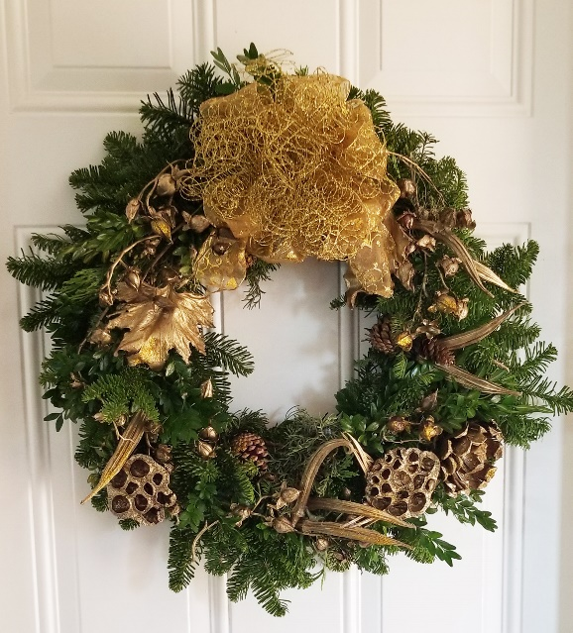
This workshop is held every year after Thanksgiving so that members and guests may decorate holiday wreaths for use as door or table adornments for their homes or as gifts for family, friends or community spaces. This is a fundraising project whereby the club purchases wreath bases wholesale and members donate additional greens, pods, cones, shells, ribbons and berries. Members purchase the mixed green wreaths from the club and decorate them in a communal atmosphere, learning from each other and sharing ideas and skills. Other holiday crafts may be taught in associated mini-workshops (e.g., boxwood trees, Williamsburg door décor). Light refreshments are donated and prepared by members and profits from this activity help fund the club’s civic improvement projects.

Horticulture Committee
This committee takes the lead in promoting horticulture education, programs and projects by coordinating workshops and training, reporting on relevant topics at club meetings and sharing information in newsletters. The committee strives to keep members apprised of gardening trends and shares current information on the science and art of growing plants and landscaping practices, particularly those appropriate for gardening in the Chesapeake Bay Watershed. The chair liaises with the FGCMD State and District Horticulture Chairs and avails her/himself of countless additional resources in order to pass on information on to our members.

Hospitality Committee
The Hospitality Committee represents our club at meetings and events, setting an open, welcoming and professional atmosphere for members and guests. The committee is responsible for providing support and assistance at meetings, as needed, to the program chair, officers, speaker(s) and to representatives at the meeting venue.

When the yearbook is in production for the new program year, the Hospitality Chair recruits members in alphabetical rotation to serve as hosts at each meeting. The scheduled hosts’ names are listed in the yearbook by meeting date. Before a meeting, the chair confirms that the two hosts will attend the meeting and be available to assist in whatever manner needed. On the date of the meeting, committee members arrive early to arrange the welcome table, set up the name badges for members and guests along with sign-in sheets and other materials for distribution to attendees. Hospitality duties for special club events (e.g., Holiday Luncheon, Annual Picnic) are usually handled by that specific event committee.

Membership & Recruitment Committee
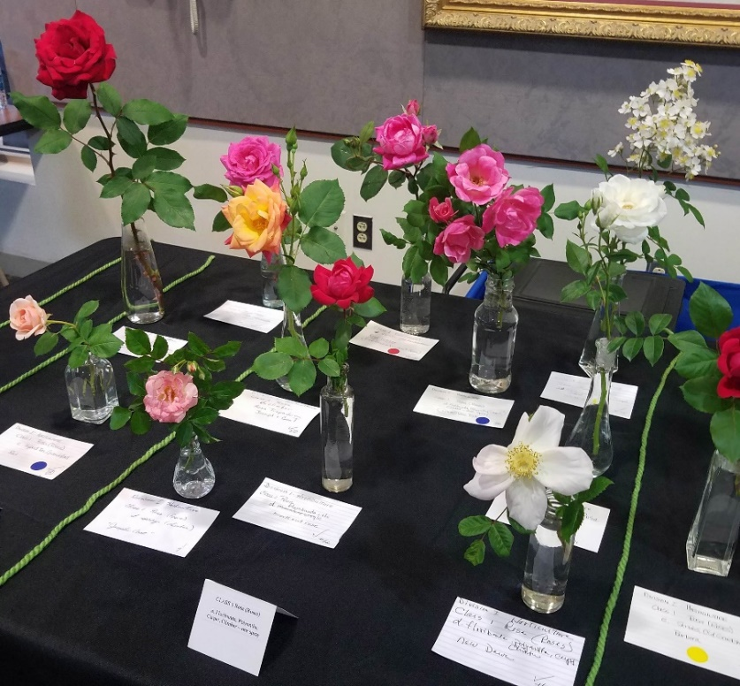
This committee coordinates with the FGCMD State and District Membership Chairs to share strategies and tools that will help grow and diversify our Club membership while retaining current club members. The chair/committee educates and informs current and prospective members about the advantages and resources available through garden club affiliation. They distribute and receive membership applications and inform prospective members about procedures for joining the club and requirements of active membership. Upon fulfillment of those requirements, the Membership Committee welcomes the new member, introduces them at the next meeting they attend and provides them with our welcome kit. The committee chair keeps the Executive Board apprised of membership updates (new members, transfers to associate status, resignations).

Mini-Flower Show Committee
This committee manages our mini-flower shows staged at most of our monthly meetings. The committee chair recruits volunteers for tasks such as entries and placement, staging and judging.

The DGC is one of only a few clubs that regularly holds mini-flower shows (see Flower Show Section, pages 33-40) at club meetings. The exhibits are judged by members (in consultation with certified judges) and the judges’ observations are shared with members during the business meeting as a learning experience. Some members are hesitant about entering competition, but we think you will find it is fun to participate even if you are not at all competitive or feel you are too unskilled to do so. Exhibiting in a flower show and viewing the entries of others is a great way to learn about what grows in members’ yards (on patios and decks, in containers, as houseplants) and how to arrange flowers artfully. It is about education! There is a required number of ‘entry points’ (awarded when you exhibit—whether you are awarded a ribbon or not) expected for active members.

This committee can serve to ease the apprehension of exhibiting by stressing how much fun participating can be and how simple it is to properly display a horticultural exhibit. Exhibiting in and viewing a flower show offers the opportunity to see and learn about many different types of horticulture and design. Our club’s experience has positioned us to perform really well in district and other standard flower shows.

Nominating Committee
This committee consists of a chair and two (2) members who are assigned in alphabetical rotation from the active membership list. The committee members must have been active members for one (1) full club year. Their task is to identify members who agree to serve on the Executive Board of the club—President, Vice-President, Recording Secretary, Corresponding Secretary, Treasurer, Parliamentarian and Advisor (usually the immediate past president). According to the by-laws, the slate of officer candidates is identified and presented to the membership at the October meeting of even-numbered years. Election procedures are described in the club’s by-laws.

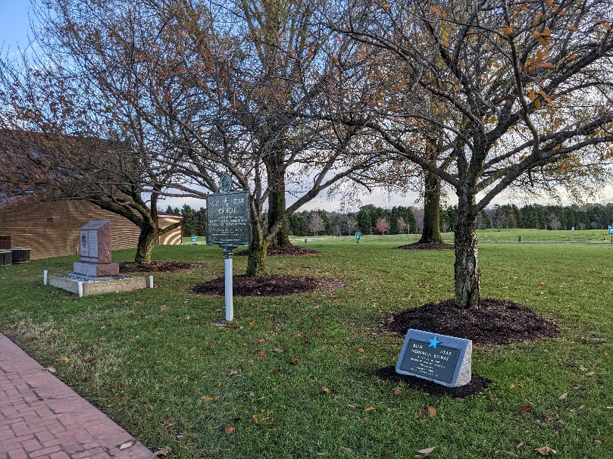
Patriotic Programs Committee
This committee promotes activities honoring our veterans, active service members and their families through a variety of programs--
- Coordinates and encourages participation in annual events commemorating our veterans on Memorial and Veterans’ Day, Wreaths Across America, installation of Blue and Gold Star Markers;
- Liaises with the District Patriotic Programs Chair to fundraise in support of commemorative events, to publicize these events and to encourage club participation and attendance.
- The Eastern Shore Veterans’ Cemetery in Hurlock (shown above) has a Blue Star Memorial Marker as a tribute to our Armed Forces which was purchased by the Dorchester Garden Club and dedicated April 19, 2012. The Blue Star program was started in World War II and led by garden clubs!
- A Gold Star Memorial marker was installed in 2020 as a tribute to Gold Star families whose loved ones paid the ultimate price defending our country. It is sponsored by the FGCMD in cooperation with the Maryland Department of Veteran’s Affairs and the Eastern Shore Veterans Cemetery. These distinctive and permanent markers are adjacent to the Chapel on cemetery grounds.

Program Committee
Our Program Committee coordinates with other club committees such as Horticulture and Design to plan a meeting schedule of ten (10) or more regular meetings, workshops, trips and special events. The program is based on an annual theme which helps inform the programs selected, the names of design classes for the mini-flower shows and other aspects of that club year. Examples of past themes include: “It’s a Garden Party,” “Go Native!” “Color Our World,” “Origins and Roots,” and “the Garden is my Canvas.” Members fill out evaluation forms after meetings and the information provided helps us to be responsive to members’ comments and requests for particular topics of interest.

The committee identifies and schedules speakers for monthly programs which are designed to fulfill National Garden Club goals and objectives such as horticulture and design, education, beautification, fellowship, recognition and the like. The committee provides the program and biographical information to the Yearbook Committee; negotiates speaker honoraria, travel expenses or supply costs within the specifications of their projected budget; maintains contact with the speakers; and assists them in any way necessary before and after the meeting. The committee coordinates audio-visual needs of the speaker and may assist with display set-up or sales of speakers’ books, plants, flowers or design mechanics.

Publicity Committee

The Publicity Chair/Committee communicates the club’s mission, goals and activities to the greater community and functions to maintain a high public profile for the club. Keeping what we do in the public eye helps with the recruitment of new members; development of public, private and non-profit partners; and encouragement of community and business support for our projects. The chair/committee arranges for photographs to be taken at all meetings and events which are used to enhance our press releases, internal and outside publications and social media platforms. They submit articles for publication and coordinate with local print (Star Democrat, The Banner), internet (Cambridge Spy, government and non-profit organizational websites and radio (WCHP) media to promote DGC activities to the public. Our club also maintains a website and Facebook page to reach a broader audience and elevate the club’s profile in the community.”

This committee produces a quarterly newsletter, “The Diggers,” which is sent electronically to all members and is posted on our website. Club members are encouraged to assist the committee in promoting the club by submitting articles of interest, photographs, member news and other relevant items. Other club communication tools are addressed on pages 28-30 and include The Weekly Buzz, a monthly Announcement Sheet, a Rack Card and business card, the latter two used predominantly for recruitment. The business card provides contact information and a list of annual program listing.

There are many additional resources available to help promote our club activities. As FGCMD members, we can post calendar items on their website and Facebook page. There are countless newsletters, websites and blogs from which we can get inspiration and ideas for our own publicity as well as avail ourselves of these sources to post our information to attract more participation.

Scholarship Award Committee
DGC annually awards a scholarship to graduating seniors from each of Dorchester County’s high schools who intend to pursue conservation, environmental or horticultural studies. The committee distributes scholarship application forms to guidance offices at NDHS and CSDHS in April and is responsible for identifying qualified applicants. The Executive Board approves the selection and the recipients are notified by letter with an invitation to attend a club meeting to be recognized. The scholarship recipients receive a DGC certificate while the monetary award is sent directly to the recipient’s intended school.

Social Media Committee
DGC has a dedicated e-mail address (dorchestergardenclub@gmail.com), a website (www.dorchestergardenclub.com) and a Facebook page. The latter was established to reach out to a younger, more tech savvy audience as well as to allow the public to view photos of garden club activities, schedule of events, newsletters and reference guides on gardening and design. These sites may be managed by the Corresponding Secretary or another member with the technical ability to do so.

Webmaster
DGC pays an annual fee to a web hosting site in order to have a presence on the web. It provides visibility to the public while making information easily accessible to our members. The webmaster, having a basic working knowledge of MS Word and Internet communications, maintains the site by updating the calendar of events, posting pictures of club activities, membership information, gardening tips and links to other sites for gardening information.

Yearbook Committee
The Yearbook Committee convenes annually, usually in January and program planning for the coming year has been completed, to begin design and production of this most important club publication. The yearbook provides members with extensive information on the program schedule, membership contact information, calendar of events and much more. The committee is provided information such as the list of meeting hosts by the Hospitality Committee; the names of monthly judges, consultants and clerks for mini-flower shows as assigned by the Flower Show Committee; theme, programs, speakers and venues as coordinated by the Program Committee, etc. In addition to providing a very useful resource for our club members, the Yearbook is shared with other District garden clubs to publicize and invite guests to our club’s programs and activities. Additional information about the yearbook is on pages 24-25.

Youth Gardening Committee
Our Youth Gardening program seeks to engage young gardeners in a variety of activities designed to raise awareness of the value of gardening and to cultivate the next generation of conservation leadership. From reading nature stories at the library to playing garden-themed games to decorating flower pots at afterschool programs, the committee focuses on nature, horticulture, the environment, seed-starting, birds, butterflies, wildlife, and more—all in order to educate, mentor and encourage creativity and understanding of a range of gardening topics in ‘budding’ gardeners. This committee is best served by partnering with other local organizations in order to reach out to youth, particularly those in otherwise underserved populations. Schools, the public library, the YMCA, community centers, church and scout groups are all potential collaborators for this project.

Ad hoc Committees for Special Projects or Events

The President or Executive Board may establish additional standing committees as deemed necessary or convene ad hoc committees to serve specific, often temporary, needs of the club. For example, ad hoc committees have been appointed to plan anniversary celebrations, to undertake a special project such as the Maryland House & Garden Pilgrimage or to produce publications such as a cookbook or anniversary book. An ad hoc committee will be appointed by the President when the club decides to plan and execute a Standard Flower Show.

Membership and Member Responsibilities
The Dorchester Garden Club strives to be a diverse, inclusive body with broad appeal to men and women, young and older members from Dorchester County and the surrounding areas. We see our club as a means to make new friends, learn new skills and broaden our horizons--whether we consider ourselves to be novice or experienced in landscape design and gardening, the cultivation and care of plants in the house and garden, the creative and traditional design of floral material, or conservation and stewardship of our environment. There is much to learn for everyone!

We do not discriminate based on race, gender, creed, color, national origin, age, disability, sexual orientation or otherwise. Our club does not have a membership cap or limit. In fact, the more members we have, the greater the pool of volunteers for club projects and the broader depth of skill and experience we can draw upon. However, the Board reserves the right to impose such a limit if deemed in the best interest of the club.

Prospective Members
Active or associate members may invite a guest to a meeting to give them an overview of our club activities and the expectations of membership. Guests are warmly welcomed and introduced to club members at the business meeting; are encouraged to enjoy the social aspects of mingling with the membership, viewing flower show exhibits and sharing the lunch experience; and have the opportunity to learn new skills from our programs.

If interested in joining DGC, the prospective member is mentored by their sponsor as they navigate belonging to a new organization. They receive an application form and a summary of events scheduled throughout the year. After submitting their application (Appendix D) to the Membership Committee, the prospective member must attend two meetings within six months, preferably with their sponsor. Upon completing this requirement and paying full or prorated dues, the prospective member becomes an Active Member. The sponsor continues to provide guidance to the prospective member regarding the club’s policies, practices, and procedures, and makes every effort to ensure the new member feels welcomed and included.

Active Members
You are considered an active member if you have met the attendance and exhibit requirements and are current in payment of dues. At the first meeting attended by a new active member, the Membership Chair introduces you and your sponsor to the club at the business meeting and presents you with the yearbook (your guide to DGC program schedule), this DGC member handbook and a welcome letter and gift (a horticulture exhibit bottle!) from the President. New members are urged to purchase the NGC Handbook for Flower Shows and the NGC Horticulture Exhibiting and Judging book to learn about exhibiting and designing for our mini- and standard flower shows. The books are available in our Diggers’ Boutique or on the NGC website. If a member cannot purchase these books, one may be borrowed from another member when planning to exhibit in order to be aware of and prepared for the exhibit requirements. Again, flower shows are an important part of our club’s program and members’ experiences.

Specific Requirements of Active Membership
- Pay their dues in full in April of the new fiscal year which includes payment for dues and all lunches served at regular meetings and the annual picnic;
- Agree to support the mission of the club;
- Participate, to the extent they are able, in the affairs of the club through committee work, serving as an officer, chair, host, judge or otherwise volunteering for the club;
- Attend four (4) meetings of the club (or other approved activities) each year, which is tracked when they sign-in on the attendance sheet at meetings. Attendance is counted only if the member attends both the business meeting and program.
- Exhibit horticulture or design, being guided by their sponsor and other club members, three (3) different times during a club year.

Meeting attendance and exhibit requirements can be fulfilled in a number of ways and serve to help the member derive the maximum benefits from the club experience. Member attendance is counted if they attend a regular meeting (which is preferred), participate in a workshop or another special meeting/activity of the club.

Club Activity | Attendance Credit | Exhibit Point
Monthly Meeting | √
Annual Picnic | √ | √ (for exhibit of horticulture, no judging)
Bus Trip | √
Workshop | √ | √
Holiday Luncheon | √ | √ (if horticulture or designs are exhibited and judged)
Flower Show  Monthly Mini- |  | √ (one point is awarded regardless of the number of exhibits entered)
Standard, Club or District | √
Other Events | Credit/Point approved on case-by-case basis

Resignation and Reinstatement
To resign from the club, members must submit their intent in writing to the membership chair. Active members who have resigned from the club for any reason may apply to the Membership Chair for reinstatement. The request must be approved by the Executive Board.

Associate Members
Except as approved by the Executive Board, associate membership is only available to those who have been active members for at least five (5) years. An exception to the five-year rule may be made in extenuating circumstances. To transfer to associate status, you must make the request, in writing, to the Membership Chair, who presents it to the Executive Board for approval.
An associate member pays a higher fee for dues than does an active member and the payment does not include lunches. Lunches for associates must be paid each time the member attends a meeting and reflects a small program fee.

As an associate member you may attend all meetings and events of the club, but may not vote or be counted in a quorum. You may not hold office, but may chair or serve on selected committees and club projects. You may apply, again in writing, for reinstatement as an active member at any time!

Active and associate members are issued a membership card annually upon payment of dues. On the back of the card are listed the names of business sponsors and the discounts they offer our members for their patronage.

Other Membership Categories
Honorary Membership is conferred for life by a two-thirds vote of the Executive Board to those nominated for outstanding service to the Dorchester Garden Club and promotion of the mission of FGCMD. Typically, an honorary membership is bestowed upon a long-standing member who, for health or personal reasons has moved from the local area, so they rarely, if ever, attend a meeting. Honorary members have none of the obligations of active membership, but are entitled to all the privileges of membership except those of making motions, voting and of holding office. There are no limits to the number of honorary members so designated by the Board.

Friends of the Garden Club are individuals or groups who express an interest in the club’s mission and activities, may financially support or donate goods or services to the club, but are not interested in active membership. Friends of the Garden Club will be advised of the annual program and may attend meetings as guests. They may be included on club mailing lists to receive newsletters and other correspondence and may volunteer with club projects such as civic improvement or garden therapy activities.

Business Sponsors are those entities who demonstrate support for the club through donation of goods or services or by conferring discounts to members which are reflected on our membership cards. Business sponsors will be acknowledged on the club website, in the yearbook and other publications. Our members are encouraged to patronize these establishments and to thank them for their support of our club.

Dues & Fees
The fiscal (and membership) year of the club is in accordance with the calendar of the Federated Garden Clubs of Maryland, Inc. and runs from April 1 through March 31.

Dues help the club meet its financial commitments and responsibilities and are set annually by the Executive Board. To enhance members’ understanding of how the dues amounts are determined, a breakdown of dues and fees is provided in Appendix F.
Payment of dues, in full, is expected by the first meeting of the new year (April). Invoices are sent out, usually by e-mail, just after the March meeting. Payments should be given to the Treasurer or mailed to the club post office box.

As of 2018, dues for active members are $150 which currently includes the members’ district and FGCMD dues as well as the cost of lunches at every meeting. Dues are pro-rated for new members who join at various times throughout the year as follows:
Joining between April and October 1st: $150.00
Joining October 1st through March 31st: $75.00

Associate members pay a flat rate of $50.00 for dues. In addition, they pay $20.00 at each meeting they attend which reflects the cost of lunch and a nominal program fee.

Guests are encouraged at all meetings and they also pay $20.00 for their meal and program. If they attend the program only, generally no fee is assessed, but donations are always welcome! This is designed to encourage guest participation with a view towards community outreach, enhancing club visibility and recruiting prospective members.

The club pays dues to both District I and the FGCMD on behalf of honorary members who are listed on our membership roster. If they do attend a meeting, they are considered guests and pay for their own lunch.

Friends of the Garden Club are asked to pay dues of $20.00 for their association with DGC, for being kept informed of club activities through our electronic communications and for participating in activities to the extent they wish.

Fiscal Requirements and Financial Procedures

Federal Tax Requirements
The FGCMD is a non-profit organization covered under Section 501(c)(3) of the Internal Revenue Code. This is a federal designation which exempts the Federation and its subordinate organizations from paying federal income tax on income generated at our events and activities. A member garden club may elect to join the FGCMD Group Exemption from federal income tax, which also allows contributions to the club that are tax-deductible to donors.
Our club has been issued an Employer Identification Number (EIN or FEIN) unique to our club which is equivalent to an individual’s Social Security Number and has no expiration date. Federal law requires each club to have an EIN that must be reported to the FGCMD Central Office, which in turn reports it to the Internal Revenue Service when filing its annual request for updated information regarding its subordinate organizations.
In lieu of taxes, the club files a 990 Form with the IRS. The 990 Form is filed electronically after the end of the fiscal year [e-postcard]; there is no paper 990 form unless gross receipts exceed $50,000. This filing informs the Federal Government that we had sales of less than $50,000 and are therefore not required to file a corporate tax return. Failure to file the 990 for three consecutive years will result in the automatic revocation of the district’s and club’s 501(c)(3) tax‐exempt status. Districts and clubs may track their filing history by going to the IRS link: https://www.irs.gov/charities-non-profits/exempt-organizations-select-check and following instructions. Submit the completed on‐line form. Upon form submission, note the confirmation information; print a copy, and write the user ID and password on the copy. File the copy with district or club permanent records. It is suggested that a record of the filing be reported in the district or club minutes

Maryland Sales Tax Requirements—Sales tax is levied by the State of Maryland. There is no federal sales tax at present. 501(c)(3) organizations are NOT exempt from collecting and paying sales tax. Our club has been issued a Sales and Use Tax Registration Number. An EIN is required to apply for this number which also has no expiration. On a quarterly basis, the DGC Treasurer electronically files Maryland Sales and Use Tax Return to remit collected sales tax. Of note, when our club sells merchandise, the item is priced inclusive of the requisite (6%) sales tax; when we pay sales tax it is on the gross receipts minus the included percentage of sales tax.

Budgeting
Our club’s budget document is broken down into the following account categories:
- Dues and Donations
- Operating Expenses (Taxes, P.O. Box, Office Supplies, Storage Facility, Banking, Website, Yearbook Printing, IT Purchase and Repair)

- Scholarships and Awards (High School Scholarship, DGC Horticulture & Design Awards, Perennial Bloom Award)
- Programs (Lunches, Speaker Fees and Gifts, Venue Costs, Supplies)
- Holiday Luncheon
- Trips
- Fundraising (50/50 Raffles, Diggers Boutique, Pit Beef Sales, etc.)
- Projects (Garden Therapy, Youth Gardening, Annapolis Tree Decoration, Wreaths Across America, Curb Appeal)
- Wreath Workshop
- Flower Shows

All committee chairs submit anticipated income and expenditures for recording in the budget document. It is the Finance Committee’s responsibility to prepare the fiscal year’s budget assuring compliance with statutory requirements including the filing of tax reports. The proposed budget is reviewed by the Executive Board prior to the Annual Meeting in March, the close of the fiscal year. The Budget is presented to the membership and voted upon at the March Annual Meeting. Budgets are working documents, planning tools to guide the generation of income or the expenses incurred by the club. Budgets can be balanced, which is what we strive for in budget planning. A balanced budget is a situation where total expected revenues are equal to planned spending. Budgets can also reflect surplus or deficit depending on the club’s current situation.
Important: Any expenditure not already reflected in the budget must be reported to the Treasurer in advance of the purchase. Any individual expenses of $200 or more, not otherwise approved in the budget, must be presented to the Executive Board for prior approval.

The accounts of the club are to be audited by a committee appointed by the President after the end of each fiscal year, unless the Executive Board determines that a professional, independent audit is needed.

Financial Forms are available for members’ use when requesting a check to pay a vendor, requesting personal reimbursement for club expenses or needing a receipt for a contribution of goods or services. These forms assist the Treasurer in accurately tracking payments (see Appendix G)
- Invoice Form
- In-Kind Contribution Receipt
- Check Request Form

Members are reminded, if they need to make purchases for the Ccub, they should present the tax identification number to avoid payment of sales tax where appropriate. In advance of making a purchase for the club, the member may request the tax ID number from the Treasurer.

Club Support/Donations
Every two years, when the club develops a budget, we allocate funds to support local, state and national efforts that contribute to or are in keeping with our mission. This support is part of the operating costs of running a club. The entities we support may change over time.
- American and Maryland Daffodil Societies- Our club supports these two societies because we have certified daffodil judges and membership in ADS and MDS is a requirement for them to retain their certification. They sponsor daffodil shows in which some of our members compete and have a semi-annual publication about daffodils which is very informative.
- Dorchester Center for the Arts (DCA)-DGC often works in partnership with DCA on joint programs and exhibitions such as floral interpretation of art. We have also used their facilities for meetings and events over the years.
- DGC Awards for Horticulture & Design-These awards are given annually to members who accumulate the highest annual point totals in horticulture and design competition at our monthly mini-flower shows.
- DGC Scholarship Fund-Each spring, a $1000 scholarship is awarded to a graduating senior from each of our Dorchester County High Schools. Applicants are selected based on their intent to pursue conservation, environmental or horticultural studies.
- Eastern Shore Hospital Center (ESHC)- The club makes an annual donation to the Hospital Auxiliary in appreciation for their hosting many of our meetings and events. The donation is in support of patient services. In addition, we pay for lunches served at our monthly meetings.
- Eastern Shore Land Conservatory (ESLC)- In keeping with our club mission, we make an annual contribution to this local environmental group. As their presence and activities grow in Cambridge, the DGC hopes to develop a stronger relationship with ESLC.
- FGCMD-Dues are paid annually to the FGCMD at the rate of $11.00 per member (active, associate, honorary). $1.00 of each member’s dues goes to NGC and $.50 per member is returned as a rebate to each district. In addition, a donation is often made in support of the President’s project.
- FGCMD, District I- Clubs pay the District $1.75 per member in dues. In addition, clubs may be asked to contribute monetarily in support of raffles or auctions at district events.
- Dorchester County Historical Society (DCHS)- Our club annually makes a contribution (membership) to this organization which has hosted some of our meetings and events over the years and with whom we partner in the design and maintenance of the four-square garden on the grounds of the Heritage Museums and Gardens.
- Immanuel United Church of Christ- The club makes an annual donation to the Church in appreciation for their hosting many of our meetings and events. In addition, we pay for lunches served at our monthly meetings.
- Mallard Bay Nursing Home- Flowers are purchased by the club and donated along with containers to provide garden therapy bi-monthly to residents.
- National Disaster Funds-The club contributes to this fund annually (via the FGCMD) to support the replanting or restoration of areas destroyed by natural disasters either within the United States or throughout the world. For example, monies have been donated to Ellicott City, MD after the catastrophic floods they experienced.
- NGC Penny Pines Program- NGC is a proud supporter of this Reforestation/Forest Education Program started in 1941 in partnership with the USDA Forest Service. This is a meaningful conservation project in which our club contributes funds to help defray the costs of replanting replacement trees at a national forest site damaged by fire or other natural catastrophes. Under a conservation agreement, the forest service plants new tree seedlings native to the area being planted (not necessarily pine trees) so that the area may potentially become productive timberland.
- Pleasant Day Adult Day Care Facility- Flowers are purchased by the club and donated along with containers to provide garden therapy bi-monthly to residents.
- Zion United Methodist Church- The club holds its annual wreath workshop in the church’s Garretson Hall and makes use of their kitchen facilities to prepare and serve refreshments. We make an annual donation to the church in appreciation for this opportunity.
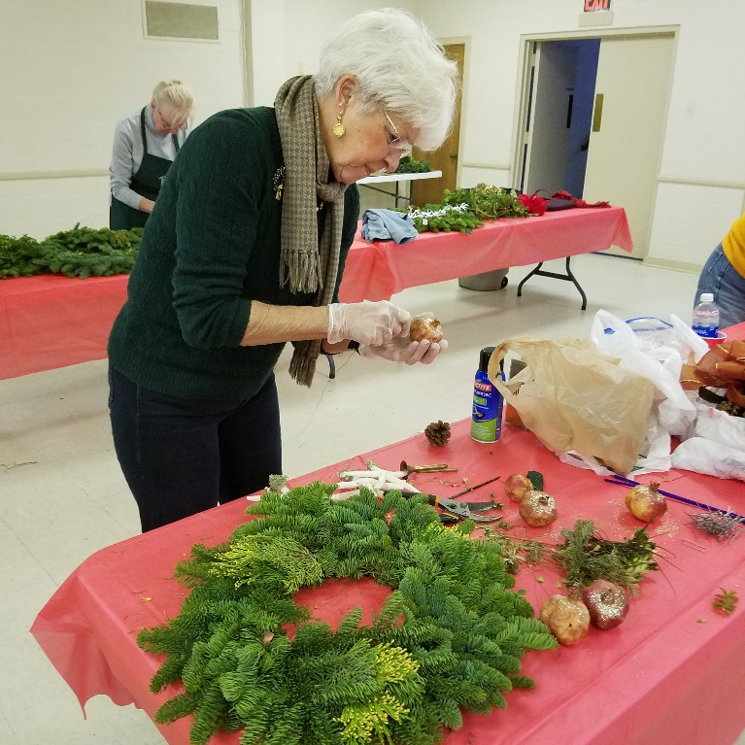
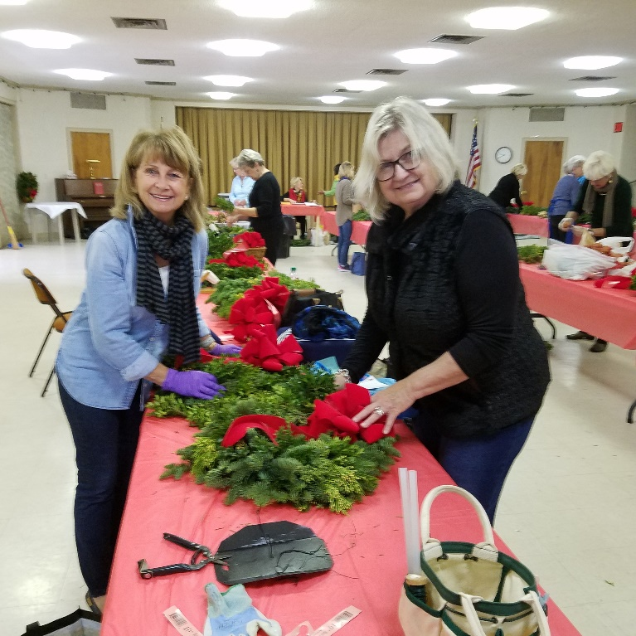
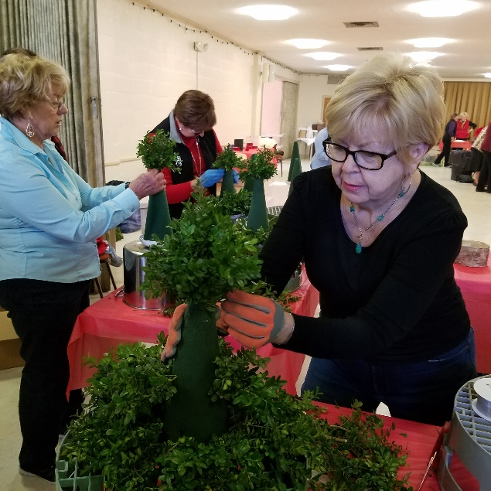
How do I know what is going on with the garden club—
when and where to show up?
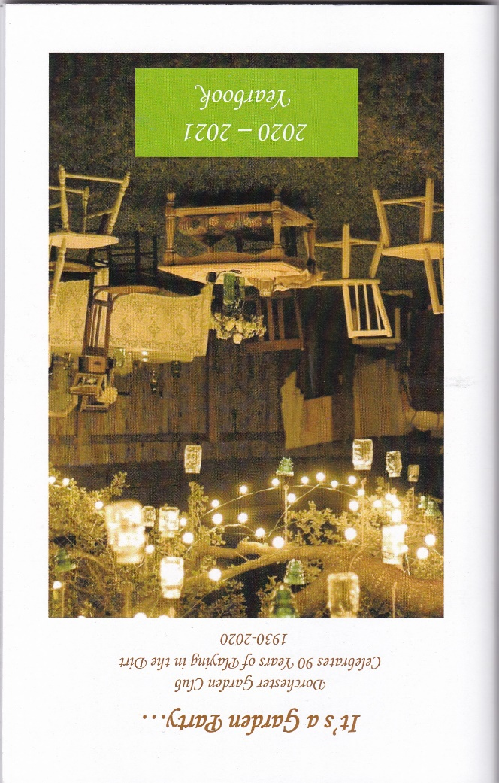
Club Yearbook
The yearbook is a publication produced annually which is your ‘bible’ for information about DGC activities throughout the year. It is distributed to members at the March Annual Meeting in anticipation of the new program/fiscal year which begins in April. The yearbook, while not a required club publication by NGC/FGCMD standards, generally follows guidelines outlined by the NGC, and is designed based on a theme for the up-coming year as chosen by the club’s Program Committee. (See also Yearbook Committee on page ____)

The yearbook, currently a 5” x 7” booklet formatted as a Word document, is saved as a pdf for submission to the local Copy Shoppe in Cambridge for printing. It must be submitted in its final form by the third week of February in order to be ready for distribution at the club’s and district’s annual meetings in March. In addition, we provide copies of the yearbook to all district club presidents and key personnel at the state and district level (e.g., Director and Assistant Director, Awards Chair, Gardenews Chair). The yearbook is provided to club members only, both active and associate, but abbreviated program descriptions may be distributed to the general public and posted on social media platforms to encourage guest attendance at meetings and recruitment of prospective members.

In addition to providing monthly program information, the yearbook includes much more:
- A dedication to one or more members selected by the President for their extraordinary contributions to the club
- List of DGC affiliations and memberships
- Contact information for NGC, FGCMD, District I Officers and Committee Chairs, Club Presidents
- By-laws of DGC
- List of club projects
- List of organizations, programs and activities to which our club contributes
- Individual and club awards received in the previous year
- Host, Judge, Consultant and Clerk assignments for all our meetings
- Schedule-at-a-Glance for the year (programs and activities)
- Program descriptions, meeting venues and mini-flower show schedules for all meetings
- Detailed directory of active, associate and prospective members
- Recognition of members lost during the past year (‘In Memoriam’)
- List of past club presidents
- Calendar of events

Additional items which have been added over the years to further educate and enhance the experience of club members include:
- Useful gardening and design resources on the Web
- Glossary of terms
- List of plants considered invasive in the State of Maryland
- List of Master Judges, students and consultants in NGC Schools, Master Gardeners and Master Naturalists and Perennial Bloom Award Winners
- Gardening quotations
- Photographs and other images
- Tips for a long-lasting floral arrangement
- Seasonal gardening tasks
- Business Sponsors of DGC

Our yearbook is submitted annually for state and national recognition and has consistently won awards for its design and content!

Meeting Information
Regular club meetings are held on the second Friday of the month, unless otherwise noted. We meet a minimum of ten times in a year. As the club has grown substantially over the last several years, our meeting venues have had to change to accommodate our expansion. We do not have a permanent club house or meeting site. We typically meet in English Hall at the Eastern Shore Hospital Center on Woods Road in Cambridge or at the Immanuel United Church of Christ on Route 50 in Cambridge. Each site comfortably accommodates members and guests, has the technical facilities for audio-visual presentations, room to set-up our beautiful mini-flower shows and offers the service of a delicious lunch.

Meeting attendees check in at the welcome table upon arrival and are greeted by designated hosts. They are asked to sign the member attendance list or guest registration forms and pick-up their name badges. Guests and associate members pay their lunch/program fees ($20.00) to the Treasurer or a designee at the welcome table. Each attendee is given an announcement sheet which details the many educational and training activities available throughout the region. Other handouts are distributed, event flyers are displayed and members may be asked to volunteer or register for activities on sign-up sheets.

Most meetings consist of a mini-flower show—something pretty unique to our club and why we perform so well at District I Flower Shows! A minimum of six (6) mini-flower shows are held during a full club year. There is ample time for socializing, a business meeting, lunch and a program. The meeting times are listed in the yearbook. Typically, members start arriving between 9:00 and 9:30 am if they want to enter exhibits into the mini-flower show. All horticulture entries and designs must be checked in and placed by 10:30 am, at which time the formal judging begins. Attendees may view the flower show entries before and after the judging takes place, but not during that time. Again, details of flower show procedures may be found on pages 33-40.

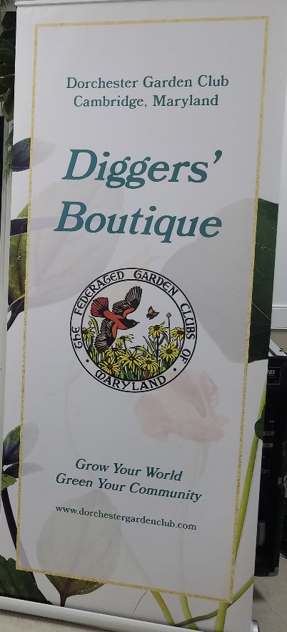
The business meeting, presided by the club President, begins at 11 am and lasts for about an hour. A sample meeting agenda is provided on page ___, in the appendix on parliamentary procedure. Officers and committee chairs may report on their activities (no longer than a 2 minute report except under special circumstances) but are encouraged to submit a written report on their committee activities to the Recording Secretary for inclusion with the minutes. Other club matters are discussed and, perhaps, voted upon. Attendees are advised of upcoming events and opportunities; unfinished and new business are shared. If time permits, the Flower Show Chair shares the results of the mini- flower show, announcing the award-winning entries and offering helpful tips based on the judges’ observations of the exhibits. Otherwise, these results are provided by e-mail subsequent to the meeting and are often published in our local newspaper in an article about the monthly meeting and program.

At noon, lunch is served and at 1 pm, the program begins. Programs may be presented by club members, but more often feature outside speakers who have been invited to discuss some aspect of horticulture, design, environmental issues or other relevant topics. Note: to qualify for an attendance credit, the member must be present for both the business meeting and program.

Members and guests are asked to silence all cell phones during meetings.

At every meeting, our wonderful Diggers’ Boutique is set up at the back of the room. Members and guests can purchase mechanics, floral design supplies, vases and containers, books, gardening gloves, plant stakes, embroidered DGC aprons, assorted donated items and much more. The Digger’s Boutique is a significant source of fundraising dollars and members are encouraged to support the effort.

At the close of the meeting, attendees are strongly encouraged to fill out the evaluation forms available on their tables so that their feedback can be used for quality improvement and planning of future programs. Evaluation forms may be completed anonymously. All attendees are asked to assist with ‘take-down’ and clean-up, ensuring the room is returned to its original state. Staff at each venue are most gracious, but should not be responsible for the Garden Club’s trash and returning the room to the condition in which it was found. We appreciate everyone’s courtesy.

In addition to our monthly, regular meetings, special meetings, workshops, bus trips and other events may be held throughout the year. For example, we hold an Annual Picnic in June, a Holiday Wreath Workshop in November, a Holiday Luncheon in December, occasional bus trips, fundraising activities, workshops and training programs, flower shows and social events.

Meeting Cancellation Policy—in the event of school closings in Dorchester County, the President will advise the membership by 9 am via e-mail of the meeting’s cancellation. For members without e-mail, their assigned liaison will contact them with the cancellation information.

Club Projects
The club is engaged in a number of community outreach projects which serve to educate and hone skills, build community, promote fellowship and help beautify our surroundings.
Agape Ministry
Each year members donate gifts, decorative items, Christmas wrap, ribbons, and ornaments to the Agape Ministry which hosts a holiday party for children whose parents are incarcerated. The children ‘purchase’ these items for use as holiday gifts and décor.

Annapolis State House Holiday Tree
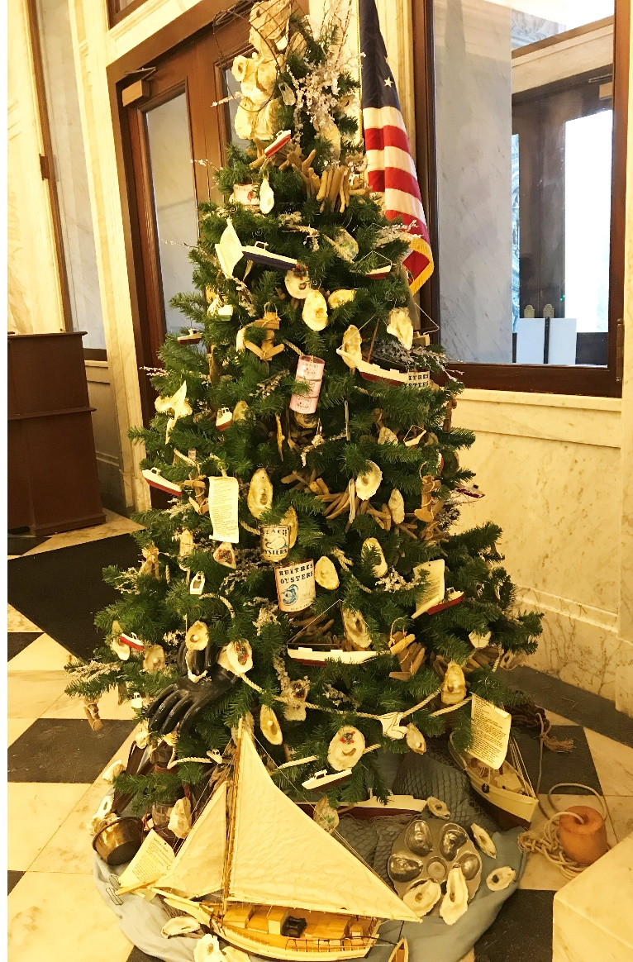
This is an initiative introduced by Governor and Mrs. Hogan as a means of highlighting and celebrating each county in the state during the holiday season from the point of view of history, industry and points of interest. Garden clubs throughout the state are invited to decorate a tree reflective of their respective county which is displayed in the Statehouse rotunda throughout the month of December.

The committee convenes, usually in late summer, to identify a theme for Dorchester’s tree and begin soliciting donated/loaned decorations from our membership in keeping with that theme. For example, in 2018, Dorchester’s heritage, as reflected in the oyster industry, was highlighted and members contributed oyster shell ornaments in their natural or painted state, garlands of driftwood and sea glass, photo ornaments of oyster cans and oyster recipes, workboat models, waterman’s gloves and more.

Curb Appeal Community Awards Program
Periodically throughout the year (seasonally perhaps), club members will nominate one business and one residence whose gardening or outdoor decorating activities do much to enhance the public’s view from the road. The recognized homeowner or business establishment will be presented with a certificate and their award will be noted in the local papers and on Facebook and our website. This award is intended to promote and recognize beautification efforts by non-Club members of our community.

Garden Therapy
As already discussed under Committees, our club conducts garden therapy at Mallard Bay Nursing Home and Pleasant Day Adult Day Care Center, partnerships that have been in place for years.

Patriotic Programs
Our club supports a variety of commemorative events honoring our veterans and armed forces. We typically create wreaths for Memorial and Veteran’s Day observances. The club purchased and had installed a Blue Star Marker which is next to the Chapel at the Eastern Shore Veteran’s Cemetery in Hurlock. In 2020, the FGCMD funded a Gold Star Marker which is now in place adjacent to the Blue Star Memorial. District I and our club have been ardent supporters of the Wreaths Across America program. Members make donations for the purchase of wreaths and help to lay wreaths at the cemetery in December every year. Our district’s participation in this event surpasses the efforts of all the other districts and in the recent past has resulted in a wreath on every one of the 3000+ graves.

Share Our Warmth - Members and guests attending our annual holiday luncheon are encouraged to bring items of clothing for donation to the ‘Share the Warmth’ project conducted by Sunnyside Alliance Church. This DGC project garnered a Community Service Award from the FGCMD in 2021.

Club Communications
The Bi-Weekly Buzz – This bi-weekly e-mail blast is sent to all members every other Friday and provides calendar updates and reminders, recognizes birthdays of club members, contains messages from the President, other officers and committee chairs, posts members’ photographs and anecdotes and features articles on horticulture or design. This tool was initiated in 2017 because so many separate e-mails were being sent to members. We decided to consolidate the information in one communication tool that is designed to keep members connected and engaged between meetings, advising them of learning opportunities outside of the club’s program schedule.

Diggers Newsletter- This beautiful and comprehensive publication is published and distributed quarterly. It features many wonderful photographs of club members and activities and chronicles all that the club does throughout the year. The newsletter may also feature informative articles on ‘garden-y’ subjects or recipes, craft and design ideas.

There are so many additional publications available, many of which we share with The Buzz. NGC produces the quarterly publication, The National Gardener and a bi-monthly newsletter called Keeping in Touch. FGCMD sends out the monthly Gardenews and the State Horticulture Committee pens Tall Weeds, an excellent resource for gardening information. On the district level, Garden Basket is sent out monthly. Of course, the internet is a wealth of information! You can find great articles on every gardening topic imaginable and the majority of garden authors and organizations produce regular newsletters, blogs and podcasts. There are a number of websites listed in the yearbook which are very useful.

Monthly Announcement Sheet-This form was created to save time during the business meeting and to make it easier for members to have information readily available about events taking place outside our regular club activities. We encourage our members to take advantage of training and other opportunities offered by other clubs, the district, the state or by partner organizations, a major advantage of belonging to NGC and FGCMD! The announcement sheet is subsequently sent out as an attachment to The Bi-Weekly Buzz for members who were not able to attend that month’s meeting.


Web Presence and Social Media- As previously addressed, our club maintains a web page (www.dorchestergardenclub.com) and has a Facebook presence. FGCMD also maintains a Facebook page. If we are interested in reaching out beyond our immediate membership, Facebook has broad reach. Note: We must be very careful about showing faces on the web, making sure we have signed permission (media form). We must particularly avoid showing the faces of children or seniors all together. As discussed further on pages 51 and 61, Media Release forms are available and are kept on file with the club.

Club Liaisons- Some members are assigned the names of other members who may be disconnected from club information because of a lack of a computer, email or internet access. The liaison checks in with the member periodically to ‘keep in touch’ and advise of them of important club announcements and activities.

Rack card/business card- The club has designed a rack card for distributing to potential members and for placing in locations throughout the community (such as the Tourism Office, Chamber of Commerce) where residents might seek information about community resources. The business card is produced annually and is given to members for distribution to people who may be interested in garden club. The card provides contact information and a summary of programs being offered that year.

Awards (Club, District, State and National)
Our club has a unique set of awards given annually at our Annual Picnic to recognize members’ achievements. These awards include:
- Horticulture-The Lednum Cup is awarded to the member receiving the highest Points in horticulture exhibition at the club’s mini-flower shows.
- Design-The Tawes Bowl is award to the member receiving the highest points in design competition at the club’s mini-flower shows.
- Horticulture Award for most Points in the Rosa Classification- The Kathryn (Kit) C. Holdt Cup is awarded to the member receiving the most points in the rosa classification at the club’s mini-flower shows.
- Perennial Bloom Award-This award, created by the Central Atlantic Region (CAR) of NGC recognizes long-time members who have made our clubs grow and bloom with their continuous support of our goals and objectives. The executive officers of the club choose a recipient who is recognized at the Annual Picnic and is presented with a certificate and a cash award ($100.00) for the purchase of a tree or shrub for their garden. Clubs may give more than one award but must choose only one candidate whose nomination will be forwarded first to the District and, if selected, on to the State. The state winner is forwarded to the CAR for consideration for the Golden Perennial Bloom Award.
- Volunteer of the Year Award- This award was meant to be initiated in 2020, our 90th anniversary year, but its introduction was delayed by the pandemic which curtailed pretty much all garden club activities. A beautiful, engraved cup will be awarded each year to a club member who has contributed an exceptional amount of service to the Dorchester Garden Club. The Volunteer of the Year is selected by the Executive Board and is given the honor at the Annual Picnic when other club awards are announced.

Scholarship and awards availability outside our club:
NGC and the FGCMD also recognize the breadth of member achievement with numerous annual awards in categories such as flower shows, civic improvement, community service, conservation and preservation. A comprehensive manual about the availability of awards, the application and selection process, and a timeline is available on the FGCMD website to guide clubs through the process. Some awards provide recognition and promote the club or individual achievements, while other awards may offer financial incentive. The awards year is January 1st - December 31st, but due dates vary for different awards.

The NGC and FGCMD Awards Programs recognizes achievement in the following areas:

Awards of Excellence

Civic Achievement

Conservation & Environment

Historic Preservation

& Historic or Memorial Gardens

Horticulture

Horticulture Therapy & Garden Therapy

Landscaping & Landscape Design

Non-Competitive Awards

Operation Wildflower Awards

Promotion

Publication Awards

Service & Recognition Awards

Vision of Beauty Calendar

The NGC Robert Lewis Baker Memorial and Life Scholarships provide grants to college students majoring in landscape design or related horticulture and environmental fields. Garden club members may cultivate these future stewards of the natural world by becoming a Life Member ($75), or by donating to the fund.

General Criteria for Awards Applications:
- Any FGCMD member club is eligible to apply for these awards and, except for those awards given at the club level, applications should be submitted first through the District Awards Chair.
- Generally, applications may be submitted for each award category, however a given project is eligible for one FGCMD award per year and may not be submitted for an award in two consecutive years.
- Applications must be received by the District Awards Chair by October 15th.
- The application form is limited to three printed pages – front of pages only.
- The project or activity must have been completed by October 15th.
- If the same project is eligible for various awards, it is not acceptable to submit an exact duplication of the application.
- State applications are judged according to the size of the club as determined by the number of members on whom NGC dues are paid. Again, Dorchester Garden Club is considered a large club (60 – 99 members) and therefore competes in this category.
- Application forms will not be returned. (Exceptions: publications (books), CD/DVD). Copy applications for your club files.

Some of the Awards Available:
Photography Awards
Yearbook and Publication Awards
Flower Show Awards
Landscape Design Council Awards (Habitat for Humanity, Landscape for Public Spaces, Mae Scott Tapestry Landscape Award)
Gardening Consultants Council Awards (Container Garden, Edible Garden)
Environmental Council Awards (Jean Lowry Sustainable, Landscape Award)
Perennial Bloom Award
Youth Gardening Awards and Contests
Garden Therapy Awards
Membership Growth Awards

Club/District Assets
DGC has the following items/equipment for use at meetings, events or other activities:
- Dell Laptop for use in recording entries in Mini-flower Shows (OS Microsoft 10 and MS Office)
- HP Laptop for use during programs and other club projects
- LCD Projector, EX3260
- Rechargeable Wireless Portable PA System by Hisonic®
- Several Banners and Signs
18” x 24” Foam Board Sign—‘Crafty Gardeners’ Arts and Crafts Guild
4’ x 6’ Outdoor Vinyl Banner with Grommets “Dorchester Garden Club”
24” x 36” Yard Sign “Dorchester Garden Club”
33” x 86” Single Sided Retractable Banner “Diggers Boutique”

In addition, the FGCMD District I has large, retractable banners which clubs may borrow for positioning at the entry to flower shows or other public events. They retract into a small tube and come with a lightweight carrying case.

DGC rents a storage facility in which are stored an extensive inventory of supplies for flower shows, design activities, luncheons, Diggers Boutique, etc. A digital locking mechanism is in place and members accessing this space must sign-in and record what items were retrieved. Information about accessing the storage facility or about the contents held therein may be obtained from the President or his/her designee.

The club also has a post office box which we rent annually where mail is received. This serves as our official address for the Club. The President and Treasurer have a key to the box.
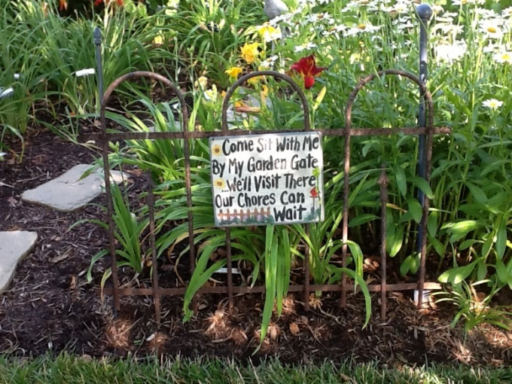
Our historical records (scrapbooks and such) are kept at the Dorchester County Historical Society. Club officers and committee chairs maintain records for their respective activities and are responsible for passing on said materials to subsequent chairs.

Photo by Susie Middleton of Member Karen Collins’ Garden
Flower Show “How-To” -- Competitive Exhibition of Horticulture and Design

We are one of very few garden clubs regionally that hosts Mini-Flower Shows at most of our meetings. The shows have just a few classes of horticulture and design exhibits, but they conform to exhibit guidelines outlined in the NGC’s Handbook for Flower Shows and exhibits are judged. Our mini-flower shows help to expose and educate members about a variety of horticulture species and design types. Our members really enjoy the opportunity and get lots of practice exhibiting. As such, we do very well when competing in Standard Flower Shows hosted by other garden clubs or the district. After you join DGC and exhibit for the first time, you will be assigned an Exhibitor Number. This ensures that judging is anonymous—no one can see your name associated with your exhibit until after judging is completed. Remember this number! It is important.

NGC Flower Shows, which conform to a set of standards outlined in the NGC Handbook for Flower Shows, are free and open to the public and they are popular educational and social events held by garden clubs This title encompasses Standard Flower Shows, Small-Standard Flower Shows, Horticulture Specialty Flower Shows and Design Specialty Flower Shows. They stimulate interest in horticulture and floral design and raise the visibility of the sponsoring club with a view towards recruiting new members.

What is the difference between these types of shows? Put simply,
- Standard Flower Shows require both Horticulture and Design Divisions, and there are specific rules for the number of classes and the number of exhibits in each division and each class.
- Specialty Shows focus on either Horticulture or Design.
- Youth shows,
- General or petite shows,
- Holiday and/or patriotic shows
- Shows co-sponsored with a plant society (e.g., an iris or daffodil show)
- Major Flower Show which is a state or national show or one sponsored jointly with a botanical garden.

No need to go into all this here—it’s all in the Handbook. You will also learn the ins and outs of staging a flower show if you attend NGC Flower Show School. More about that later (page 47).

The club generally puts on a Standard Flower Show every two years or so, however, there is no requirement to do so and the show can be one of the several different types mentioned above. This show is open to the public and is meant to be entertaining and educational by sharing the joys of growing and designing with visitors. This is a very large undertaking with many required steps which are outlined in great detail in the, yes, the NGC Handbook for Flower Shows. Staging a Flower Show is not a fundraising activity as admission is not typically charged. Yet there are significant costs associated with putting on a show. Funds are raised through advertisements (in the flower show schedule referenced below), the sale of lunches or other goods and by soliciting donations. Periodically, DGC will be asked to host or actively participate in a flower show for District I.

Why Should I Exhibit?

Having exhibits judged in a flower show helps everyone learn and improve and does not need to be a daunting or intimating experience. We will help you and it doesn’t have to be difficult. Even if you don’t have a garden—only container plants on a deck or houseplants in your home-- you are able to fulfill exhibit requirements without breaking a sweat! Have a pine bough, potted houseplant or a rose stem and a clear exhibit bottle? Follow the rules and recommendations in the schedule and reference books and you’re done! Entry Point Taken!

Many really enjoy the competitive aspect of exhibiting in flower shows and strive for those blue ribbons and horticulture/design awards. However, this is not for everyone and that is OKAY! Put simply, the purpose of our flower shows is to Encourage, Educate and Inform. They give members a chance to exhibit their gardening achievements and creativity and to get inspired by what others are growing. They are a perfect forum to convey the objectives of the NGC and the joy of gardening.

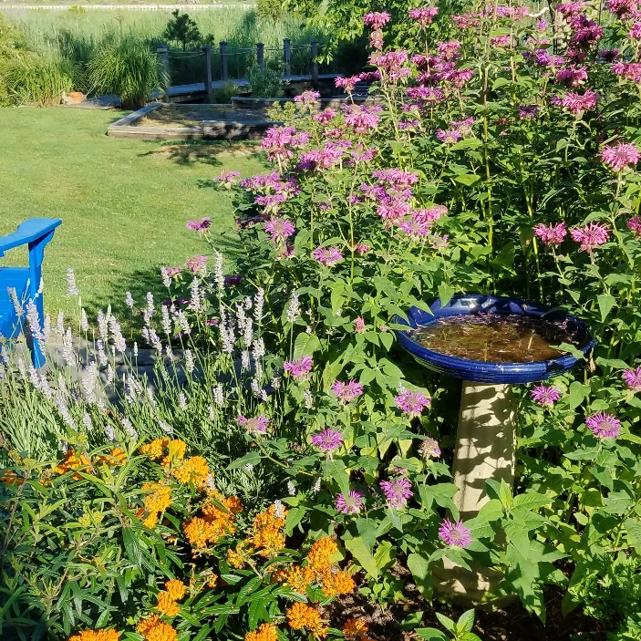

What is a flower show schedule?

The flower show schedule provides guidelines for the exhibitors, judges and the viewing public. It is the ‘Law of the Show’ and should be comprehensive, but concise, complete and clear. Should issues arise in staging or judging a flower show, the NGC Handbook for Flower Shows is the final authority. For DGC mini-flower shows, the schedule is listed for each month in the yearbook and is divided into two divisions—horticulture (Division I) and design (Division II). Each division is subdivided into classes, similar to this:

Division I – Horticulture
Class 1 Rosa (Roses)

a. Miniature single

b. Miniature spray

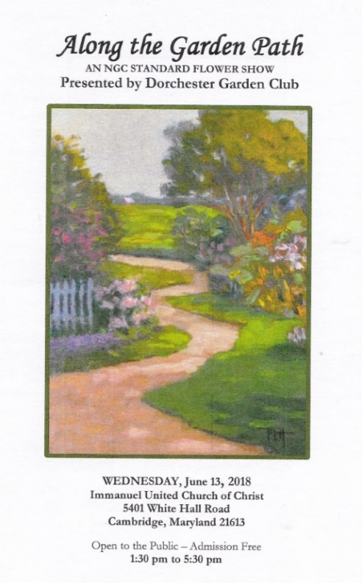
c. Hybrid Tea, Grandiflora

d. Floribunda, Polyantha, Carpet, Climber – one spray

e. Shrubs, Old Garden Rose
Class 2. Conifers – one branch (minimum length 6”/maximum length 24”)
a. With cones or berries

b. Without cones or berries

Class 3. Broadleaf Evergreen Tree or Shrubs – 1 branch (minimum length 6”/

maximum length 24”)

a. Flowering

b. Foliage

c. Fruited

Class 4. Deciduous Tree or Shrub – 1 branch (minimum length 6”/maximum 24”)

a. Flowering

b. Foliage

c. Fruited

Class 5. Ilex (Holly) – 1 branch (minimum length 6”/

maximum length 18”)

a. Foliage

b. Fruited

Class 6. Open Class

a. Annual

b. Perennial

c. Biennial

d. Bulb, corm, rhizome, tuber

Class 7. Iris, Tall or Intermediate Bearded

a. White, cream, yellow, orange or peach

b. Pink, rose, red or brown

c. Blue, purple or violet

d. Blend or bi-color
Class 8. Miniature Iris
Class 9. Bearded Iris – Japanese, Spuria or Siberian

Class 10. Bulbous Iris – English, Dutch or Spanish

Class 11. Any other Iris

Class 12. Container Grown Plants (maximum pot diameter 8”)

a. Flowering

b. Foliage

Designs are exhibited in Division II. For a standard flower show, there are usually many design classes. For our monthly mini-flower shows, the schedule might look like this:

Division II – Design – Great Expectations

Class 1. *HB pg. 74, Section F. Creative Mass Design

Class 2. HB pgs. 70-71, V. A & B American Traditional Line Design. This class is eligible for Companion Design (see p. 31).
*HB refers to Handbook for Flower Shows
Okay, I’m ready to give exhibiting a try….what do I do now?

For mini-flower shows, club members follow the schedule posted for each meeting in the yearbook. The committee members are responsible for recording entry and placement of exhibits, staging and judging consistent with the NGC Handbook for Flower Shows and the supplement publication, NGC Horticulture Exhibiting and Judging. As such, this committee assigns members to serve as Horticulture Judges, Design Judges, Consultants and Clerks for each show. These assignments are listed in the yearbook. It is a good idea to rotate through these positions to learn more about flower show exhibition.

The judges select the exhibits in each class to earn a first place (blue ribbon), second place (red ribbon), third place (yellow ribbon) and Honorable Mention (white ribbon). Each place conveys a certain number of points which are tabulated throughout the year and serve as the basis for horticulture and design awards given at the Annual Picnic.
General Exhibit Information for DGC’s Mini-Flower Shows
- All members should refer to the current NGC Handbook for Flower Shows (rev. 2017) which governs the rules for horticulture, design and judging of all exhibits. Updates and amendments to these rules are published in The National Gardener, an NGC quarterly publication. The Horticulture: Exhibiting and Judging book provides excellent guidance for conditioning, grooming and displaying different plant genera (that’s plural for genus!)
- As stated earlier, active members must exhibit horticulture or design at least three (3) different times during each club year. One exhibit point only will be given per show, regardless of the number of exhibits entered. Still, with multiple exhibits which are awarded ribbons, your points can accumulate, making you eligible for an annual horticulture or design award. Exhibit or entry points are also given for participating in a workshop, for judging or for serving on a design team. Thus, it is fairly simple to fulfill the three-entry point requirement per year.
- All exhibits must be recorded in the Entry Book between 9:00 am and 10:30 am and must be in place before judging begins at 10:30 am. When you arrive at the meeting, check your exhibits in at the entry table where clerks will record and verify the information on your entry card. If you have difficulty identifying the correct botanical name, committee members are there to help. Your horticulture exhibit is then given to the person in charge of placement of entries in the correct classes on the exhibit tables because you are not permitted to place your own exhibit on the horticulture table. However, you DO place your own design exhibit on the design table or in the designated area; how you place (stage) your design ensures it is shown in the best vantage point for the judges’ review.
- An exhibit received after judging begins will receive one exhibit point for entering, but is not eligible to be judged and will be marked “Not in Competition.” A “For Display Only- No Judging Table” may available for members to exhibit horticulture and design which they would like to share with others, but prefer not to be judged in competition.

Rules for the Exhibiting of Horticulture
- Each exhibit must be grown by the exhibitor. Take a stroll in your garden several days before the meeting to determine what specimens you might potentially exhibit. Remember to follow the recommendations for conditioning your plant specimens before exhibiting so they will be viewed at their peak of perfection. Conditioning involves cleaning and grooming your plant specimen, ensuring there are no insects or insect damage, and allowing the cut specimen to acclimate to new conditions before exhibiting.
- It is very important to properly display your specimen in the correct container. Cut specimens should be exhibited in a clean, clear glass container in proportion to the size and shape of the exhibit. You should collect glass containers of different sizes to accommodate your exhibits. These small glass jars are readily available and are inexpensive at flea markets and yard sales, discount stores, antiques stores.
- Container-grown plants must meet the size requirements stated in the schedule (e.g., ‘maximum pot diameter 8”’).
- One exhibit per class or sub-class is permitted. Exception: in Iris and Daffodil classes, up to three exhibits are permitted per class or sub-class, provided each is a different cultivar/variety.
- Each exhibit must be accompanied by a plain, white 3 x 5” index card you prepare in advance stating the category of the exhibit as listed in the schedule, the plant material in exhibit and your exhibitor number. Botanical names must be included in horticulture exhibits, but common names may be added. Plant material on the Invasive Plant List of FGCMD will not be accepted. Plant material on the current FGCMD Protected Plant List is acceptable if obtained from a legal source (not gathered in the wild) and so stated on the exhibit card. On the back of the card you may write your name. It will not be visible during judging, but after the show, others may see whose exceptional exhibit it is!

Division I – Horticulture [The Division, Class and Section are provided in the schedule in the yearbook]

Class 3 Broadleaf Evergreens Trees & Shrubs

a. Flowering

Rhododendron x Encore Azalea [List the Genus & Cultivar]

‘Autumn Princess’

Exhibitor #____

[Put your membership number in bottom right corner] 75

Rules for the Exhibiting of Design
- All designs must be the original work of a single exhibitor (unless otherwise indicated or stated as eligible as a companion design whereby a novice designer is paired with someone more experienced).
- Only one (1) design exhibit is permitted in each class;
- Designers should pay close attention to the specifications listed in the schedule which describes each of the two design classes with regard to design type, theme (often reflected in the class title) and any other requirements.
- Fresh plant material may be purchased anytime, however, exhibitors are encouraged to use garden grown plant material whenever possible.
- Fresh plant material may not ever be treated and artificial plant material may not be used at all; dried material may be treated unless otherwise stated in the schedule;
- All plant material must be listed as shown on a plain, white 3” x 5” index card with either the common or botanical name and must include your exhibitor number.
- Plant material on the current Maryland Protected List may be used only if obtained legitimately, grown in a home garden and is marked as such on the exhibit card;
- In a creative design, the designer has complete freedom to choose components; accessories are permitted unless otherwise stated in the schedule.

Division II - Design [The Division, Class, Title and Type of Design are provided in the schedule listed in the yearbook]

Class 1: “Always in Season”
Chrysanthemum, Wax Flowers and Boxwood

[You must list the plant material in your design. Common names may be used; inclusion of the botanical names is optional.]

Exhibitor #__________

[Put your membership number in bottom right corner] 75

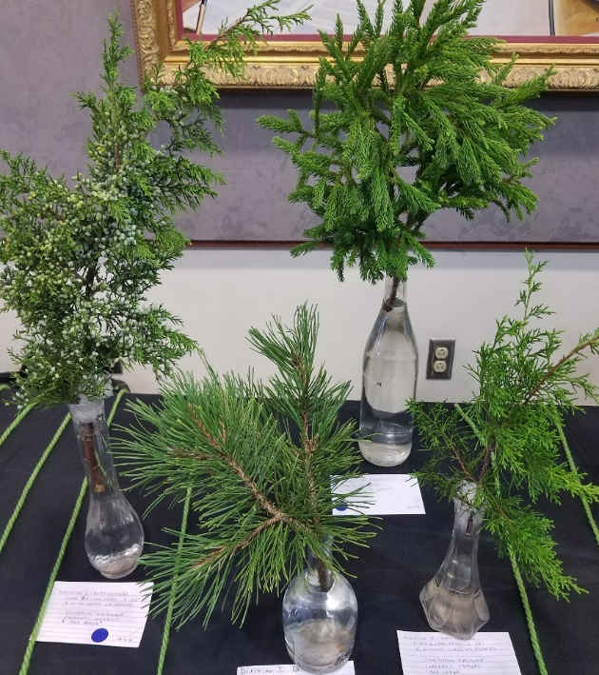
Point Scoring for Judged Horticulture & Design Exhibits in DGC Mini Flower Shows:
First Place (blue ribbon)- 15 points.
Second Place (red ribbon) - 10 points.
Third Place (yellow ribbon) - 5 points.
Honorable Mention (white ribbon) - 1 point.

The points awarded for each entry are tracked for each member; the total point score is used to determine annual awards in horticulture and design which are given at the Annual Picnic in June.

What do judges do and how can you expect me to serve as a judge?

- All club members have the opportunity to serve as judges for our monthly mini-flower shows. If you haven’t entered an exhibit, you will receive an entry point for serving as a judge! Training sessions are held periodically to educate club members about successful exhibiting and judging procedures, however experience is best gained by serving with more experienced judges and taking cues from the consultant assigned for that show. Consultants are typically accredited or Master Judges or those who have more extensive experience with the judging of horticulture and design based on their years of experience in the club. Judging is not an exact science and subjectivity may certainly come in to play, however there are certain guidelines DGC has established to encourage fairness and competence.
- Judges should familiarize themselves, in advance, with the schedule for that month’s flower show and be aware of resources available to assist in evaluating exhibits. The NGC Handbook for Flower Shows should be readily available for the judge to use as a reference. A ‘Quick Guide’ for Judges’ reference has been developed for both horticulture and design (See Appendix ____).
- Judges should avoid the show area before judging begins and base all decisions on the appearance of an exhibit at the time of judging.
- Judges should be knowledgeable of and help exhibitors understand the requirements for the exhibition of floral specimens and designs as outlined in both the schedule and the Handbook. They should assess the work of others exhibiting, either horticulture or design, in a thoughtful manner and judge with fairness and knowledge.
- Judges should serve with integrity, grace and dignity with a consideration for exhibitors and guests. Avoid your own personal preferences in judging (avoid words such as “I like” or “…it would have looked better if…”).
- If judges have questions, they should seek judging assistance from Accredited Judges, the assigned Consultant or the Horticulture Committee members.
- Decline a judging assignment for a class in which you have entered an exhibit.
Criteria for Judging Horticulture
(Cut, Container-grown, Flowering, Foliage, Arboreal, Fruit/ Vegetable/Nuts)

A full-scale of points is available in the Handbook for Flower Shows, but, generally, this is what a judge will look for (See Appendix ____ for a Quick Guide to Judging Horticulture):
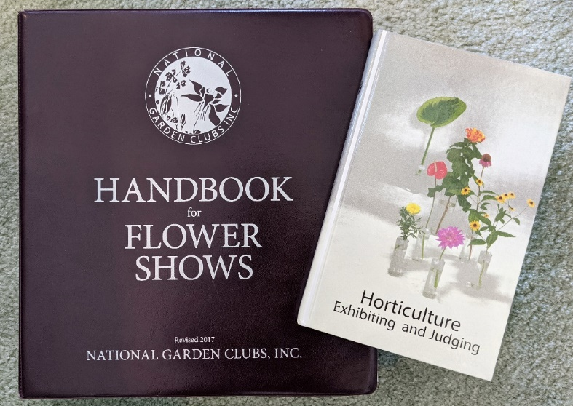
- Conformance
- Plant Identification
- Peak of Perfection
- Form
- Color
- Maturity
- Condition/Blemishes
- Grooming/Staging

Criteria for Judging Designs

The Attributes of Design, as outlined specifically for floral design by NGC, include Beauty, Distinction, Expression and Harmony

The Elements of Design are the basic, tangible and/or visible qualities of all art and include Color, Pattern, Form, Size, Light, Space, Line and Texture.

The Principles of Design are the basic standards used to judge all visual art. Their correct application is necessary for a well-executed design. They include Balance, Contrast, Dominance, Proportion, Rhythm and Scale.

Much more information on the attributes, principles and elements of design is provided in the Handbook for Flower Shows and, again, a Quick Guide for Judging Design can be found in Appendix ____.

What does the Consultant do?

Consultants are assigned to each flower show to answer potential questions of exhibitors, placement personnel or judges. They may be called upon to assist with check-in and placement of exhibits, advise on plant identification or explain schedule requirements and NGC policies, as needed.

What does the Clerk do?
The clerk is there to assist judges and consultants by helping to set up the exhibit area, recording judges’ comments and awarding ‘ribbons’—we don’t actually use ribbons in our mini-flower shows. Colored stickers are placed on the entry cards to indicate the award.

Why Do We Belong to the National Garden Clubs, Inc.
& the Federated Garden Clubs of Maryland, Inc.?

Our garden club does not stand alone. We have close ties with many other like-minded organizations and are part of a much bigger gardening movement globally. We are affiliated with the Federated Garden Clubs of Maryland, Inc. (FGCMD), the Central Atlantic Region of State Garden Clubs (CAR-SGC) and the National Garden Clubs, Inc. (NGC).

We pay dues to these organizations and follow their guidelines for club administration. Belonging to these cutting-edge gardening organizations affords us many resources to help our club grow and our membership blossom! Specifically, they:
- Help us develop programs and find great speakers on a broad variety of topics;
- Provide members with informative print and electronic publications, training and educational opportunities in floral design, horticulture, garden study, conservation and environmental stewardship;
- Engage nationally-recognized speakers at fundraisers and annual meetings;
- Offer opportunities to apply for scholarships to assist students interested in horticulture, landscape design and a host of other related fields;
- Recognize individual and club achievement with a robust awards program;
- Provide the umbrella for our 501(c)(3) tax exempt status; and
- Provide a group insurance policy with liability coverage for our public events

Background
In 1926, the Federated Garden Clubs of Maryland, Inc. (FGCMD) was founded and in 1929, Maryland was one of sixteen charter states that organized into what is now the National Garden Clubs, Inc. (NGC). The FGCMD (www.fgcofmd.org) was incorporated in 1950 and is currently a large network of 85 garden clubs around the State with over 3100 members. It is divided into five districts from the Eastern Shore of the Chesapeake Bay to the mountains of Western Maryland. (See Appendix ___) The FGCMD is part of the Central Atlantic Region of the NGC along with the states of Delaware, New York, New Jersey, Ohio, Pennsylvania and Washington DC.
The office of the FGCMD is located in Baltimore at the Vollmer Center, Cylburn Arboretum. Members of FGCMD were instrumental in the development of the Vollmer Center, a model of green technology illustrating how we can reduce energy use, conserve water and restore our environment.

The organization’s current theme is “Planting Maryland with the SEEDS of Growth through Education” and the seal (page 1) depicts Maryland symbols—the black-eyed susan, an oriole and the Baltimore Checkerspot butterfly, all in the black and gold of the Calvert family arms. Dorchester Garden Club is one of ten clubs in District I of the FGCMD which encompasses all of the Eastern Shore of Maryland.
These are the constituent clubs of District I (See Appendix B):

Chestertown GC
Dorchester GC
Four Seasons GC
Greenfingers GC
Kent Island GC
Oxford GC
Queen Anne’s County GC
Somerset GC
Talbot County GC
Worcester GC

Unless otherwise noted, the FGCMD meets annually on the 4th Tuesday of March. District I holds an annual meeting the 1st Wednesday in March and a semi-annual meeting the 1st Wednesday in October. These meetings are typically held at a large venue and feature an excellent program in addition to a business meeting, awards, lunch and sometimes, vendor shopping.

Throughout its history, the FGCMD has played an important role in reducing the number of billboards along Maryland roadsides and placing and preserving Blue and Gold Star Memorial markers which honor military service personnel and their families. FGCMD partners with the Chesapeake Bay Foundation in planting to protect critical watershed areas and partners in reforestation projects and disaster relief around the country. By raising awareness and practicing what they preach, garden clubs are essential to wildlife conservation. They provide a strong, legislative voice in environmental efforts to promote clear air, clean water and the preservation of wetlands. Our Maryland Federation has been a leader in providing support for the preservation of endangered land and open spaces. Examples of this work include—
- the preservation of Battle Creek Cypress Swamp in Southern Maryland, one of the northernmost stands of the bald cypress, now designated as a National Natural Place, as well as Nassawango Bald Cypress Swamp on the Eastern Shore;
- the preservation of Assateague Island as a National Seashore Park; and
- the preservation of historic properties such as Hammond-Harwood House in Annapolis through the Maryland House and Garden Pilgrimage which was started by FGCMD.

On a larger scale, the National Garden Clubs, Inc. (www.gardenclub.org) is organized into eight regions and 51 State Federations comprised of approximately 222,000 members in over 6,200 clubs around the country, leading the growing garden club movement around our country. In fact, it is the largest group of organized gardeners in the world and one of the largest volunteer organizations!


NGC’s mission is to provide education, resources and national networking opportunities for its members to promote the love of gardening, floral design, civic and environmental responsibility. The basic objective of NGC over the course of its history is knowledge and networking among members across the nation to have one powerful voice.

The current NGC theme, “Plant America—Play Outdoors,” inspires the direction and programming of the organization across the country. NGC is headquartered in St. Louis, adjacent to the world-famous Missouri Botanical Gardens. The official seal of the NGC, adopted in 1931, is the columbine, chosen because it is so widespread in our country. Its Latin name, Aquilegia, suggests that of an eagle, Aquila, our national bird. Its common name, columbine, comes from the Latin columbus meaning dove-like or peace loving.

One of the signature resources of NGC is the presentation of four comprehensive ‘schools’ which provide members and non-members with a range of educational opportunities to increase their knowledge of the environment, expand interest in gardening, embrace creativity in floral design and beautify homes and communities using landscape design principles. More information on the NGC schools can be found on pages ____ or on the NGC website. Successful completion of these programs can result in certification and opportunities for continued education and training.

The state and national programs are funded by membership dues paid by all our clubs to the FGCMD. We pay $11.00 per member (active and associate) to FGCMD; $1.00 of each member’s dues goes to NGC and $.50 per member is returned as a rebate to each district. Clubs pay the district $1.75 per member. These dues support our many educational and outreach programs. For example, FGCMD awards two scholarships annually to college students whose major course of study is in a field consistent with FGCMD’s mission.

FGCMD provides guidance and information for members interested in Youth Gardening and Garden Therapy outreach activities, or in establishing or renovating Blue Star Memorial Markers to honor men and women of the U.S. armed services, past and present. Funds from the Alice Rush McKeon Trust are used by each of the five districts, in turn, to beautify roadsides in their area with the planting of trees. We partner with local conservation and environmental groups, plant societies and similarly-purposed organizations to inform members and coordinate hands-on opportunities to learn and participate.

Just so you know, there are many garden clubs that are unaffiliated or are part of another gardening organization such as the Garden Clubs of America. Their mission and goals are very similar to clubs in NGC, however their focus and priorities may differ slightly.

Our association with NGC also provides ways to honor special members

- PERENNIAL BLOOM AWARD - NGC garden clubs have been privileged to have long-time members who, like the faithful perennials in our gardens, have made our clubs grow and bloom with their continuous support of our goals and objectives. Serving as officers and chairmen over the years, their love of gardening has planted many a seed for garden club programs and events, while their enthusiastic leadership has inspired members to nurture these seeds into successful bloom. In grateful appreciation for their support, a Perennial Bloom Award may be presented to them and a tree or shrub planted in their honor. The deadline for an individual club to select a Perennial Bloom recipient is June 1st. Further details on the selection of recipients and forwarding awards applications to District, State and Regional levels can be found in the annual FGCMD Awards Manual on their website.

- PURCHASE OF A FGCMD LIFE MEMBERSHIP -Funding for FGCMD scholarships comes from Life Memberships and the generous support of garden clubs and individual members. To support scholarships, please consider giving a gift to honor a club member who has served your garden club. A donation to FGCMD Life Member is $75. Additional non-life member donations, memorial or honorary contributions to the FGCMD Scholarship Fund are appreciated and may be sent to the FGCMD office; donations to scholarship funds are tax-deductible.

- HONOR A CLUB MEMBER WITH CAR-SGC LIFE MEMBERSHIP - Life Membership in CAR-SGC is an honorary title often awarded to a garden club member by local or state garden clubs to recognize an incoming or outgoing President, the chair of a successful fundraiser or committee, someone celebrating a milestone anniversary in your garden club, or any CAR-SGC member that you, your club or even a family member wishes to honor. ​A donation to the CAR-SGC Scholarship Fund is $50.

- NGC LIFE MEMBERSHIP - Your choice of becoming a NGC Life Member or honoring another individual with a Life Membership demonstrates your commitment to the youth of our nation. Your gift of $200 to become a Life Member is shared equally by the Scholarship Fund and the Permanent Home Endowment Fund. The recipient is invited to attend the National Life Member Banquet at all conventions, and a portion of the contribution is tax deductible.

- THE GIFT OF EDUCATION – Scholarships to an FGCMD School - You may also honor a club member by giving a scholarship to attend any of the FGCMD Schools: Environmental; Flower Show; Garden Study; or Landscape Design.

NGC Provides Our Club Access to Unique Grant Programs
The NGC strives to assist clubs in projects that support our shared mission. Monetary grants from NGC or supplies from organizations are available and include the Plant America Community Project Grant, the Ames Tools Grant, the Natural Disasters Grant and the Native Plant and Wildflowers Education Grant.
- PLANT AMERICA GRANTS – Plant America is focused on education, supporting and building America’s garden communities. This theme is chosen to help NGC members and the public return to the ‘roots’ of why most members join garden clubs—to learn about gardening! Individual member garden clubs may apply for this grant. Projects submitted for receiving a grant may be a joint venture with another organization/s. Up to $1000 is made available for direct expenses of projects. The application deadline is October 15th and funds are awarded the following January.

The scope of these projects in communities may include:
  - Beautification and/or restoration
  - Community gardens
  - School gardens/classrooms
  - Landscapes for Habitat for Humanity Homes
  - Landscaping of Blue Star Memorial Markers
  - Implementation of environmental practices
  - A horticulture or environmental education event for the public
DGC was a recipient of the very competitive Plant America grant in 2018 and the funds were used to purchase beautiful and informative signage for our civic garden projects.

- ESPOMA & NGC WANT TO PLANT AMERICA! - National Garden Clubs is excited to continue its partnership with the premier provider of organic plant foods and potting soils – The Espoma Company. Espoma is a manufacturer of organic fertilizers for gardeners nationwide and offers over 70 organic products and manufactures over 50 million pounds of organic fertilizer per year. Espoma’s commitment to environmental sustainability extends to its manufacturing facility that is 100% solar powered with panels covering 67,000 sq. ft. and producing over 810,000 kilowatt hours of electricity - enough to power over 70 homes for a full year. This saves more than 1.6 million pounds of greenhouse gas emissions annually and reduces as much C02 as planting two million trees. Members of NGC are passionate about growing with a purpose and The Espoma Company wants to help. NGC selects up to 20 clubs to receive a $250 grant for their plant foods and potting soils. Grant applications are accepted October 1st through May 31st.

- AMES TOOLS GRANT- Ames has set aside funds for garden tools to be used for local community gardening projects. Grants for tools with a total retail value of no more than $250 are available. NGC clubs are eligible to apply for these grants for gardening projects performed or supported by the club which are scheduled to be carried out March 1st - September 30th. Projects may be a joint venture with another organization, however the garden club applying must be a member of NGC. Awarded tools will be shipped to the successful applicants about two weeks following their notification as grant recipients.

- NATIVE PLANTS AND WILDFLOWERS GRANT- A grant of up to $500 is available to be used towards direct expenses for an educational program on the subject of native plants and wildflowers. State Garden Clubs, districts, councils and individual garden clubs may co-sponsor a symposium with state agencies, arboreta, native plant societies, or similar organizations. Gardeners are eager for information on native plants; state highway or transportation departments need publicity and support for their planting programs. Programs should address one or more topics on
- Native flora: endangered species, plants for butterflies, plants for special habitats, identification using keys, invasive species management, etc.
- Public planting: state highways, rest areas, preservation of community natural areas.
- Propagation of wildflowers.
- Designing native plant gardens or developing nature trails.

- YOUTH POLLINATOR GARDENS GRANT - National Garden Clubs, Inc. is excited to provide a grant opportunity for garden clubs working with youth clubs or groups planning and planting Pollinator Gardens. Grants, up to $200, are available for projects that include educational materials on the vital role pollinators play in nature and youth involvement in planning and planting gardens providing nesting and food sources for pollinators. Youth will learn the importance of providing appropriate food sources, nesting areas, shelter, and practicing sustainable gardening practices for pollinators by planning, planting, and maintaining these pollinator gardens.

For more information about grant opportunities, visit the National Garden Club website (www.gardenclub.org).

Become Involved in National & Regional Programs that Benefit the Public Good

- PLANT AMERICA- As the premier volunteer gardening organization in the world, NGC is uniquely positioned to fight climate change by planting at least 165,000 native trees every year—one for every member. Worldwide tree-planting initiatives for carbon sequestration help offset loss of flora due to natural disaster and intentional deforestation. NGC encourages members to involve their communities in this ‘Each One, Plant One’ effort.

- PENNY PINES – This is a partnership of NGC and the USDA Forest Service to sustain forests through reforestation and education. Our garden club can participate in a meaningful and practical conservation project by contributing $68.00 to a Penny Pines plantation as part of the costs of replanting replacement trees indigenous to a particular damaged area in a National Forest. Whether by fire or by other natural catastrophe, pine trees and other trees are replaced. You may designate a specific state you wish to have benefit from this contribution.

Under a conservation agreement, the forest service will do the planting, using your donation together with federal funds, and will provide to the plantation the same protection from fires, insects, and disease given other forested areas. The plantations are a part of the regular national forest reforestation program planted on burned-over and brush-covered areas which are potentially productive timberlands. Planting sites are selected by the supervisor of each national forest. These plantations provide soil protection, watershed protection, soil stabilization, future harvestable timber, as well as beauty and shade for recreation.
States, regions, districts, clubs, and/or individuals may participate in this program by donating in multiples of $68. The donation may be made in honor or in memory of ONE individual, organization, or theme.

- NATURAL DISASTER USA FUND - Disaster USA Fund was established by NGC to receive monetary contributions from states, clubs and individuals for the purpose of assisting local and state clubs with their garden-related restoration efforts. This fund has helped to replant parks, municipal gardens and other garden related sites due to natural disasters caused by floods, hurricanes, earthquakes, tornadoes, ice storms and wildfires. Internationally, projects to provide safe drinking water to Guatemala and bio-filtration for earthquake-damaged Haiti have been implemented as needs arise. Locally, Disaster funds have been awarded to Ellicott City, MD in the wake of two catastrophic floods.

“Garden Club members love gardening; they are interested in their communities; they are concerned for their environment; they want to conserve our natural resources; they take pride in their heritage. They know that by combining their efforts they can achieve a better world.” ngc
GRow Your World
Green Your Community

Grants of up $5000 per project may be awarded in a fiscal year to local or state clubs. The Natural Disaster USA Fund is supported solely by the generous donations of dedicated garden club members and has extended a helping hand by awarding grants to many fellow garden clubs across the country. All donations are tax deductible and are gratefully acknowledged!

- Habitat for Humanity – NGC and HFH partner to engage volunteers in landscaping projects that assist HFH-qualified homeowners in establishing low-maintenance, environmentally-friendly gardens.

- GLOBAL PARTNERS RUNNING WATERS, INC. is a nonprofit organization working in cooperation with the United Nations, to increase access to safe water in Latin America. 1.1 billion people around the world currently get their water from rivers, ponds, or other sources subject to contamination. Donations made through NGC will help to bring safe drinking water to villages.

More Reasons Why We Affiliate With NGC & FGCMD

Many topical workshops, lectures and demonstrations enhancing member interest in design, horticulture, conservation, legislation and other subjects are sponsored by FGCMD and NGC. Members are encouraged to avail themselves of these opportunities as, often, the speakers are nationally-recognized and their fees would probably not fit our Club budget! Members receive notification about these educational programs through our Club publications, e-mails or in other newsletters from garden organizations.

In addition, there are four different NGC councils that conduct schools offering comprehensive instruction in the Environment, Flower Shows/Judging, Gardening and Landscape Design. The courses and exams are open to everyone, however, the Consultant Certification Card awarded upon successful completion of a school is issued only to members of NGC. Each of the following schools are offered in four parts (courses). For those who wish to take the courses for credit and attend all four sessions of a given school, completion leads to a certificate as a consultant.

Schools of Study:
Environmental School focuses on the appreciation of the natural world. Courses teach participants environmental literacy, encouraging action for sustainable development and an appreciation of the interrelation of all natural things. Particular emphasis is presently placed on land conservation, water conservation and air quality.
Flower Show School focuses on floral design, horticulture and flower show procedure with the primary purpose of training those wishing to become Flower Show Judges. Participants are welcome to attend this school even without the objective of becoming a Flower Show Judge. The horticulture curriculum consists of information on techniques from plant selection and culture to preparing show-worthy specimens and superior container plants. Design instruction encompasses traditional floral arrangements through contemporary styles, including table settings.
Gardening School focuses on increasing knowledge of gardening skills and horticulture. Courses cover all aspects of growing including basic botany, soils, growing annuals, perennials, trees and shrubs, fruits and vegetables, lawns, pests and diseases of plants, plant classification, pruning and related subjects. Additional topics and areas of interest that may be covered are subjects such as Reconciliation Ecology (the science of inventing, establishing, and maintaining new habitats in places where people live, work, and play), and creating backyard habitats to help endangered species such as pollinators and amphibians.
Landscape Design School (LDS) focuses on both natural and built landscapes. The LDS curriculum covers a wide range of subjects from landscape design history to landscape architecture, and a design approach intended to make garden spaces more beautiful, useful, convenient, ecologically-sound and easily maintained. Also offered are many optional programs, such as conferences, symposia and tours.
Some additional things you may need/want to know:
Calendar Posting Procedure
Member clubs may post their events on the State calendar which may help garner more participation, especially important for the success of fundraising activities. A very detailed calendar of events, including major religious and secular holidays, is posted on the FGCMD website which provides tremendous exposure for garden club events, particularly fundraisers and flower shows where the aim is to attract and educate as many visitors as possible. When scheduling a club event, it is wise to check with this calendar to avoid double-booking and scheduling conflicts. The state-wide publicity advises other clubs of our open events and demonstrates to web browsers and prospective members the breadth of garden club activities around the state. Calendar postings should be e-mailed to the FGCMD Office Administrator (website@fgcofmd.org). All information should be in an attached Word document (not in the text of the e-mail) and include the event sponsor, date, time, location and type of event along with any contact information. Due to copyright issues, postings are limited to text only; no photographs or art unless permission has been granted.

Conflict of Interest Policy
In applying this policy, the term “interest” shall include personal interest, interest as director, officer, member, stockholder, shareholder, partner, manager, trustee or beneficiary of any concern and having an immediate family member who holds such an interest in any concern. The term “concern” shall mean any corporation, associate, trust, partnership, limited liability entity, firm, person or other entity other than the organization.
No director or officer of the organization shall be disqualified from holding any office in the organization or with any entity of which the organization is an affiliate. No transaction of the organization shall be voidable by reason of the fact that any director or officer of the organization has an interest in the concern with which such transaction is entered into, provided:
- The interest of such officer or director is fully disclosed to the Board of Directors;
- Such transaction is duly approved by the Board of Directors not so interested or connected as being in the best interests of the organization;
- Payments to the interested officer or director are reasonable and do not exceed fair market value;
- No interested officer or director may vote or lobby on the matter to be counted in determining the existence of a quorum at the meeting at which such transaction may be authorized;
- The minutes of meetings at which such votes are taken shall record such disclosure, abstention, and rationale for approval.

Liability Insurance Coverage
There is no need or requirement for clubs to show evidence of insurance if they go out collectively as a group to tour someone else’s gardens, facilities or even to lunch afterwards. The exception to this is if they sign a rental/lease contract at a third party’s facilities for hosting a function or a sales/display stall. In these cases, individual clubs are covered under the insurance umbrella of the FGCMD. The liability coverage is underwritten by AssuredPartners of MD, LLC in Severna Park, MD. The Certificate of Liability Insurance can be found on the FCMD website, should a club need to present proof of insurance.

Logo Use
The FGCMD logo may be used on print materials and related items only in conjunction with the name of the District/Council/Garden Club and with the approval of FGCMD, Inc. The logo may not be used commercially or on documents that are in conflict with FGCMD policies or procedures (i.e., political statements). The logo must be used as provided by FGCMD with no changes to proportion, text or design. Further information is available on the FGCMD website.

Media Release
Our digital age makes it so easy to share information in many forms, however it is also easy to unwittingly violate copyrights by using photos/articles and other information without permission. Legal action and fines may be levied for infringement of the law. It is important to be cautious when sharing digital information, particularly photographs--whether taken by a club member or pulled from the internet. Care must be taken when photographing children under 18 years of age or vulnerable seniors who are clients of care facilities. Facial images may not be used—only rear shots. If a club has a website or publishes digital or print newsletters, the editor should be aware of these issues. This does not preclude using photographs taken by club members or information that is publicly available as long as they are attributed to the author/site, used with permission and do not entail a potential copyright infringement. A FGCMD Media Release Form is provided in the Appendix and should be signed by club members and kept on file.

Non-discrimination Statement
The DGC and FGCMD operates on a non-discriminatory basis without regard to race, creed, color, religion, gender, age, disability, sexual orientation or otherwise.

Raffles of Personal Property/Gambling
Raffles of personal property (generally defined as all property other than real estate) are usually governed at the county level in Maryland. Many counties and Baltimore City require non-profit organizations to apply for a gambling license or permit before conducting a raffle or selling raffle tickets in a county, even if the raffle is conducted in another county. According to the Clerk of the County Court, Dorchester County does not require licensure for 50/50 or other types of raffles; only for events such as casino nights, Texas Hold ‘Em events, etc.
APPENDICES
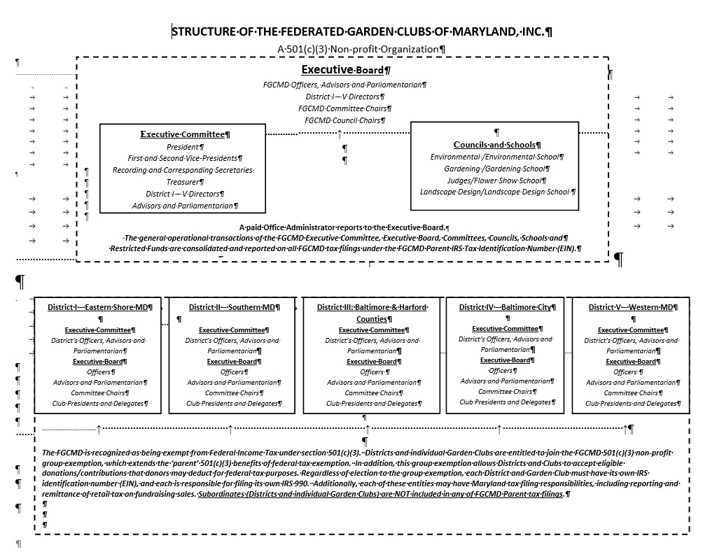
Appendix A
Appendix B
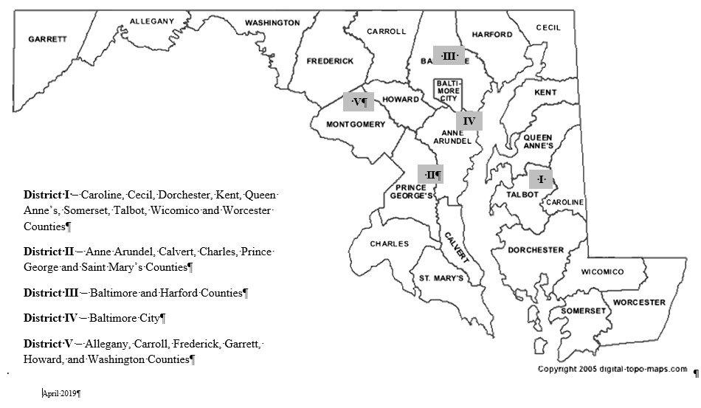
The Five Districts of FGCMD

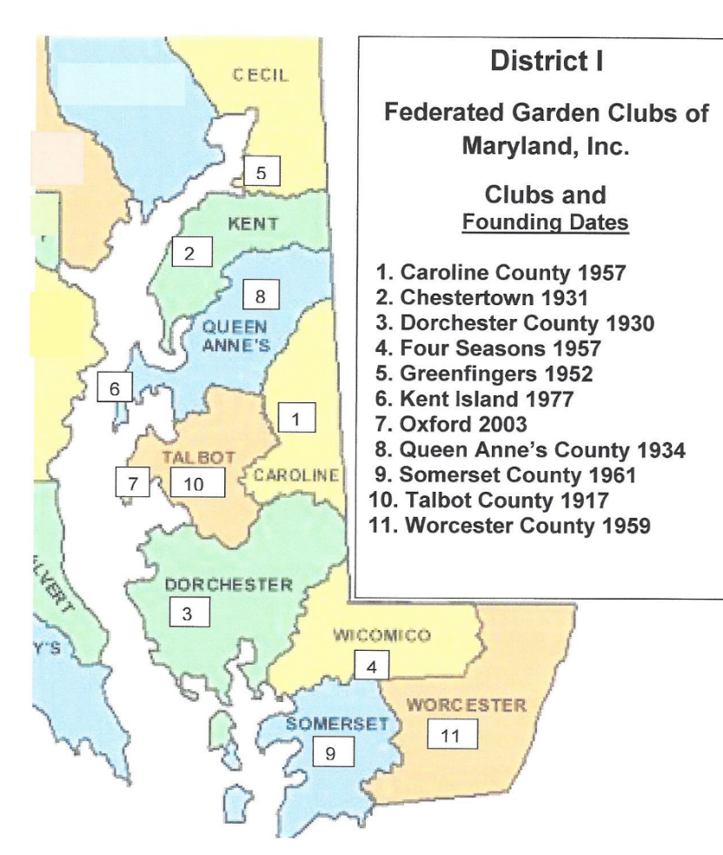

Note: Caroline County Garden Club is no longer affiliated with the FGCMD. Map will be amended.
Appendix C
Summary of Parliamentary Procedure
According to Robert’s Rules of Order, Newly Revised, parliamentary procedure is the name given to the tradition of rules and customs for deliberative assemblies (organizations that meet to decide on actions to be taken). DGC operates according to these Rules. They specify the process for orderly discussions, voting procedures, rules for debate, voting procedures, decision-making and the documentation of by-laws. We will not go into these subjects here but Robert’s Rules of Order is an excellent resource when issues arise.
What is Parliamentary Law?
- Courtesy and Justice for all.
- Consider one thing at a time.
- The Minority must be heard.
- The Majority must prevail.
Order of Business/Sample Meeting Agenda
Call to Order by President- “The Chair”/Opening Exercise (Pledge of Allegiance)
Note: The Chair always stands when addressing members. Committee Chairmen and Officers stand when giving their reports, always addressing the Chair first: “Madame/Mister Chairman/President.”
Minutes of Previous Meeting read or reviewed by Recording Secretary
After any additions or corrections by a member, say “Approved as Read (or Corrected),” usually by general consent. No motion to approve is needed.
Minutes are the written record of the proceedings and should include:
Date
Time
Place of Meeting
Presence of President and Secretary or their substitutes
Approval of Minutes of Previous Meeting
Treasurer’s Financial Report
Record of Actions Taken, including all main motions whether adopted or lost (but not if withdrawn); name of maker (but not seconder) of the main motions
Time of Adjournment
Signature of Recording Secretary
Treasurer’s Report read by Treasurer
After any questions or corrections, say “the Report Will Be Filed.”
Example of a Brief form for Treasurer’s Report:
Balance on Hand (date of last report)
Receipts (for Current Month)
Expenses for Current Month
Balance on Hand (date of present report)
Signature of Treasurer
Reports of Officers and Standing Committees (2-3 minutes; may be on a rotation)
Reports of Special Committees
Unfinished (not Old) Business
New Business
Announcements
Adjournment by Presiding Officer

In our club, lunch follows the adjournment of the meeting and then the program is conducted.

What is a quorum? This is the minimum number of members who must be present (as stated in our By-Laws) for a meeting to conduct substantive business.

How to Make a Motion—“I move that…”
- Motions are used to present business to the assembly for their consideration. All important issues should be acted on by a motion and voted on by the organization.
- Instruct your Board and Members the correct manner to propose a motion. Never say “I make a motion that...” but say “I move that...”
- Until a motion is stated by the Chair, the mover may withdraw or modify it without consent of anyone. After the motion has been stated by the Chair, it is before the members present for consideration and action; it cannot be withdrawn or modified without the consent of those present.
- Before any motion is open to debate it has to be made, seconded and most important of all, stated by the Chair.
- Refrain from discussing a motion when presiding. Put all motions to a vote after discussion and state the results. A motion is not complete until the negative vote is taken and the results stated by the Chair.
- Instruct your Secretary that all motions should be entered in the minutes except those that are withdrawn. Minutes are the legal record of your activities so the motion should be recorded exactly as approved. Minutes record the maker of a motion, but not the seconder.

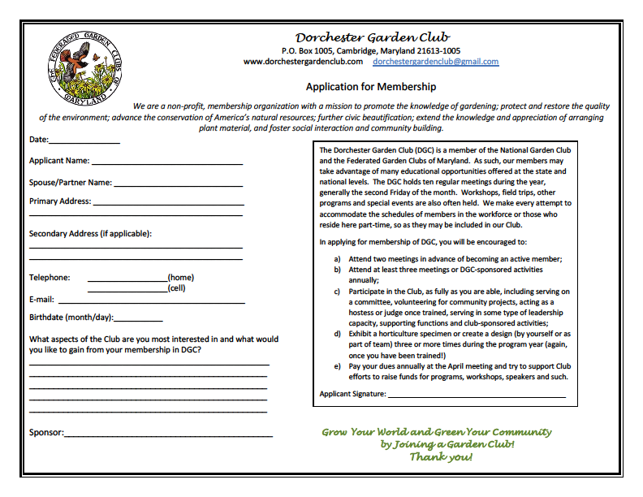
Appendix D

Appendix E

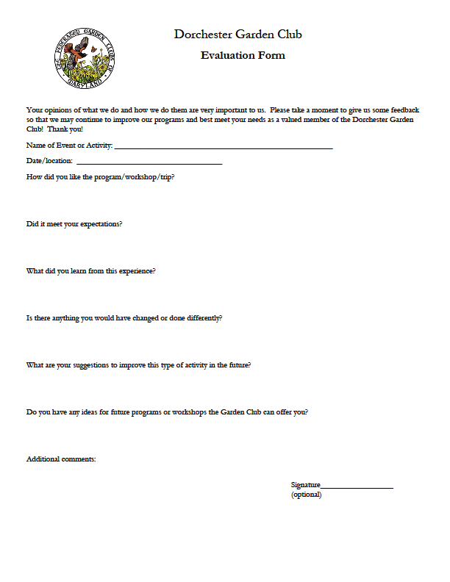
Appendix F – Sample Dues Analysis--ReDo
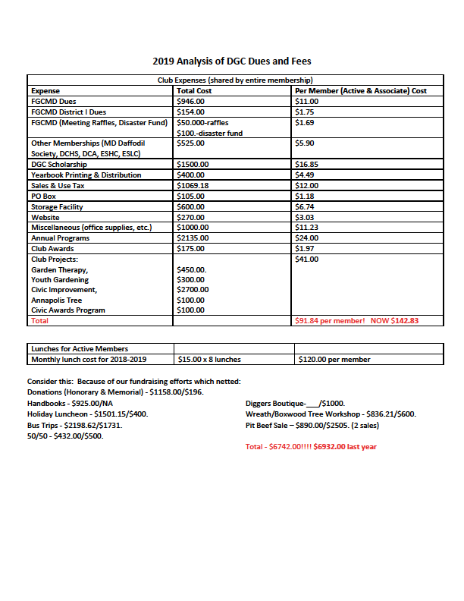

Appendix G--Financial Forms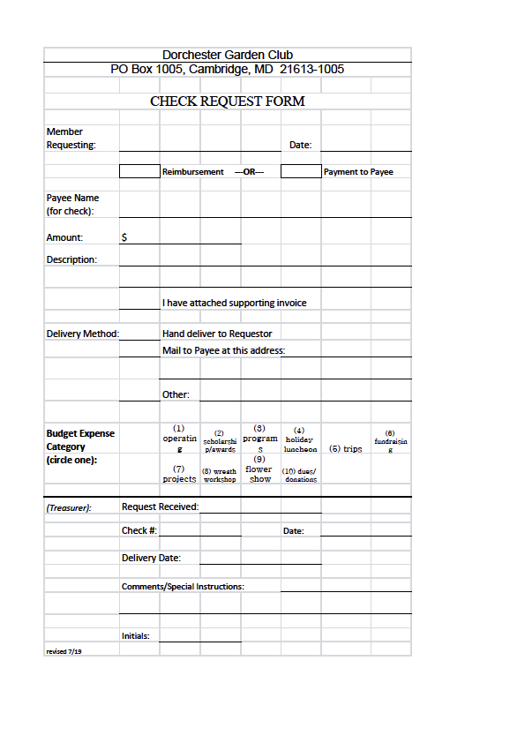
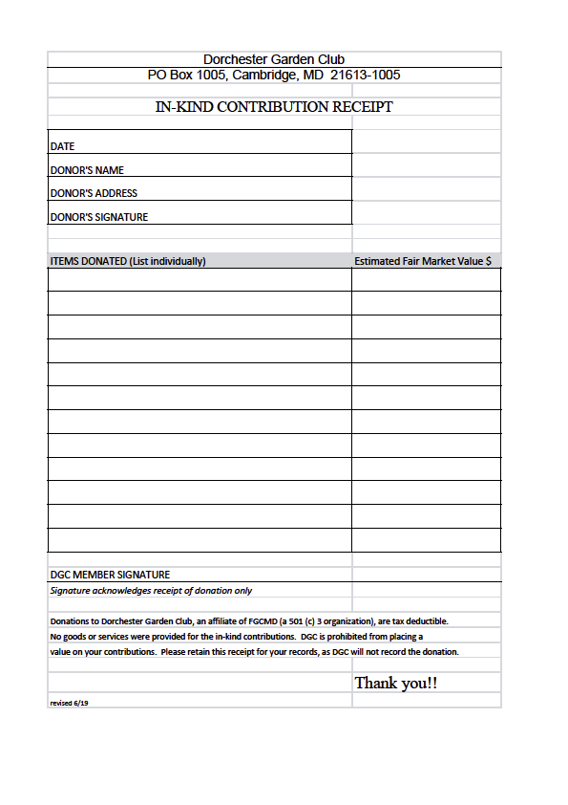
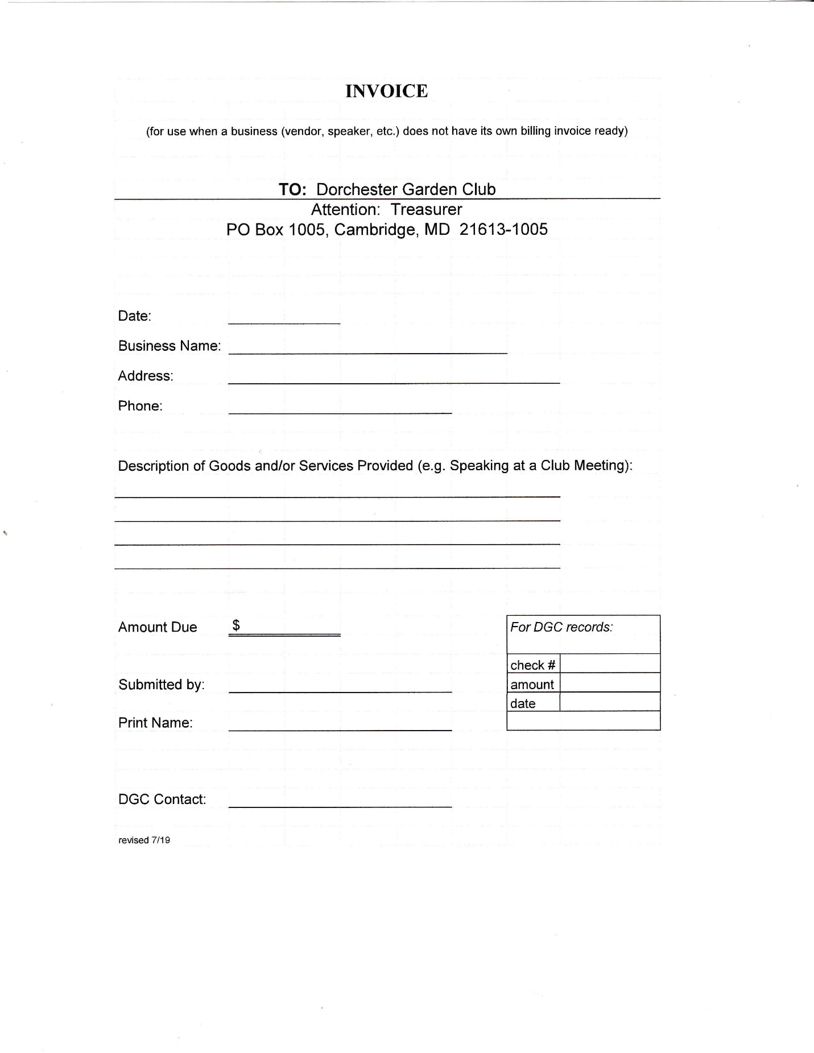
Appendix H--Media Release Form

Appendix I-- Quick Guide to Judging
What Judges Look For – Horticulture
Cut, Container-grown (Flowering, Foliage, Arboreal, Fruit/Vegetable Nuts)
- Conformance – Adherence to the class’ requirements. Judges are the final arbiters.
If requirements not met – ALL POINTS MUST BE DEDUCTED
- Plant Identification
  - Genus, Species, + Variety, Cultivar as required
  - Formatting - Genus (Capitalized, underlined) species (lower case, underlined.)
  - Legible
- Peak of Perfection
  - Form
    - For cut specimen exhibits, FORM includes leaves, stems, flowers, fruit, berries, cones
    - For Container grown – FORM as above + overall shape of the plant
    - For fruits/vegetable/nuts -FORM is only the actual shape of fruit/vegetable/nut
    - Symmetry
    - Exhibit characteristic of specimen
  - Color
    - Even, pure, distinct color
    - Consistent variegations, spotting, if applicable
    - Color ideal for specimen
  - Maturity
    - Ideal bloom stage (No wilting, fading, creping)
    - Foliage fully expanded leaves
    - Container-Grown – new growth
    - Arboreal – at least 3 nodes and apical bud present
    - Fruit/Vegetables – table ready
  - Condition/Blemishes
    - Well-conditioned – hydrated
    - Free from mechanical injury
    - Free from insect and weather related damage
- Grooming/Staging
  - Grooming
    - Clean
    - No dead or Damaged parts
    - No wax or polishes
  - Staging
    - Proper Positioning – unobtrusive wedging
    - Clean, unobtrusive containers
    - No foliage below water level
    - Stem length Proportional to flower
    - Container grown centered in pot, soil clean, plant/pot proportional

