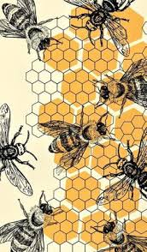
February 2026
The DGC Buzz
President’s Message
As I sit here and write this, I am looking out on my front yard and it looks like an ice rink…too bad I don’t have any ice skates! I hope you and your family were safe during this last week with the cold weather. Makes me look forward to Spring even more :)
On January 16, about 17 of us met here in my barn and planted forced tulip bulbs. Mary Ann Moore gave us a quick lesson on how to force bulbs and then we went about planting them. I am keeping my fingers crossed that mine will bloom in a few weeks to provide some much needed “flower power” in the house.
Coming up at our February 13th monthly meeting, we will be treated to an English tea! Connie Glover and her team have been working diligently to provide a beautiful table setting complete with finger sandwiches and tasty desserts, plus delicious tasting tea. Let’s get in the spirit and wear a decorated hat or fascinator and bring your favorite teacup and saucer. It should be lots of fun ….REMINDER: the venue has changed from the Center for the Arts. We will be meeting at the Eastern Shore Hospital Center (the Center for the Arts is under renovation) Hope to see you then.

Information has been sent out this past month regarding one of our horticulture classes (dish gardens) as well as Alice in Wonderland posters for the Class 2 Design Interpretation in the Mini-Flower Show. I encourage many of you to give these fun classes a try. Can’t wait to see your entries. Let me or Jeanne know if you need the information resent.
Stay warm, Sandy
And a pox on the head of Puxatawny Phil!
Mark your calendars with many great events and learning opportunities in the coming months!
The New York Botanical Garden is offering many virtual classes on subject matter from composting to landscape design to pruning and so much more. Visit https://www.nybg.org/ for more information
February 9, 2026 FGCMD Photography Zoom Workshop: Prune Your Photos 1 pm
Visit www.craft.andrewlinke.com/garden-photography to register.

February 10, 2026 Mosses, Ferns and Grasses: Serene and Sensuous Plants for the Garden with Bill Cullina, a Zoom seminar sponsored by the Horticultural Society of Maryland. “Serene, sensuous, and deer-proof, ferns, moss, and grasses serve as a lush canvas for colorful blooms. These elements bring a level of refinement and sophistication to the landscape that flowers alone cannot match; indeed, no garden is truly complete without them. They provide a rich, verdant background with the invaluable benefit of being unpalatable to deer.” For details: https://mdhorticulture.org.
February 10-13, 2026 Annual Flower Seminar at Washington National Cathedral—See full information below**.

February 13, 2026 Note Change! Meeting location has been moved to Eastern Shore Hospital Center as DCA is under renovation.

February 28 – March 8, 2026 2026 Philadelphia Flower Show:
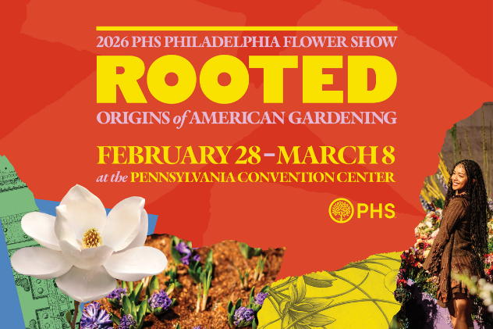
ROOTED: Origins of American Gardening

According to the Pennsylvania Horticultural Society, “Gardens aren’t just made; they’re passed forward through generations, carried across land, oceans, and lifetimes. Whether it’s the nostalgia of a grandparent’s garden, a beloved family recipe that begins with the bright scent of freshly picked herbs, or the practices that shape how we gather, ROOTED brings to life the personal stories, cultural traditions, and horticultural inspiration that connect us to nature and each other. The 2026 Flower Show marks the final chapter in a three-year trilogy of themes exploring gardening across time. United by Flowers (2024) current connections and community, Gardens of Tomorrow (2025) sparked imaginations of the future, and ROOTED (2026) looks to the past to honor the origins of today’s gardens.” Visit https://phsonline.org for more information.

March 4, 2026 District I Annual Meeting at Prospect Bay Country Club. If you’ve never seen horticulturalist and designer of outdoor containers ‘extraordinaire,’ Kent Russell, aka The Garden Guru, you won’t want to miss this very entertaining and educational program. Kent always offers many beautiful plants for sale and those shoes! You’ll just have to experience this guy. His program is called ‘The Sensational Spring Garden.’

March 25 & 26, 2026 Landscape Design School, Course 2, DoubleTree Hotel in Columbia, MD. Visit the NGC website for more information on this and the other three special schools.

April 18-19, 2026 The Leesburg Flower and Garden Festival. This will be the 36th year for the show which was founded in 1990. You can wander the vendor-filled streets of beautiful and historic Leesburg and be regaled with horticulture vendor after horticulture vendor. In the evening, if you make reservations early, you can enjoy superb dining at one of several excellent restaurants in the town.

April 28, 2026 FGCMD Annual Meeting at Turf Calley Country Club in Ellicott City.
Annual Meeting Program: Linda Harris, Program Laison Our program for the FGCMD Annual Meeting on April 28, 2026 will be titled “Night Sounds of Mountain Maryland,” presented by Kevin Dodge, Professor and Director of the Natural Resources and Wildlife Technology program at Garrett College in far western Maryland. Kevin will present an entertaining and educational introduction to the different hoots, toots, peents, and peeps heard after sunset in the Central Appalachians. Weaving together facts, stories, and sounds, Kevin will recreate a night in the mountains of western Maryland.

May 2, 2026 The Ladew Topiary Gardens GardenFair. This show is in its 17th year and is among the finest gatherings of top tier horticultural vendors in the country. The venue is rated as one of the top five gardens in the United States and it is at its peak viewing during the month of May. (https://ladewgardens.com).

May 11, 2026 FGCMD Photography Zoom Workshop: Harvest Your Best Shots 1 pm
Visit www.craft.andrewlinke.com/garden-photography to register.

May 14, 2026 DGC Field Trip to Chanticleer Gardens, Wayne, PA Flyer Attached

May 2026 Maryland House and Garden Pilgrimage (MHGP)
Seven tours are being offered across the state to complement America’ 250th celebration. The tours begin on April 25th with Mount Vernon in Baltimore; Talbot County on May 9th; Port Tobacco in Charles County on May 16th; Mount Harmon and Cecil County on May 24th; Mount Clare Museum and Baltimore on May 30th; Kensington, Montgomery County on June 7th; and Frederick County on June 13th. Stay tuned for more information. The proceeds from contributions and ticket sales support the restoration of significant historic sites throughout Maryland. For more information visit www.mhgp.org or email info@mhgp.org.

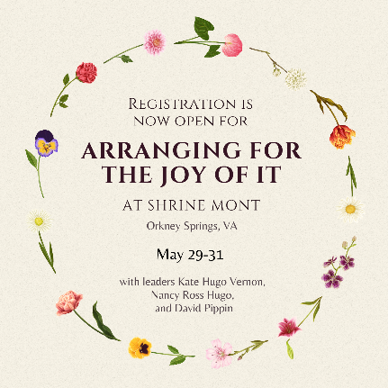
May 29-31, 2026 Arranging for the Joy of It at Shrine Mont, Orkney Springs, VA. This is the Flower Camp workshop attended by Mary Ann Moore, Sandy Lucas and Julie Bryan las Fall. They had a wonderful time and learned so much! “Join us for a fun-filled weekend immersed in floral design. From educational demonstrations to hands-on activities, you're sure to have a great time!!” Open to all skill levels. The only requirements: an appreciation for flowers and curiosity to explore. Space is limited!!! This is presented by three excellent designers associated with The Arranger’s Market. Sandy Lucas has already sent out an email about registration and other details.

June 18, 2026 District I Flower Show, The Packing House, 411-A Dorchester Ave, Cambridge Maryland 21613.

Julie Bryan shared this with us:
**The Flower Guild of the Washington National Cathedral is pleased to offer its annual Flower Seminar. The seminar will be from February 10-13, 2026, in Bethlehem Chapel at the Cathedral. Participants sign up for 2-day sessions — either February 10 & 12 or February 11 &13.
The program's structure is as follows. Flower Guild members demonstrate various types of arrangements on both mornings. Every step of the flower-arranging process is discussed — conditioning flowers, mechanics, and design. Then , in the afternoons, students have a hands-on workshop when they create their own arrangements, following one of the basic designs they have just been taught. The arrangements are critiqued by members of the Flower Guild.
The instruction is ideal for church flower guilds because the designs are suited to altars and other church spaces. Those same designs are also ideal for many other settings, including private homes.
All the workshop materials — flowers, containers, even scissors — are provided. Participants will take home their creations.
As a special treat for Seminar participants this year, one of the Cathedral's most beloved docents will give a tour of the Cathedral on both Wednesday and Thursday mornings. You are invited to come on whichever day you do not have Seminar classes.
Space is limited. The cost of the Seminar is $400. To register and pay, please use the link below. Payment is not refundable after January 28, 2026
https://tickets.cathedral.org/EventAvailability?EventId=18201
Interim Co-Leaders of the Flower Guild


Preparation Goes a Long Way to Success
GBBC is rapidly approaching. Our #1 question each year is about the tools to participate. First and foremost if you love using Merlin, feel free to use it at least once Feb 13-16 and save your sighting or sound ID and you have participated! It's that easy.
For those who are new to GBBC, review our step-by-step directions to make sure you are ready. You may want to bookmark one of these for the weekend event.
- Using Merlin Bird ID App
- Using eBird Mobile (phone or tablet)
- Using eBird on a Computer

GBBC data is entered entirely online. If you don't use online tools, see if a close family member or friend could enter your data. Or, consider reaching out to an Audubon Chapter to see if they have the capacity to get your birds counted.
And, don't forget to register to attend our How to Participate in GBBC live event happening Thursday, February 5 or Wednesday, February 11. All registrants will get a recording of the webinar.
If you live in the U.S. or Canada, and you prefer not to use mobile devices for bird identification, this new Birds Near Me tool, may be helpful for identifying birds you may see during GBBC weekend. It works like Merlin, but you use it on a web browser. Or, maybe you like posters you can print ahead of time to have near your windows for quick ID.
Feel prepared with us,
The GBBC Team

This important information is being shared by Terry Holman of District I and Mari Stanley:
Maryland Invasive Plants Prevention and Control From the Maryland Department of Agriculture
Invasive plants threaten native plant health and biodiversity in both agricultural and natural systems in Maryland. Many of these problematic plants are imported, bred, distributed, and promoted for sale in the landscape and nursery industries. Maryland's Invasive Plant Advisory Committee (IPAC) was established by legislative mandate in October 2011. The IPAC's primary responsibility is to advise the Maryland Secretary of Agriculture on regulating the sale of invasive plants and preventing them from entering Maryland or from spreading further into the state.
On June 1, 2024, significant changes were made to the invasive plant law. As a result, the website is currently undergoing updates to reflect these changes. You can find more information about Senate Bill 915 regarding the invasive plant species regulation here.
Notice of additions to the Prohibited Invasive Plant List
On June 1, 2024, significant changes were made to the invasive plant law. In accordance with the new law, plants that were previously considered “Tier 2" were re-assessed using a new invasive plant species status assessment protocol. Re-assessment resulted in the addition of the following species and associated cultivars to the Maryland Prohibited Invasive Plant List:
-Aralia elata (Japanese angelica tree)
-Berberis thunbergii (Japanese barberry)
-Cytisus scoparius (Scotch broom)
-Euonymus alatus (Burning bush, Winged euonymus)
-Ligustrum obtusifolium (Border privet)
-Nandina domestica (Nandina, Sacred bamboo)
-Phyllostachys aurea (Golden bamboo)
-Phyllostachys aureosulcata (Yellow groove bamboo)
-Pyrus calleryana (Callery pear)
-Tetradium daniellii (Bee bee tree)
-Wisteria floribunda (Japanese wisteria)
-Wisteria sinensis (Chinese wisteria)
-Wisteria x formosa (floribunda x sinensis hybrid)

Maryland Prohibited Invasive Plant List
Plants on the Maryland Prohibited Invasive Plant List may not be acquired or sold in-state after the regulations effective date. Existing stocks of prohibited plants have a phase-out period of 1 year for potted plants and 2 years for in-ground plants. Prohibited plants must not be in stock after the phase-out period ends. The updated Maryland Plant List including regulations effective date and phase-out periods is included below:
Maryland Prohibited Invasive Plant List

Species Name | Common Name | Effective Date | Phase Out Period (potted) | Phase-out Period (in-ground)
Aralia elata | Japanese angelica tree | 1/15/2026 | 1/15/2027 | 1/15/2028
Berberis thunbergii | Japanese barberry | 1/15/2026 | 1/15/2027 | 1/15/2028
Corydalis incisa | Incised fumewort | 6/1/2024 | 6/1/2024 | 6/1/2024
Cytisus scoparius | Scotch broom | 1/15/2026 | 1/15/2027 | 1/15/2028
Euonymus alatus | Burning bush, Winged euonymus | 1/15/2026 | 1/15/2027 | 1/15/2028
Euonymus fortunei | Wintercreeper | 6/1/2024 | 6/1/2024 | 6/1/2024
Ficaria verna | Fig buttercup, Lesser celandine | 6/1/2024 | 6/1/2024 | 6/1/2024
Geranium lucidum | Shining geranium | 6/1/2024 | 6/1/2024 | 6/1/2024
Iris pseudacorus | Yellow flag, Yellow iris, Water flag | 6/1/2024 | 6/1/2024 | 6/1/2024
Ligustrum obtusifolium | Border privet | 1/15/2026 | 1/15/2027 | 1/15/2028
Lonicera maackii | Amur honeysuckle | 6/1/2024 | 6/1/2024 | 6/1/2024
Nandina domestica | Nandina, Sacred bamboo | 1/15/2026 | 1/15/2027 | 1/15/2028
Phyllostachys aurea | Golden bamboo | 1/15/2026 | 1/15/2027 | 1/15/2028
Phyllostachys aureosulcata | Yellow groove bamboo | 1/15/2026 | 1/15/2027 | 1/15/2028
Pyrus calleryana | Callery pear | 1/15/2026 | 1/15/2027 | 1/15/2028
Tetradium daniellii | Bee bee tree | 1/15/2026 | 1/15/2027 | 1/15/2028
Wisteria floribunda | Japanese wisteria | 1/15/2026 | 1/15/2027 | 1/15/2028
Wisteria sinensis | Chinese wisteria | 1/15/2026 | 1/15/2027 | 1/15/2028
Wisteria x formosa | floribunda x sinensis hybrid | 1/15/2026 | 1/15/2027 | 1/15/2028

Next Plants to be Assessed
The following species were chosen from the Plant Invaders of Mid-Atlantic Natural Areas Field Guide as the next species to be assessed starting in 2026. The top ten plants are prioritized for assessment in 2026.

Plants to be assessed in the future
Species Name | Common Name
Hedera helix | English ivy
Mahonia bealei | Leatherleaf mahonia
Miscanthus sinensis | Chinese/Japanese silvergrass
Akebia quinata | Chocolate vine
Albizia julibrissin | Mimosa or Silktree
Buddleja davidii | Orange-eye butterfly bush
Cenchrus purpurascens | Chinese fountain grass
Hemerocallis fulva | Orange daylily
Vinca minor | Common periwinkle
Vinca major | Largeleaf periwinkle
Elaeagnus umbellata | Autumn olive
Glechoma hederacea | Ground ivy
Acer platanoides | Norway maple
Ligustrum ovalifolium | Garden privet
Ligustrum sinense | Chinese privet
Ligustrum vulgare | European privet
Lonicera japonica | Japanese honeysuckle
Paulownia tomentosa | Empress tree, Princess tree
Phyllostachys bissetii | Bisset bamboo
Pseudosasa japonica | Arrow bamboo

