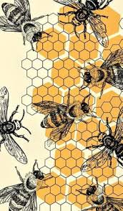
December 1, 2025
The DGC Buzz
President’s Message
Here’s wishing everyone the opportunity to find some peace and joy this holiday season. It is a busy and stressful time, but self-care is so important. Wishing you good times, good food, good friends and family, and the time to focus on all that is good in our lives.
Merry Christmas, Happy New Year!
And Keep Blooming, Sandy
Mark your calendars:
CLTR-Click on the link below to read all about the many exciting goings-on in Dorchester in November and throughout the holiday season. Makes you proud to live here! Lots of holiday events listed in a special section.
https://visitdorchester.us11.list-manage.com/track/click?u=6b7a8d1884eb5d8edb9ba7d88&id=d6055fa67e&e=c7baca6f75

November 25 – End of December Christmas Display at State House in Annapolis
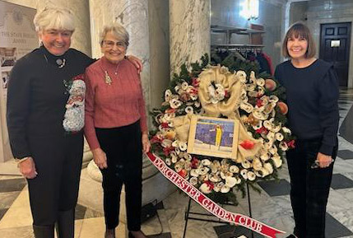
See the trees and wreaths created by garden clubs from all over the state. Dorchester’s entry, a large wreath crafted by Kay Karminski, Cookie Brohawn, Fran Collins and Carol Williamson is certainly emblematic of Dorchester’s seafood heritage! Sandy Lucas helped install the wreath at the Statehouse.

December 2, 2025 Annual Holiday Wreath Workshop (see yearbook)
If you are new to wreath making or would like to learn some new techniques, we will hold a special session from 9:00 am – 10:00 am where three of our members will share some design ideas and how to use special ‘tools of the trade’ to inspire you.

December 5, 2025 DGC Annual Holiday Gala at the Hyatt
Over 200 people have registered for our Holiday Gala on Friday! What an event it will be! The meal is always wonderful and our speaker this year, David Powers of Potomac Floral Wholesale in Silver Spring, will wow everyone. Lots of shopping opportunities including our fabulous Diggers Boutique, great entertainment, Christmas flower sales, silent auction of wreaths, 50-50 raffle AND a raffle of all David’s designs and his remaining floral materials. Some celebratory additions have been added to help us commemorate our 95th Anniversary—an historical presentation about our club, a mini-flower show highlighting a signature activity of DGC, and don’t forget to enjoy our signature cocktail, the Dorchester 95!

December 6, 2025, 5 pm Cambridge Dorchester Christmas Parade
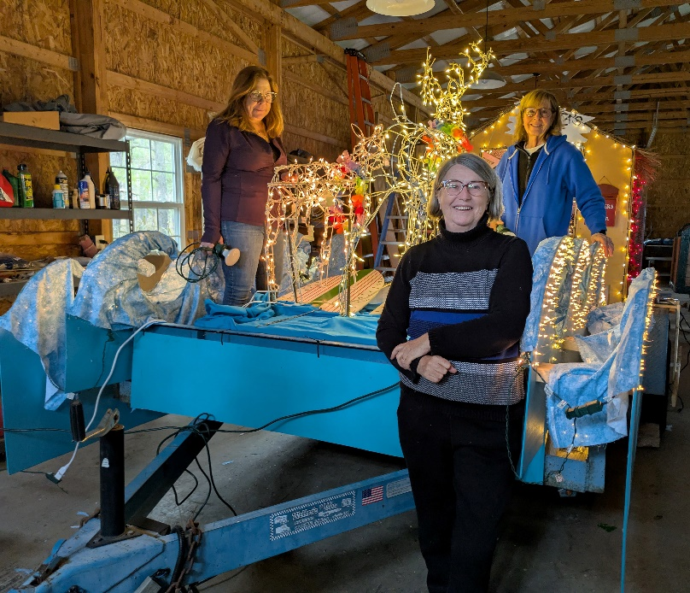
Mari Stanley and her team of ‘Floaters’ have been working since August, if not before, on designing and constructing another amazing float entry in keeping with this year’s theme, “Surfing into Christmas.” The float, stored in the Bernard Barn, looks amazing. The volunteers –Jan Sonberg and her husband Michael, Carol Williamson and son Greg, Susan Matthews, Sue Lachenmayr, Steve Hyneman, Gloria Brake, Cheryl Willey and Karen Cartright have all worked very hard and are so enthusiastic about this project. Perhaps another award may be in the offing? Thanks as well to local landscaper, Jeronimo Ramos, who lends us his large trailer and to Bruce Bernard who will help with transportation to the parade. Please come and support, if not ‘march’ with our float to show support for our club. The workmanship and clever design elements will wow everyone!

December 13 & 14, 2025 Chorus of Dorchester Concerts, Annual Christmas Concerts directed by our own, Cookie Brohawn. Saturday, December 13^{th,} 4-6 pm at Crist Episcopal Church and Sunday, December 14^{th,} 4-6 pm at Immanual Church of Christ, 5401 White Hall Road, Cambridge. “2025 marks the 50th anniversary since the Chorus of Dorchester held its first rehearsals in preparation for the 1976 American Bicentennial celebrations. Since then, the Chorus has been bringing together Dorchester County residents and friends from surrounding counties, all united by a shared love of singing. Its membership continues to grow and includes all ages from high schoolers to those who have articipated since the Chorus first began in 1975.” This is a lovely way to boost your Christmas spirit!

December 14, 2025 A Mt. Cuba Center Solstice Celebration, 1:00 – 5:30 pm
Celebrate the magic of the season with an unforgettable afternoon of music, dance, winter garden tours, ornament-making and more! Register on their website www.mtcubacenter.org.

February 9, 2026 FGCMD Photography Zoom Workshop: Prune Your Photos 1 pm
Visit www.craft.andrewlinke.com/garden-photography to register.

February 13, 2025 Note Change! Meeting location has been moved to Eastern Shore Hospital Center as DCA is under renovation.

February 28 – March 8, 2026 2026 Philadelphia Flower Show:
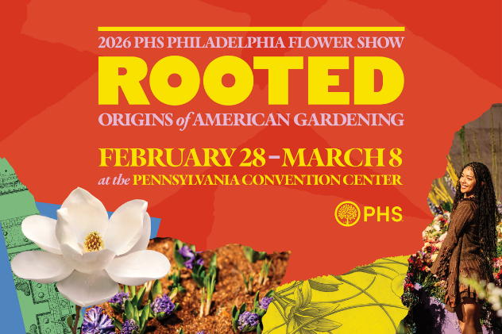
ROOTED: Origins of American Gardening

According to the Pennsylvania Horticultural Society, “Gardens aren’t just made; they’re passed forward through generations, carried across land, oceans, and lifetimes. Whether it’s the nostalgia of a grandparent’s garden, a beloved family recipe that begins with the bright scent of freshly picked herbs, or the practices that shape how we gather, ROOTED brings to life the personal stories, cultural traditions, and horticultural inspiration that connect us to nature and each other. The 2026 Flower Show marks the final chapter in a three-year trilogy of themes exploring gardening across time. United by Flowers (2024) current connections and community, Gardens of Tomorrow (2025) sparked imaginations of the future, and ROOTED (2026) looks to the past to honor the origins of today’s gardens.” Visit https://phsonline.org for more information.

March 4, 2025 District I Annual Meeting at Prospect Bay Country Club. If you’ve never seen horticulturalist and designer of outdoor containers ‘extraordinaire’, Kent Russell, aka The Garden Guru, you won’t want to miss this very entertaining and educational program. Kent always offers many beautiful plants for sale and those shoes! You’ll just have to experience this guy. His program is called ‘The Sensational Spring Garden.’

March 25 & 26, 2026 Landscape Design School, Course 2, DoubleTree Hotel in Columbia, MD. Visit the NGC website for more information on this and the other three special schools.

April 28, 2026 FGCMD Annual Meeting at Turf Calley Country Club in Ellicott City.
Annual Meeting Program: Linda Harris, Program Laison Our program for the FGCMD Annual Meeting on April 28, 2026 will be titled “Night Sounds of Mountain Maryland,” presented by Kevin Dodge, Professor and Director of the Natural Resources and Wildlife Technology program at Garrett College in far western Maryland. Kevin will present an entertaining and educational introduction to the different hoots, toots, peents, and peeps heard after sunset in the Central Appalachians. Weaving together facts, stories, and sounds, Kevin will recreate a night in the mountains of western Maryland.

May 11, 2025 FGCMD Photography Zoom Workshop: Harvest Your Best Shots 1 pm
Visit www.craft.andrewlinke.com/garden-photography to register.

May 2025 Maryland House and Garden Pilgrimage (MHGP)
Seven tours are being offered across the state to complement America’ 250th celebration. The tours begin on April 25th with Mount Vernon in Baltimore; Talbot County on May 9th; Port Tobacco in Charles County on May 16th; Mount Harmon and Cecil County on May 24th; Mount Clare Museum and Baltimore on May 30th; Kensington, Montgomery County on June 7th; and Frederick County on June 13th. Stay tuned for more information. The proceeds from contributions and ticket sales support the restoration of significant historic sites throughout Maryland. For more information visit www.mhgp.org or email info@mhgp.org.

June 18, 2026 District I Flower Show, The Packing House, 411-A Dorchester Ave, Cambridge Maryland 21613.

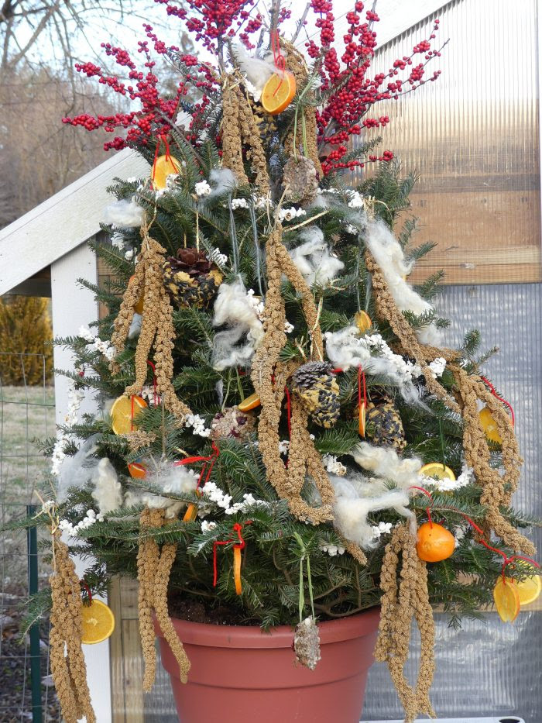
We all know Claire Jones who has spoken to our district and our club several times. Claire has a blog call the Garden Diaries which is very informative. This week she shares some terrific ideas about how to ‘Turn Your Christmas Tree into a Bird Buffet.
“Repurposing a fresh-cut Christmas tree into a winter wildlife buffet is the ultimate form of recycling. Instead of hauling your tree to the curb, set it up outdoors as a bird feeding station and enjoy weeks of entertainment. I placed mine beside my existing feeder last year and spent hours watching birds feeding, chirping—and the squirrels pigging out! Their antics kept us entertained for days, and even my dogs were intrigued by the low-hanging fruit. It truly became a smorgasbord for everyone. I have done this with larger trees and smaller ones. Birds will feast on whatever you put out.”. Read the whole article on-line at https://thegardendiaries.blog.

A symbol of hope
As seen in Barbara Melera’s Harvesting History Newsletter:
…Just remember in the winter, far beneath the bitter snows,
Lies the seed that with the sun’s love, in the spring becomes the rose.
From the song The Rose by Amanda Bloom and sung by Bette Midler.

