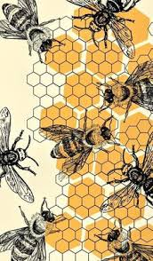
October 1, 2025
The DGC Buzz

President’s Message
Happy Fall! Isn’t this weather just great!...I really love the change of seasons. It’s hard to believe that it is October 1. Our club has been really busy with our speaker from our September meeting, Jennifer Vaccaro, talking about Native Plants, our members volunteering for Iron Man, our “floaters” working on the Christmas float, the planning of the Holiday Luncheon and helping our youth to get ready for the Talbot County Garden Club Flower Show on October 17..whew, I am tired just thinking about all of it!!

Thank you to all who volunteered for the Iron Man this year. I don’t know how much money we will get from helping, but I will keep you updated.
Speaking of the changing of the seasons, you will not want to miss our next monthly meeting on October 10 at the Immanuel United Church of Christ. We will have two dynamic women who will present tablescapes for tables and mantles to get us ready for the holiday season. Becky Wozny and Linda Easter will be presenting and just be prepared to be Wowed!
The CAR (Central Atlantic Region) will hold their conference at the Hyatt in Cambridge October 20-23. This will be a wonderful opportunity to see presenters who are at the top of their field….please make every effort to attend at least one of the sessions, you won’t be disappointed.
Please make sure you read all of the Buzz and the attachments to be kept abreast of what is happening not only in our club, but in the District and State too!
Keep blooming,
Sandy

Calendar Items
So maybe you want to take a road trip? The events listed below (through to the Talbot Flower Show) were posted in the Peg’s Plants Newsletter on-line and offer some interesting activities, in-person and/or virtual.
October 1st Wednesday, Maryland’s Living Landscapes, Bay-Wise 2.0, 7:00 pm, free lecture, open to the public, Annapolis Horticultural Society https://annapolishorticulture.org/
October 2nd Thursday, Lecture: Design with Autumn Flowers and Foliage, 10:30 to 11:30 am, fee and must register, Ladew Topiary Gardens https://www.ladewgardens.com/
October 2nd Thursday, Make Your Own Halloween Porch Pot Workshop, 4 to 5:30 pm, fee and must register, Homestead Gardens https://homesteadgardens.com/
October 3rd Friday, Guided Forest Bathing Walks, 9:30 to 11:30 am, fee and must register. Also on Saturday October 11; Friday October 17; and Saturday October 25. Hillwood Estate, Museum and Gardens https://hillwoodmuseum.org/
October 9th Thursday, Gardener’s Focus Tour: Plants of the Fall, 2:30 to 3:15 pm, included in suggested donation. Also on Tuesday October 7; Tuesday, October 14; and Thursday, October
October16th, Hillwood Estate, Museum and Gardens https://hillwoodmuseum.org/
October 9th Thursday, Lecture: Beneficial Bats in your Belfry, in person and virtual, 10:30 am to 11:30 am, fee and must register, Ladew Topiary Gardens https://www.ladewgardens.com/
October 9th Thursday, Keystone Plants for the Home Landscape, 7 to 8:30 pm, virtual, fee and must register, Brookside Gardens https://montgomeryparks.org/parks-and-trails/brookside-gardens/
October 10th Friday to October 19th Ikebana International Exhibition, 10:00 to 4:00 daily, free admittance, U.S. National Arboretum https://usna.usda.gov/. On Saturday, the 18th there will be a Sogetsu Ikebana Demonstration, 1:00 to 2:30 pm, free admittance, U.S. National Arboretum https://usna.usda.gov/October 19-22, 2025
October 14th Tuesday, Tradition in Bloom: Longwood’s Chrysanthemum Festival, 6 to 7:00 pm, virtual lecture, fee and must register, Longwood Gardens
October 15th Wednesday, Restoring Soils for Native Plants, online, 6 to 7:30 pm, fee and must register, Mt Cuba Center https://mtcubacenter.org/
October 16th Thursday, webinar: Next Steps for Nature with Doug Tallamy, 7 to 8:00 pm, free but must register to get link, Wild Ones https://wildones.org/
October 17th Friday, An Evening of Poisons and Potions, 6 to 8:30 pm, fee and must register, U.S. Botanic Garden https://www.usbg.gov/
October 17th Friday through Sunday October 19, Prune & Protect: End of Season Landscape Tasks, free but must register, at all three locations of Homestead Gardens, see website for times https://homesteadgardens.com/
October 17, 2025 Talbot County Garden Club Standard Flower Show “Holidays.” The Talbot County Garden Club proudly presents its annual flower show, celebrating the full holiday season from Halloween to New Years, on Friday, October 17, 2025, from 1:00 to 4:00 pm at St. Mark’s Church Parish Hall, 100 Peachblossom Rd, Easton, MD. The event is free and open to the public. Both experts and novices have the opportunity to showcase their expertise, vying for design and horticultural excellence awards. New this year will be a Youth category where children grades K-₋8 can showcase their talent. The publicity contact for the show is Carolyn Rugg, laborsend@aol.com, 610-585-5693. Entry numbers can be obtained from Pam Keeton pvkeeton@yahoo.com, 202-904-7265. The show schedule is provided in attachment.
October 19 – 22, 2025 CAR-SGC (Central Atlantic Region of State Garden Clubs)--
Maryland: “America in Miniature. Registration may be now full. This link will take you to the conference information https://www.car-sgc.org/-- just click on "Let's go!"

October 30, 2025 Topiary 101: A Beginner’s Guide to Living Sculpture, 7 to 8:00 pm, virtual, fee and must register, American Horticultural Society https://ahsgardening.org/

Mark your calendars:
December 2, 2025 Annual Holiday Wreath Workshop (see yearbook)
If you are new to wreath making or would like to learn some new techniques, we will hold a special session from 9:00 am – 10:00 am where three of our members will share some design ideas and how to use special ‘tools of the trade’ to inspire you.

December 5, 2025 DGC Annual Holiday Gala at the Hyatt
Volunteers are needed to help pull off this very successful and always sold-out event. There is something for everyone to do, so contact Nancy Leonard, Luncheon Chair, to see how you might help. There will be a committee meeting on September 9th. Be sure to tell your friends and family to mark their calendars as well. The meal is always wonderful and our speaker this year will wow everyone. Lots of shopping opportunities, great entertainment, and celebratory additions to help us commemorate our 95th Anniversary. Don’t forget to start putting aside items to donate to our fabulous Diggers’ Boutique—contact Sue Jones.

March 4, 2025 District I Annual Meeting at Prospect Bay Country Club. If you’ve never seen horticulturalist and designer of outdoor containers extraordinaire, Kent Russell, The Garden Guru, you won’t want to miss this very entertaining and educational program. Kent always offers many beautiful plants for sale and those shoes! You’ll just have to experience this guy. His program is called ‘The Sensational Spring Garden.’

March 25 & 26, 2026 Landscape Design School, Course 2, DoubleTree Hotel in Columbia, MD.

April 28, 2026 FGCMD Annual Meeting at Turf Calley Country Club in Ellicott City.
After some research and discussion, the Federated Garden Clubs of Maryland Executive Board voted to move the annual meeting from the 4th Tuesday in March to the 4th Tuesday in April. This is because many garden clubs do not meet in January, February or March, and many club members do not return from winter vacations until April. It is also becoming more difficult to contact the club membership about upcoming meetings.

May 18, 2026 District I Flower Show, The Packing House, 411-A Dorchester Ave, Cambridge Maryland 21613

New-ish Member Profile: Carol Williamson
Carol has such a fascinating and impressive background. We are very lucky to have someone of her skill and enthusiasm in our garden club. She was raised in Dorchester County and after graduating from high school, Carol attended the University of Maryland. She did not complete her studies the first go-around. Instead, got married, had children and then divorced. When she returned to school to continue her undergraduate studies at Salisbury University, she received her degree in Elementary Education, in spite of her early interest in nursing. Carol taught school for 7 years and then became a supervisor of Instruction - and later director of instruction in the Dorchester County Public School System for another 13 years. She loved kids, instruction and working with the other educators. Carol pursued a Masters from George Washington University and received her doctorate (Ed.D) from the University of Maryland during her tenure in Dorchester County. For the next 17 years, Carol was Asst. Superintendent of Instruction in the Queen Anne’s County Public Schools and then Superintendent for her last 8 years. But that’s not all! Carol went to work for the Maryland State Department of Education, as Deputy State Superintendent of Instruction. She managed to raise her three children and get remarried to her wonderful husband, Jay, to whom she has been married for 53 years!
After retirement, Carol wanted to meet people in Dorchester County. She considers herself a novice gardener, but she loves gardening and has been eager to learn more about plants and flowers. Susan Matthews, who has been a club member for many years, encouraged her to join DGC and she has certainly jumped in with two feet. Carol just joined in 2024 and is already serving as Corresponding Secretary. Thus, she serves on the Executive Board AND the Civic Improvement Committee (she’s a regular ‘water-er’ at the Courthouse) and is a very active ‘Floater’-- that is, Carol is very busy working with Mari Stanley and her exceptional team on designing and building DGC’s entry float for the Christmas Parade. Wow! And she is active on the Youth Gardening Committee helping in the garden and teaching several of the lessons. “It is back to my roots of working with children.”
Of note, Carol is so pleased with how much she is learning from DGC’s Mini-Flower Shows! She was apprehensive when she first learned about entry points and exhibiting, but she found she learns so much looking at entries by other members. She now researches plants in her handbooks and on-line, has mastered the Lens feature on her phone to help with plant identification and has worked hard to understand how to properly prepare her entry card using binomial nomenclature, cultivar and common names. She says she has become much more strategic in what she is planting and replacing in her own garden. Carol has also engaged her husband in selecting and learning about plants to exhibit. Having pretty well mastered horticulture entry procedures, she is almost ready to move on to design!

Great News for Cambridge! Source: www.eslc.org
The Eastern Shore Land Conservancy (ESLC) “is excited to announce that a brand new ESLC easement in Cambridge will become a 114-acre public park. Located just off Maryland Rt. 50 this thriving woodland is easily accessible and will now be protected forever thanks to funding from the Department of Defense’s Navy REPI program (http://repi.mil/). Through the support of Program Open Space, the property will soon be transferred from Chesapeake Conservancy to Dorchester County, providing opportunities for more than six miles of public hiking, biking and horseback riding trails, all while protecting the property’s most sensitive habitats…..Many rare and threatened endangered species relied on these rare wetlands across the shore before two-thirds of them were filled in for farms and development (even though they have the highest biodiversity conservation value of any wetland type on the peninsula). Now this Dorchester County woodland will protect these unique sanctuaries for a host of amphibians, pollinators and migratory birds.” For more information, visit the ESLC website, cited above.

Did You Know This? What do you think?
As seen in The Washington Gardener Magazine
The Myth of Drainage Material in Container Plantings
Linda Chalker-Scott, Ph.D., Extension Horticulturist and Associate Professor, Puyallup Research and Extension Center, Washington State University cites advice we have always heard about container planting--"Add a layer of gravel or other coarse material in the bottom of containers to improve drainage"

The Myth: This is just one of those myths that refuses to die, regardless of solid scientific evidence to the contrary! Nearly every book or web site on container gardening recommends placing coarse material at the bottom of containers for drainage. The materials most often recommended for this practice are sand, gravel, pebbles, and pot shards. Other ‘benefits’ often mentioned include preventing creatures from entering through the drain holes and stabilizing the container. Some of these recommendations are quite specific and scientific sounding. Consider this advice from a 1960’s book on container plants: “Adequate drainage is secured by covering the hole in the bottom of the pot with a piece of broken flowerpot, concave side down; this in turn is covered with a layer (1/2" to 1" deep) of flowerpot chips. On top of this, a 1/4" to 3/8" layer of coarse organic material, such as flaky leaf mold, is placed.” The advice seems to make perfect sense, and it’s presented so precisely. After all, we know that plants need good drainage so their roots receive adequate oxygen, and we also know that water passes through coarsely textured material faster than it does fine material. So what’s not to like?

The Reality: Nearly 100 years ago, soil scientists demonstrated that water does not move easily from layers of finer textured materials to layers of more coarse textured. Since then, similar studies have produced the same results. Additionally, one study found that more moisture was retained in the soil underlain by gravel than that underlain by sand. Therefore, the coarser the underlying material, the more difficult it is for water to move across the interface. Imagine what happens in a container lined with pot shards! Some of my previous columns have mentioned soil interfaces and their inhibition of water movement. We can see the same phenomenon occurring here: gravitational water will not move from a fine soil texture into a coarser material until the finer soil is saturated. Since the stated goal for using coarse material in the bottoms of containers is to "keep soil from getting water logged,” it is ironic that adding this material will induce the very state it is intended to prevent.

The Bottom Line:
• Planting containers must have drainage holes for root aeration.
• “Drainage material” added to containers will only hinder water movement.
• Use good topsoil throughout in perennial container plantings for optimal water conditions and soil structure. For more information, please visit Dr. Chalker-Scott’s web page at http://www.theinformedgardener.com.

Bartlett Tree Experts share the news that our Beech Trees are at risk of deadly infection!

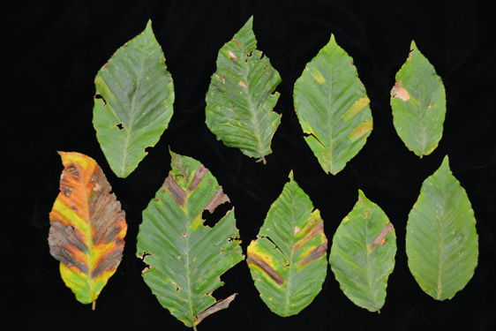
“Beech leaf disease (BLD) is caused by microscopic worms called nematodes. The first outward sign of infection is discolored stripes between the veins of impacted leaves (see second photo below). As the disease progresses, the tree will show signs of stunted growth and yellowing eaves. Symptoms worsen over time and the tree can die in just a few years after infection.”

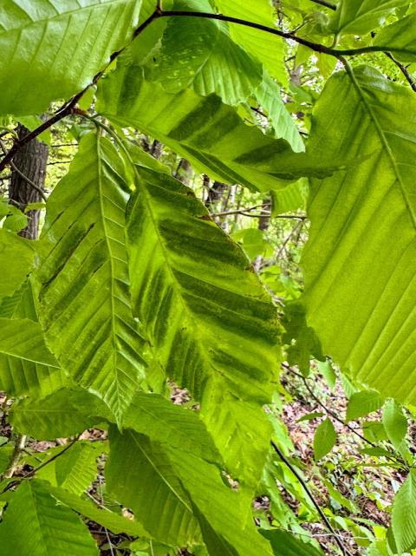
The University of Maryland Extension Office adds that ”the invasive, foliar nematodes (Litylenchus crenatae subsp. mccannii) overwinter in leaf buds, and enter leaves as they develop in the spring. BLD was first detected in Ohio in 2012, but it has spread throughout the mid-Atlantic and New England. It was first identified in Maryland in 2023 and is present in many Maryland counties. The bands are best seen by looking at the leaves from below and allowing sunlight to pass through the leaf tissue. Leaf tissue thickening and distortion can also be observed as symptoms progress. Infected leaves may be unevenly distributed in the lower canopy of a tree. Over time, the canopy becomes thin (sparse) due to premature leaf drop and aborted leaf bud development. This stresses and weakens trees, causing them to die.
If you find Beech Leaf Disease:
- Report beech leaf disease symptoms to the Maryland Department of Agriculture by email: fpm.mda@maryland.gov. Reports are encouraged from counties that have not yet been added to the detection map above.
- If you are uncertain as to whether the symptoms you are seeing are beech leaf disease, you can first send digital photos to us at Ask Extension and we can assist with preliminary identification.
- Work with a certified arborist or licensed tree expert with experience diagnosing beech tree conditions. Laboratory analysis of a sample may be needed to confirm a diagnosis.”
Other News….
The American Horticultural Society has lifelong learning certificates designed for learners seeking master horticultural knowledge and skills to apply them for a greater good. The certificate is a culmination of self-paced study, live programs, and community service. Currently there is a Certificate in Horticulture and the Environment and a Certificate in Horticultural Design and Techniques. There is a fee; check out the American Horticultural Society website for more information.

Mt. Cuba Center in Hockessen, DE also offers a learning certificate course on Ecological Gardening. They have so many programs and events that it was impossible to list them all in our calendar. Visit www.mtcubacenter.org for a complete listing of their many offerings.
Adkins Arboretum, closer to home in Ridgely, MD, also offers many programs and events. Check out their website ay www.adkinsarboretum.org. The second round of their online Fall Native Plant Sale continues through October 9. Fall's cooler air temperatures combined with warm soil temperatures encourage roots to establish and develop. Plants will settle into their new homes, ready to thrive next Spring. To learn more about online sales and scheduled pick-up appointments, read our Native Plant Sale FAQs.
Kat, The Succulent Eclectic pens a regular online newsletter with excellent articles about succulents and cacti. Sign up at https://thesucculenteclectic.com/ for so many wonderful articles She recently published an Illustrated Glossary of Succulent Terms that you can view by clicking this link: https://thesucculenteclectic.us17.list-manage.com/track/click?u=12194ecd56a33384ec7364b69&id=9a546b04ec&e=75298a34b9 (Highlight, then Ctrl-left click on your mouse)

