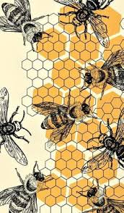
July 1, 2025
The DGC Buzz

President’s Message

Hello everyone,
Wow, what a fabulous time we all had at Cindy Burns’ house for our annual picnic!! Cindy’s house and gardens are beautiful with the gorgeous setting on the Choptank River. Thank you to Cindy, Mary Ann and Becky for being such wonderful hostesses…..the special cocktail, our set up outside under the shade tree for our meeting…I felt like I was at a Southern Living party!
Congratulations to all of the award winners, but especially to Patti Hopkins who won the Perennial Bloom Award. This was a well deserved award for Patti who has been a member since 1992 and has consistently helped the club with being on various committees as chair or as a member. Her willingness to always help out speaks volumes as to her dedication to this club. Her name will now be sent to the District 1 as our nominee for the District 1 Perennial Bloom Award.
A big “thank you” to Fran Collins and Becky Wozny for giving us a history of the awards that were given that day… the Lednum Cup for Horticulture, the Tawes Bowl for Design and the Rosa Award cup for Roses. We were also able to see the original Lamkin Cup that was given to the member who received the highest number of first honors for flower exhibiting at the monthly meetings. We also saw the plaque with the names of the members who won the Design category from 1952-2012.
Don’t forget that we will not have a monthly meeting in July, but we will have our Flower Camp where we will learn how to do a Monochromatic Design. If you are interested and haven’t signed up, contact Mary Ann Moore to see if there spots available.
Stay Cool and Keep Blooming,
Sandy

Calendar Items…..
July 2, 2025 DGC Board Meeting, 12 pm – 2 pm in the Library Meeting Room

July 3, 2025 Youth Gardeners meeting at 12:15 pm at the YMCA (see additional info below)

July 11, 2025 Flower Camp Session 2 “Color My World”, 11 am – 2 pm at Robbins Family YMCA. Pre-register with Mary Ann Moore.
July 16, 2025 Rain Barrel Workshop with the Federalsburg Activities Center. Learn how to use a rain barrel and all the environmental benefits at the Caroline Public Library, 123 Morris Avenue, Federalsburg 21632. Fifteen rain barrels will be given away. To register, go to www.nanticokeriver.org/FAC.

August 8, 2025 DGC Monthly Meeting at Immanuel Church of Christ. Panelists include Jan Kirsh, a landscape designer and sculptor and Tabetha Evans, a horticultural professional with extensive experience in the green industry. The plan is to moderate an informal discussion/Q&A about how we are being impacted as gardeners with warmer summers, more violent storms, wetter springs and what the change in hardiness zone for our region (to zone 8) means for our gardening strategies. Please think about this topic and formulate some questions that we can discuss as a group.
***Send questions or topics to Jeanne (jeanneabernard@gmail.com) so that the speakers can have some idea of what you would like addressed.

Save the Dates
September 6-7, 2025 Annual Conference of the Maryland Native Plant Society, Washington College in Chestertown. The theme is “Extraordinary Ecosystems of Maryland’s Eastern Shore.” You can attend both in-person and virtually. The costs are as follows--Members:* In person $100 / Virtual $50, Nonmembers: In person $130 / Virtual $60, Students: In person $30 / Virtual $15, Saturday Social: In person $30 / Virtual $15.As our club is an organizational member, I believe we can attend as members. Presentations include—
- Rare and Threatened Coastal Plain Species and Efforts Underway to Protect Them - Jim Brighton (Keynote Speaker) {Mom Jane Brighton is a DGC member!]
- Threats to Unique Plants and Animals within Tidal Salt Marshes and Collaborative Conservation Efforts - Henrietta Bellman and Sophia Seufert
- Managing Early Successional Habitats to Support Declining Grassland Wildlife Species - Kathy Thornton
Register on-line info@mdflora.org. There will be field tripos and a plant sale.
October 17, 2025 Talbot County Garden Club Flower Show “Holidays.” Information to follow.

October 19-22, 2025

CAR-SGC (Central Atlantic Region of State Garden Clubs)
This Year’s Conference Theme--Maryland: “America in Miniature”
This conference will celebrate Maryland’s diverse landscapes and cultural heritage. From mountains to seashores, urban centers to rural farmlands, Maryland reflects the vastness of the country in one small state.
Registration is now live on their website. October 19-22, 2025Susie Middleton is chairing the conferences and states there are excellent presentations on tap. Given that is conference is being held right here in Cambridge at the Hyatt, you should definitely avail yourself of this wonderful educational opportunity!
This link will take you to the conference information https://www.car-sgc.org/-- just click on "Let's go!"
Check out the yellow tabs for all the information about the conference - speakers/programs, tri-refresher courses for environmental, gardening and landscape design schools, agenda, etc. and on to the registration form.
Together we will Plant America for a cleaner, greener and healthier world
CAR-SGC Theme for 2023-2025
Garden clubs come together throughout Delaware, Maryland, National Capital Area, New Jersey, New York, Ohio and Pennsylvania for opportunities to plant, protect, create, learn and network with others who share our interests. We do this through membership in National Garden Clubs, Inc. and the Central Atlantic Region of State Garden Clubs, Inc.
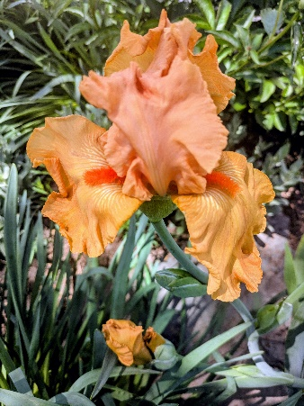
Garden Photos for our New Website—Mary Ann McNamara made this request at our annual picnic. Please submit to her photos of flowers and your landscape for inclusion in our new website to her by July 8, 2025.

DGC Member News:
Congratulation to all the awardees at our annual picnic!

Tawes Bowl (awarded to the members receiving the highest points in design competition at our mini-flower shows: 1st Place Mari Stanley
2nd Place Julie Bryan
3rd Place Diana Brooks

Lednum Cup (awarded to the members receiving the highest points in horticulture exhibition competition at our mini-flower shows): 1st Place Patti Hopkins
2nd Place Cheryl Willey
3rd Place Diana Brooks

Kathryn ‘Kit’ C. Holdt Cup (awarded to the members receiving the highest points in the rosa classification at our mini-flower shows:
1st Place Helen Saum
2nd Place Patti Hopkins
3rd Place Sandy Lucas

Perennial Bloom Award (recognizing a long-time member who has made our club grow and bloom with their continuous support of our goals and objectives. Patti Hopkins

Congratulations to all our winners!!

Celebrating 8 years, the Talbot County Free Seed Library is hosting a fundraiser. All donations go towards the purchase of seeds and supplies.
$8.00 buys 4 packets of veggie seeds
$16.00 buys 200 seed envelopes
$24.00 buys 12 packets of flower seeds
Online donations can be made at this link: https://secure.tcfl.org/np/clients/tcfl/donation.jsp?campaign=12
OR you can drop off a check at either branch of the library (please put "seed library" in the memo).
In case you weren't aware, the seed library is entirely donation-based. This fundraiser will provide the funds for purchasing all seeds for the next growing season. I'm hoping to raise enough to purchase lots more flower seeds, which we can't seem to keep in stock.
Plant Profiles on YouTube:
Washington Gardener Magazine has a series of videos on YouTube profiling plants The contents are researched and written especially for the Mid-Atlantic USA gardener. They are photographed in private and public gardens in our region. Follow the link below:
https://youtube.com/playlist?list=PLOv-yep94vRPiOxDFjHlKhL1S1qYPOaNB&si=houhgvHKk-zCuaGy

Committee Reports:

Cambridge Christmas Parade
‘Surfing Into Christmas’
The DGC Floaters have met several times already planning for another fabulous float. They will meet again on Thursday, August 28th, 1:30 pm at the home of Steve Heyneman when they will finalize plans before beginning construction in mid-September.

Chairperson Mari Stanley reports our float will feature Santa’s Surf Shack, lots of lights, reindeer, surf and boogie boards, palm trees, large flip flops and so much more.

Donations are needed—plywood, lights, garlands, surf/boogie boards, carpet cores (cardboard tubes made of recycled paper fibers). This editor had to ‘Google’ that last item!

The committee would love your suggestions for a float title (e.g. Dorchester Gardens are Gnarly, Hanging Ten in Dorchester Gardens)

Youth Gardening
Youth Gardeners began their summer camp schedule on June 19th at the YMCA. The committee and the young gardeners will next meet on July 2 at 12:15 pm to install a scarecrow and to have the kids weed, water and harvest as the garden is starting to produce. Additional volunteers are welcome to join in.
Courtesy of Bartlett Tree Experts:
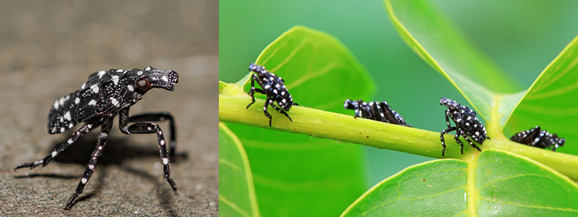

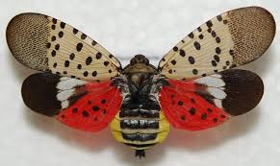
Above is the nymph form of an invasive plant hopper insect, the spotted lanternfly (SLF). This pest was first detected in Pennsylvania in 2014, and the invasion front continues to spread across the Northeast, Southeast, and Midwest. SLF should be killed on sight. The adult SLF is pictured at right.

Find more details from the USDA.

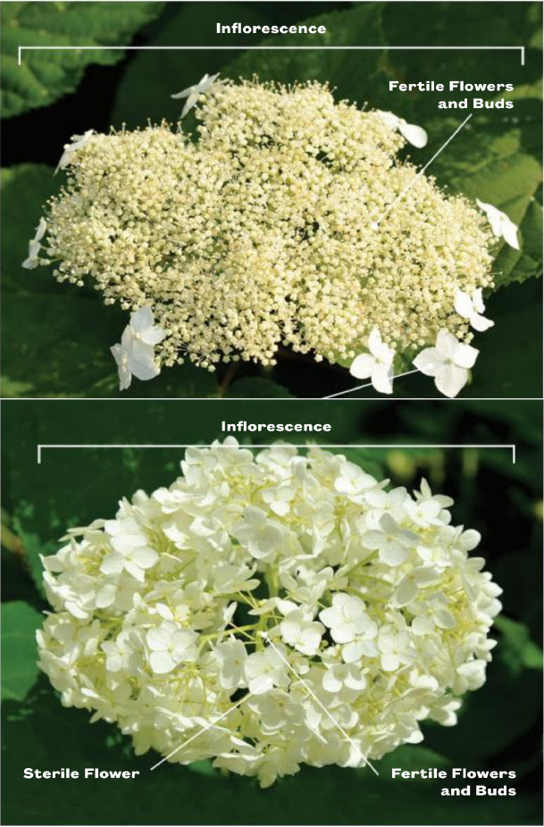

From Mt. Cuba Center:

Hydrangeas are in peak bloom, including our native Hydrangea arborescens and H. quercifolia, as well as the commonly planted non-native H. macrophyllya. Hydrangeas are characterized as lacecaps (top image) or mopheads (bottom image) based on the number of sterile flowers. While showy for humans, mopheads attract and support fewer pollinators, which need the nectar and pollen found only in the tiny fertile flowers that are more numerous in lacecaps.

The gardens at Mt. Cuba are open Wednesdays through Sundays, 10 am to 6 pm. Visit their website as they have many terrific events as well as classes, held year-round. www.mtcubacenter.org.

