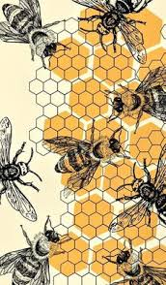
November 1, 2025
The DGC Buzz
President’s Message
October has been a really busy month! At our October 10th meeting, Becky Wozny and Linda Easter wowed us with their beautiful tablescapes for the fall holidays….I think a lot of us went home and got out the Halloween and Thanksgiving decorations and started decorating.
Our Youth Gardening group entered their plaques and floral designs in the Talbot County Garden Club Standard Flower Show, ‘Holidays,’ on October 17th…..the kids’ entries were great! One of the young gardeners won a blue ribbon for her plaque design as well as Best in the Show for that category! Thanks so much to everyone who helped make this possible. Our award-winning Youth Gardening program is a wonderful activity that is teaching more than just things related to gardening, it is boosting the children’s self esteem and exposing them to things that they may not have had the opportunity to do without this program. And speaking of Talbot’s Flower Show—congratulations to all our members who entered design or horticulture. The exhibits were just beautiful. Special kudos to Anne Dremluk who created a holiday parallel design which won a blue ribbon, the Designer’s Choice award (purple ribbon) and the Award of Design Excellence (orange ribbon).
The CAR conference was held at the Hyatt on October 20-23, 2025 and several of our members participated. Some helped with the floral centerpieces for the lunch and dinner on Tuesday, some attended the dinner with special speakers and some attended the whole conference to refresh their previous NGC School certificates. Susie Middleton and Diana Bonner did a fantastic job organizing the event. A big shout-out to the DGC floral design team—Diana Brooks, Mary Ann Moore, Jeanne Bernard, Anne Dremluk and her sister, Jane and myself. The arrangements reflected Dorchester themes like agriculture and canning, as well as the all-important the crab and oyster industries.
Later next week you will be receiving some information from me concerning the proposal to raise the dues for next year for both Active and Associate members. This is a conversation we have touched upon briefly at almost every meeting. Please be looking for it through your email.
If you have not done so already, please go to our new website and register. We will be using the website to start RSVPing for lunches and other meetings. I just want to give a BIG SHOUT OUT to Mary Ann McNamara for all the time and effort she has put into this endeavor!!
Keep blooming, Sandy
Mark your calendars:
CLTR-Click on the link below to read all about the many exciting goings-on in Dorchester in November and throughout the holiday season. Makes you proud to live here! Lots of holiday events listed in a special section.
https://visitdorchester.us11.list-manage.com/track/click?u=6b7a8d1884eb5d8edb9ba7d88&id=d6055fa67e&e=c7baca6f75

November 4, 2025, 6:30 – 8:30 pm Today’s Chesapeake Bay Ecosystem: Our Disappearing Osprey
Sponsored by Chesapeake Forum. Held at Avalon Theater. Register at www.chesapeakeforum.org. $60.00 in person or livestream $40.00.

November 4, 2025, 6:00 pm Recycled Landscapes with Martha Keen and Hans Hesselein of Apiary Studios.
A joint presentation of Cylburn Arboretum Friends and the Horticultural Society of Maryland. To be held at the Vollmer Center at Cylburn. The event is free but requires a ticket (www.mdhorticulture.org)

November 5, 2025 New Exhibition begins at Dorchester Center for the Arts:
Vanishing Landscapes
Second Saturday Reception for Vanishing Landscapes on 11/8, 5 -7 pm.

“Vanishing Landscapes is an open medium, group exhibition of artists working across painting, photography, sculpture and more, who question the relationship between the environment and self. The selected works are both personal and universal responses to the disappearing natural places that we call home.
Traditionally, a landscape is defined as a natural scenery with mountains, forests, rivers, etc. Exhibited works in Vanishing Landscapes define the term ‘landscape’ as both the depiction of a natural scenery, as well as the emotional, psychological and cultural landscape that we share with the natural world.
While Vanishing Landscapes expresses a sense of loss, it also embraces a brighter future where the resilience of Mother Nature and the presence of man can remain in harmony. It holds a space for reconstruction and reconnection, and the viewer is asked to slow down, take in the beauty that surrounds them, and engage with the subtle rhythms of a world in flux.”

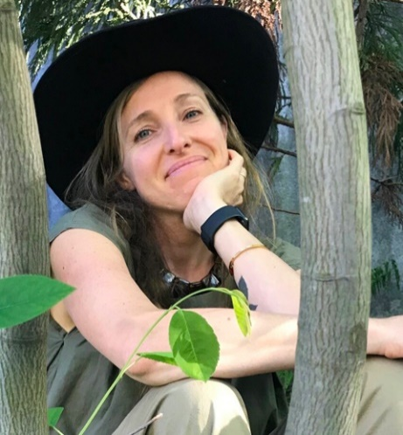
November 9, 2025 at 2 pm – 4 pm Reimagining Our Landscapes: A Talk by Rebecca McMackin
Ecological horticulturist, Rebecca McMackin, will explore how we can transform gardens and green spaces into thriving, resilient ecosystems that support biodiversity and respond to a changing climate.
This talk takes place at the Avalon Theatre in Easton. Advance registration is recommended (https://www.adkinsarboretum.org). This talk is FREE for all.

November 14, 2025 at 10 am Botanical Art Sampler
For anyone curious about the Botanical Art Program at Adkins, this mini-class will introduce you to the art form. Students will experiment with several traditional mediums and learn how to use them in a simple piece of art. This is a beginner-friendly class with no prerequisites and all materials will be provided.
Advance registration is required. This class is FREE for Members.

December 2, 2025 Annual Holiday Wreath Workshop (see yearbook)
If you are new to wreath making or would like to learn some new techniques, we will hold a special session from 9:00 am – 10:00 am where three of our members will share some design ideas and how to use special ‘tools of the trade’ to inspire you.

December 5, 2025 DGC Annual Holiday Gala at the Hyatt
You should have received your beautiful invitation to our Gala this past week. Be sure to get your reservations in early and invite friends and family. It’s a great way to showcase our wonderful club. Volunteers are needed to help pull off this very successful and always sold-out event. There is something for everyone to do, so contact Nancy Leonard, Luncheon Chair, to see how you might help. There will be a final committee meeting on November 17th. The meal is always wonderful and our speaker this year, David Powers of Potomac Floral Wholesale in Silver Spring, will wow everyone. Lots of shopping opportunities, great entertainment, and celebratory additions to help us commemorate our 95th Anniversary. Please continue to donate to our fabulous Diggers’ Boutique—contact Sue Jones.

December 6, 2025, 5 pm Cambridge Dorchester Christmas Parade
Mari Stanley and her team of ‘Floaters’ have been working since August, if not before, on designing and constructing another amazing float entry in keeping with this year’s theme, “Surfing into Christmas.” The float, stored in the Bernard Barn, looks amazing. The volunteers –Jan Sonberg and her husband Michael, Carol Williamson and son Greg, Susan Matthews, Sue Lachenmayr, Steve Hyneman, Gloria Brake, Cheryl Willey and Karen Cartright have all worked very hard and are so enthusiastic about this project. Perhaps another award may be in the offing? Thanks as well to local landscaper, Jeronimo Ramos, who lends us his large trailer and helps with transportation to the parade. Congrats to Jeronimo and family on their new baby!
February 28 – March 8, 2026 2026 Philadelphia Flower Show:
ROOTED: Origins of American Gardening
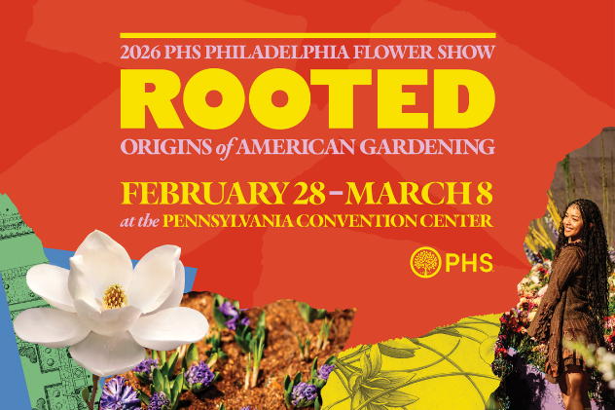
According to the Pennsylvania Horticultural Society, “Gardens aren’t just made; they’re passed forward through generations, carried across land, oceans, and lifetimes. Whether it’s the nostalgia of a grandparent’s garden, a beloved family recipe that begins with the bright scent of freshly picked herbs, or the practices that shape how we gather, ROOTED brings to life the personal stories, cultural traditions, and horticultural inspiration that connect us to nature and each other.
The 2026 Flower Show marks the final chapter in a three-year trilogy of themes exploring gardening across time. United by Flowers (2024) current connections and community, Gardens of Tomorrow (2025) sparked imaginations of the future, and ROOTED (2026) looks to the past to honor the origins of today’s gardens.” Visit https://phsonline.org for more information.

March 4, 2025 District I Annual Meeting at Prospect Bay Country Club. If you’ve never seen horticulturalist and designer of outdoor containers ‘extraordinaire’, Kent Russell, aka The Garden Guru, you won’t want to miss this very entertaining and educational program. Kent always offers many beautiful plants for sale and those shoes! You’ll just have to experience this guy. His program is called ‘The Sensational Spring Garden.’

March 25 & 26, 2026 Landscape Design School, Course 2, DoubleTree Hotel in Columbia, MD. Visit the NGC website for more information on this and the other three special schools.

April 28, 2026 FGCMD Annual Meeting at Turf Calley Country Club in Ellicott City.

May 18, 2026 District I Flower Show, The Packing House, 411-A Dorchester Ave, Cambridge Maryland 21613.
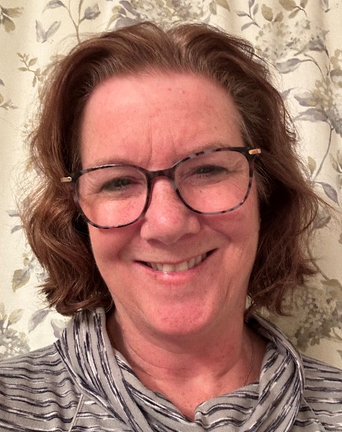
Another New-ish Member Profile: Shawna McQueen
Shawna and her husband of 27 years, Craig Marcum, purchased their Cambridge home about thirteen years ago. They are here on Riverton Road (off Casssons Neck) fronting Hudson Creek which is in the Neck District. This is a part-time residence with Annapolis being their primary home. When looking for a second home (a get-away of sorts from the hectic DC area) Shawna and Craig knew of Cambridge through some friends in Church Creek. Craig, a realtor in Annapolis and, occasionally, Cambridge, learned of the house available on Riverton and they fell in love with the area. They enjoy hosting gatherings of family and friends, which often includes crabbing in Hudson Creek and harvesting and eating oysters from their floats off their dock. They are still tied to the Annapolis area through family—many nieces, nephews, grand nieces and nephews who bring them joy—as well as old friends that go back to middle school.
Shawna got an undergraduate degree in Natural Resource Management from the University of Maryland and earned her Masters from George Washington University in Science, Technology and Public Policy. She first worked as a contractor for the Department of Energy and then became a federal employee in the Office of Energy Efficiency and Renewable Energy. Her job entailed procurements, meeting planning and special projects for the Hydrogen and Fuel Cell Technologies Office.
As for the Garden Club, Shawna got to know Teresa Troll (a former member who moved to Southern Maryland this summer) at the Cambridge Yacht Club who convinced her to join DGC last year (2024) with Teresa as her sponsor. Shawna enjoys working in the Diggers Boutique with Sue Jones and her team. She’d like to meet more folks, though, so be sure to reach out and introduce yourself. She has a strong interest in native plants and gardening (“we have lots of lawn I’d like to get rid of!”) and learning more about the resources in the area such as Adkins Arboretum and Mt. Cuba. She also enjoys floral design and is eager to learn more about all the design techniques and tools. Learning in garden club about the potential damage of floral foam to the environment greatly concerns her.
We welcome Shawna and appreciate the specialized knowledge and skills she can bring to our club.

Other News….
- Get well wishes to Cheryl Willey who just underwent knee surgery. Hope you have a speedy recovery!

- View the Fall 2025 issue of The National Gardener (NGC’s quarterly publication) online now. There are some great articles on a variety of subjects and it’s FREE. You can access all previous issues on their website as well. (www.gardenclub.org)

- Go to www.finegardening.com for information on their on-demand virtual course, The Ultimate Guide to Container Gardening. The course fee was listed as $79 but it is now being offered at 60% off ($32.00)! Check out all of Fine Gardening’s online learning courses

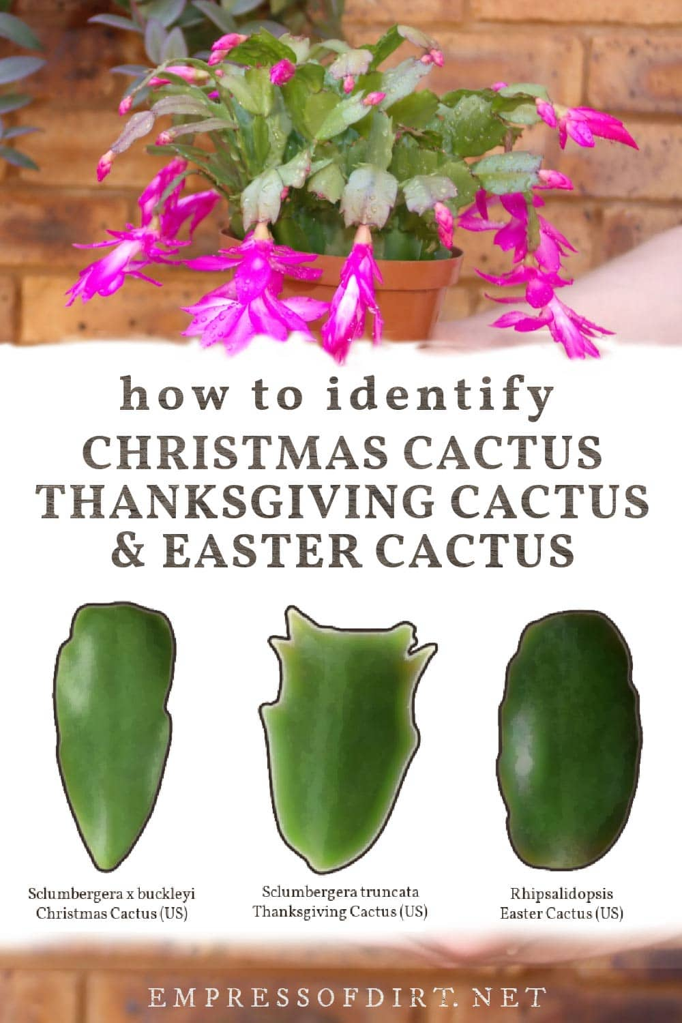
- Do you know how to identify your holiday cactus? In The Empress of Dirt newsletter on-line (www.empressofdirt.net), Melissa Will provides detailed information on how to determine whether you have a Thanksgiving, Christmas or Easter cactus. How? It’s all based on the shape of the leaves! Read the full article for Holiday Cactus care tips.

- Spotted by Jeanne: my first spotted lantern fly!
They are known to be all over MD, but I saw mine just over the border in northeast DC while shopping at COSTCO! The unusual-looking insect (like a spotted, gray, armored moth) was sitting on the lady’s cart in front of me in line. Yes, inside the store! I pointed it out to the woman who swiftly knocked it to the floor. It opened its wings to reveal the red color which confirmed to us both that it was a spotted lantern fly. So what did I do? I immediately ‘smooshed’ it. I was eager to report my find, but learned one must have photographed the invasive critter in order to report to the authorities. Oh well—be sure to take a picture before smooshing.
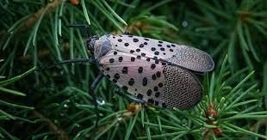

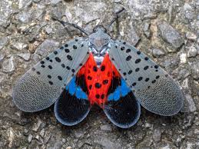

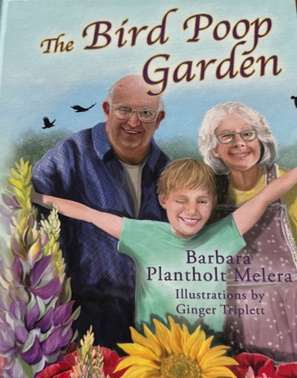
Barbara Plantholt Melera, founder of Harvesting History – Seeding Our Future, offers unusual horticultural and agricultural products with an emphasis on heritage cultivars. Barbara spoke to our club a number of years ago and has been a featured speaker statewide and nationally. You can likely see her and visit her amazing booth at next year’s Philly Flower Show. Well, Barbara has now penned her first children’s gardening book (just in time for Christmas ordering!). The book is called The Bird Poop Garden and is available ($30 plus shipping) on the Harvesting History website (https://harvesting-history.com) or by calling 410.627.6831. It is beautifully illustrated and addresses ﻿“by far the most important and complicated and seemingly insurmountable issue -- how to teach children about gardening when their parents have never gardened.” Attention Youth Gardening Committee!
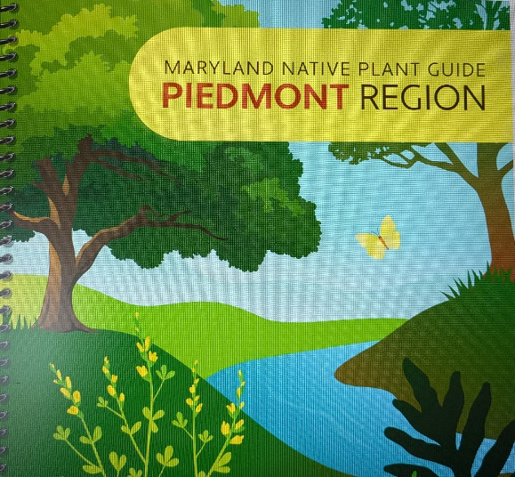
Mari Stanley has shared a wonderful new resource on native plants produced through a partnership between the University of Maryland Extension, the Maryland Native Plant Society, the Department of Natural Resources and the Maryland Department of Agriculture. The 180-page reference, Maryland Native Plant Guide Piedmont Region, is a very comprehensive resource you will definitely want to download. The link is also on the DGC website. Mari says it will be printed and sold in the not too distant future. It is very timely in view of all the emphasis on the benefits of planting native on our local and global landscapes. Here is the link (CTRL + Click to open): https://umd.box.com/s/wor658gif8nm79jd7gc0i8m89fbpvojz
Congratulations to Mari who is credited as one of the authors of featured plant descriptions!
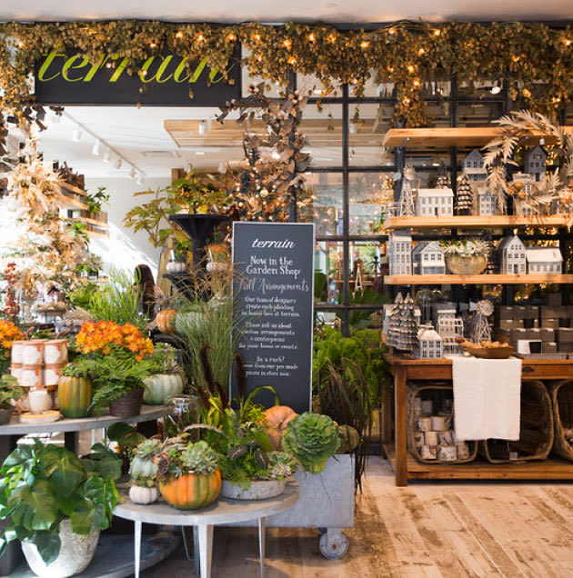
Exciting Retail News!
For those of you familiar with the amazing garden and design shop, Terrain, located in PA, CT, CA and NY—a new shop has opened in Bethesda, MD (Montgomery County)!!! The inventory can be pricey, but so unique, beautiful, inspiring….
The store is located at 4801 Bethesda Avenue in Bethesda 20814. Open Monday through Saturday, 10 am – 6 pm, they can be reached at 240-345-9413.
This news was reported in the November 2025 Pegplant’s Post Gardening Newsletter, another great on-line resource for gardeners in the DC Metro area. (www.pegplant.com).

Happy Fall…..Stay Safe….
Share a Smile…..and Be Kind
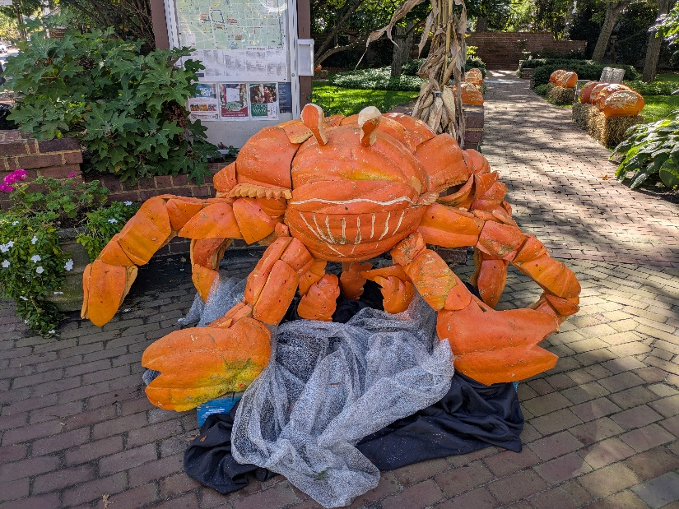

Spotted in Easton at the corner of Washington St and Dover Rd

