
April 2026
The DGC Buzz

Great meeting last month. Unfortunately, our speaker was unable to present because she suffered injuries from a recent fall. But, talk about stepping in at the last minute….Julie Bryan and Mary Ann Moore created an engaging and enjoyable activity that was fun and somewhat eye-opening for all. Eye opening because the was an assortment of flowers which all members selected and placed in a triple vessel—retrofitted tool boxes able to hold oasis and water. Everyone randomly placed the flowers and at the end the finished product was amazing. Just shows how a beautiful arrangement can be created with little stress, little fuss, little planning even!

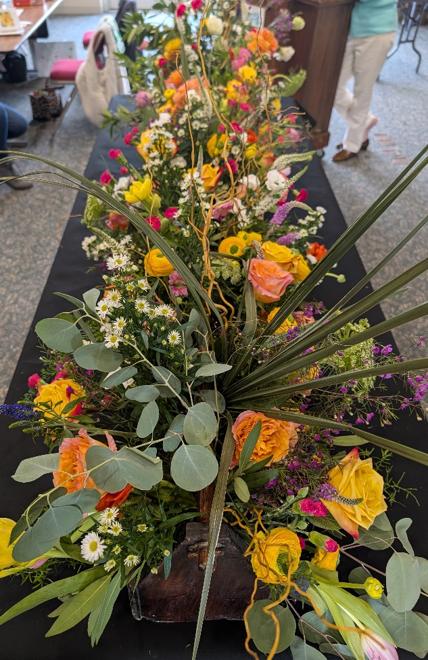
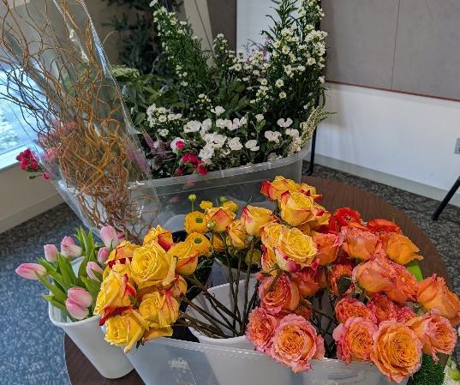
Top Left: Starting Materials
Bottom Left: A work in progress

Right: The Finished Product!
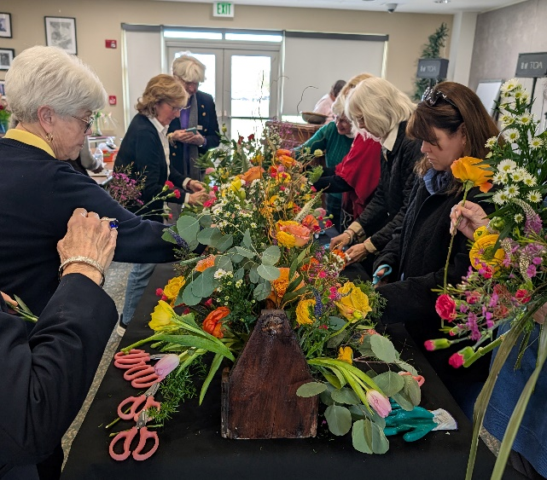

For next week’s April meeting, our own very talented Ann Dremluk will instruct us in the creating of a mass line creative design. Many of us have signed up for the activity (so we know how many flowers to purchase) and have paid the nominal fee of $11.00 to help defray floral costs. This is likely the new normal for meetings and workshops where participants work with flowers. As you know, the price of flowers has risen precipitously due to tariffs, supply chain issues , the costs of fuel and even the effects of climate change on product availability. Mary Ann Moore has sent out several reminders about this. You have till April 4th to let us know if you would like to participate. Mary Ann states “DGC will provide vase, frog and flowers that day. You will be able to take your arrangement and give it to someone in the community to brighten someone's day with your creation! Our theme for April is ‘Random ACTS Of Kindness" Looking forward to seeing everyone next week as we kick off our new programming year!”
Please be prepared to pay your Active or Associate dues at the April meeting. You can give your check to membership chair, Fran Collins, mail your check to her or pay on-line on our website!
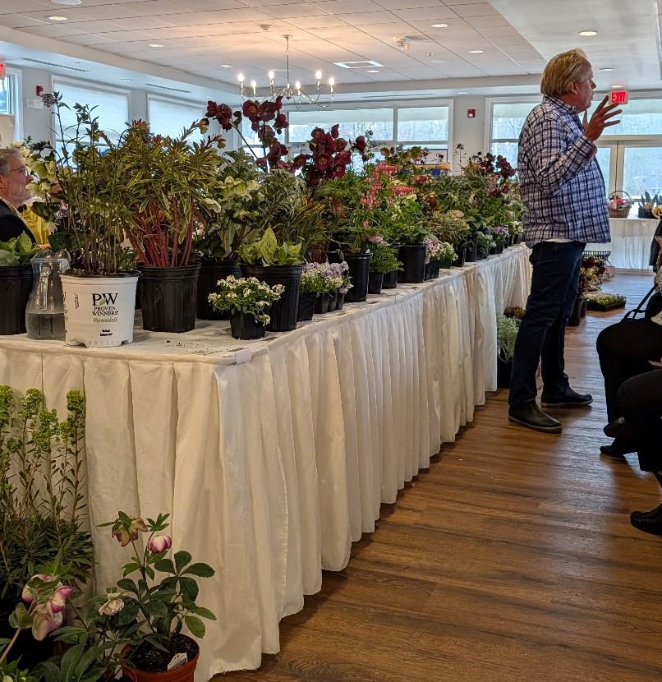
The District I Annual Meeting was held in early March and featured Horticulturalist and Garden Designer Kent Russell who did not disappoint with his humorous anecdotes and expert advice on combining plants in our gardens and containers. He brought with him a very large assortment of spring plants (lots of gorgeous hellebores, in particular) for purchase by the attendees. To say it was a veritable feeding frenzy when it came time to grab up plants would not be an understatement!

Mark your calendars with many great events and learning opportunities in the coming months!
April 1, 2026 U-pick Tulip season begins at Vintage Family Farms
Katelin Frase, owner of Vintage Family Farms will be our speaker at the May DGC meeting!
April 7, 2026 “Birds, Bugs and Blooms: The Harmony of a Native Garden”
A talk sponsored by the Chestertown Garden Club by Janet Davis, a Virginia Tech horticulturalist who has operated a landscape design and consulting business for more than 30 years.
“There’s a lot of ‘buzz’ around native plants and their importance in our landscapes for providing pollinator, insect and bird habitats. So how can we digest all the science and plant lists to create rich and enticing gardens? Jane3t will share her garden design experience and ‘grower know how for creating landscapes for our region that have purpose—and beauty—using ‘5 First Steps and 15 Great Natives.’

April 9-10, 2025 NGC Gardening School, Course 2. Hybrid. Contact Connie Richards hcrrgc@gmail.com.

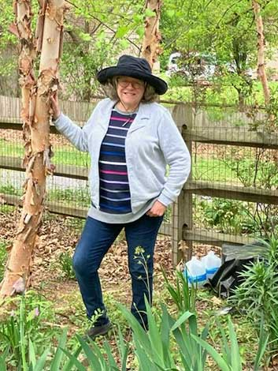
April 11, 2025 “Make Your Own Yard A Wildlife Refuge” sponsored by the Friends of Blackwater Wildlife Refuge.
“Just in time for Earth Day!!! Join us for an evening of hope. Join us for an evening learning how you can make an absolute difference for the future of our planet…which will be inherited by our children, grandchildren, and generations yet to come. Speaker Reenie Rice is a Naturopathic Doctor who has had a lifelong passion for environmentalism and gardening. She has melded these fields to provide a workable blueprint for how we all can “help Mother Earth” by supporting pollinators, birds, butterflies, lightning bugs and other fascinating creatures we love. Learn how to create your own wildlife refuge right in your own yard. Specific needs of birds, pollinators, and neighbors will be addressed. Questions will be enjoyed after the talk. Members $30.00; Non-Members, $40.00 Make your own yard a Wildlife Refuge! Saturday April 11, 2026 • 6:30: meet ’n greet • light refreshments • 7:00: presentation 7:50: Q & A Intergenerational Center at 108 Chesapeake Street, Cambridge Maryland.” https://friendsofblackwater.org/speaker-series.html

April 28, 2026 Talbot Garden Club Free Winter Lecture Series featuring Cece Haydock, esteemed landscape architect, garden scholar and lecturer presenting “Edith Wharton and the Villas of Rome” at the Talbot Free Library 11 am – 12:30 pm.

April 27, 2025 Flowers After Hours. 5:00-7:00 pm at Harvest Drive Greenhouses in East New Market. Member/Owner Kim Harper invites DGC Members and friends to come buy spring annuals and perennials at the nursery and a portion of the proceeds will be donated to our club. Please support them…and us!

April 28, 2026 FGCMD Annual Meeting at Turf Valley Country Club in Ellicott City.
The featured program is “Night Sounds of Mountain Maryland,” presented by Kevin Dodge, Professor and Director of the Natural Resources and Wildlife Technology program at Garrett College in far western Maryland. Kevin will present an entertaining and educational introduction to the different hoots, toots, peents, and peeps heard after sunset in the Central Appalachians. Weaving together facts, stories, and sounds, Kevin will recreate a night in the mountains of western Maryland.

Also at this meeting, the Judges Council will sponsor a Small Standard Flower Show titled, ‘Federated Garden Clubs of Maryland, Inc. Celebrating 100 Years; ‘Yesterday
and Today’ (1926–2026)” that will be held from 11:00am to 2:15pm. Entries will be received on
Monday, April 27 from 4:30pm to 6:00pm, and on Tuesday, April 28 from 7:30am to 8:15am.
Exhibits may not be removed before 2:15pm on April 28, and must be removed by 2:45pm.
Judging will begin at 9:00am, April 28. Decisions of the judges are final.

May 1, 2026 Chestertown Garden Club’s May Mart Plant Sale, 9 am – 1 pm at Memorial Park Plaza in Chestertown. Rain or Shine.

May 11, 2026 FGCMD Photography Zoom Workshop: Harvest Your Best Shots 1 pm
Visit www.craft.andrewlinke.com/garden-photography to register.

May 14, 2026 DGC Field Trip to Chanticleer Gardens, Wayne, PA
Check this out on the Dorchester garden club website and learn more about Chanticleer on their site: www.chanticleergarden.org. This is an amazing place; if you’ve never been don’t miss this trip which features a guided tour. If you have been, it’s always worth revisiting.
“Chanticleer has been called the most romantic, imaginative, and exciting public garden in America. The garden is a study of textures and forms, where foliage trumps flowers, the gardeners lead the design, and even the drinking fountains are sculptural. It is a garden of pleasure and learning, relaxing yet filled with ideas to take home.”

May 2026 Maryland House and Garden Pilgrimage (MHGP)
Seven tours are being offered across the state to complement America’ 250th celebration. The tours begin on April 25th with Mount Vernon in Baltimore; Talbot County on May 9th; Port Tobacco in Charles County on May 16th; Mount Harmon and Cecil County on May 24th; Mount Clare Museum and Baltimore on May 30th; Kensington, Montgomery County on June 7th; and Frederick County on June 13th. Stay tuned for more information. The proceeds from contributions and ticket sales support the restoration of significant historic sites throughout Maryland. For more information visit www.mhgp.org or email info@mhgp.org.

June 1-7 National Garden Week

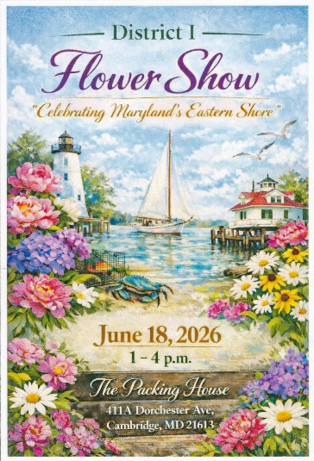
June 18, 2026 District I Flower Show, The Packing House, 411-A Dorchester Ave, Cambridge Maryland 21613. The schedule will be out soon so we hope many of you will want to participate since it is in our ‘neck of the woods.’ Reminder: Please consider going through your gardening and design supplies (vases, tools, mechanics, garden art, etc.) for donation to the Green Elephant Table at the Flower Show. Every little bit sold will help the District continue to offer exceptional programming. (See schedule cover at right)

The final schedule has been shared by Sandy (e-mail). Take a look at each division and class and see what you might be able to enter.
PATRONS for the June 18 Standard Flower Show Wanted:
Patrons play an important role in supporting the District Flower Show. A donation of $10 allows a patron’s name to be published in the Flower Show Schedule, and receive a copy of the schedule booklet. Barb Brooks will collect payment for show patrons at the April club meeting with checks payable to DGC. These are due April 20th and we’ve been asked to send one club payment. If past the due date, you can directly send your check by April 24th to: Nancy Thompson, Talbot County Garden Club,
9640 Leeds Landing Circle, Easton, MD 21601 Email: nancy66@gmail.com.

SPONSORS for the June 18 Standard Flower Show
If you know of any local businesses that may be interested in sponsoring our show, we would be delighted to connect with them. Sponsors will receive advertising in our show schedule as well as in materials distributed to the general public.
A letter of introduction is attached for your use. It provides information about the Federated Garden Clubs of Maryland, and District I, along with available sponsorship levels. Each sponsor will need to submit a copy of their logo and information that can be published on advertisements. Sponsor checks are to be made payable to District I, FGCMD.
Please notify Boots Michalak, Chairman as soon as a sponsor is confirmed. Submit Sponsor information no later than April 24th to:
Boots Michalak, Flower Show Chairman
28735 Emmanuel Street
Easton, MD 21601 Phone: 410-770-4573 Email: boots@goeaston.net
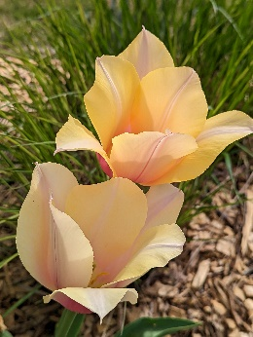
Thank you to those members who have stepped up to help out with club positions recently vacated:
Fran Collins is handling Membership. Cindy Burns will take on Civic Improvement. Fay Singer will serve as Treasurer, a role very important for us to comply with regulations governing our IRS non-profit status as a 501(c)3 organization. We appreciate you all!

An enjoyable weekend activity!
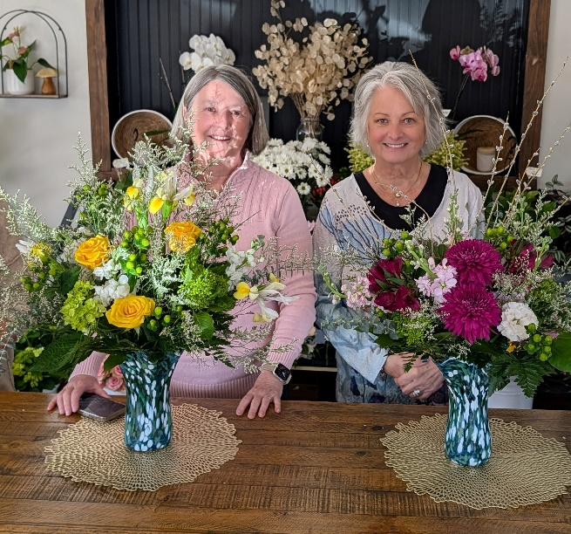
Mari Stanley and Jeanne Bernard attended ‘Blow and Bloom’ a weekend collaborative class offered by Jeffrey Auxer, Glass Blower, and Kelly Dean, Florist of Sylvie Rose in Berlin. On Saturday, a group of four ‘assisted’ in blowing a beautiful glass vase (we picked the colors and helped hold the tools!). The vases cooled over night and on Sunday we were given a brief floral design tutorial and then selected beautiful blooms to arrange in our vases. It was such a wonderful experience and lunch in Berlin couldn’t have been better. Five stars recommendation!
Kelly (formerly of Flowers ‘n Things fame) shared the calendar of upcoming classes:

Glass blowing with Jeff Auxer:
April 4th - 9am - 4 spaces available
April 11th - 11am - 2 spaces available
April 18th - 9am - 4 spaces available
April 25th - 9am - 4 spaces available

Flower Class with Sylvie Rose:
Sunday April 12th - 11am
Sunday April 26th - 11am

News You Can Use!
Kathy Jentz, Editor of the Washington Gardener, shared some of these gardening tips for early spring:
- Check your roses every few weeks and prune out and dispose of (do NOT compost) any sign of Rose Rosette Disease (RRD) immediately. The old guidance was to destroy and dispose of the entire shrub if any signs of RRD were seen.
- Prune our native Hydrangea arborescens (aka smooth hydrangea or wild hydrangea) in March as it blooms on new wood. In general, other hydrangeas should not be pruned until after they finish blooming.
- Group 3 Clematis bloom on "new wood" (this year's growth) usually in mid-summer and fall - so in late winter/early spring, whack it all down to a healthy bud about a foot from the ground.
- Foliage of spring bulbs should be left alone until it begins to wilt and discolor so that nutrients are stored in the bulb for flowering next spring. There is no need to braid or fold it over. As soon as the leaves begin to fade, they can be cut back to the ground.

Barry Glick, owner of Sunshine Farms and Gardens in West Virginia explains the benefits of snow in The Washington Gardener….
“Whenever the temps drop so drastically into the single digits and the winter winds start a-roarin’, the volume of phone calls and emails that I receive from concerned gardeners skyrockets. What are they looking for? Mainly reassurance and peace of mind that the plants that they can’t see are gonna come back. This year, I can give them a pretty good dose of reassurance, and why you may ask? In a word, SNOW! It took me a while, when I first started growing perennial plants, to wrap my head around the fact that snow was a good thing for them. Now, you must come to grips with the reality that gardening is not a risk-free adventure; you’re going to have a few casualties and lose some plants in some years. Reasons are plenty. There are plants that just have a shorter lifespan than others. Sometimes a hungry varmint is going to dig up your dormant bulbs, tubers, and roots, and eat them or just leave them lying on the ground to freeze to death when they discover that they taste terrible! Wrong plant! Wrong place! It’s definitely a crap shoot! However, just because you can’t see any growth above ground, it doesn’t mean that your plants are dead. They’re considered “dormant.” Actually, there is a miraculous beehive of activity going on down there under the snow. Think of the cells in the underground parts of the plant as having a chemical compound that acts like antifreeze and prevents the water in its cells from bursting and killing the plant. These compounds are continually moving water in and out of the cells to maintain a balance during winter’s freeze-and-thaw cycles. These natural “antifreeze” compounds are actually sugars and carbohydrates that the plant sent down during its growing cycle to the roots for storage to use over the winter, or what we “think” of as the dormancy period. The roots also take in moisture over the winter during freeze/thaw cycles to stave off dehydration. Roots can and do grow during the winter, albeit slowly. They can penetrate the soil more deeply to not only hunt for and absorb nutrients, but to hug the ground more tightly to prevent the plant from being “heaved” out of the ground during the freeze/thaw cycles of late winter/early spring.”
Dr. Shelby Carlson of the Cornell Lab of Ornithology shares this:
“Migration season is on the horizon for many of your favorite birds! As a friendly reminder, now is the perfect time to make sure your home is safe and ready to welcome our feathered friends back to the neighborhood.

More than 1 billion birds in the U.S. are killed from collisions with windows every year and nearly half of all collisions occur at residential buildings. Making your windows more visible to birds is one of the most effective ways to protect birds at your home year-round. Fortunately, a range of affordable and evidence-based collision deterrents are available, including products from Feather Friendly® and Acopian BirdSavers.
In addition, the Gardener’s Catalog of The Kinsman Company (www.kinsmangarden.com) –a great gardening resource--sells translucent bird decals which reflect ultraviolet light so they appear like frosted glass to humans but show clearly to birds. They are self-adhering, inexpensive and are easily removable. The decals come in sets of hummingbirds, maple leaves or a medley of leaves.


The Maryland House and Garden Pilgrimage is offering for purchase two lovely silk scarves to commemorate the nation’s 250th anniversary. For more information contact Carolyn Benson at ctbenson30@gmail.com.


Our friend, Claire Jones, who pens the blog “The Garden Diaries” has announced a trip for next May (2027) which will bring a small group of lucky gardeners to the Chelsea Flower Show, Cotswolds and Wales. This writer joined Claire on a trip to Belgium, the Netherlands and France three years ago and it was wonderful!

Breakfast daily, 3 lunches, 4 dinners, 1 Afternoon Tea
4- Star Hotel Accommodations for 12 nights, including London, Wales, and Windsor
- Full day immersion at the Iconic Chelsea Flower Show (RHS Member’s Day)
- Explore the idyllic Cotswolds village, Ilmington, visiting private cottage gardens
- Private winery tour and tasting at White Castle Vineyard in Wales, plus a cider tasting at The Newt, a forward-thinking English estate integrating contemporary garden design
- Discover the historic market town of Petworth, known for antique stores and galleries and literary Hay-on-Wye, famed for its bookshops
- Explore St Fagan’s National Museum of History, an open-air museum near Cardiff, featuring historic Welsh buildings
- Spend a day at Great Dixter known for its bold planting combinations and Sissinghurst Castle Gardens to view the world-renowned white garden
- Visit RHS Garden Wisley, The Royal Horticultural Society’s flagship garden
- Experience Arts & Crafts-inspired Hidcote Manor and Kiftsgate Court Gardens
- Multiple nights in Abergavenny, “Gateway to Wales” and Windsor, historic royal town, home to Windsor Castle
- Limited to a small group for an intimate experience (minimum 15 – maximum 24 guests)
- For complete itinerary, contact Claire Jones jonesb1@comcast.net or 443-927-6285 or visit https://thegardendiaries.blog/trips/ or click here
Price: $8,185.00 double, $2,600 add’l for single- Tour price is based on current exchange rates and may adjust slightly if currency fluctuations exceed standard thresholds.

Hope You’re Collecting Plastic Bags!
Our first bunch of plastic came to the March meeting and DGC collected 35 pounds! Sandy and Mari have set a goal for us to amass 200 pounds for the District’s Nextrex project by December so keep those bags coming. Learn more by visiting www.NextTrex.com.
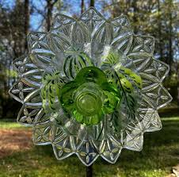
A reminder to take photos of any garden art
you create and submit to the Buzz!

Also please look through your floral design supplies (things you have too much of or don’t use any more) and gardening tools, pots, garden art, books, baskets …Consider donating these things to District I for sale at the June District Flower Show. Proceeds go to educational programming for garden club members.
Special thanks to Joan P. Johnson who has donated tons of things for the sale.
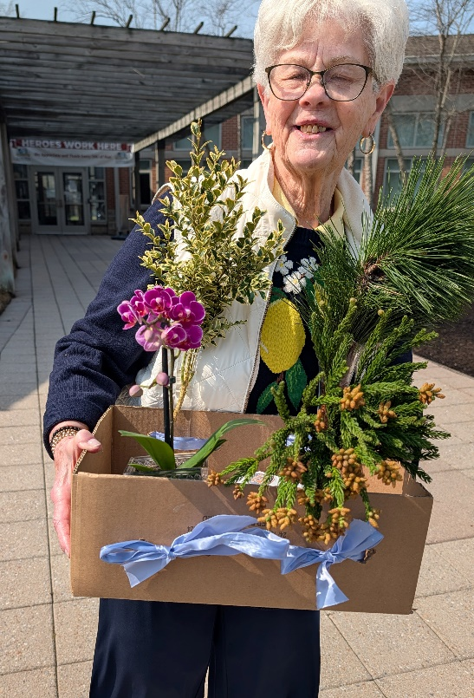
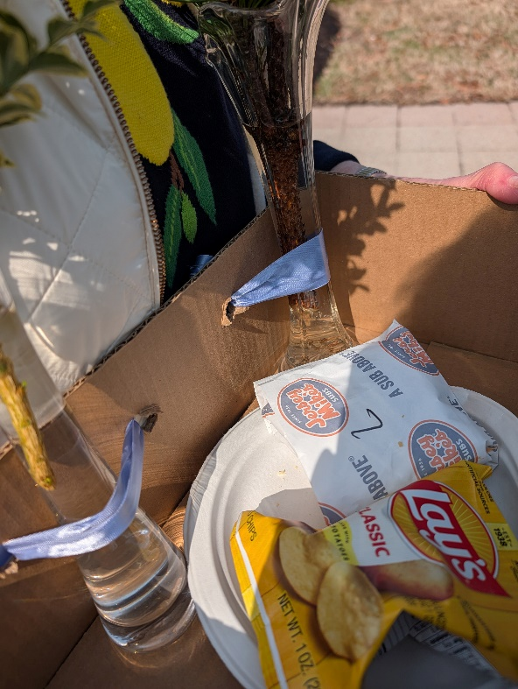
Speaking of Joan Johnson, at the last meeting it was noted the clever way in which she transports her horticulture exhibits. She places the bottles in a cardboard box with holes in the side through which ribbons are threaded. She then ties the ribbons around the bottles to keep them secure for transport. Such a good idea. Apparently, the box is handy for carrying snacks as well!

