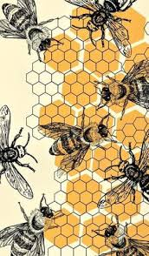
January 2026
The DGC Buzz
President’s Message
Happy New Year!! I hope you all had a wonderful holiday season with your family and friends. During the month of December our club was certainly busy! We had our fantastic Wreath Workshop, our beautiful DGC float in the Dorchester Christmas Parade, our wreath on display in the Statehouse and, of course, our Holiday Luncheon celebrating our 95th year Anniversary.
I think our Holiday Luncheon was one of the best we have had….the room looked beautiful, the Mini Flower Show greeting our guests was so pretty, our Silent Auction items were outstanding, the Christmas ball wreaths were glittering, our vendors had all kinds of goodies to buy (especially the Diggers Boutique), the display with artifacts from our 95 years was so interesting. Our speaker David Powers not only wowed us with his floral designs, but entertained us along the way!! Overall, an amazing day, in fact, several people mentioned an interest in becoming club members.
Congratulations to Nancy Leonard and her committee for a job well done!! As I heard one person comment “the luncheon was a Master Class in event planning and execution”.
Coming up…
There will be an Executive Board meeting on January 14 at 2:00 o’clock at the Dorchester Public Library.
Even though we do not have a formal club meeting for the month of January, there will be a Flower Camp on January 16 where we will be planting tulip bulbs in a container that will be blooming in a few weeks. If you have signed up and have not yet paid, please send your check for $25 to Cindy Burns.
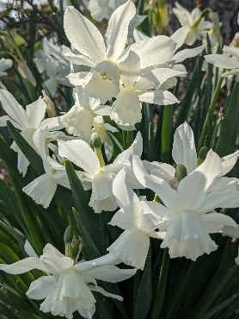
Our February 13th meeting promises to be a lovely day…plans are coming along well for our tea party and program. Let’s pretend it’s mid-century (again part of our anniversary celebration) and get dressed up, wear a hat or fascinator, maybe even gloves!
Stay warm, Sandy
We all mourn the loss of former DGC members, Peggy Van Huisen and Jane Parks. Get well wishes to Barbara Massetti who recently had a hip replacement.
Mark your calendars:
The New York Botanical Garden is offering many virtual classes on subject matter from composting to landscape design to pruning and so much more. Visit https://www.nybg.org/ for more information
January 5 Mondays through January 26, 6:30 to 8:30 pm, Botany for Gardeners, virtual, fee and must register, Phipps Conservatory https://www.phipps.conservatory.org/

The above two event postings are from the Pegplant online newsletter which focuses on gardening in the DC Metro area. You can subscribe for free at www.pegplant.com.

January 15, 2026 Growing Older, Gardening Smarter Zoom lecture presented by Kathy Jentz at Brookside Gardens. Discover practical strategies for modifying your landscape and gardening practices to accommodate physical changes and mobility challenges. Fee is $15. Register at: https://montgomeryparks.org/events/

February 9, 2026 FGCMD Photography Zoom Workshop: Prune Your Photos 1 pm
Visit www.craft.andrewlinke.com/garden-photography to register.

February 13, 2026 Note Change! Meeting location has been moved to Eastern Shore Hospital Center as DCA is under renovation.

February 28 – March 8, 2026 2026 Philadelphia Flower Show:

ROOTED: Origins of American Gardening

According to the Pennsylvania Horticultural Society, “Gardens aren’t just made; they’re passed forward through generations, carried across land, oceans, and lifetimes. Whether it’s the nostalgia of a grandparent’s garden, a beloved family recipe that begins with the bright scent of freshly picked herbs, or the practices that shape how we gather, ROOTED brings to life the personal stories, cultural traditions, and horticultural inspiration that connect us to nature and each other. The 2026 Flower Show marks the final chapter in a three-year trilogy of themes exploring gardening across time. United by Flowers (2024) current connections and community, Gardens of Tomorrow (2025) sparked imaginations of the future, and ROOTED (2026) looks to the past to honor the origins of today’s gardens.” Visit https://phsonline.org for more information.

March 4, 2026 District I Annual Meeting at Prospect Bay Country Club. If you’ve never seen horticulturalist and designer of outdoor containers ‘extraordinaire,’ Kent Russell, aka The Garden Guru, you won’t want to miss this very entertaining and educational program. Kent always offers many beautiful plants for sale and those shoes! You’ll just have to experience this guy. His program is called ‘The Sensational Spring Garden.’

March 25 & 26, 2026 Landscape Design School, Course 2, DoubleTree Hotel in Columbia, MD. Visit the NGC website for more information on this and the other three special schools.

April 28, 2026 FGCMD Annual Meeting at Turf Calley Country Club in Ellicott City.
Annual Meeting Program: Linda Harris, Program Laison Our program for the FGCMD Annual Meeting on April 28, 2026 will be titled “Night Sounds of Mountain Maryland,” presented by Kevin Dodge, Professor and Director of the Natural Resources and Wildlife Technology program at Garrett College in far western Maryland. Kevin will present an entertaining and educational introduction to the different hoots, toots, peents, and peeps heard after sunset in the Central Appalachians. Weaving together facts, stories, and sounds, Kevin will recreate a night in the mountains of western Maryland.

May 11, 2026 FGCMD Photography Zoom Workshop: Harvest Your Best Shots 1 pm
Visit www.craft.andrewlinke.com/garden-photography to register.

May 2026 Maryland House and Garden Pilgrimage (MHGP)
Seven tours are being offered across the state to complement America’ 250th celebration. The tours begin on April 25th with Mount Vernon in Baltimore; Talbot County on May 9th; Port Tobacco in Charles County on May 16th; Mount Harmon and Cecil County on May 24th; Mount Clare Museum and Baltimore on May 30th; Kensington, Montgomery County on June 7th; and Frederick County on June 13th. Stay tuned for more information. The proceeds from contributions and ticket sales support the restoration of significant historic sites throughout Maryland. For more information visit www.mhgp.org or email info@mhgp.org.

June 18, 2026 District I Flower Show, The Packing House, 411-A Dorchester Ave, Cambridge Maryland 21613.


Thanks to all those who brought donations of paper goods and toiletries to our December Wreath Workshop. The folks, staff and clients alike at One Mission Cambridge were thrilled! You can drop off donations of food items or paper goods whenever the Mission is open (Monday, Tuesday and Thursday).

Help Wanted
Well folks, we are ISO of few good volunteers…
- Linda Chandlee, who has entered flower show entries and awards for years, would like to retire from this registrar duty. Any one with bit of computer experience/facility willing to step up? Please contact Linda to discuss.
- Ellen Higgins is working hard on the coming year’s yearbook as she has done for many years now. It is time for Ellen to pass the torch and now would be a great time to step up while she is still working on and finishing up the document. You could see firsthand how it is done. A good working knowledge of word processing is important. Specialty skills like importing photos can be taught. So, if you like to learn and become more proficient on computer skills, this could be the job for you!
- Our treasurer, Cindy Burns, has already served a couple of years and is taking on some new responsibilities with another organization. We cannot do without a treasurer so we ask that someone please step up to, at minimum, serve out the rest of this term.
- Finally, Evelyn Renkwist, due to work responsibilities must give up the chair of civic improvement. There’s a great crew working on this club activity but we need someone to coordinate.
- Mary Ann McNamara is stepping down as Membership Chair. But Fran Collins has already offered to serve in this very important role helping us to continue to grow our garden club.

Let Sandy Lucas know if you can help with any of these important tasks.

Thank you!!!

Don’t toss those plastic bags!

District I is participating in the NEXTREX Recycling Challenge. We are being asked to immediately start saving all #2 and #4 plastics such as bread bags, produce bags, newspaper sleeves, pallet wrap & stretch film, plastic grocery bags, cereal bags, case overwrap, bubble wrap, wood pellet bags, dry cleaning bags, Ziploc & other reclosable food storage bags, plastic shipping envelopes—any kind of ‘stretchy’ plastics. A full program will be presented on this project at our February meeting to explain how it works. We have a year to participate and our success will be measured in pounds! For every 250 pounds collected, we are eligible for a prize.
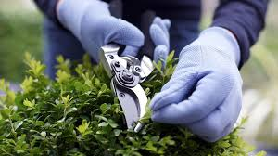
Your District Needs your Support to provide
quality programming!
At the March Annual Meeting, which features the amazing horticultural designer Kent Russell, we will have a ‘Green Elephant’ table at which we will sell donated (by You!) floral design supplies, tools, mechanics, small to medium-sized containers, garden art and whatever else in this vein you surprise us with! Ideas below, but be creative.
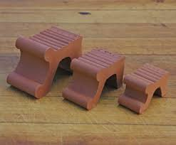
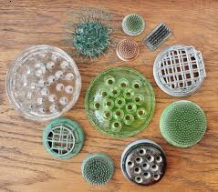


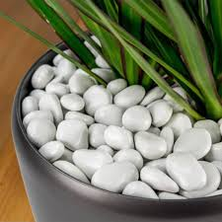

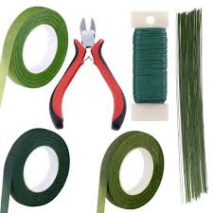

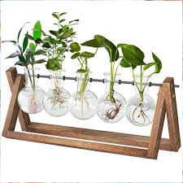
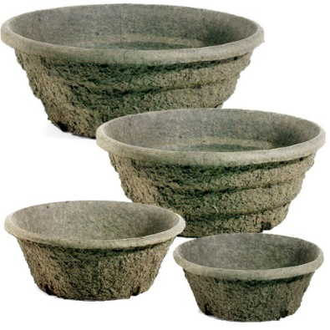
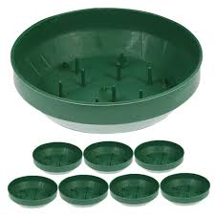
Please gather your donations (they may be gently used, but in a condition that someone would buy it) and give them to your club president. The District Board, which includes club presidents, will meet in early February. We will collect all items then and prepare them to sell at the District meeting.


As we welcome a new year, we invite you to begin 2026 with a gift that grows beauty, education, and environmental stewardship through the Plant America Matching Grant Program.

Your donation to Plant America directly supports grants awarded to garden clubs across the country—helping communities plant, preserve, and inspire. For a limited time, every gift will be matched, doubling the impact of your generosity.

As a special thank-you, with any donation of $25 or more, you will receive the 2026 Vision of Beauty Calendar, a gift from Donna Donnelly, President of National Garden Clubs, created to inspire beauty throughout the year.

When you’re ready to give, simply use the donation form below:

DONATE NOW!

Your Gift Will Be Matched - Support PLANT AMERICA

