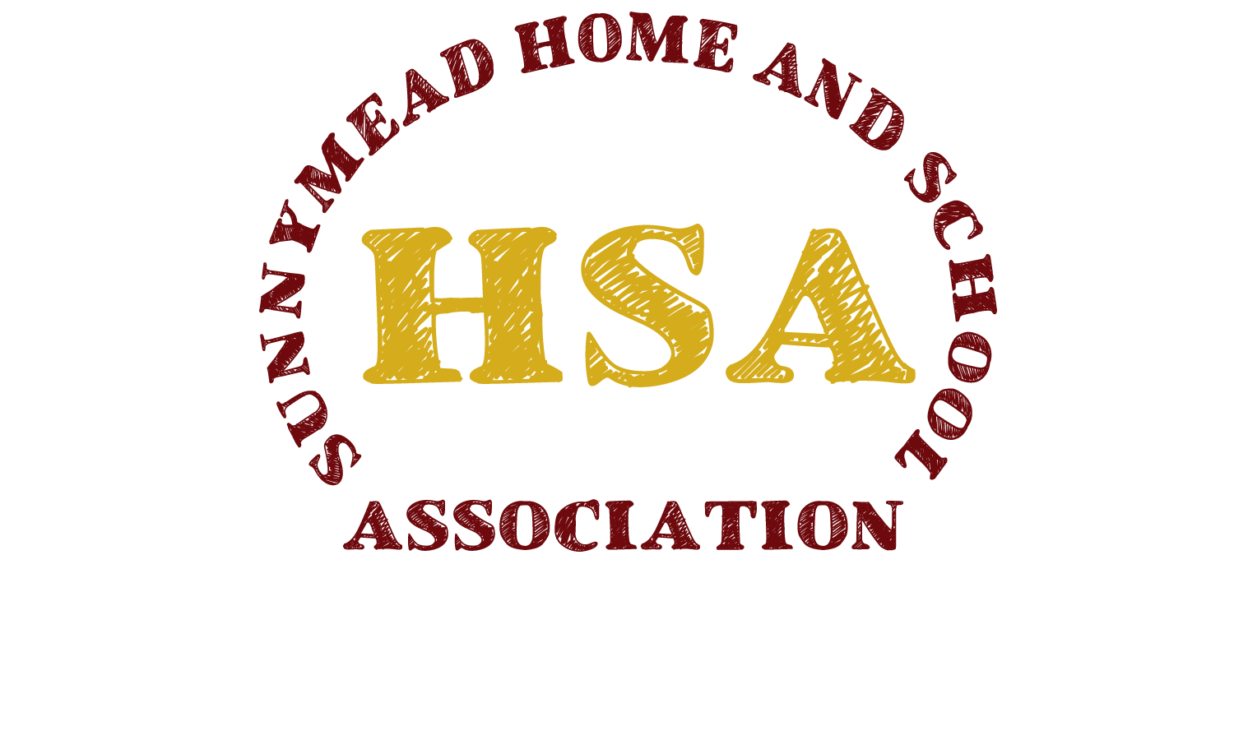

August 28, 2018

Dear Sunnymead Staff,

The HSA is pleased to be able to offer teacher grants. This year, we have $4000 in grant money available to you, and we will be honoring requests of $75 or less on a first come, first serve basis until the funds are depleted.

Attached, please find the Teacher Grant Request Form. Please consider the following when completing the form:

- Determine that the items requested are not available through district/school funds.
- Teachers may pool their grant money to share a more expensive project i.e. Friendship Soup or Young Author’s Day. Please indicate this on the form.
- This year we have two requirements for Teacher Grant eligibility:
- You must be an HSA member. Membership is $10.
- All requests must be approved by the school principal.
- Once your grant has been approved, feel free to:
- Make your purchase and submit your receipt for reimbursement to the Treasurer OR
- Request a check using the Teacher Grant Request Form for the exact amount payable to the vendor.

Completed Teacher Grant Request Forms should be turned into Dr. Jenkins, then placed in an HSA drawer in the main office. Please email treasurer@sunnymeadhsa.org with any questions. On behalf of the HSA, we encourage you to take advantage of this opportunity. All grant requests must be submitted by Friday, May 31, 2019. Please feel free to contact us if you have any questions.

Sincerely,

The HSA Board
sunnymeadhsaboard@gmail.com

Teacher Grant Request Form 2018-19

Date: ____________________________________________
Teacher Name: ____________________________________________
Teacher Initiative: ____________________________________________
Items to be purchased: ___________________________________________
I would like to (choose one):
- Buy the item(s) and submit receipt for reimbursement.
- Request a check for the exact amount of the item(s) payable to the vendor.
Order form or description must be attached or emailed.
Vendor Name to appear on check:________________________

Exact amount of check (incl. s/h, tax):______________________

Additional Information: ___________________________________________________________________________________
___________________________________________________________________________________

Please return this to the School Principal for approval, then place in the HSA drawer in the main office or email to: treasurer@sunnymeadhsa.org All requests must be received by Friday, May 31, 2019.

For committee use only:
Date request received by principal: _______________________
Date received by HSA: _______________________
Date check distributed: ________________________
Check number: ________________________

